CURRICULUM VITAE
Work experience :
[2016 to present] Private lessons during my free time, in Toulouse.
This work experience is about private lessons in Mathematics, Automatic and Physics for High school and degree students.
This work experience gives me teaching and social skills.
[07/06/2016 – 12/07/2016] Research internship of last Degree year, in the LAPLACE Laboratory, Toulouse.
Subject: Visualization and quantification of heat exchanges by convection on a heatsink for LED lighting sources.
During the five weeks of this internship in the “Light and Material” group of LAPLACE (PLAsma and Energy Conversion Laboratory), I have studding Schlieren photography, an optical visualization method for seeing the optical index differences. In this project, this optical method is applied to the study of thermal convection of the LED light source heatsink. After that, I created an image processing chain in Matlab for improve the convection study.
This internship allows me to acquire or improve skills in geometrical optic, optical manipulation, image processing, Matlab language and graphical interfaces, LaTeX editing and scientific method.
[12/2016 – 06/2017] Master project during my first year of Master degree, University Paul Sabatier.
Subject: Non-deterministic discrete events systems modelling, analysis and simulation.
During this group project supervised by a university teacher, we studied non-deterministic discrete-event system through non-deterministic automaton. The automaton formalism was one of the formalism we learn throughout this year. As a theorical example we took a labyrinth. We have also established equivalence between automaton and lattices, a special kind of graph, for defining properties about non-deterministic automaton. All of this was implemented in Matlab by an oriented object approach whit a graphical interface.
This project allows me to discover a new mathematical formalism, improve my knowledge in Matlab programming, group working and project management. This entire project was managed by a scientific method approach from theory to implementation.
[09/08/2017 – 14/08/2017] IFAC 2017 World Congress Volunteer, Toulouse.
I was a volunteer at the IFAC (International Federation of Automatic Control) World Congress. This conference receives more than 3000 persons and is about the last scientific and technologic discoveries in the domain of automatic.
I addition to my volunteer duties, I see conferences and I have practice English.
[2016/2017] Research internship, ISI group, LAAS-CNRS, Toulouse.
Subject: D.E.S modelling
During this research internship, I discovered modelling whit DEVS (Discrete EVents System Specification) a type of DES (Discrete Event Systems) models and worked on DC motor modelling.
This research experience allowed me to practice discretized time modelling, DEVS model and modelling.
[01/04/2018 – 31/08/2018] Research internship, DISCO and MAC groups, LAAS-CNRS, Toulouse.
Subject: Active diagnosis on hybrid systems
Active diagnostic, Hybrid system, observer, parity space, …
During the five months of this research work experience, the goal is to mix diagnosis and control to improve the detection of faults in a hybrid system. Indeed, in some situation, it is actually impossible to know if the system presents a fault or not or which faults happened. In this state, sometime by modifying the command applied on the system, we can clarify the situation. This is the way I am exploring.
This research experience allowed me to discover hybrid models and modelling, diagnosis on linear continuous and hybrid model. It also improved my Matlab skills, research interest and scientific methodology.

- I have my driver’s license.

- Software skills:
  - For automatic: Matlab: Simulink, OOP, GUI, RTW
  - For computer science: Eclipse, Git, Doxygen
  - Office software: TEXmaker, Microsoft office suite, Free Office Suite
- Languages:
  - Matlab good knowledge,
  - LATEX good knowledge,
  - C good knowledge,
  - Assembler notion,
  - VHDL good foundation,
  - ST and IL-LIST notion,
  - Arduino good foundation,
  - Java basics,
  - C++ notion.
- Language and communication skills
  - Language: French (mother tongue), English.
  - Communication: Oral and written in French and English
  - Project management: Gantt, WBS, RACI, Agile.
- Implementation:
  - Computer science:
    - System modelling (UML, UML2, SysML, embedded systems),
    - object-oriented,
    - parallel (mutual exclusion, synchronisation, thread, multitasking)
  - Industrial computing:
    - DSP notions,
    - Microcontroller basics,
  - Real time:
    - OSEK/VDX standard,
    - scheduling,
    - RTOS,
    - requirement checking,
    - reactivity
  - Network:
    - Internet basics,
    - Network Calculus,
    - CAN,
    - AFDX,
    - real time network

Personal interests:
Until my childhood, I am interested in travelling. I spent four times six months in India and I also have travelled to Morocco, Italy, North America, Europe, Vietnam, Cambodia, Thailand, … I like seeing monuments, wild nature and discover different peoples, cultures, societies and art.
I appreciate doing handmade and do-it-yourself things and repair work.
I like reading French and foreign literature (Fred Vargas, Carlos Ruiz Zafón, Arto Paasilinna, Henning Mankell, Hermann Hesse, …).
I also enjoy cycling.

__________________ _____________________________
(Place and date) (Signature)
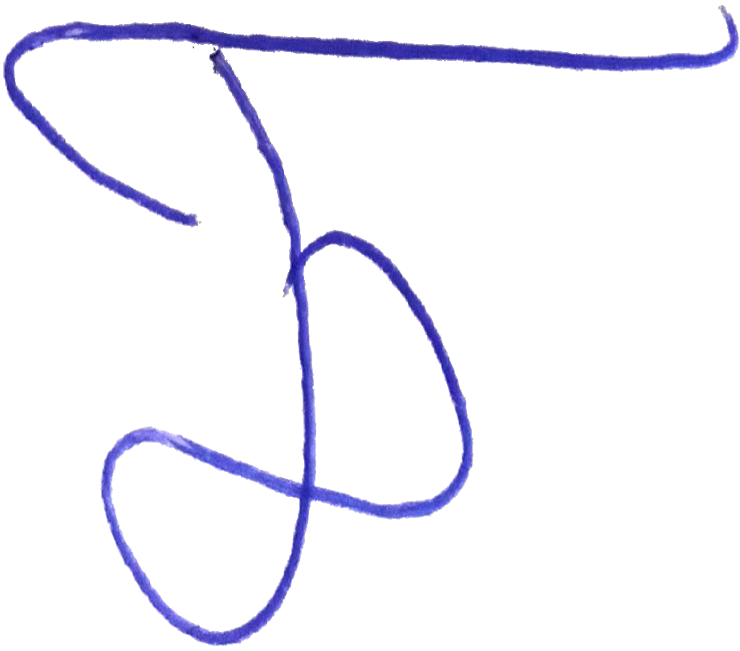
Toulouse the 26th of June 2018.

