**The modeling techniques included within this course:**

1. SWOT Analysis
2. Use Cases
3. Organizational Chart
4. Stakeholder Map
5. RACI Matrix
6. Scoring Matrix
7. Process Flowcharts
8. User Stories [NEW]

**No.1 Visual Modeling**

**What is visual modeling?**

Visual modeling is Graphical representation using a modeling language that takes something complex and makes it easier to understand.

**Benefits of Visual Modeling**

* Easily understand complex information
* Gets all stakeholders involved
* Receive requirements efficiently
* Identify the underlying problem
* Analyze ‘What if’ scenarios
* Allows removal of irrelevant information

**SWOT ANALYSIS**

**SWOT Analysis defined**

* What is it?
* What is it used? (Internal and External)

* Why is SWOT used?
* Uncover Opportunities
* Raise Awareness
* What does it accomplish?

**Breakdown of SWOT**

**Internal**

* Customer Feedback
* Employee Survey

1. Capabilities
2. Resources
3. Processes

**External**

* Market Ecosystem
  + Industry
  + Technology
* Third Parties
  + Competitors
  + Government

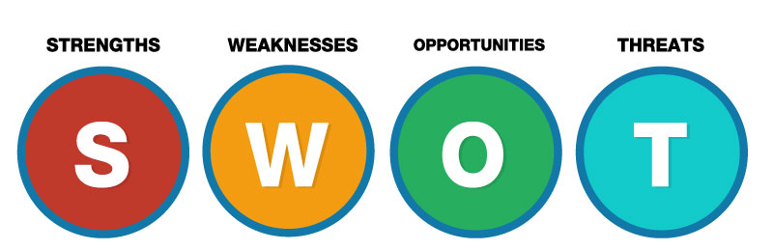

**ORGANIZATION**

What does your organization do well?

What are your unique resources?

What do others view as your strengths?

**PERSONAL**

What do you do well?

What are your unique skills?

What experience do you have?

What do you do better than others?



**ORGANIZATION**

* What could you improve?
* What resources do you lack?
* What parts of the organization lack profitability?

**PERSONAL**

* What factors lose your job offers?
* In what areas do you need to improve?
* Where do you need further education or experience?
* What costs you time or money?



**ORGANIZATION**

* How can you do more for your existing customers?
* How can technology be used to enhance your business?
* Any new target audiences you can potentially reach?
* Are there new products or services that provide opportunity?

**PERSONAL**

* What additional education would provide a boost?
* How can you leverage technology to aid you?



**ORGANIZATION**

* What obstacles do you face?
* Are regulations or standards for your products or services changing?
* Could any weaknesses seriously threaten your business?

**PERSONAL**

* What obstacles do you face?
* What are your job competitors doing?
* Is changing technology threatening your strengths?

**Practical Walkthrough**

**Template Explained** (In File Excel)

**No.2 Use Case**

**What is a Use Case?**

Use cases may contain both textual and diagramming pieces

* Diagrams offer a visual to the written use case
* Could contain one or more diagrams

Generally used for systems

Capture functional requirements (what the system should do)

Describes interactions between actors and the system

**What does it accomplish?**

Uses Cases explain:

* Who will interact with the system
* What the system must do
* The goal of the system

**Why do we create Use Cases?**

* Validates the system (or specific process) is necessary
* Ensure understanding of business needs
* Uncovers actors that will interact with the system
* Captures the goals actors will have in using the system

**Written Use Case Overview**

No standard format

Describes the steps involved between the primary actor and the system

Begin with the success scenario

Then look for alternative paths

**Use Case Elements Breakdown:**

**SYSTEM**

Represented by **rectangle**

Represents the scope of the system that actors will interact with

Contains all of the use cases

Only one system shape per diagram

Use case diagrams may contain external systems, but they will be displayed as actors

**ACTOR**

Represented by **stick or business figure**

* Represents
* People (role, not specific user)

Should be labeled

Primary actor

* Use system’s main function, deriving benefits

Secondary actor

* Supporting role to assist primary actor in achieving goals

**USE CASE**

Represented by an **ellipse**

Represented the goal of an actor

Describes the interaction between the user and the system

**ASSOCIATION**

Represented by a **line**

Connects an actor and a use case

* Indicates actor participates in that use case

**Dependency relationship**

* One use case depends on the existence and execution of another

Include dependency

* Specifies a use case contains the behavior defined in another use case

Extend dependency

* Specifies a use case may be extended by the behavior of another

*Ex: A system that has a login. An extended relationship use case could be “Forgot Password”*

**Steps to create a Use Case**

1. Know the system
2. Identify the actors of the system
   * Start with primary actors
3. Define goals of the system and how the actors achieve those goals
   * Start with success paths
   * Move into other paths
4. Build the use case diagram(s)
5. Validate the diagram is intuitive

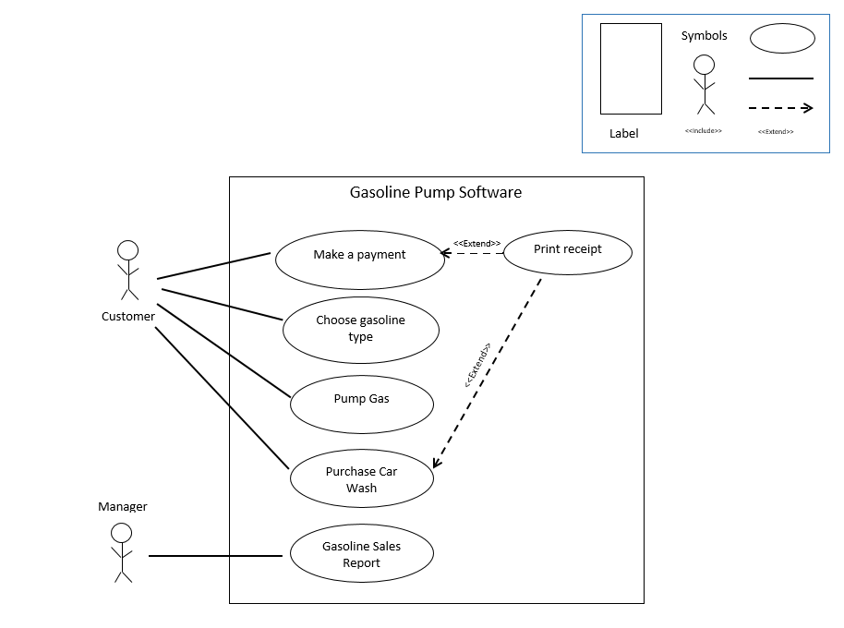

**Use Case of Gasoline Pump Software**

**No.3 Organization Chart**

Tip 1: **Keep it SIMPLE**

2 popular tools used to build the Organization Chart are **Visio** and **Excel**

***Example of Organization Chart***



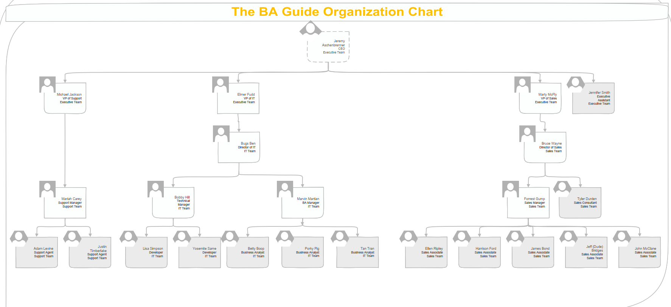

**No.4 Stakeholder Map & RACI Matrix**

What is a Stakeholder Map?

A Stakeholder Map is a visual representation of stakeholders that effected by activities and projects



What is a stakeholder?

* Project team members
* Customer
* Supplier
* Employees
* City/Community
* Professional organizations
* Any individual impacted by the project
* Any individual to support the project

Why identify stakeholders?

* It increases the chances for success
* Additional ideas
* Varied perspectives
* Gains buy-in
* Increases credibility

How to identify stakeholders to my project?

* Walk through anticipated scope/process
  + Beneficiaries of the effort
  + Directly involved with the beneficiaries of the effort
  + Jobs that may be affected by project or results
  + Government officials
  + Influencers
  + Interest in outcome
* Get ideas from stakeholders as you identify them

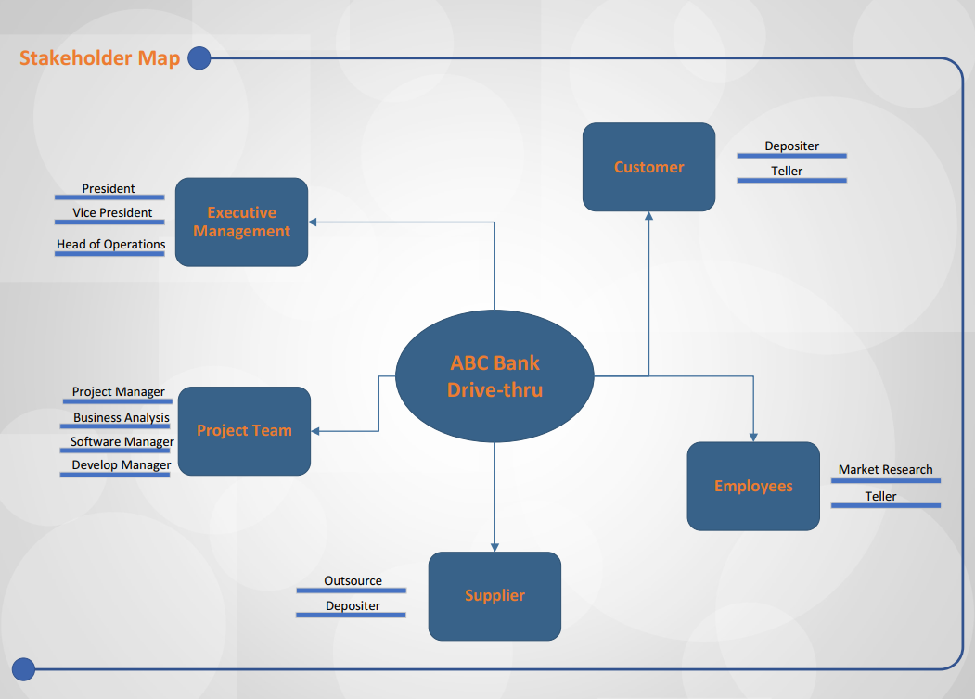

**RACI MATRIX**