**REPORT 2: SERVO LIFECYCLE SETUP**

* Fitted remaining magnets and Hall-switches with glue
* Taped temperature sensors to servo motors ( sensors will be replaced in time)
  + Note: maybe possible to 3D print a new servo holder with an extra slot for the temperature sensor because tape is getting too loose because of the heat
* Ordered spare sensors and resistors in case of sensor failure: spare sensors and resistor available
* Drew electric schemes for each individual PCB: hall-switches, temperature sensors, servo control
* Soldered PCB’s according to schemes (pictures added in directory)
  + Note: Cable colors not according to the convention! Check documentation and datasheets (power cable from power source to servo control PCB, ground cable is red but was marked with black marker)
  + PCB underdimensioned for required current (datasheet)

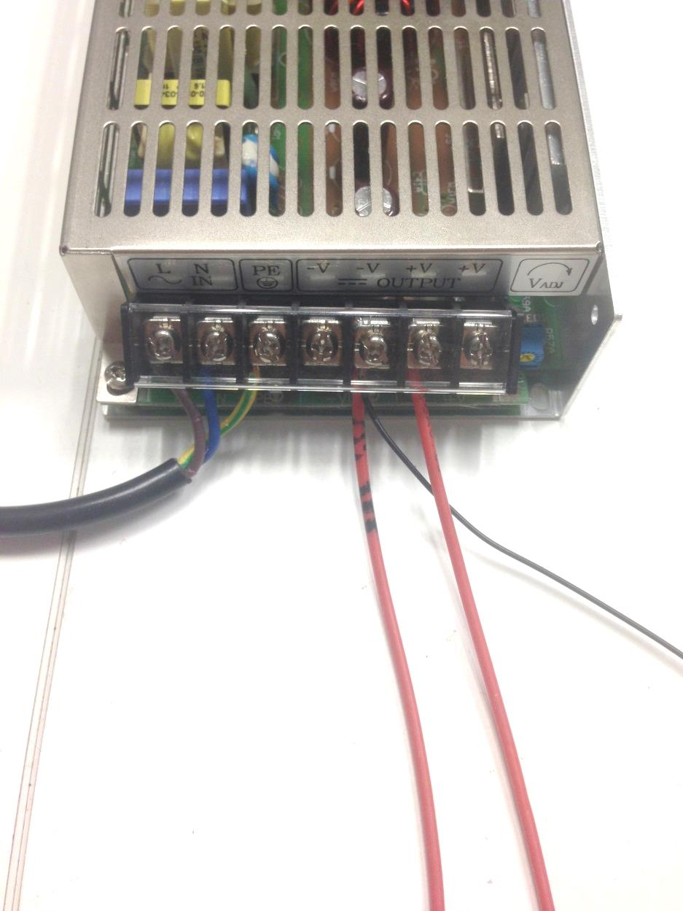

* Tested PCB’s and all sensors with test program – all sensors and servo’s working
  + Note: T-sensor reading sometimes gives a faulty measurement due to a bad connection
  + Note: Current reading seems a bit too high, probably fault in programming, calibrations shows measured amperes with FLUKE multimeter

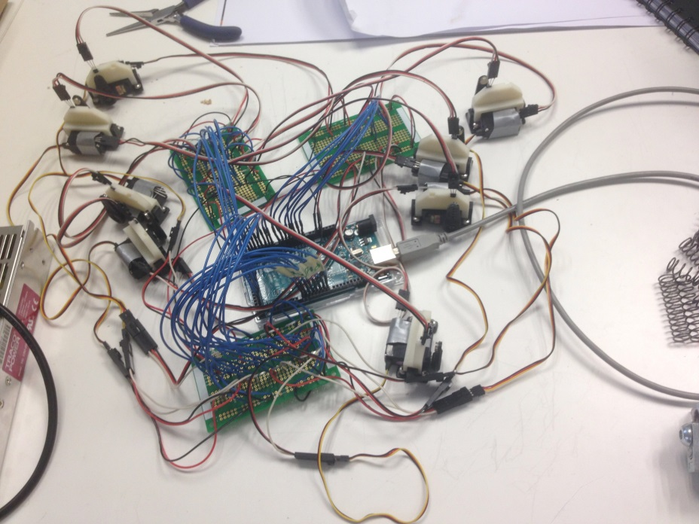

* Enlarged drilled holes in MDF plate to ensure all cables can fit through

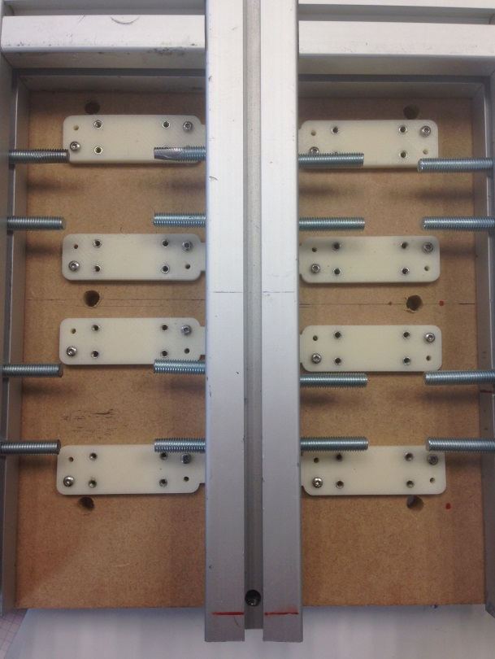

* Replaced threaded pens to prevent spring buckling with parallel pens. This eliminates unwanted friction between spring and thread
* Power supply cable stripped and connected to power supply
  + Note: Voltage output measures 5V between each negative and positive connection (to have the same reference point in the circuit, attached negative connection to GND line of the Arduino)
* Replaced temporary feet with machine feet, this gives the electronics hardware more space
  + Note: added a nut to prevent wobbling of the setup (screw out machine foot to level out setup and tighten up nut to secure foot)

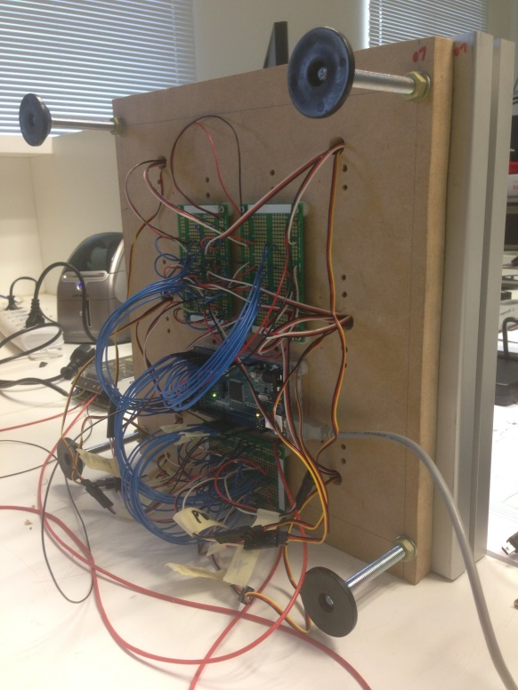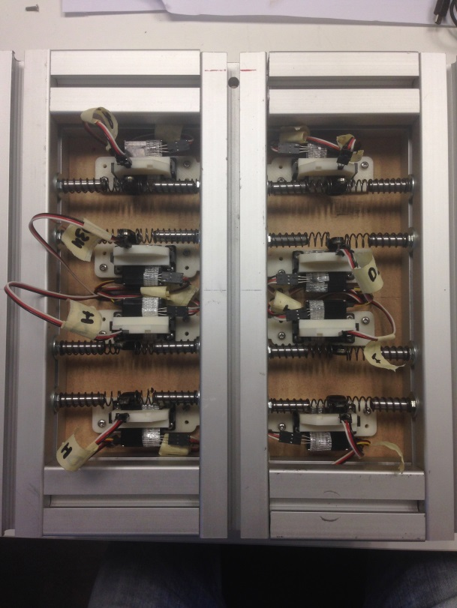

* Complete program contains servo sweep and sensor measurements, data is sent to serial monitor
  + Note: data still needs to be written to .txt file or .csv file (report file)
* Further User-Friendly software needs to be written:
  + Start-Stop interface
  + Every 10min write the average value of the temperature for each servo and give a total average value for each servo in report
  + Check if servo is still working (in case servo not working anymore -> Servo.. stopped working at ..:.. = ..Days/Hours/Min lifetime (check sensor every … millisecond, if Hall-sensor keeps output HIGH for.. seconds/Minutes -> Servo horn stuck in position => servo stopped working OR Hall-switch failed during test)
  + Every 10min write the average value of the current through each servo and give a total average value for each servo in report (Current doesn’t have a linear pattern so readings need to be faster)
  + Better conditions for Boolean servo1Running-servo8Running need to be written
* PCB’s and Arduino were screwed to bottom of MDF plate with threaded inserts
  + Note: all inputs and PWM’s were labeled for easier troubleshooting
* All servos still have to be calibrated with the servo programmer to lower the standard over-current protection.

