Solution Architecture: BP Internet Banking
C4 Design · Internet Banking System
Document following the C4 model (Context, Container, Component) with architectural justifications per exercise requirements.
- Executive Summary
This document lays out an internet banking platform for BP covering account visibility, own and interbank transfers, and real-time notifications. The architecture is built on microservices on AWS: two front-end channels (SPA + Mobile App), OAuth 2.0 + PKCE authentication with biometric onboarding, a unified API Gateway, append-only audit logging, and multi-region availability. The guiding principle throughout was keeping each service independently deployable and scalable so the system can grow without a structural rewrite.
- Context Diagram (C4 — Level 1)
High-level view for non-technical stakeholders. Shows what BP Internet Banking does and which external systems it depends on.

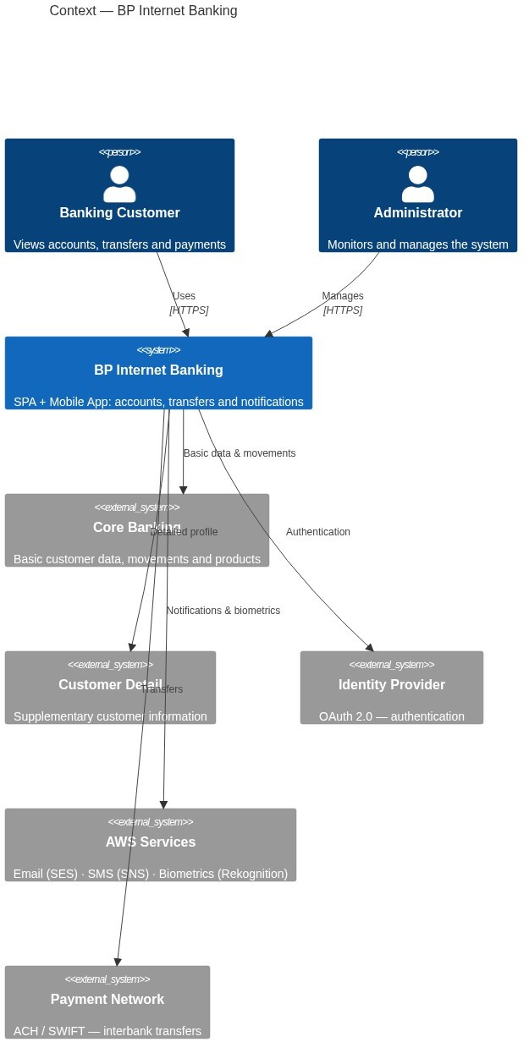

Actors and External Systems

Actor / System | Type | Role
Banking Customer | Person | Retail user — accounts, history, transfers
Operations Administrator | Person | Internal staff — monitoring and alerts
Core Banking Platform | External system | Primary source: basic customer data, movements, products
Customer Detail System | External system | Supplementary information for enriched customer profiles
Identity Provider (OAuth 2.0) | External system | Issues and validates tokens
AWS Services (SES · SNS · Rekognition) | External system | Email alerts, SMS/OTP, facial verification
ACH/SWIFT Payment Network | External system | Interbank transfer execution
- Container Diagrams (C4 — Level 2)
Technical detail of the main deployment units. Split into two views to keep each readable: channels and authentication on the left, domain services and data on the right.

3a. Channels and Authentication Shows user-facing containers and the authentication flow. Entry point for all client
interactions.
3b. Business Services and Data
Shows domain services, data stores and external integrations. API Gateway is referenced from diagram 3a.

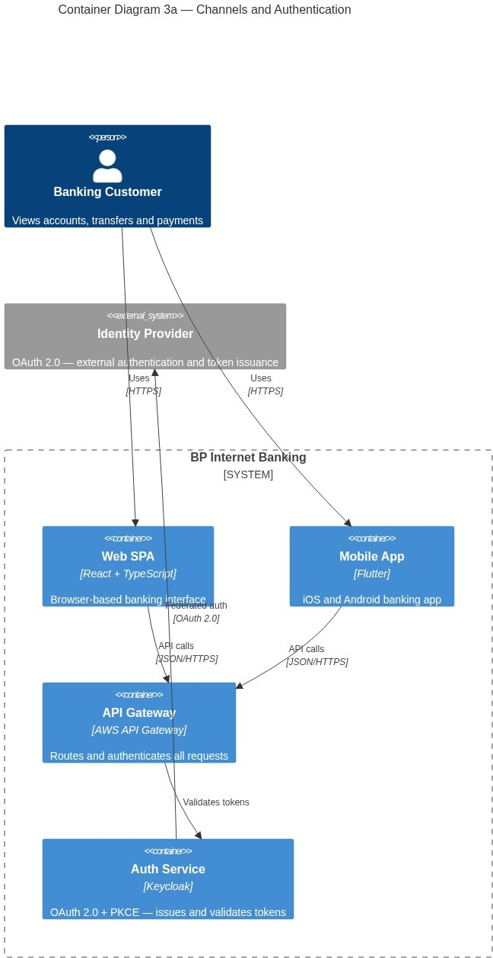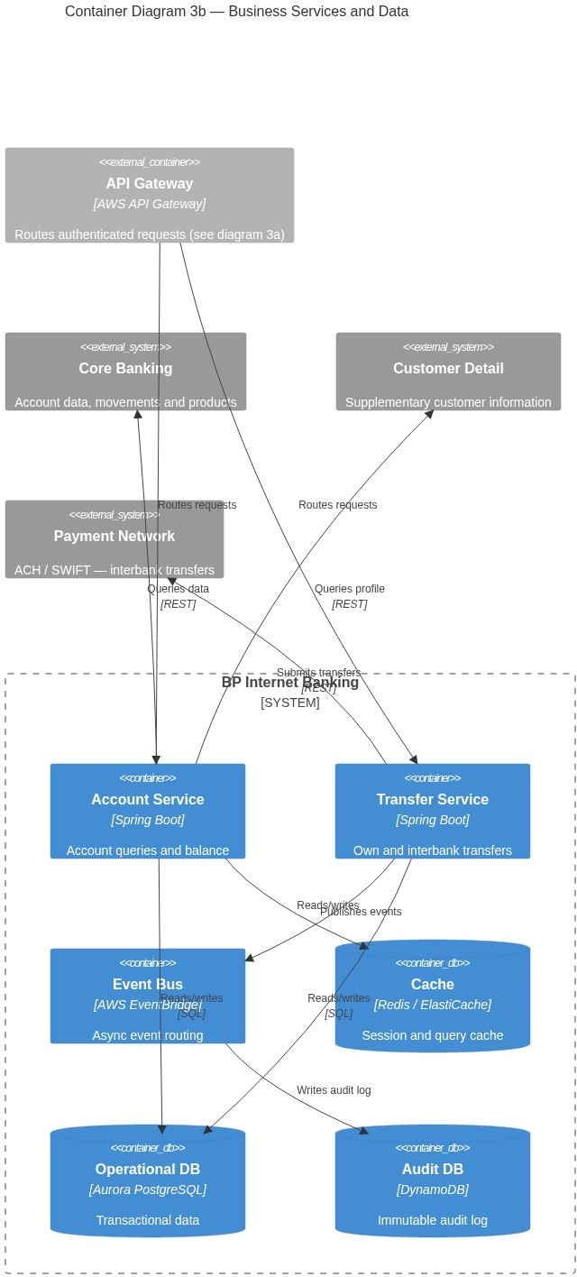

- Component Diagrams (C4 — Level 3)

  - Transfer Service — Components Critical service: handles own and interbank transfers with Circuit Breaker fault tolerance.
  - Auth Service — Components (Keycloak + PKCE)

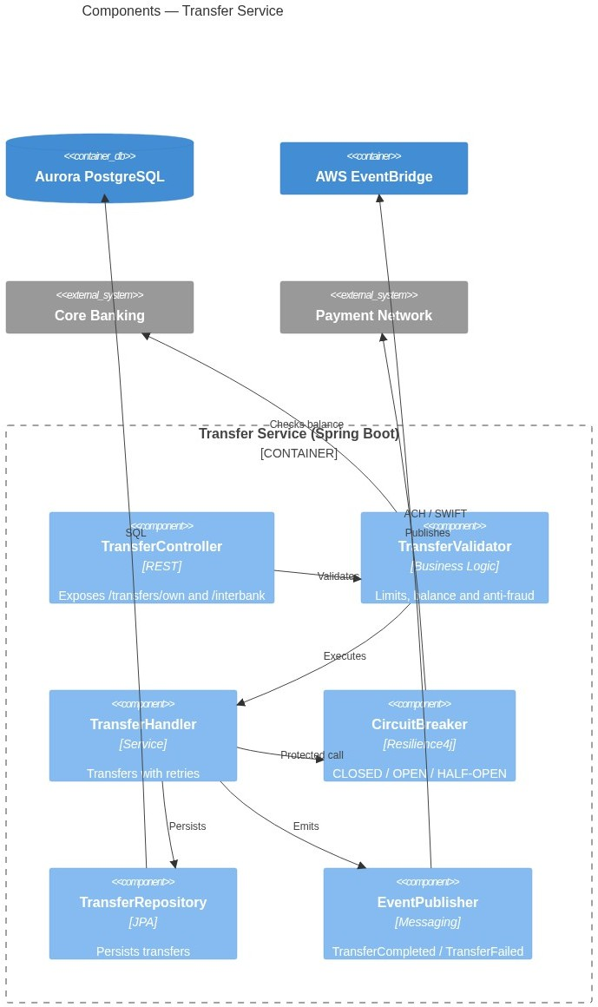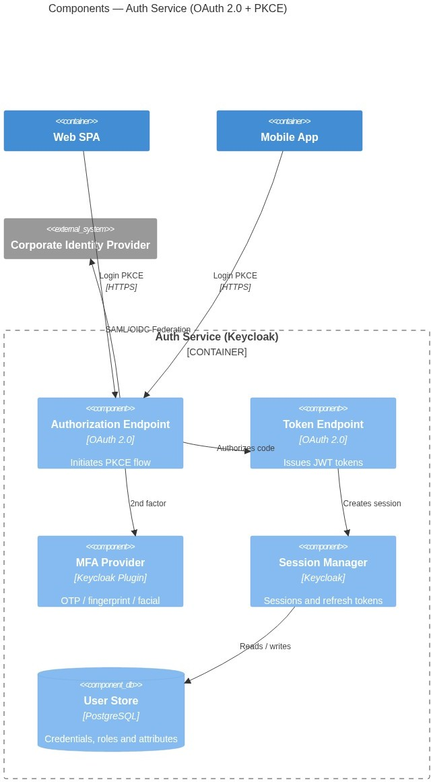

  - Account Service — Components (Cache-Aside)

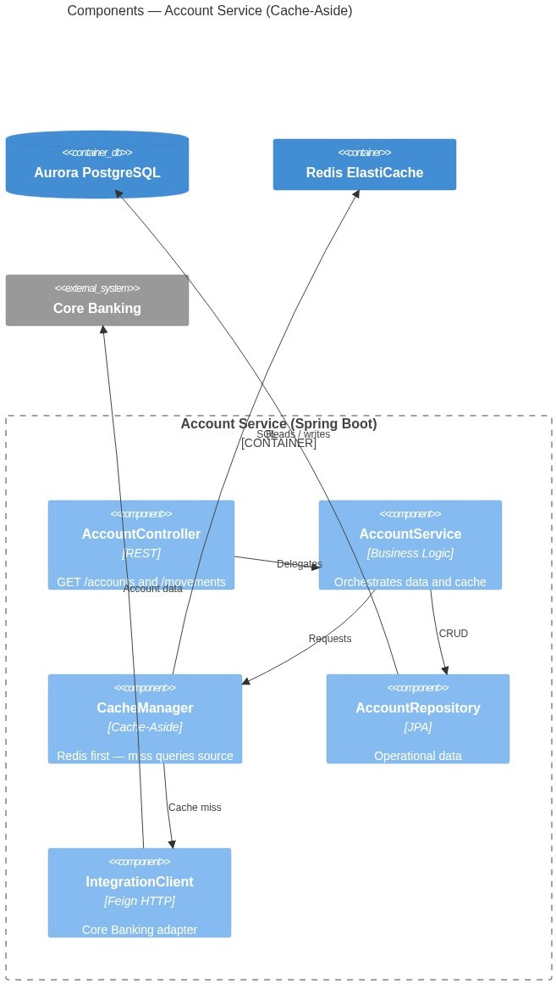

- Authentication Architecture: OAuth 2.0 + PKCE Recommended Flow: Authorization Code Flow + PKCE Why Authorization Code + PKCE and not Implicit Flow?
Criterion | Implicit Flow | Authorization Code + PKCE
Token exposure | Access token in URL (insecure) | Only temporary code in URL
Mobile security | Not recommended (RFC 8252) | Recommended standard
Refresh token | Not supported | Yes, with rotation
Standard status | Deprecated (OAuth 2.1) | Actively recommended
RFC 9700 / OAuth 2.1 formally deprecates Implicit Flow — access tokens ending up in URL fragments and server logs is a real exposure in a banking context. Authorization Code + PKCE eliminates that without requiring a client_secret embedded in the app, which matters for public clients like SPAs and mobile apps. RFC 8252 is equally specific: PKCE is mandatory for mobile because phones can't safely store secrets. The code_verifier is generated on-device at login time, so anyone who intercepts the authorization code in transit gets nothing useful without it.
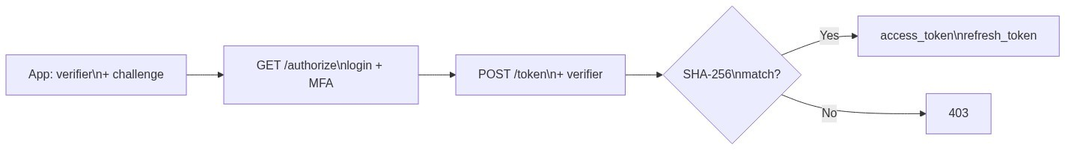

Post-Onboarding Authentication Methods

Method | Platform | Implementation
Username + password | Web + Mobile | Native Keycloak
Fingerprint | Mobile | Flutter LocalAuth + FIDO2 / WebAuthn
OTP via email/SMS | Web + Mobile | Keycloak OTP plugin
Facial recognition | Mobile | AWS Rekognition + Keycloak plugin
- Onboarding Architecture — Facial Recognition
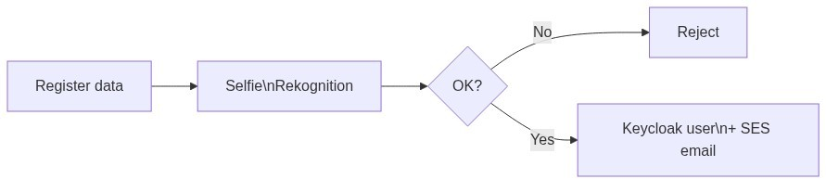
AWS Rekognition handles facial verification — managed service, no ML team required, >99.5% accuracy for 1:1 verification, and BP is already on AWS. Azure Face API was evaluated and has comparable capabilities, but introducing a cross-cloud dependency just for biometrics adds latency and a new vendor to audit for financial compliance. Not worth it. Onboarding runs as its own microservice precisely so registration spikes during campaigns don't touch the transactional services at all.
- Cache Pattern — Cache-Aside
Chosen pattern: Cache-Aside (Lazy Loading)
Cache-Aside was the only realistic option here. Core Banking is a legacy external system — there's no way to hook writes on the source side, which rules out Write-Through entirely. Beyond that, banking data requires selective invalidation: balances and movements have very different change frequencies, and a blanket cache-all-writes approach would serve stale data. Cache-Aside lets each service decide exactly what to cache, with TTLs tuned per data type.
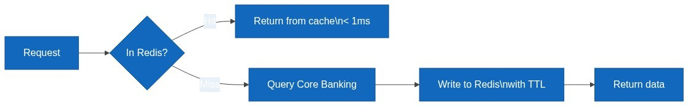

Cached data | TTL | Reason
Customer profile | 15 min | Changes infrequently
Products / accounts | 5 min | May change due to new contracts
Recent movements | 2 min | High change frequency
Session token | Token duration | Fast validation without DB hit
- Integration Layer — API Gateway + Adapters

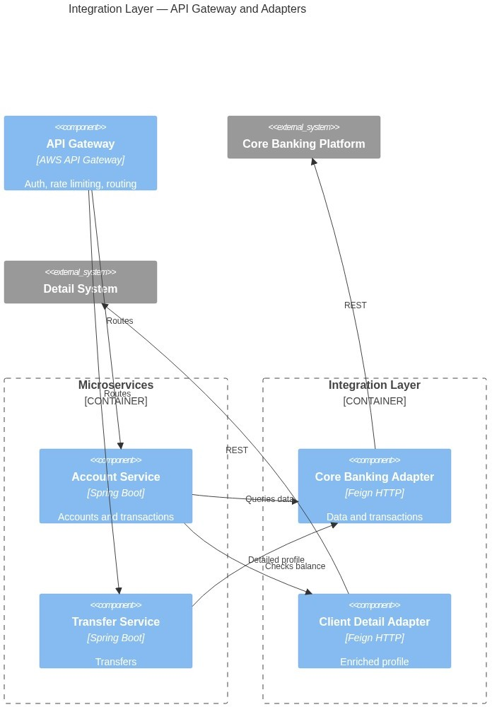

The API Gateway centralizes cross-cutting concerns — auth validation, rate limiting, WAF, request logging
— that have no business being duplicated across every microservice. The Integration Layer underneath uses the Adapter Pattern: one dedicated client per external system. If Core Banking changes its API contract, only the Core Banking adapter needs updating; the business services never need to know.
Defined Services

Service | Endpoint | Source
Basic data | GET /accounts/{id} | Core Banking
Movements | GET /accounts/{id}/movements | Core Banking
Own transfer | POST /transfers/own | Internal + Core
Interbank transfer | POST /transfers/interbank | Core + Payment Network
Customer detail | GET /clients/{id}/profile | Detail System
Notifications | POST /notifications (async) | EventBridge
- Notification Architecture
Email (AWS SES): Transaction alerts, transfer confirmations, password recovery. SMS (AWS SNS): OTP for MFA, security alerts, critical confirmations.
Pattern: Event-Driven. Services publish events to EventBridge. The Notification Service subscribes and dispatches to the appropriate channel based on customer preferences.
The event-driven approach here is non-negotiable. If the notification service is down, the transfer still completes — the event sits in SQS until the service recovers. A direct synchronous call would mean a notification outage blocks every transfer, which is unacceptable. SES and SNS were chosen over Twilio: the delivery guarantees are comparable (both 99.9% SLA), but native AWS services avoid a third-party

vendor dependency, cross-cloud data egress fees, and one more integration to audit for financial regulatory compliance.
- Audit Architecture
Database: AWS DynamoDB (append-only, no UPDATE or DELETE)
DynamoDB is a deliberate choice for audit storage. An IAM policy that denies UpdateItem and
DeleteItem makes records physically immutable — enforced at the infrastructure level, not just by convention. That's exactly what SOX requires. The practical advantages add up: unlimited scale, native TTL for automatic archival to S3, and encryption at rest by default. A relational database could technically work, but you'd need extra safeguards to achieve the same immutability guarantees, and audit tables grow indefinitely in a way that doesn't suit a relational model.
Audit record schema:
Field | Type | Description
auditId | String (PK) | UUID v4
clientId | String (SK) | Customer ID
timestamp | ISO 8601 | UTC date and time
action | String | LOGIN, TRANSFER, QUERY…
sourceIP | String | Source IP
channel | String | WEB / MOBILE
result | String | SUCCESS / FAILURE
- Cloud Infrastructure — AWS

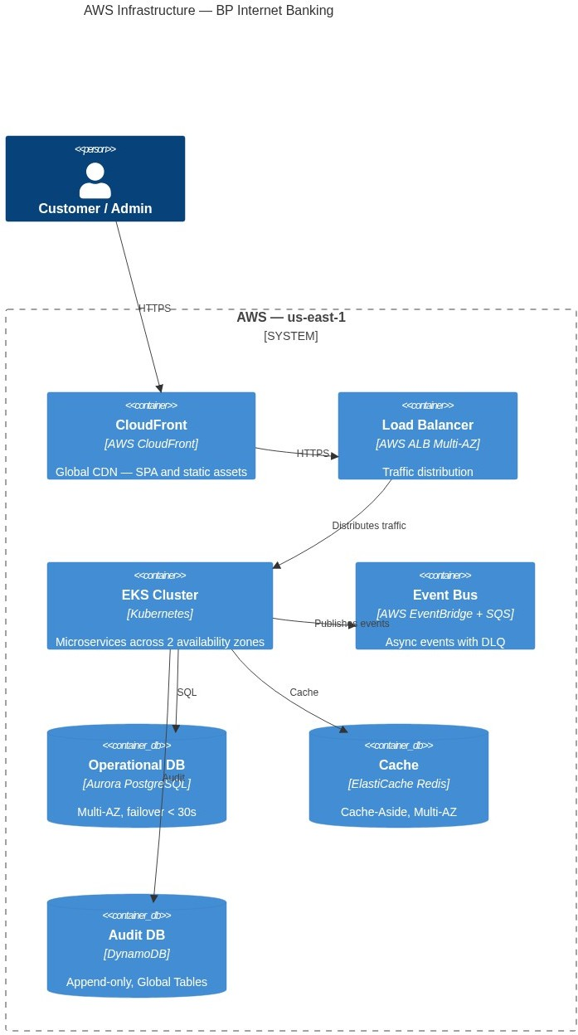

AWS Services Used
Service | Use | Justification
EKS (Kubernetes) | Microservice orchestration | Portability, auto-healing, HPA
Aurora PostgreSQL | Operational database | ACID, Multi-AZ, automatic failover < 30s
DynamoDB | Append-only audit | Unlimited scale, immutability via IAM, native TTL
ElastiCache Redis | Cache-Aside | Sub-millisecond latency, Multi-AZ
API Gateway | Entry gateway | Rate limiting, JWT validation, WAF
EventBridge + SQS | Event bus + DLQ | Decoupling, retries, fault tolerance
CloudFront | CDN for SPA | Low global latency, asset caching
Rekognition / SES / SNS | Biometrics + notifications | Managed services, 99.9% SLA
WAF + Shield | Perimeter security | DDoS protection, OWASP Top 10
CloudWatch + X-Ray | Observability | Metrics, logs, distributed tracing
Secrets Manager | Secret management | Automatic rotation, no hardcoding
Cost Management
The cost model leans on pay-per-use managed services to avoid over-provisioning. The only meaningful fixed cost is EKS + EC2 nodes; everything else scales with actual traffic.

Service | Billing model (verified) | Monthly estimate (medium load) | Optimization lever
EKS Cluster | $0.10/cluster/hr + EC2 nodes | ~$73 cluster + ~$90 nodes (3× t3.medium @ $0.0416/hr) | Karpenter autoscaler — scale to zero off-peak
Aurora PostgreSQL | ~$0.12/ACU-hr (Serverless v2) | ~$200–350 (avg 4 ACU × 720  hr) | Serverless v2 scales with traffic, no over-provisioning
DynamoDB | $0.625/M writes ·  $0.125/M reads | ~$25 (audit-only, low write volume + TTL cleanup) | TTL auto-expires old records, reduces storage cost
ElastiCache Redis | ~$0.068/node-hr (cache.t3.medium) | ~$98 (2× nodes × 720 hr, Multi- AZ) | Tune TTLs to maximize hit rate; evict stale data
API Gateway | $1.00/M requests (first 300M) | ~$10 (10M requests/month) | Response caching reduces EKS invocations
EventBridge + SQS | Per event/message (low volume) | ~$5 | Batching reduces per-event cost
CloudFront | $0.085/GB (US, first 10 TB) | ~$9 (100 GB/month) | Cache-Control headers maximize CDN hit rate
AWS SES | $0.10/1K emails | ~$1 (10K emails/month) | Suppress non-critical emails to reduce volume
CloudWatch | $0.50/GB ingested (standard) | ~$15 (30 GB/month) | Set log retention to 30 days; export to S3 for long-term
Total estimate |  | ~$600–850 / month | Scales with actual load (serverless/on-demand services)
AWS Budgets alerts at 80% and 100% of the monthly target. Cost Explorer tags are set per service so spending can be attributed by domain if needed.
- High Availability, Fault Tolerance and Disaster Recovery
High Availability
Multi-AZ: All services deployed across minimum 2 availability zones Auto Scaling: Kubernetes HPA adjusts replicas based on CPU/RPS
Circuit Breaker: Resilience4j prevents failure cascade to external systems
Aurora Multi-AZ: Automatic failover in < 30 seconds
Fault Tolerance
SQS Dead Letter Queue: Failed events after 3 retries go to DLQ
Idempotency Keys: Transfers include idempotencyKey to prevent duplicates
Graceful Degradation: If Detail System fails, Account Service returns Core data Timeout + Retry: Exponential backoff on all HTTP clients
Disaster Recovery

RTO | RPO | Strategy
< 1 hour | < 5 min | Aurora Global Database — replica in secondary region
< 4 hours | < 1 hour | DynamoDB Global Tables replicated in us-west-2
< 15 min | 0 (events) | EventBridge replay of archived events

- Security

Layer | Control | Technology
Perimeter | DDoS, OWASP Top 10 | AWS WAF + Shield Advanced
Transport | Encryption in transit | TLS 1.3 on all channels
Authentication | JWT + PKCE + MFA | Keycloak
Authorization | RBAC by role and channel | Spring Security
Data at rest | AES-256 | AWS KMS on Aurora, DynamoDB, S3
Secrets | No hardcoding | AWS Secrets Manager with rotation
Containers | Image scanning | Amazon ECR Image Scanning
Regulatory Compliance

Regulation | Application
PCI DSS v4 | Card data — encryption, logging, network segmentation
SOX | Immutable audit trail, financial access controls
PSD2 / Open Banking | Strong Customer Authentication (SCA) — mandatory 2FA
Data Protection Law | Consent, right to erasure, data minimization
ISO 27001 | ISMS — security policies, risk management
- Monitoring and Operational Excellence
Pillar | Tool | What it measures
Metrics | CloudWatch + Prometheus | CPU, memory, RPS, p95/p99 latency
Logs | CloudWatch Logs | Request traces, errors, audit
Traces | AWS X-Ray | Distributed tracing across microservices
Alerts | CloudWatch Alarms | Anomalies, errors, SLA breach
Dashboards | Grafana | Unified system health view
Production KPIs

Metric | Target
Availability | 99.95% monthly
p95 latency (queries) | < 300ms
p95 latency (transfers) | < 2 seconds
Error rate | < 0.1%
Aurora failover | < 30 seconds
- Architectural Decisions (ADR)
# | Decision | Chosen | Alternative | Justification
1 | Architecture | Microservices | Monolith | Independent scalability per service
2 | Orchestration | EKS (Kubernetes) | ECS Fargate | Portability, HPA, native self-healing

# | Decision | Chosen | Alternative | Justification
3 | Operational DB | Aurora PostgreSQL | RDS MySQL | ACID, failover < 30s, read replicas
4 | Audit DB | DynamoDB | PostgreSQL | Unlimited scale, immutability via IAM
5 | Cache | Redis (ElastiCache) | Memcached | Persistence, pub/sub for invalidation
6 | Messaging | EventBridge | Kafka | Less overhead, native AWS, declarative routing
7 | Auth flow | Authorization Code + PKCE | Implicit Flow | RFC 8252 / OAuth 2.1 — standard for public apps
8 | IdP | Keycloak | Custom | Existing corporate product, OAuth 2.0 / OIDC
9 | Biometrics | AWS Rekognition | Azure Face API | BP on AWS — lower latency, no cross-cloud egress
10 | Mobile | Flutter | React Native | Single codebase, native biometric API
11 | SPA | React + TypeScript | Angular | Flexibility, TypeScript type safety
12 | Cache pattern | Cache-Aside | Write-Through | External Core Banking; explicit invalidation control
13 | Notifications | EventBridge + SES + SNS | Twilio | Native AWS, 99.9% SLA, lower cost
14 | Gateway | AWS API Gateway | Kong | Less overhead, WAF integration, Lambda authorizer
Architecture designed under the C4 model: Context, Container, Component

