Clínica Dental Goyanca

Executive Proposal
Local SEO Improvement · Fast Landing Page Launch · Automated Reporting

Executive Summary
Clínica Dental Goyanca has a clear opportunity to improve local visibility, launch a stronger landing page quickly, and eliminate time spent on manual reporting. The best path forward is connecting SEO, conversion, and reporting into one practical growth system — built for speed, measurable from day one.

Approach
The work begins with clarity and moves fast. A focused audit comes first, then high-impact SEO fixes, a new landing page, and clean performance tracking — creating immediate progress while laying a stronger long-term foundation.

Phase 1 — Audit & Discovery
Review current site structure and identify the highest-impact gaps:
Area | What We Check
Local SEO signals | NAP consistency, Google Business Profile, citations
On-page SEO | Titles, H1s, meta descriptions, internal linking
Technical health | Page speed, mobile experience, Core Web Vitals
Conversion | CTAs, booking flow, trust signals
Analytics | GA4 setup, goal tracking, Search Console coverage

Phase 2 — Local SEO
Strategy focused on high-intent local searches — not more traffic in general, but more qualified traffic from patients in Goya and nearby areas.

Priority Improvements
- Service pages — Clear, keyword-rich content per treatment
- Location relevance — City + neighborhood signals throughout the site
- Structured data — Local Business schema, reviews schema, FAQ schema
- Internal linking — Connect services, location, and trust pages
- Trust signals — Reviews, financing options, treatment information
- FAQ content — Answer real patient questions, capture long-tail searches

Target Intent Categories
Intent | Example Keywords
Emergency | dentista urgencias Goya, dolor de muela
Cosmetic | blanqueamiento dental, carillas
Orthodontics | ortodoncia Goya, brackets adultos
Implants | implantes dentales precio Goya
General | dentista Goya, clínica dental cerca

Phase 3 — New Landing Page
Fast launch. Built around conversion.
The page must explain the clinic clearly, load quickly, build trust immediately, and make booking easy through every available channel.

Core Sections
- Hero — Clear value proposition + primary CTA (WhatsApp / phone)
- Services — Top treatments with clear descriptions
- Why Us — Differentiators: experience, technology, financing
- Social Proof — Patient reviews, ratings, before/after
- Location & Hours — Map embed, address, schedule
- Financing — Payment options, accessibility messaging
- Contact — WhatsApp, phone, and form — all in one section

Technical Standards
- Mobile-first, fully responsive
- Lighthouse score 90+ (Performance, SEO, Accessibility)
- Core Web Vitals: LCP < 2.5s, CLS < 0.1
- WhatsApp deep link with pre-filled message
- Structured data embedded

Reference Implementation — Dental Studio Landing
This is already done. Onmidental's own landing page is live — built with the same stack, structure, and SEO foundations proposed here for Goyanca.
Live demo | https://onmidental.vercel.app
Source code | https://github.com/DavidVique1998/onmidental

What was built
Feature | Detail
Animated hero | Scroll-driven 3D tooth model (Three.js / React Three Fiber)
AI chat assistant | Answers patient questions in real time — no cold starts
Full section coverage | Services · About · Clinics · Team · Financing · Reviews · Instagram
WhatsApp button | Floating CTA with pre-filled message
SEO foundation | sitemap.xml, robots.txt, Open Graph, JSON-LD (LocalBusiness + Dentist schema)
Performance | Next.js 16 App Router, Tailwind CSS v4, edge-runtime AI route
Deployment | Live on Vercel in production

The same structure, component library, and SEO patterns apply directly to the Goyanca landing. Starting from a proven base means faster delivery and lower risk.

Phase 4 — Reporting Automation
Manual reports replaced by an automated workflow.

Data Sources
- Google Analytics 4 — Sessions, conversions, channel performance
- Google Search Console — Rankings, impressions, click-through rates
- Lead events — WhatsApp clicks, phone clicks, form submissions

Automated Report Output
Each report delivers:
- Key metrics vs. prior period
- Top-performing pages and search queries
- Conversion funnel snapshot
- Recommended next actions
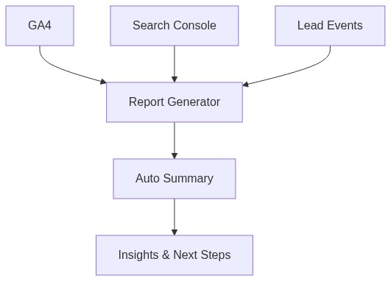

Use of AI
AI accelerates execution and reduces repetitive work — human review keeps quality high.
Task | AI Role
Keyword clustering | Group and prioritize by intent and volume
Page copy | First-pass drafts for service pages and FAQs
FAQ generation | Extract real patient questions from search data
Landing page iteration | Fast variant testing and copy refinement
Report summaries | Auto-generate insights from raw analytics data

Why This Fit Is Strong
Onmidental already has the landing, the stack, and the SEO structure in place. Extending that to Goyanca means faster delivery, lower risk, and consistency across the network — not starting from zero.

Recommended 7-Day Sprint
Day | Deliverable
1–2 | Full site audit — SEO, technical, analytics, conversion
3 | Top local SEO fixes implemented
4–5 | New landing page launched
6 | Analytics connected — GA4, Search Console, lead events
7 | First automated report generated and reviewed

Results measurable from day one. Growth compound over time.

