**Introduction**

In the current climate of post coronavirus pandemic, most people are still reeling from being forced to stay home all day and not being able to partake in outdoor activities or activities in general which leads to more people staying home doing nothing even when the pandemic has ended. I’m developing a webpage that will allow you to track and log different activities and how long the user spends performing them. This will hopefully make readjusting to getting out again easier for users that might be spending too much time on nonproductive activities inside and not enough time doing what they need to do. This report aims to walk the reader through the development process and how the website was built. It will then bring any wider concerns to light and speak about how the website could help in day-to-day life.

This report presents the project plan for the COMP1004 module coursework. The project has a focus on self-management and event planning.

As people are readjusting with all the restrictions being lifted, I aim to create a Architecture Design Document (ADD) that will help people manage not just their day-to-day tasks such as work or physical activates but will also allow people to track how long they spend on leisure activates as well such as playing games and will track if someone is spending too long on games or has not spent enough time on work based on paramotors that the user themselves will be able to set.​

This website aims to be simple enough that anyone can use it regardless of technical knowledge while also being detailed enough that it would be worth using. It will allow people to log different activates in 3 different category's those being work related, fitness related, and leisure related. This should allow users to better balance out how much time they dedicate to each activity without having to compromise their time spent on others.

**Software Development Life Cycle**

* Analysis
* Design
* Development
* Testing
* Deployment
* 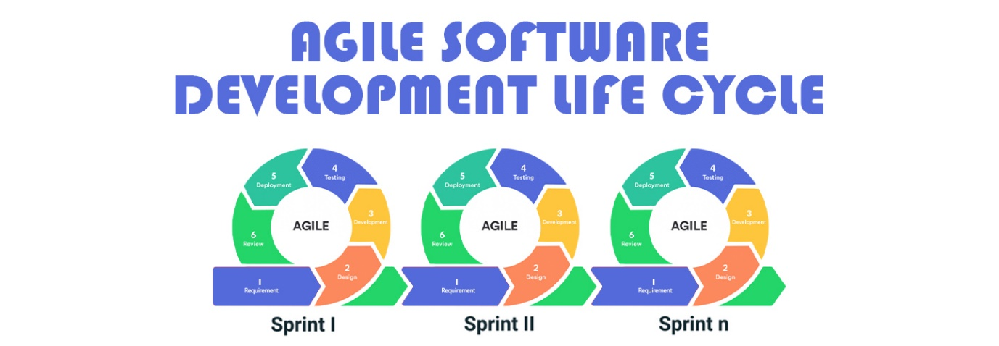Review

BitByteSoft, "Phases of Agile Software Development Life Cycle

The analysis phase for this project took place over a 2-week period. Many different ideas were mapped out such as different ideas for the design of the webpage or the implementation of the information. There were many sources of inspiration which were noted down and systematically examined for their suitability and research was carried out into these sources looking at popularity, relevance, and convenience. Notes were taken as to key interesting elements to be considered in the analysis and design phase for the project.

Having determined key elements for inclusion in the game an attempt at estimating how long these would take to create was carried out. A rough plan of 9 2-week sprints was made with consideration as to key features for creation in each sprint.

Continuing from the planning phase, the design phase focused on translating the identified key elements and user requirements into actionable development tasks. User stories were meticulously crafted and aligned with the sprint plans to ensure a clear roadmap for implementation. The product backlog served as a central repository for prioritizing and organizing these user stories, facilitating effective sprint planning and resource allocation.

During the development phase, I focused on translating the identified key elements and user requirements into actionable development tasks. This phase was by far the longest of all the stages as it required the most practical work. Tasks were prioritized based on their importance and complexity as well as their necessity to make the SPA functional. Activities included coding, designing user interfaces, implementing features, and conducting code reviews to ensure quality and maintainability. Quality assurance and testing were integral parts of the development process, with unit testing, integration testing, and user acceptance testing conducted at the end of every sprint to ensure that I had more than just my own opinion to work with. Bugs and issues were prioritized for resolution at the time and if they could not be fixed, they would be the first part worked on during subsequent sprints. Development tasks were carried out using modern tools and technologies, including IDEs such as Visual Studio 2022.

As the project progressed, testing was ongoing throughout, but I had friends test the website as it was being built every 2-weeks following the planned sprint cycles. Feedback from testers was actively sought and incorporated into subsequent sprints, ensuring that the application evolved in alignment with user needs and project objectives.

Regarding the application to the Software Development Lifecycle (SDLC), my approach was characterized by clarity, coherence, and adherence to established best practices. The SDLC was meticulously defined, with each phase clearly delineated and justified in the context of my project goals and constraints. My implementation of the SDLC was informed by extensive research and understanding of industry standards, reflecting a commitment to delivering a high-quality and sustainable software solution.

In conclusion, my project plan was structured to facilitate efficient and iterative development, with sprint plans mapping seamlessly to the backlog and overarching project aims. The application of the SDLC was clear, well-defined, and logically justified, demonstrating a comprehensive understanding of software development methodologies and best practices.

**Project Vision**

This project aims to develop a user-friendly webpage that will assist people to manage not just their day-to-day tasks such as work or physical activates but will also allow people to track how long they spend on leisure activates as well such as playing games and will track if someone is spending too long on games or has not spent enough time on work based on paramotors that the user themselves will be able to set.​

This website aims to be simple enough that anyone can use it regardless of technical knowledge while also being detailed enough that it would be worth using. It will allow people to log different activates in 3 different category's those being work related, fitness related, and leisure related. The goal is to empower users to optimize their time allocation and improve overall productivity and well-being.

**Project Background**

In the wake of the covid 19 pandemic, many individuals struggle to manage a healthy work-life balance. With increased remote work and leisure time spent at home, there has been a growing need for assistance tools to help individuals in structuring their daily routines effectively. An activity management website will help combat this as it will allow people to create a custom-built calendar within their own parameters to keep track of what it is they are doing and can use information that will be displayed on the website to decide how much time they would like to spend on their activity’s. ​

​

This gap is primarily between two groups of people. The first being students that had been forced to attend lectures at home via online lectures who up to 33.6% of students believe they have physically worsened (Sandra Claudia Gewalt, 2022). Secondly its prominent in retirees who no longer had to go to work and were also trapped at home without much to do during the pandemic. Both these groups are often online and would greatly benefit from the website as it will be a more modern and all-inclusive way of tracking how much time they spend on different activities.

**Functional Requirements**

I will be creating a list of different functions that my website will include and rank them in order of how essential each step is. Doing this will allow me to ensure that all my important functions will defiantly be completed while if any setbacks occur then I won't be losing critical functions on my website. They are as follows:​

1. A SPA allows a user to add different activates to a list to keep track of what they are doing​.
2. SPA will allow the user to put a specific day and time attached to the activity​.
3. SPA will have a calendar that will allow the activities to be displayed in a digestible format​.
4. The SPA will be able to print activities saved onto a custom JSON file.
5. The SPA will be able to load data given from a JSON file back into the calendar.
6. The calendar will be easy to navigate and responsive to user input.
7. The calendar will organize events chronologically in the day.
8. The user will be able to search for an activity added and delete it easily without issues.
9. SPA provides information about a healthy amount of time performing each activity. ​
10. SPA informs the user of information, so they know if they have spent too long on one activity​.
11. SPA allows users to share calendars with friends to compare schedules​.
12. SPA adds an additional option to track calories input and output.
13. SPA adds a log in to track data more efficiently​.

**Complete Set Of UML Diagrams**

|  |  |
| --- | --- |
| **User Story** | **Tasks Performed** |
| As a user of this SPA, I want to be able to log my day-to-day activities on the website. | - Design user interface for activity logging  - Implement activity logging functionality  - Validate user input for logged activities  - Store logged activities in database |
| As a user of this SPA, I want to be well informed on what I should spend my time on each day. | - Develop algorithm to analyse user activities and provide recommendations  - Design dashboard to display daily activity recommendations |
| As a user of this SPA, I want to be able to save my activities to a file that can be transferred to others if need be. | - Implement export functionality to save activities to file  - Define file format and encoding options  - Provide download link for exported file |
| As a user of this SPA, I want to be able to load data from a file and have it show the calendar with all activities in it, edit the activities and the resave it over the file so that the file is edited. | - Develop import functionality to load data from file  - Display imported activities in calendar view  - Implement editing capabilities for activities - Save edited activities back to file |
| As a user of this SPA, I want to be able to set a start time so I can plan my day ahead of time. | - Add option for users to set start time for activities  - Update user interface to display start time for each activity |
| As a user of this SPA, I want to be able to see activities set through the entire year and plan as need be. | - Implement calendar view to display activities for entire year  - Add navigation controls to switch between months  - Ensure smooth performance when loading large datasets |
| As a user of this SPA, I want my activities to be distinctly separated and ordered in a comprehensive manner. | - Design sorting and filtering options for activities  - Implement functionality to categorize activities  - Ensure activities are displayed in a clear and organized manner |

User wants to log day to day activities.

User wants information on healthy time to spend on activities.



User wants to be able to save data to be used later.



User wants to load data from JSON to display on calendar.

User wants to set time for activities and have them be clearly distinguished.



User wants to change calendar to see any month/year.



User wants to search for and remove activities that have been added.



We would then decompose the Use Case Scenarios further with Use Case Descriptions. Those that follow do not match the diagram above but serve to illustrate a different type of scenario.

|  |  |
| --- | --- |
| Name | page9image63141328Amend Booking |
| Short Description | Amend a booking |
| page9image35689536Precondition | page9image35689152Customer has already made a booking |
| Post Condition | Booking amended |
| Error Situations | There is not a free table at amended time |
| System state in the event of an error | Table cannot be booked at this time |
| page9image36638272Actors | page9image36642304Customer |
| page9image36649984Triggers | page9image36530880Customer needs to amend booking |
| Standard Process | 1. Customer enters booking details 2. System finds booking 3. Customer selects new date/time for  booking 4. Customer changes party size (if  needed) 5. System confirms there is a table free 6. Customer confirms booking |
| page9image36442432  Alternative Process | page9image36535296  5’ Table is not available 6’ System gives the next time slot for a free table 7’ Customer selects new time and confirms booking |

### Architecture

This section discusses how the architecture for the single page application is envisaged.

Here you would provide a package diagram to show how the layers of the software are designed before showing a class diagram.

The sequence diagrams below show how the classes will interact to implement the given use case scenarios.

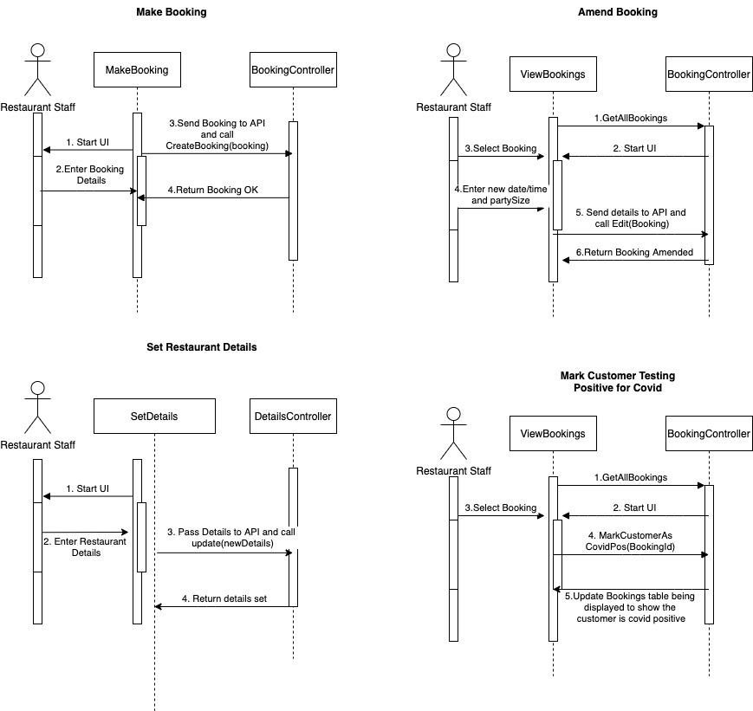

### Sitemap

This section provides an outline of how the application is designed. Whilst this is a single page application, the sitemap indicates how the user will navigate through the topics.

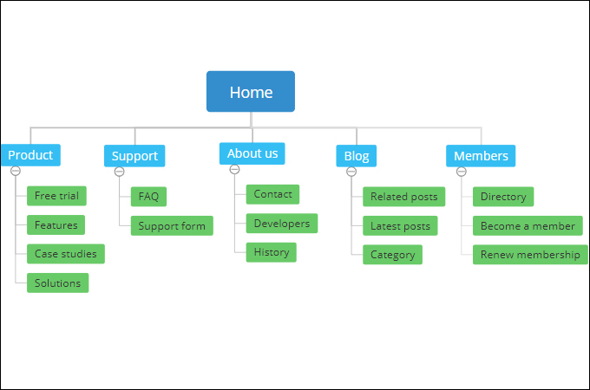

### Wireframes

This section provides an illustration of the wireframes.

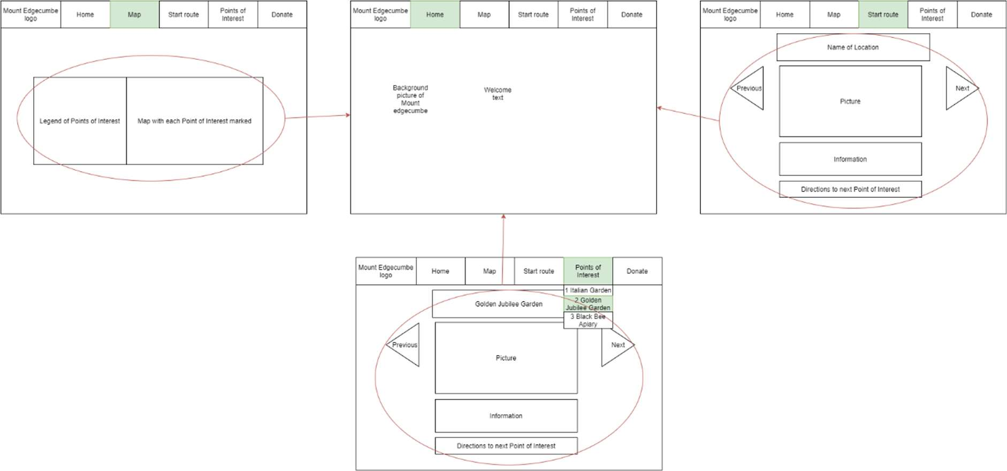

### Noted issues and constraints

This section might discuss issues around learning the technologies, planning the application and the need to account for other modules and their deliverables.

### Github repo link

http:github.classroom.com/giveyourlink

### References

Ref 1:

BitByteSoft. (2022). Phases of Agile Software Development Life Cycle. <https://bitbytesoft.com/phases-of-agile-software-development-life-cycle/>

Ref 2:

Gewalt.S (2022), Effects of COVID-19 pandemic on university students’ physical health, mental health and learning, SRH University Heidelberg

<https://www.ncbi.nlm.nih.gov/pmc/articles/PMC9432688/>

Ref 3

:Wang J (2021), Impact of COVID-19 pandemic on Older Adult

https://www.ncbi.nlm.nih.gov/pmc/articles/PMC8043147/