MATLAB Antenna Post Processing Installation Instructions, v1.0

28 September 2012

The following document is intended to get you up and running with GTU’s antenna post processing MATLAB codes.

# Copy the distribution to your computer

The post processing MATLAB code may be obtained from GTU’s network file server

\\PHXFSSVR01\Engineering\Software\POST

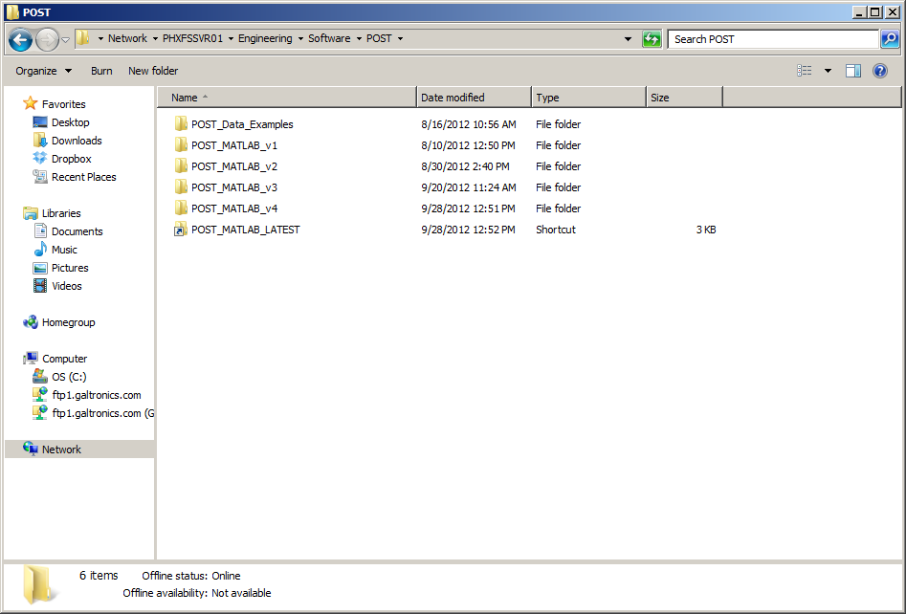

This directory contains the current and all previous versions of the software. The link “POST_MATLAB_LATEST” always points to the latest version of the software; “POST_MATLAB_v4” in this case.

# Adding the scripts to the MATLAB path

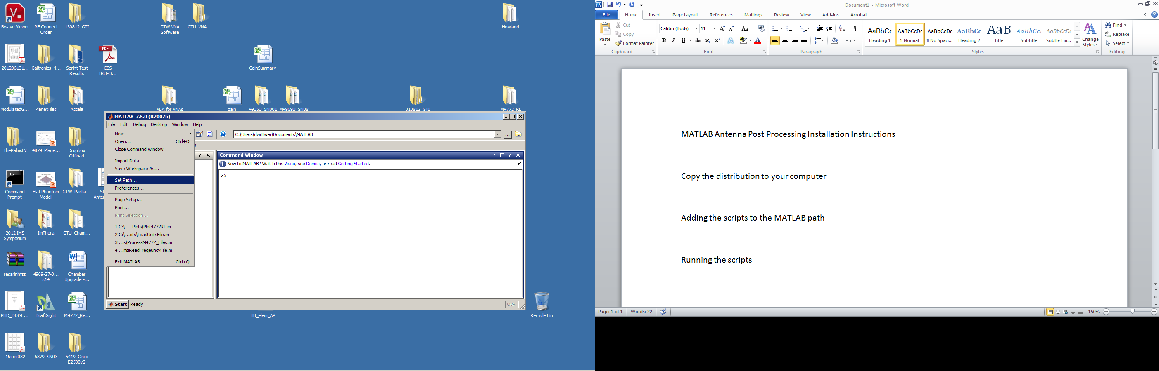

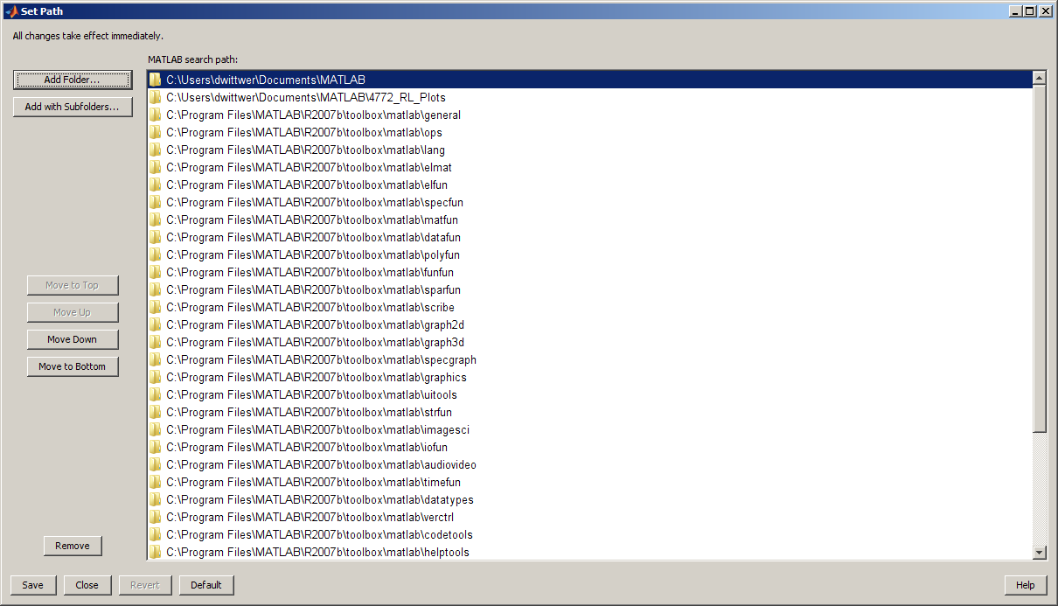

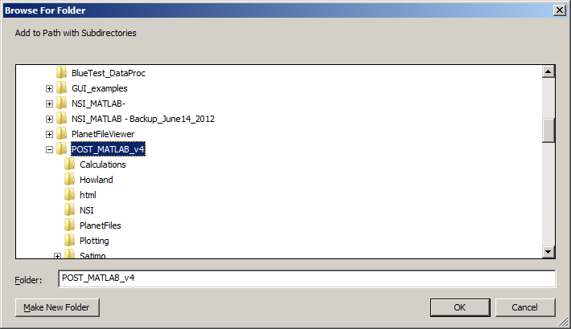

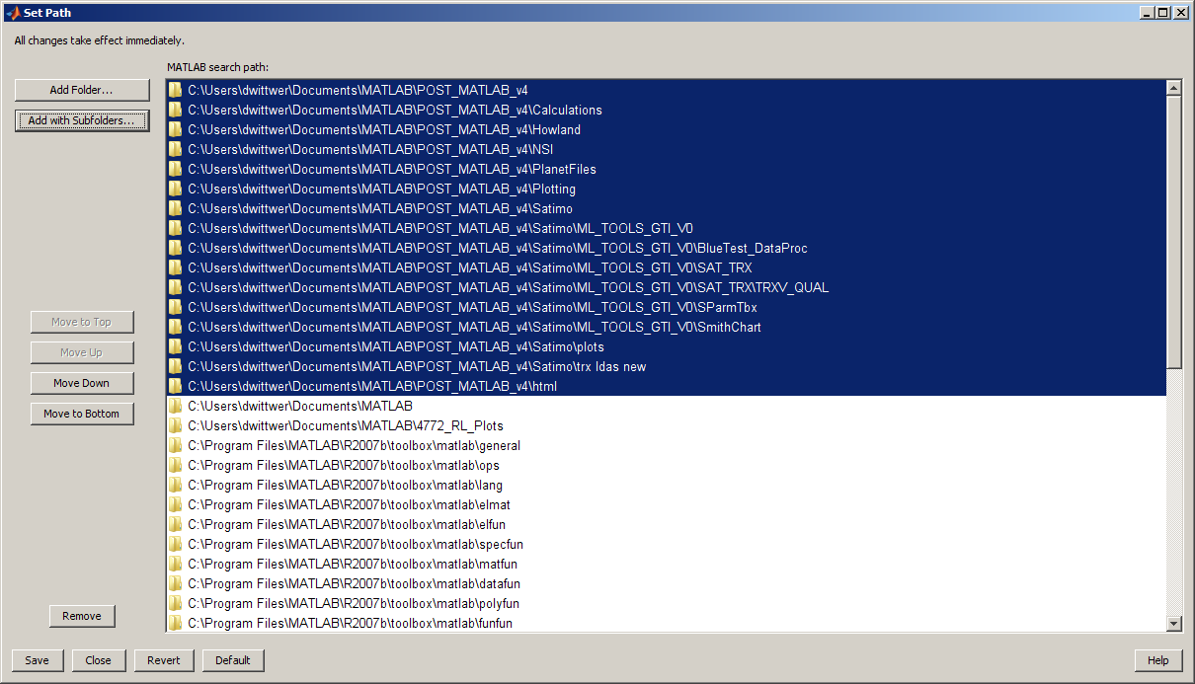

The figure above shows the POST_MATLAB_v4 directory and all subfolders below have been added to the path.

Click “Save” and then click “Close”. The script is now ready to run.

# Running the scripts

From the MATLAB command window, type “post”

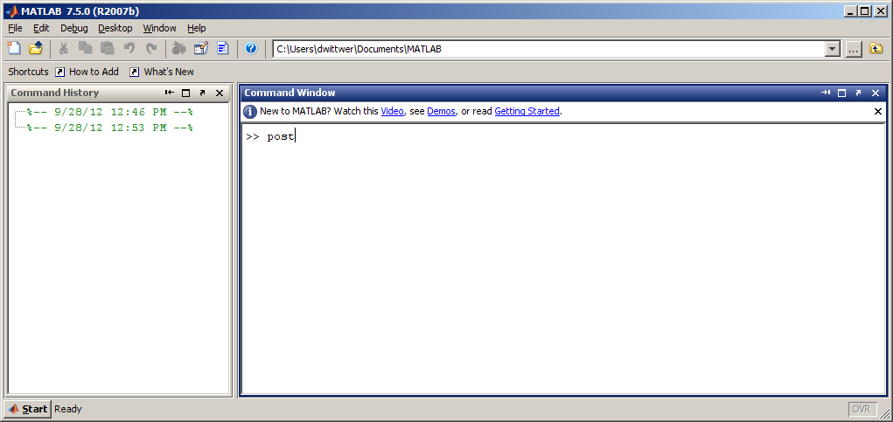

The GUI front end will be displayed on the screen

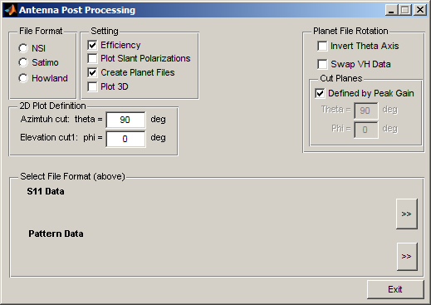

Selecting the input file format

Choosing the post processing settings

Efficiency

Plot slant polarizations

Creating Planet file output

Plotting 3D antenna patterns

Defining the 2D plot cut planes