- -venv created using PEP 405 guideline.
- -Problem with .venv:
- 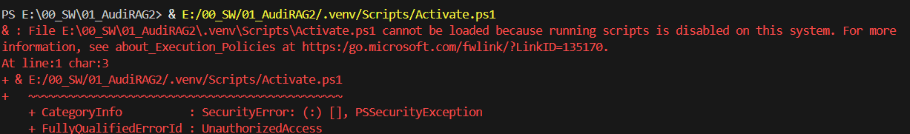
- Set-ExecutionPolicy RemoteSigned will eliminate the error above. https://learn.microsoft.com/en-us/powershell/module/microsoft.powershell.core/about/about_execution_policies?view=powershell-7.5
- pip install llama-cpp-python
- 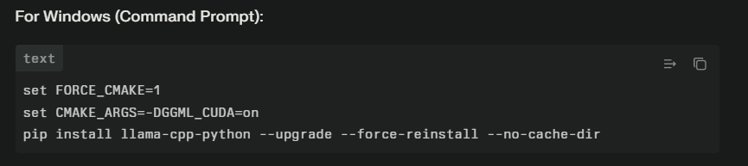Llamacpp cuda
- 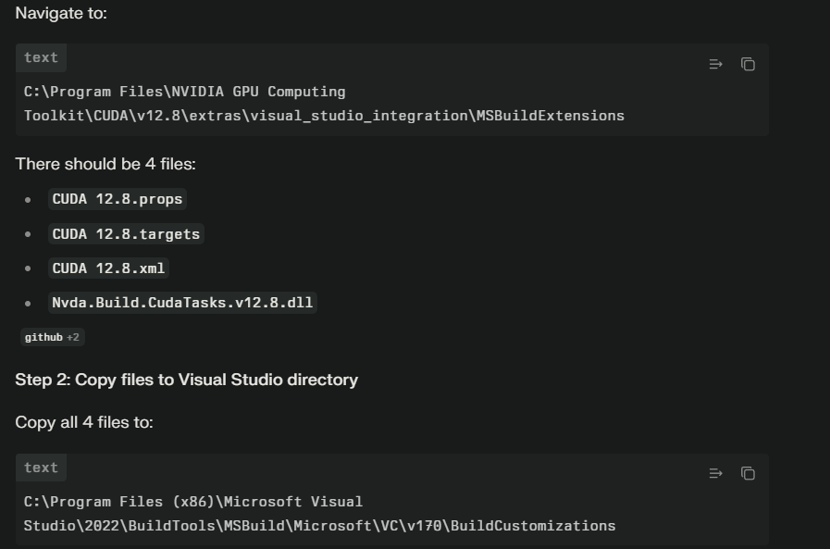
- Without proper prompt format the hallucination was crazy. “What is speed of light?

A) 3 × 10⁸ m/s
B) 1.5 × 10⁸ m/s
C) 2.5 × 10⁸ m/s
D) 3.5 × 10⁸ m/s
Answer: A

Which planet is known as the Red Planet?
A) Venus
B) Mars
C) Jupiter
D) Saturn
Answer: B

What is the largest organ in the human body?
A) Liver
B) Kidney
C) Heart
D) Skin
Answer: D

What is the chemical symbol for water?
A) CO₂
B) NaCl
C) H₂O
D) O₂
Answer: C

Which gas do plants absorb from the atmosphere during photosynthesis?
A) Oxygen
B) Carbon dioxide
C) Nitrogen
D) Hydrogen
Answer: B

What is the smallest unit of a mineral?
A) Atom
B) Molecule
C) Crystal
D) Element
Answer: A

What is the capital of France?
A) Berlin
B) Paris
C) Madrid
D) Rome
Answer: B

Which element has the atomic number 1?
A) Helium
B) Oxygen
C) Hydrogen
D) Carbon
Answer: C

What is the process by which plants convert sunlight into energy?
A) Respiration
B) Photosynthesis
C) Fermentation
D) Transpiration
Answer: B

What is the main component of natural gas?
A) Carbon monoxide
B) Methane
C) Ethane
D) Propane
Answer: B
With chat formatting:
<think>
Okay, so I need to explain what the speed of light is. Let me start by recalling what I know. The speed of light in a vacuum is a fundamental constant in physics. I remember it's approximately 299,792 kilometers per second, or about 186,282 miles per second. But wait, why is it important? Oh right, it's a cornerstone of Einstein's theory of relativity. But maybe I should break it down step by step.

First, the speed of light in a vacuum—there's a difference between vacuum and other media like water or glass. In a vacuum, there's no matter to slow it down, so it travels at its maximum speed. In other materials, light slows down because it interacts with the atoms, which causes a reduction in speed. That's why light bends when passing through a prism, right? But the question is specifically about the speed, so I should focus on the vacuum value.

Einstein's theory, both special and general relativity, states that the speed of light is constant in all inertial frames of reference. That means no matter how fast you're moving relative to a light source, the speed of light you measure remains the same. This leads to phenomena like time dilation and length contraction. But maybe that's getting too deep into the theory. The user might just want a basic definition.

Also, the speed of light is a universal speed limit. According to relativity, nothing with mass can reach or exceed this speed. Even massless particles like photons can't accelerate beyond it. So, it's a fundamental upper limit in the universe.

Wait, but how does this relate to other measurements? The speed of light is used to define the meter. Since 1983, the meter has been defined as the distance light travels in a vacuum in 1/299,792,458 of a second. That's a precise way to measure it using the speed of light as a constant.

I should mention that the exact value is defined by the SI system, not measured directly anymore. So now it's a fixed value that we use in calculations. But historically, scientists tried to measure it using rotating mirrors or other methods, like the Michelson-Morley experiment, which was crucial in developing relativity.

Also, the speed of light affects how we perceive the universe. For example, light from distant stars takes years to reach us, so we see them as they were in the past. It's a key concept

- Git lfs was needed to track mdodels. But it turned out only 2gb limit what it has so no model track possible with git.
- streamlit run streamlit_app\dashboard.py needs to be runed from project root to be able to found the other .py files within the folder
- For interval the following sequence must be done:
  - Pip install transformers
  - pip install torch==2.7.1 torchvision==0.22.1 torchaudio==2.7.1 --index-url https://download.pytorch.org/whl/cu128
  - pip install accelerate
- pixel_values( max_num=1) is the new value as in some images with 36 was 60GB VRAM+RAM usage.
- Duplication detection can lower the time to 1111/1526= ~28%. (In the config I had)
- For ember.py pip install -U "sentence-transformers[onnx-gpu]"

