Data Technician
Week 2 Workbook
Tableau and Power BI

Name: David Xu
Course Date: 21/09/2026
Table of contents
Day 1: Task 1 3
Day 1: Task 2 (Optional) 3
Day 1: Task 3 4
Day 2: Task 1 4
Day 2: Task 2 8
Day 3: Task 1 11
Day 3: Task 2 12
Day 3: Task 3 (Optional) 13
Day 4: Task 1 14
Day 4: Task 2 15
Day 4: Task 3 16
Course Notes 17
Additional Resources to learn and Practice 18

Day 1: Task 1

Please research the different versions of Tableau, compare them below and explain the limited functionality on ‘Tableau Public’.

Different Tableau versions | Tableau Desktop is a paid locally installed environment to explore data offline or online.  Tableau Server is a self-hosted enterprise analytics platform, using one’s own infrastructure or private/public cloud instances to control data sharing.  Tableau Cloud is a cloud native version of Tableau that can share insights without managing physical servers.  Tableau public is a free version of Tableau Desktop but forces all workbooks to be saved publicly online.

Day 1: Task 2 (Optional)
Please access and complete the DataCamp course.
Introduction to Tableau - DataCamp Learn

Paste your XP here. | 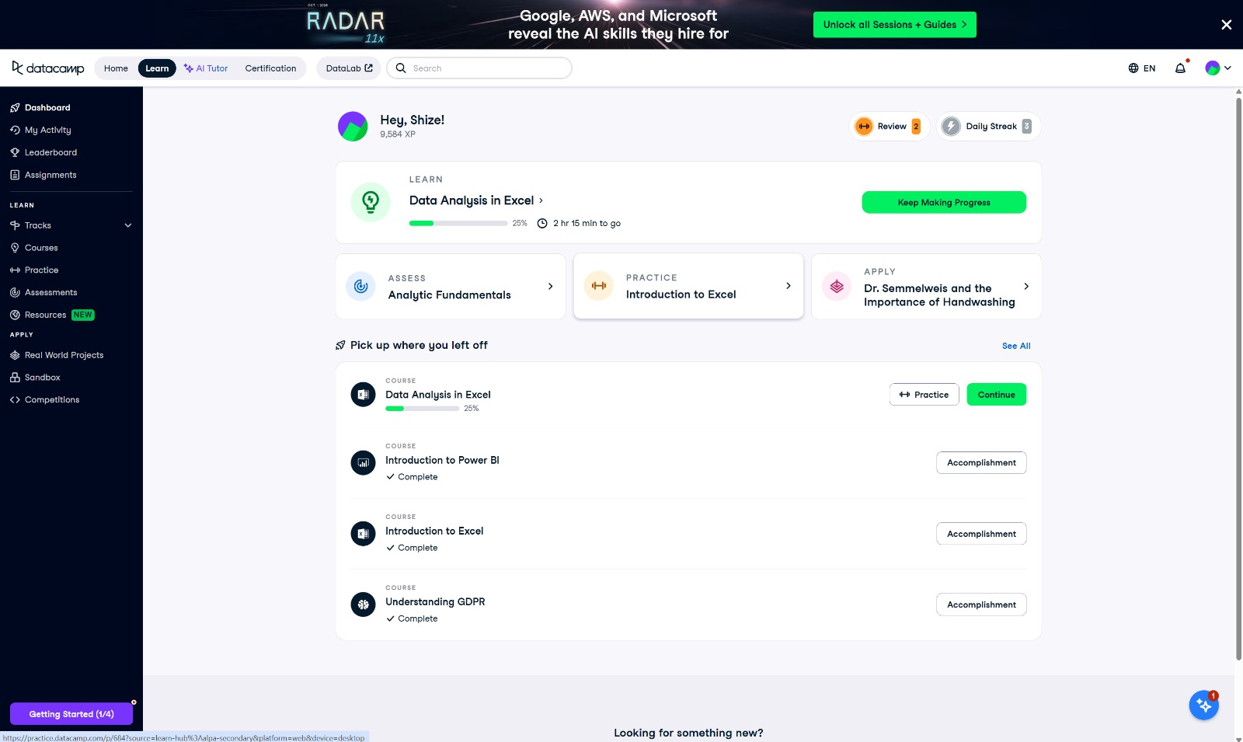

Day 1: Task 3

Please attach the screenshot and link to your EMSI Job Change (GB Employment) dashboard below.

Paste your print screen here | 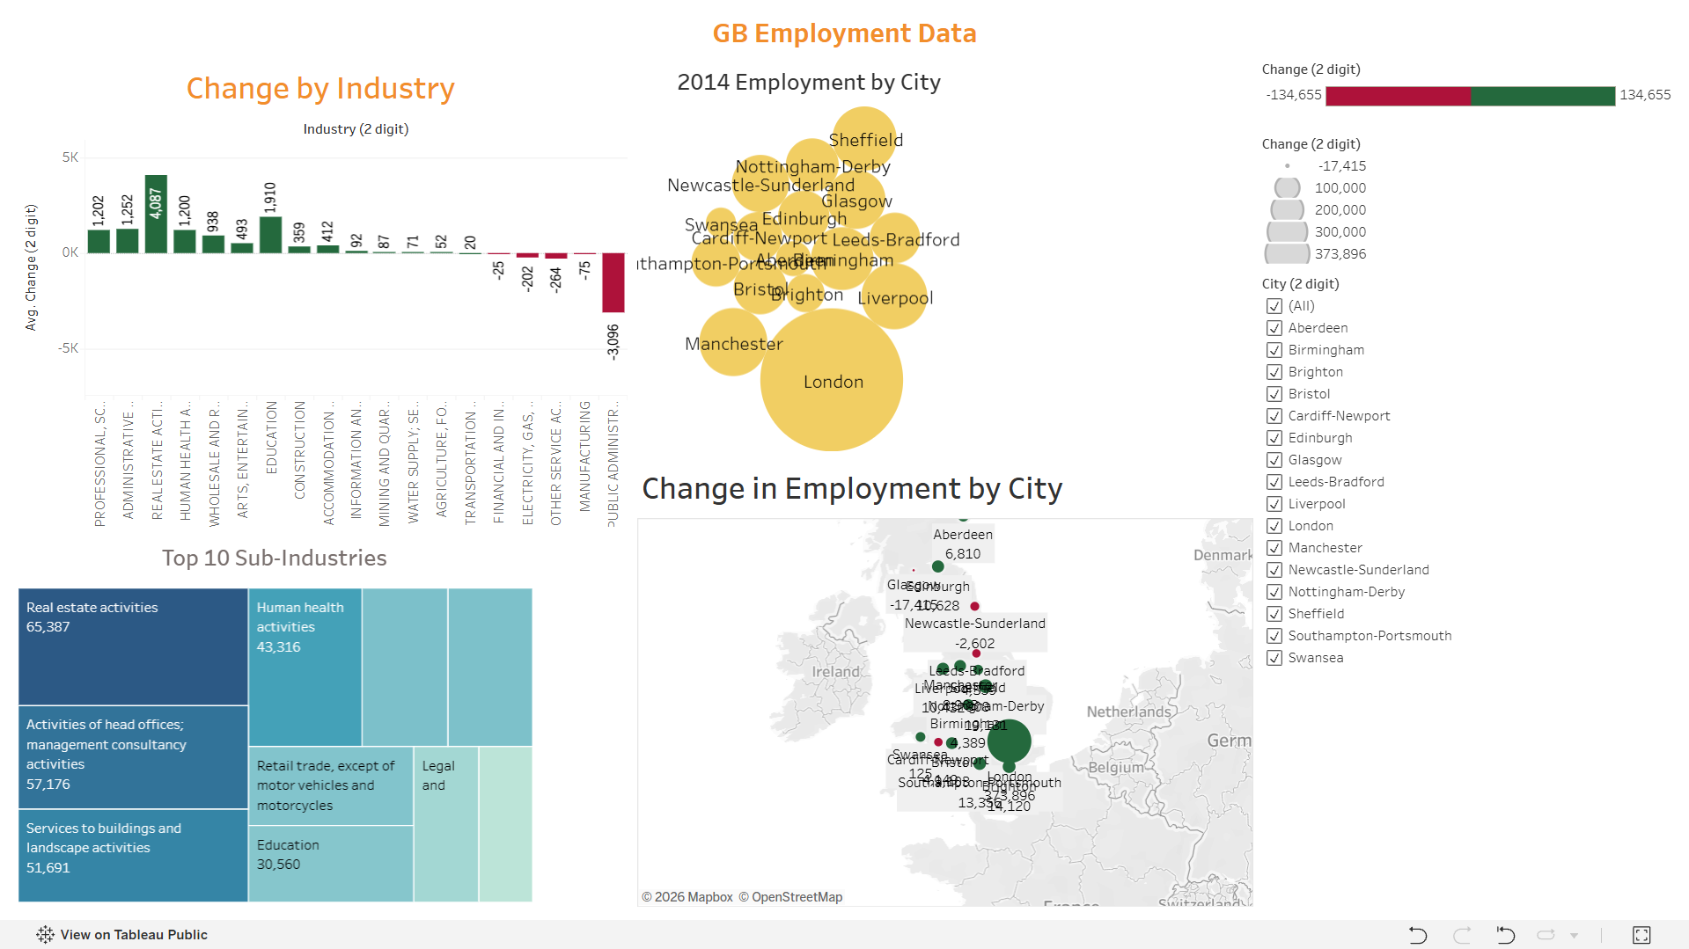
Link to your dashboard | https://public.tableau.com/views/GBEmploymentData_17900042069790/Dashboard1?:language=en-GB&publish=yes&:sid=&:redirect=auth&:display_count=n&:origin=viz_share_link

Day 2: Task 1
Start new Tableau page.
Download GapminderHealth.xlsx dataset.
Using the Health GapminderHealth dataset, conduct an analysis to find trends and key information that could be used by an organisation for future support.

Column Name | Description | Data Type | Example
Continent | Continent where the country is located. | Text | Asia
Country | Name of the country. | Geographic | Afghanistan
Year | Year of observation or measurement. | Numeric | 1990
Life Expectancy | Average number of years a person is expected to live at birth. | Numeric | 48.9
Gender | Gender group for which the metrics are reported. | Text | Women
BMI | Average Body Mass Index of the population. | Numeric | 20.7
Blood Pressure | Average blood pressure measurement of the population. | Numeric | 124
Cholesterol | Average cholesterol level of the population. | Numeric | 4.55
Lung Cancer | Lung cancer incidence | Numeric | 194
Liver Cancer | Liver cancer incidence | Numeric | 107
Stomach Cancer | Stomach cancer incidence | Numeric | 406
Population | Total population of the country for the specified year. | Numeric | 6,067,694
Population Growth | Annual population growth rate expressed as a percentage. | Decimal (%) | 6.75

Scenario:
You are a data analyst working for a global health organization. Your team needs to quickly understand key health trends and disparities across different countries and continents. They are particularly interested in seeing how health metrics vary and how life expectancy has changed over time.
Your Task:
Using the GapminderHealth dataset in Tableau, create a series of visualizations to answer the following questions. Focus on using basic chart types and features.

Instructions & Deliverables:
- Life Expectancy by Continent (Most Recent Year):
  - Create a bar chart showing the average Life Expectancy for each Continent.
  - Filter the data to show only the most recent year available in the dataset.
  - Sort the continents by Life Expectancy in ascending or descending order.
  - Deliverable: A worksheet named "Life Expectancy by Continent".

- Life Expectancy Trend Over Time (Top 5 Countries):
  - Create a line chart to show the trend of Average Life Expectancy over Year.
  - Filter the data to display only the top 5 countries with the highest average Life Expectancy across all years. (Hint: Use a Top N filter on Country based on Average Life Expectancy).
  - Use Country on Colour to differentiate the lines.
  - Deliverable: A worksheet named "Life Expectancy Trend".

- Population Distribution by Gender (Latest Year for a Selected Country):
  - Create a pie chart showing the Population distribution by Gender.
  - Add a Country filter to the worksheet (e.g., set it to 'United States' or a country of your choice initially, but ensure the filter is available for interaction). Change filter type to Single Value (dropdown).
  - Filter the data to show only the most recent year available in the dataset.
  - Add Population to Labels. Right click on sum (Population) under marks card and change Quick table calculation to Percentage of Total.
  - Deliverable: A worksheet named "Population by Gender".

- Health Metric Comparison (Scatter Plot):
  - Create a scatter plot to explore the relationship between Average Life Expectancy and Average BMI.
  - Place Life Expectancy on one axis and BMI on the other.
  - Use Country on Detail to represent individual countries as points.
  - Use Continent on Colour to differentiate points by continent.
  - Add Continent to filters and show filter.
  - Deliverable: A worksheet named "Life Expectancy vs BMI".
- Viz of your Choice
  - Use any other fields or chart types to add another visual.

- Dashboard Creation:
  - Combine all worksheets (Life Expectancy by Continent, Life Expectancy Trend, Population by Gender, Life Expectancy vs BMI, Viz of your Choice) into a single dashboard.
  - Ensure the "Country" filter on the "Population by Gender" worksheet applies to the "Life Expectancy Trend" worksheet as well (if applicable or make it a global filter if you prefer the user to select one country to see all relevant details for it). Self-correction: Given it's basic, let's keep the filters simple. Just place the filter on the dashboard and ensure it's applied to the relevant sheet(s) where it makes sense.
  - Add a Title to your dashboard, e.g., "Global Health Insights".
  - Publish your dashboard to Tableau Public Website
  - Deliverable: A dashboard named "Global Health Dashboard".

Paste your dashboard screens here | 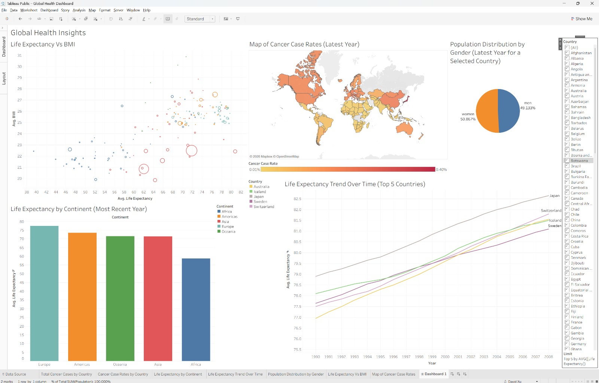
What did you find and any reflections on how the NHS could use this? | That more developed countries typically had higher Cancer Rates, and the NHS can use this to quickly look up the population distribution, BMI and life expectancy of a chosen country.
Link to your dashboard | https://public.tableau.com/app/profile/david.xu6294/viz/GlobalHealthDashboard_17900789572900/Dashboard1?publish=yes

Once you finish this task save and close Tableau.

Day 2: Task 2
Start Tableau Public Desktop and import the Spotify dataset SpotifyFeatures.xlsx, conduct an analysis to find trends and key information that could be used by an organisation for future projects.
Column Description
- genre: The genre in which the track belongs
- artist_name: The artists' names who performed the track.
If there is more than one artist, they are separated by a;
- track_name: Name of the track
- track_id: The Spotify ID for the track
- popularity: The popularity of a track is a value between 0 and 100, with 100 being the most popular. The popularity is calculated by algorithm and is based, in the most part, on the total number of plays the track has had and how recent those plays are. Songs that are being played a lot now will have a higher popularity than songs that were played a lot in the past. Duplicate tracks (e.g. the same track from a single and an album) are rated independently. Artist and album popularity is derived mathematically from track popularity.
- acousticness: A confidence measure from 0.0 to 1.0 of whether the track is acoustic. 1.0 represents high confidence the track is acoustic
- danceability: Danceability describes how suitable a track is for dancing based on a combination of musical elements including tempo, rhythm stability, beat strength, and overall regularity. A value of 0.0 is least danceable and 1.0 is most danceable
- duration_ms: The track length in milliseconds
- energy: Energy is a measure from 0.0 to 1.0 and represents a perceptual measure of intensity and activity. Typically, energetic tracks feel fast, loud, and noisy. For example, death metal has high energy, while a Bach prelude scores low on the scale
- instrumentalness: Predicts whether a track contains no vocals. "Ooh" and "aah" sounds are treated as instrumental in this context. Rap or spoken word tracks are clearly "vocal". The closer the instrumentalness value is to 1.0, the greater likelihood the track contains no vocal content
- key: The key the track is in. Integers map to pitches using standard Pitch Class notation. E.g. 0 = C, 1 = C♯/D♭, 2 = D, and so on. If no key was detected, the value is -1
- liveness: Detects the presence of an audience in the recording. Higher liveness values represent an increased probability that the track was performed live. A value above 0.8 provides strong likelihood that the track is live
- loudness: The overall loudness of a track in decibels (dB)
- mode: Mode indicates the modality (major or minor) of a track, the type of scale from which its melodic content is derived. Major is represented by 1 and minor is 0
- speechiness: Speechiness detects the presence of spoken words in a track. The more exclusively speech-like the recording (e.g. talk show, audio book, poetry), the closer to 1.0 the attribute value. Values above 0.66 describe tracks that are probably made entirely of spoken words. Values between 0.33 and 0.66 describe tracks that may contain both music and speech, either in sections or layered, including such cases as rap music. Values below 0.33 most likely represent music and other non-speech-like tracks
- tempo: The overall estimated tempo of a track in beats per minute (BPM). In musical terminology, tempo is the speed or pace of a given piece and derives directly from the average beat duration
- time_signature: An estimated time signature. The time signature (meter) is a notational convention to specify how many beats are in each bar (or measure). The time signature ranges from 3 to 7 indicating time signatures of 3/4, to 7/4.
- valence: A measure from 0.0 to 1.0 describing the musical positiveness conveyed by a track. Tracks with high valence sound more positive (e.g. happy, cheerful, euphoric), while tracks with low valence sound more negative (e.g. sad, depressed, angry)

There is no set scope for the analysis, simply to find trends and document them below:

Paste your print screens here | 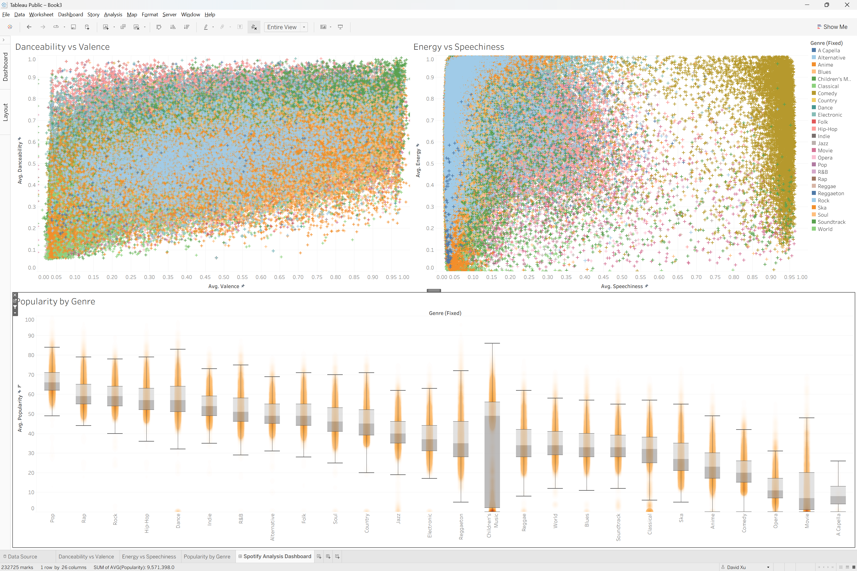

What did you find? | There is a generally positive correlation between danceability and valence, virtually no tracks have a very valence along with a very low danceability, which is to be expected. The popularity of children’s music has a much greater spread than the other genres (this is due to the fact that there seems to be 2 separate genres both called 'Children's Music' that I manually merged). Most genres of music have low speechiness, with the only exception being comedy. There is no strong correlation between energy and speechiness.
Link to your dashboard | https://public.tableau.com/app/profile/david.xu6294/viz/SpotifyFeatureAnalysis_17901539194120/SpotifyAnalysisDashboard

