Introduction to VLSI

Lab 5

11-21-2013

By:

Rebecca Curtis  
Kancy Robinson  
David Zemon  
Eric Pyle  
Will Roussin

Table of Contents

1 bit 2:1 MUX 3

Schematic 3

1 bit 4:1 MUX 4

Schematic 4

4 bit 2:1 MUX 5

Schematic 5

4 bit 4:1 MUX 6

Schematic 6

ALU 7

Schematic 7

# 1 bit 2:1 MUX

## Schematic

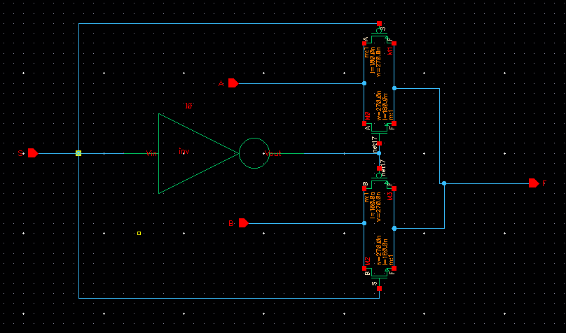

# 1 bit 4:1 MUX

## Schematic

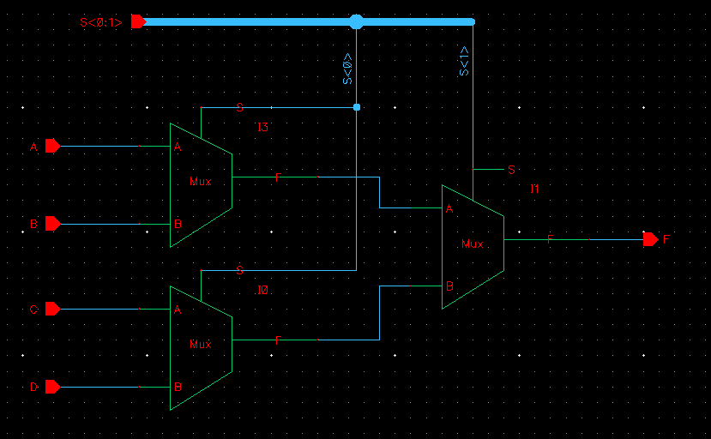

# 4 bit 2:1 MUX

## Schematic

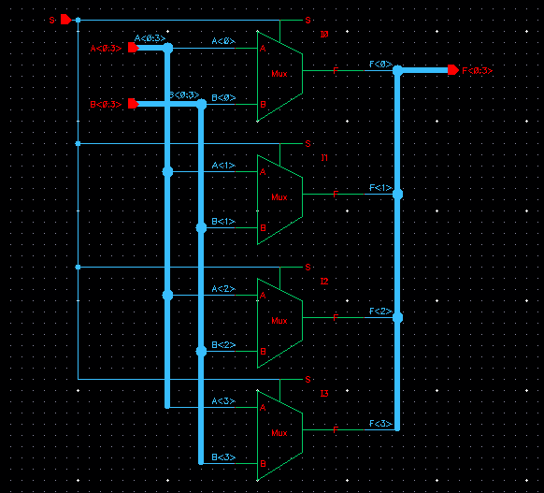

# 4 bit 4:1 MUX

## Schematic

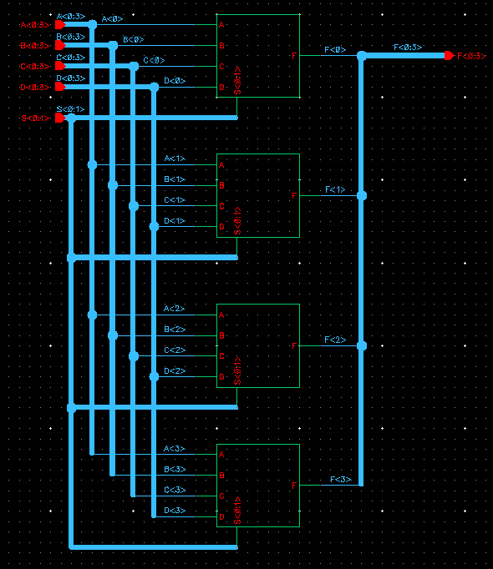

# ALU

## Schematic