Introduction to VLSI
Final Report
11 December 2013
By:
Rebecca Curtis
Kancy Robison
David Zemon
Eric Pyle
Will Roussin

Layout Design
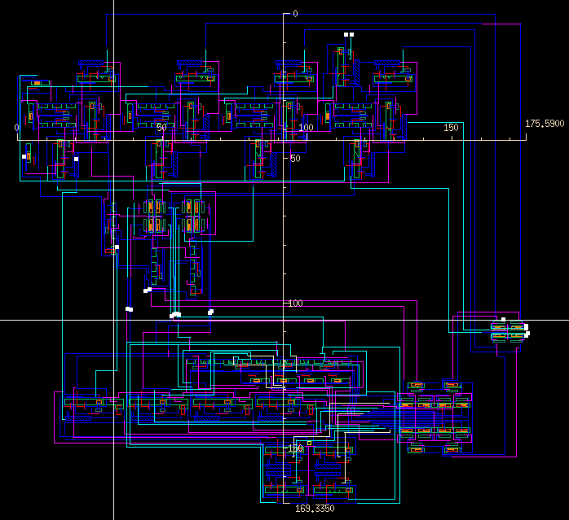

Total Area

Total Power Consumption

Worst Case Propagation Delay
For worst case propagation delay, we chose to use the following input conditions:

This yielded a worst case delay of .

