Introduction to VLSI

Lab 4
By:
Rebecca Curtis
Kancy Robinson
David Zemon

AND

Layout
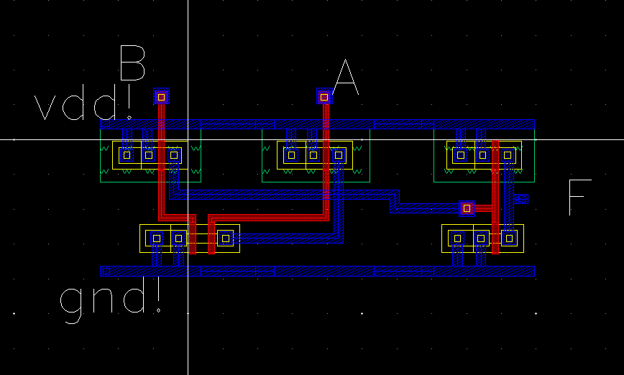

Specifications
Total Area:
Power Consumption:

Successful DRC & LVS

OR

Layout
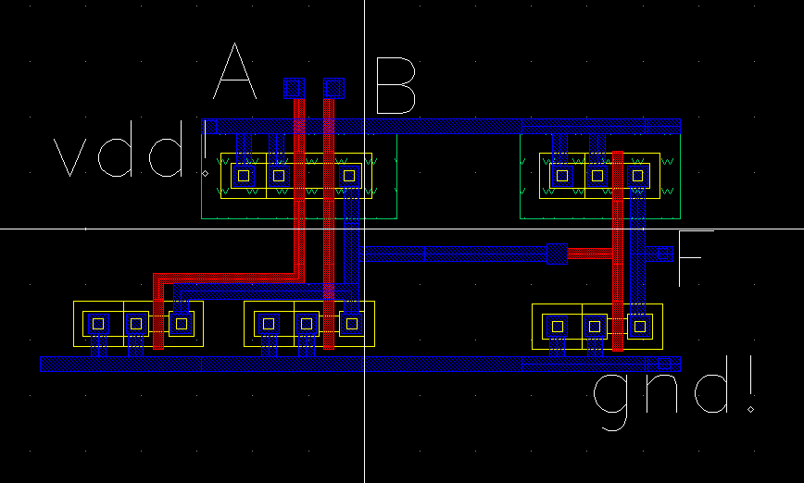

Specifications
Total Area:

NAND

Layout
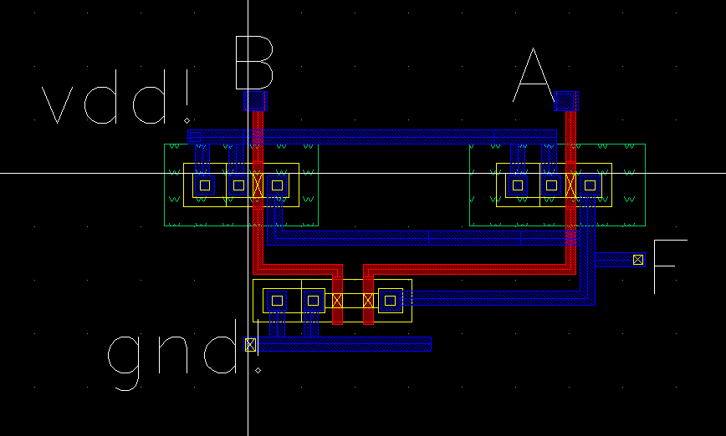

Specifications
Total Area:

NOR

Layout:
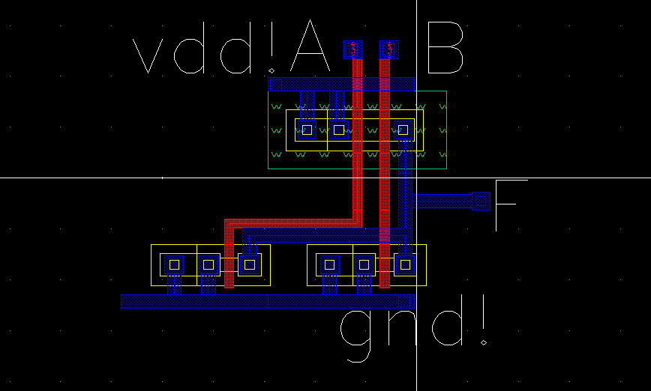

Specifications
Total Area:

XNOR

Layout
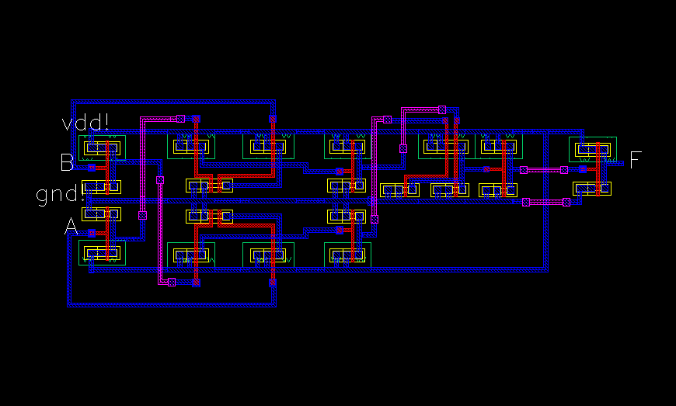

Specifications
Total Area:

XOR

Layout
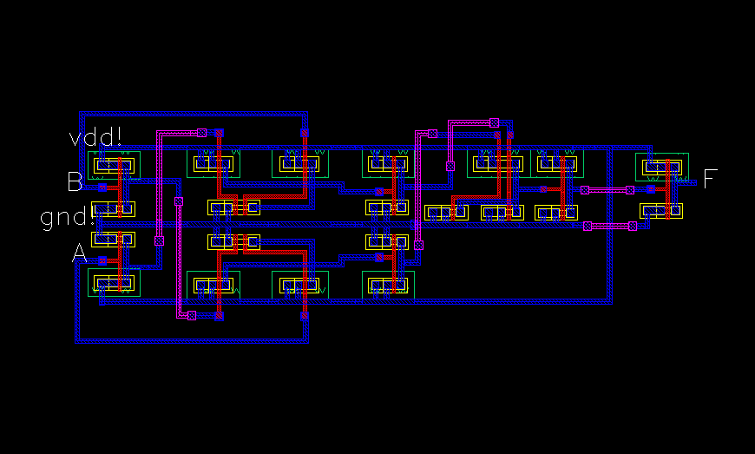
Total Area:

4-bit AND

Layout
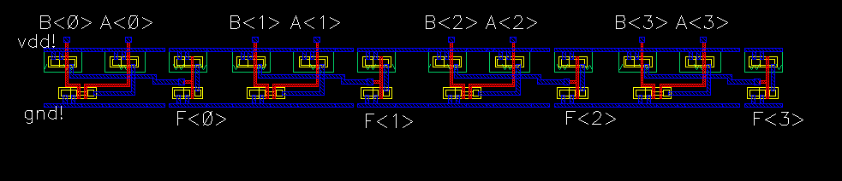

Specifications
Total Area:
Power Consumption:

Successful DRC & LVS

Post Layout Simulation
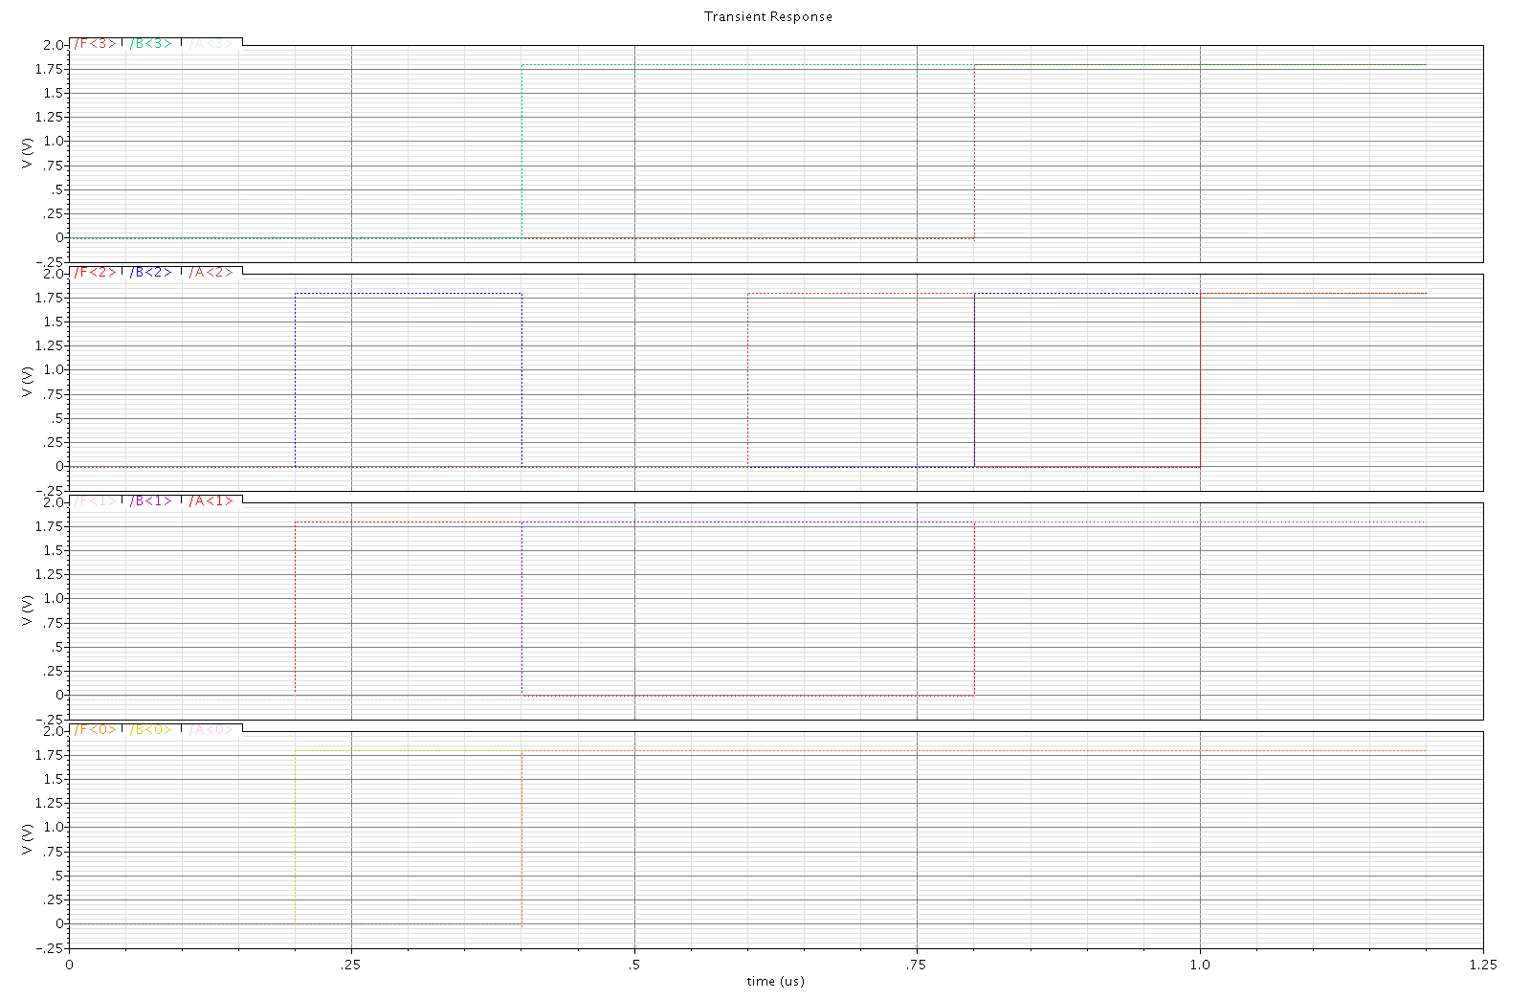

4-bit OR

Layout

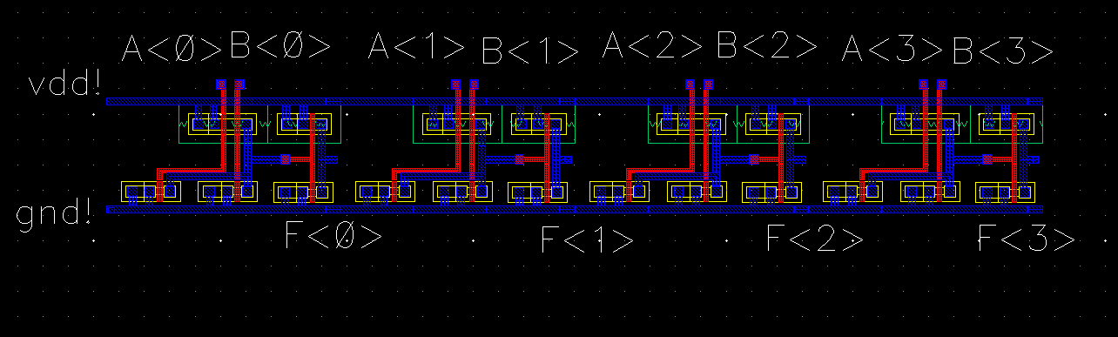

Specifications
Total Area:
Power Consumption:

Successful DRC & LVS

Post Layout Simulation
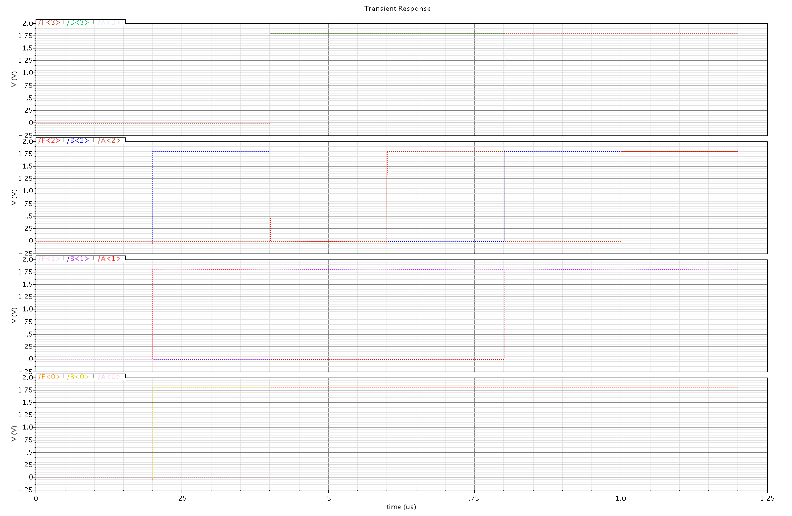

4-bit XNOR

Layout
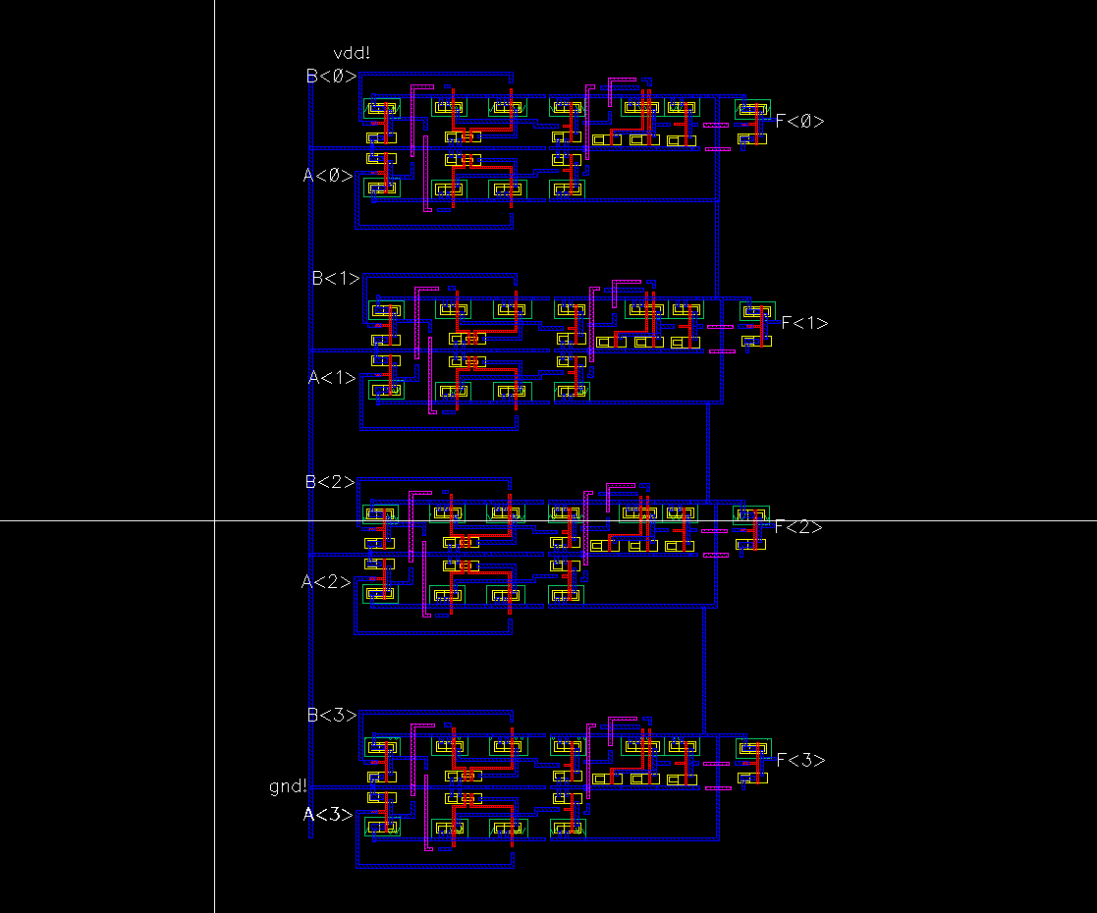

Specifications
Total Area:
Power Consumption:

Successful DRC & LVS

Post Layout Simulation
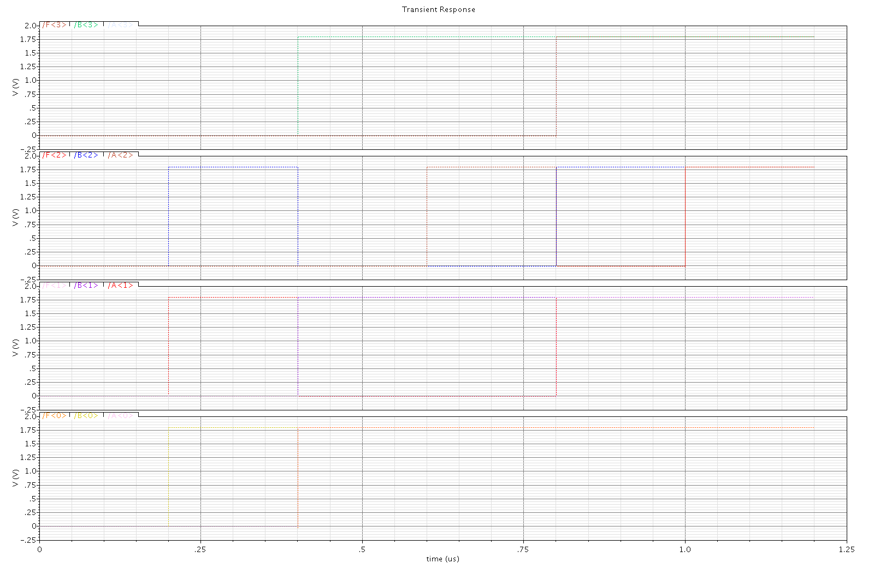

4bit XOR

Layout
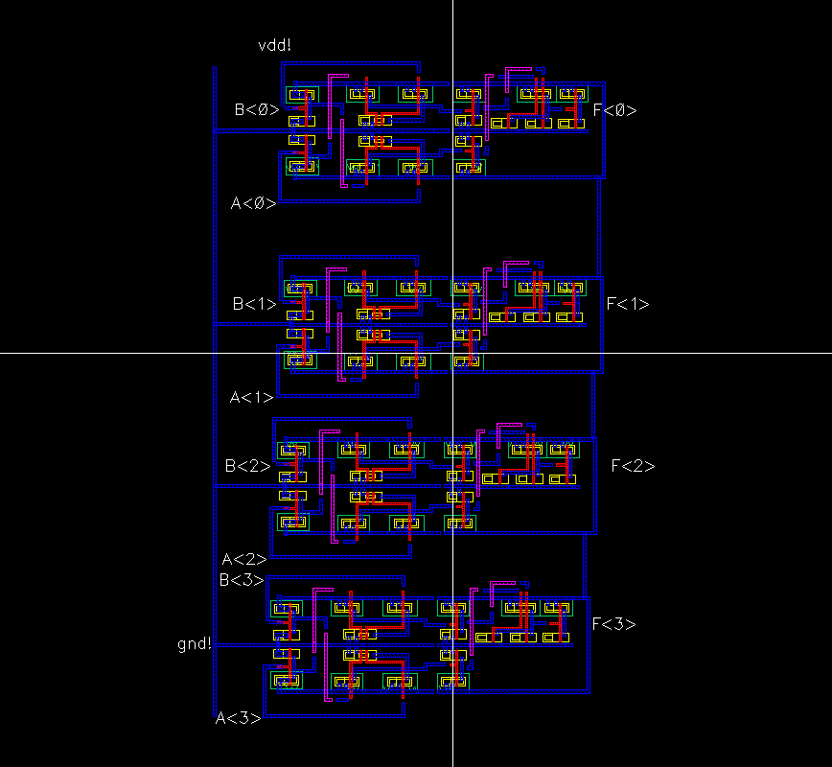

Specifications
Total Area:
Power Consumption:

Successful DRC & LVS

Post Layout Simulation
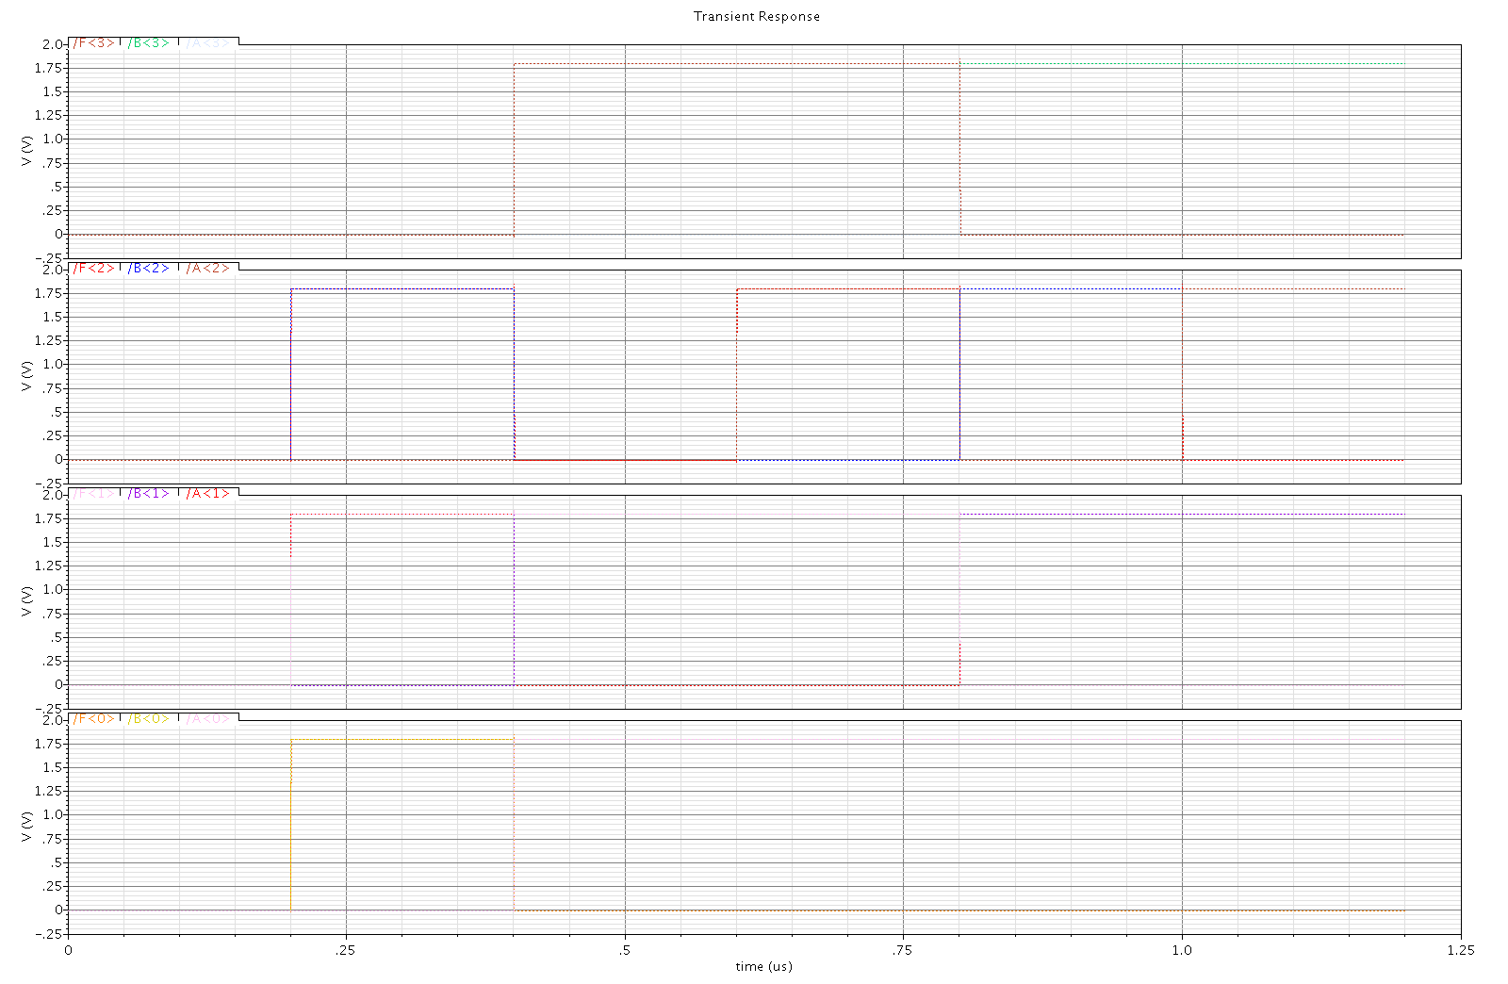

1-bit Full Adder

Layout
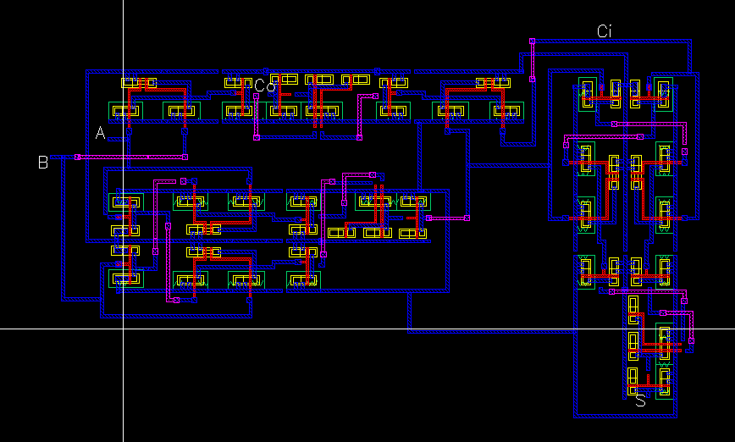

Specifications
Total Area:
Power Consumption:

Successful DRC & LVS

Post Layout Simulation

4bit Adder

Layout

Specifications
Total Area:
Power Consumption:

Successful DRC & LVS

Post Layout Simulation

