**CS 1632 – Deliverable 3**

**David Anderson**

**https://github.com/Davidboo25/CS1632-Assignment3/tree/master**

**Summary**

Overall, this deliverable wasn’t too bad but there were a few confusing issues I had when trying to test the website that was given to us.

The first issue I had was trying to keep test cases in-between 20 and 30. I had no idea how to do this because the second requirement was most of my test cases. Having to assert that each link worked individually on each page took up most of my tests. I was not sure the best way to test that each link, which is related to a specific element, correctly linked to a specific location.  
Another issue I had was testing the cathedral page. I wasn’t sure what the best way to test that an alt for an image contains “Cathedral” and looking through each list item. So instead, I just used the specific name of the alt from the image. This isn’t very scalable, but I was unsure how to loop through each list item.

Another issue I had was keeping assertions down to one per test case. There were times where I felt I was easier to condense a lot of the assertions due to them being similar in format and because creating a large amount of test cases is expensive.

Lastly, some of my test cases failed.

The first set of test cases that failed were Fib100,Fib2,Fib99, and Fib50. For some reason, the Fibonacci function does not work with numbers over 30. And for 2, there is an off by 1 error that also exists which makes this fail. I will get more into these issues in my defect section.

The second set of test cases that failed were FibString, FactorialString, FibDecimal, and FactorialDecimal. Upon these failing, an internal server error occurs. I’m assuming this is because there is lack of a catch of invalid values for these specific instances but I’m unsure what is going on specifically behind the scenes in the code.

An additional issue that I ran into upon finishing up the main program using the IDE was that it was difficult to export to junit code right out the box. The jars we were given didn’t work with the native export from selenium. There was a bunch of things I had to change to get my code to even run and there were still some issues with some of the tests with a null value.

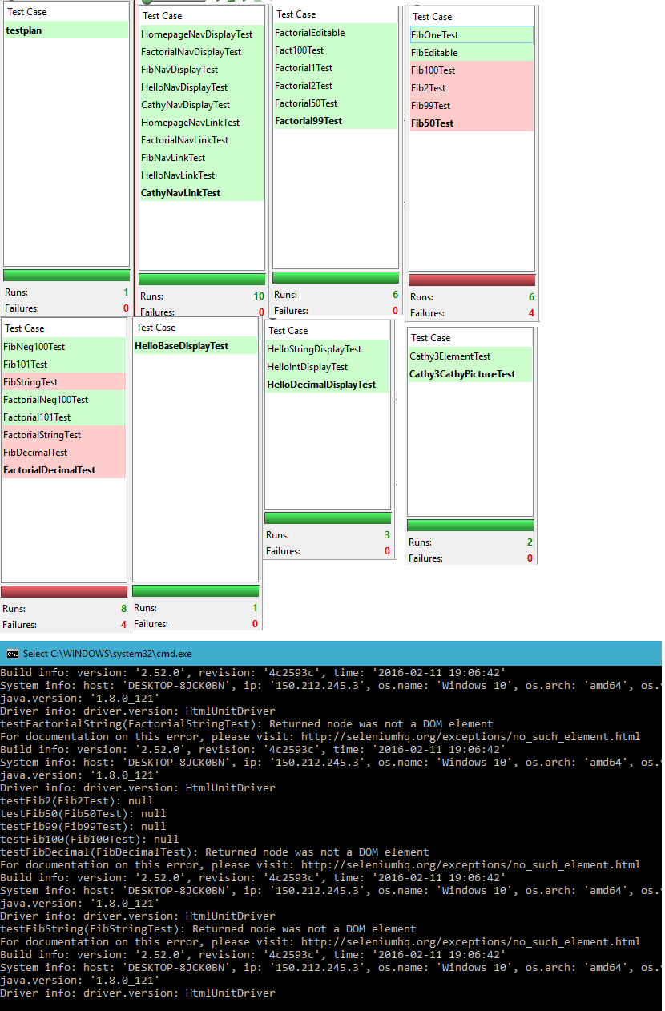

|  |
| --- |
| **IDENTIFIER: DEFECT-1** |
|  |

|  |
| --- |
| SUMMARY: The program displays 1 as the ouput for any Fibonacci input greater than 30. |
|  |

|  |
| --- |
| DESCRIPTION: When a number greater than 30 is input into the Fibonacci textbox, the output always displays as “1” as if the input is incorrect. Per the requirements, the program should be able to handle input from 30-100 successfully. |
|  |

|  |
| --- |
| REPRODUCTION STEPS: |
|  |

|  |
| --- |
| 1) Go to the website https://cs1632ex.herokuapp.com/ and click the “Fibonacci” link at the top. |
|  |

|  |
| --- |
| 2) Type 31 into the textbox and hit enter. |
|  |

|  |
| --- |
| EXPECTED BEHAVIOR: The website will display “Fibonacci of 31 is 1346269!” |
|  |

OBSERVED BEHAVIOR: The website displays “Fibonacci of 31 is 1!”

|  |
| --- |
| **IDENTIFIER: DEFECT-2** |
|  |

|  |
| --- |
| SUMMARY: The program displays the Fibonacci digit of the number one less than the input. |
|  |

|  |
| --- |
| DESCRIPTION: When the user enters a correct input to the Fibonacci textbox, the output always displays the Fibonacci of one greater than the input. This is an off by one error. |
|  |

|  |
| --- |
| REPRODUCTION STEPS: |
|  |

|  |
| --- |
| 1) Go to the website https://cs1632ex.herokuapp.com and click the “Fibonacci” link at the top. |
|  |

|  |
| --- |
| 2) Type 25 into the textbox and hit enter. |
|  |

|  |
| --- |
| EXPECTED BEHAVIOR: The website will display “Fibonacci of 25 is 75025!” |
|  |

OBSERVED BEHAVIOR: The website displays “Fibonacci of 25 is 121393!”

|  |
| --- |
| **IDENTIFIER: DEFECT-3** |
|  |

|  |
| --- |
| SUMMARY: The program is unable to handle string, or decimal, input for factorial. |
|  |

|  |
| --- |
| DESCRIPTION: When the user enters a string or a decimal input into the Factorial textbox, the website will crash. Per the requirements, the program should display “1!” as the factorial of a string or a decimal. |
|  |

|  |
| --- |
| REPRODUCTION STEPS: |
|  |

|  |
| --- |
| 1) Go to the website https://cs1632ex.herokuapp.com and click the “Factorial” link at the top. |
|  |

|  |
| --- |
| 2) Type “jester” into the textbox and hit enter. |
|  |

|  |
| --- |
| EXPECTED BEHAVIOR: The website will display “Factorial of 5 is 120!” |
|  |

OBSERVED BEHAVIOR: The website displays an internal server error.