AR

TEXTBOOK

* Opeoluwa

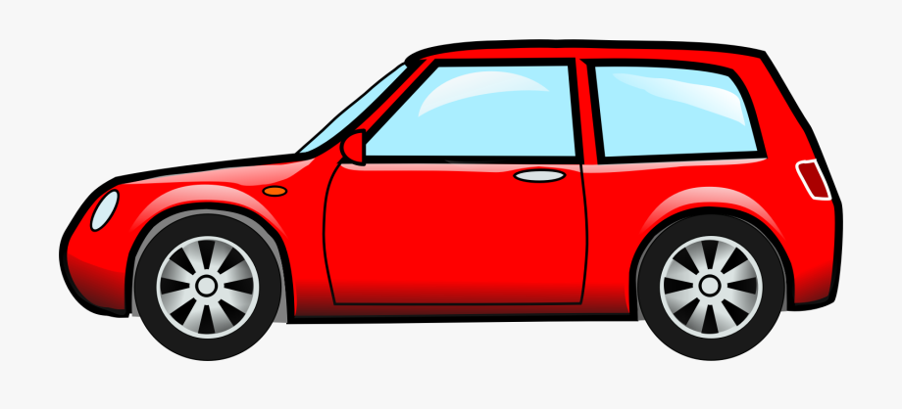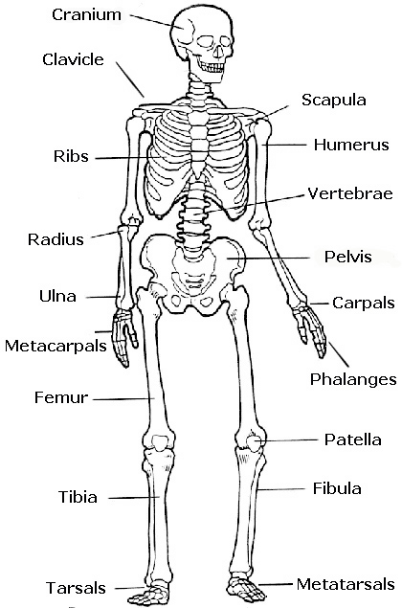

A SHIP

Stern

Hull

Bow

Sail

A CAR

Boot

Head light

Wheel

Roof

Windshield

Handle

Wheel

A HUMAN SKELETON

D

A HOUSE

Garage

Window

Door

Roof

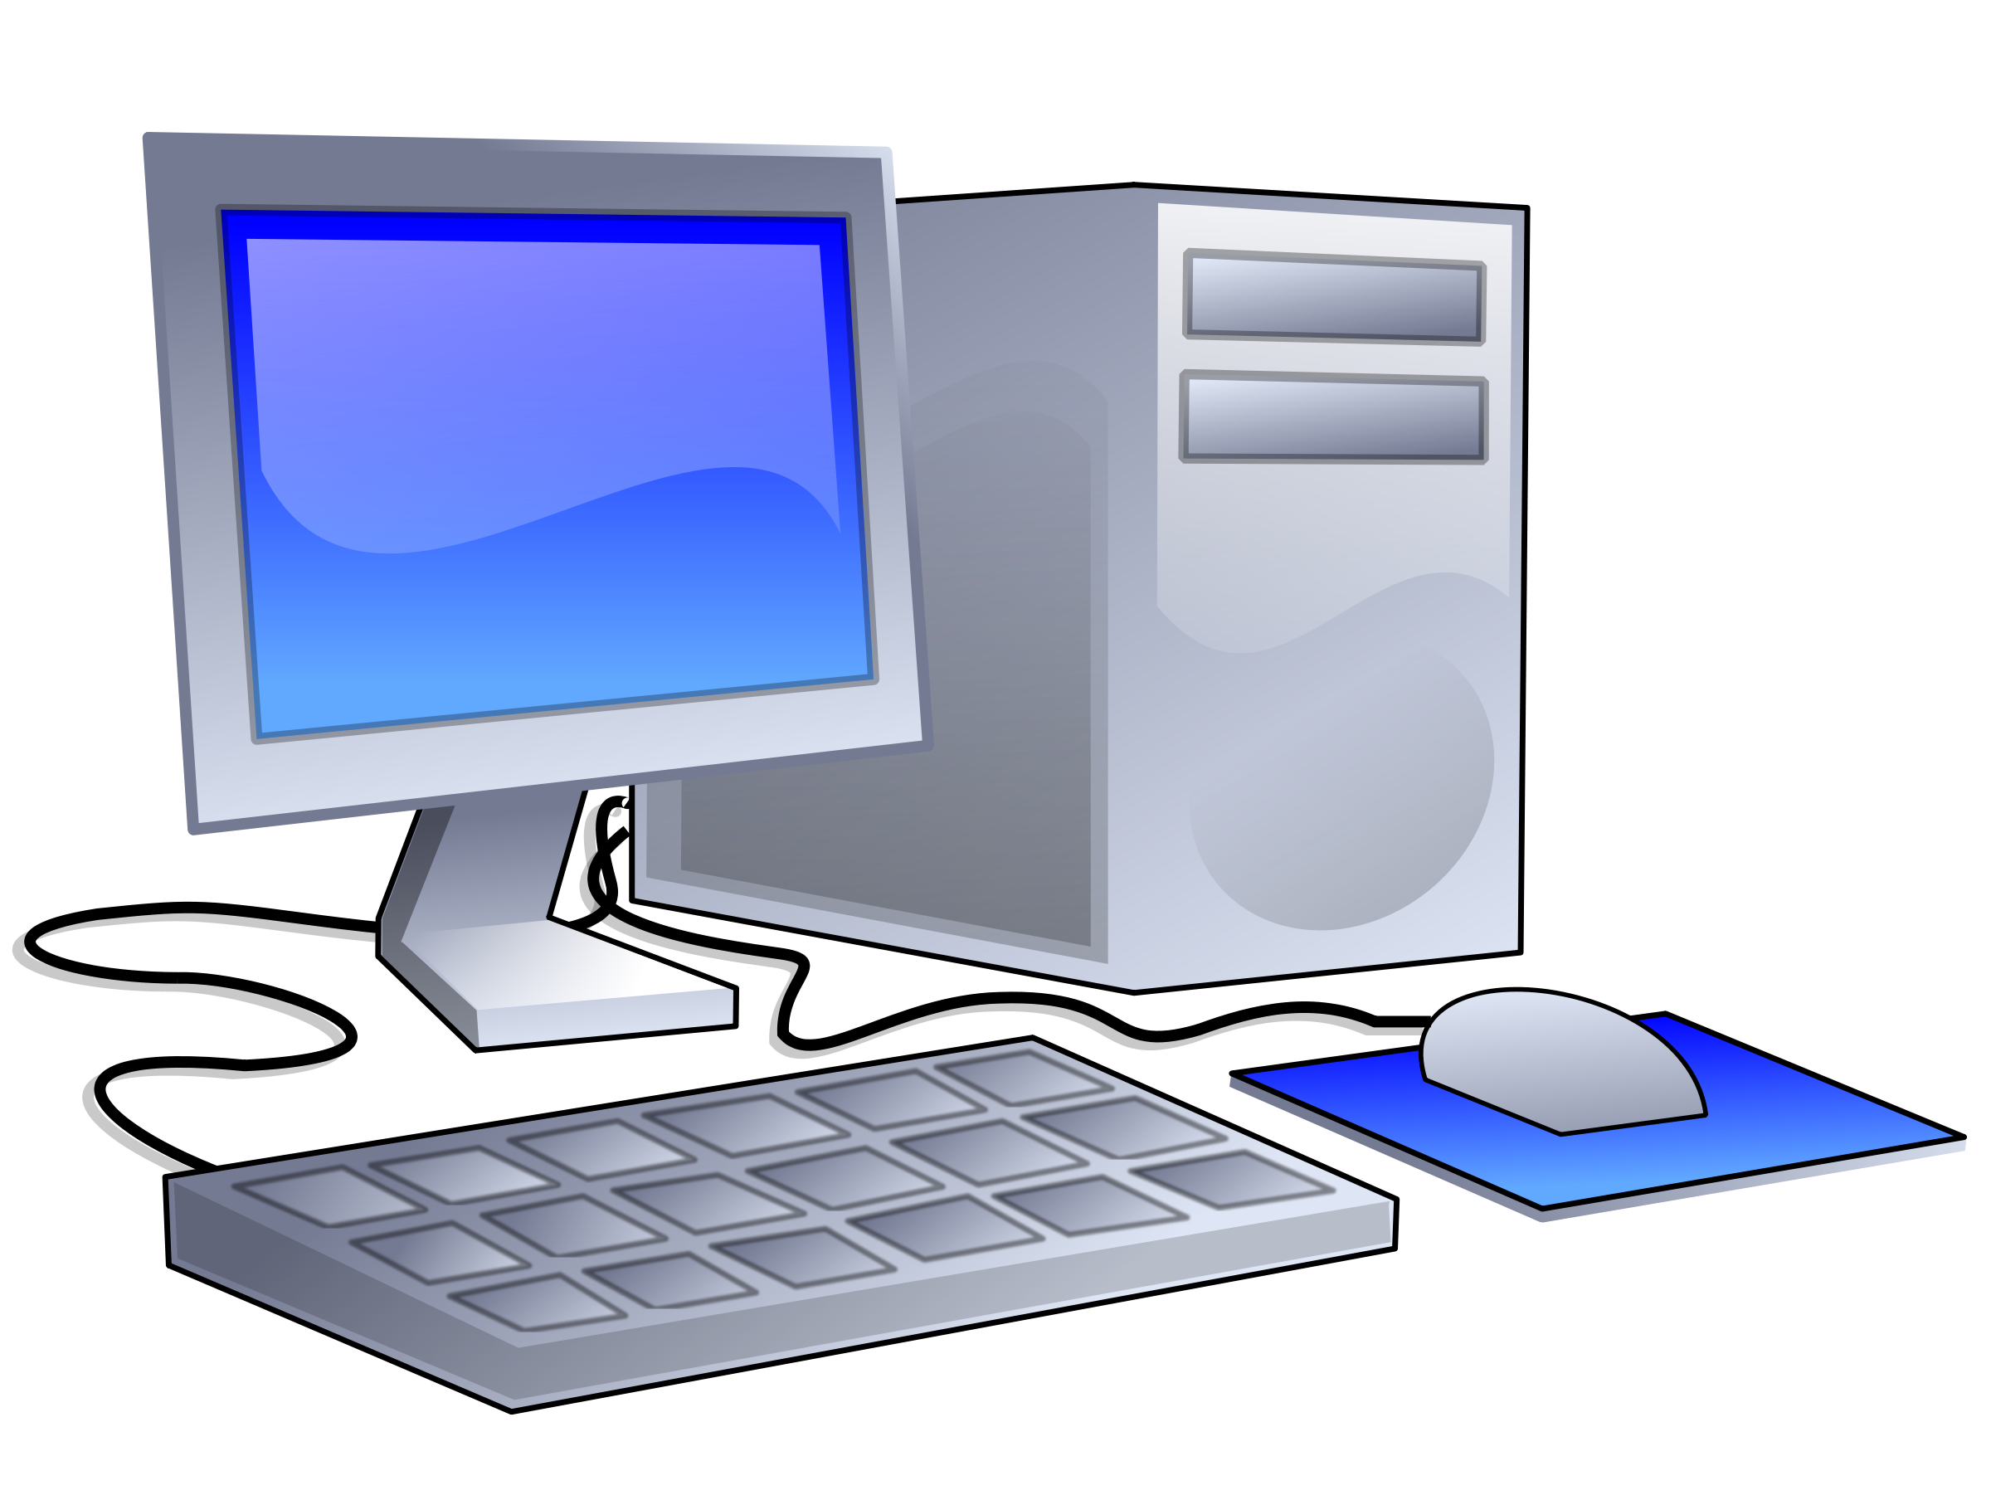

A COMPUTER

Mouse

C.P.U

Keyboard

Monitor

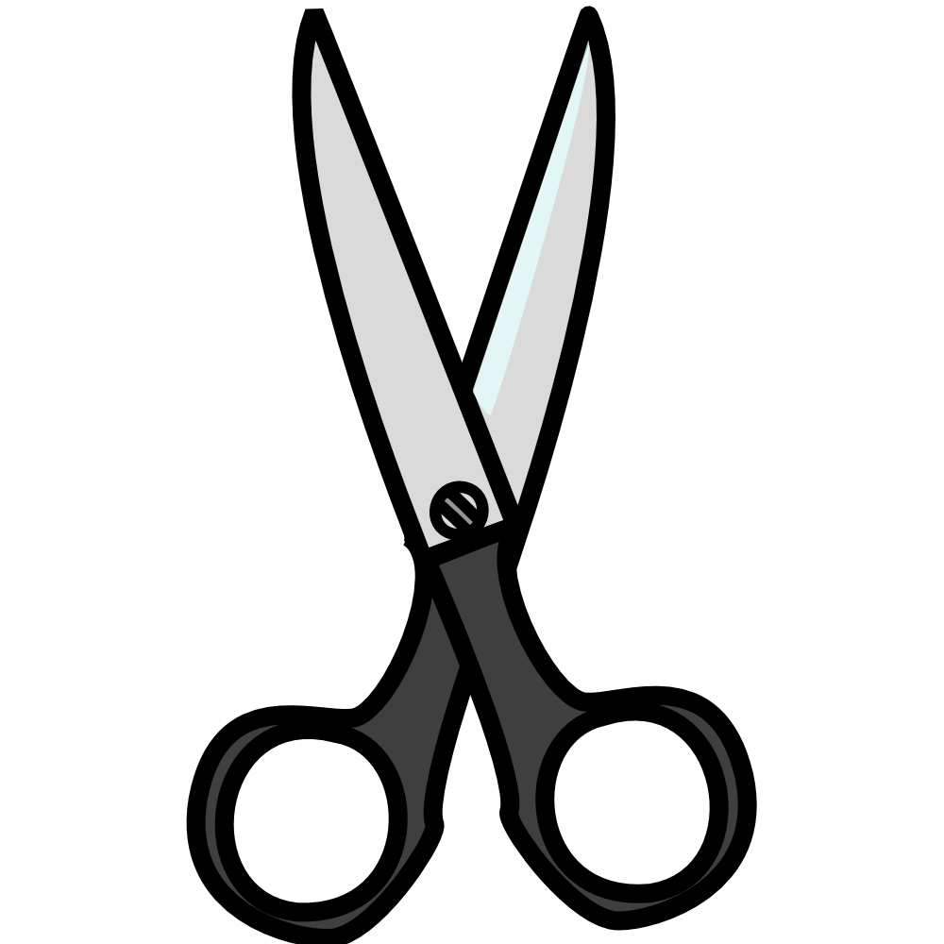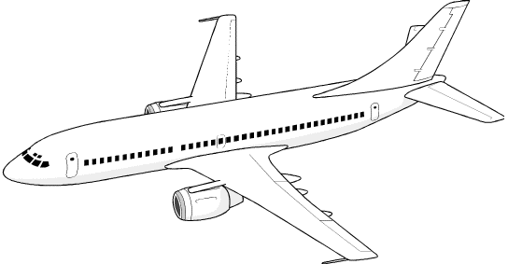

A SCISSORS

Finger Holes

Handle

Pivot Points(Pin)

Blade

AN AEROPLANE

Tail Plane

Wing

Tail

Cabin

Jet Engine

Flight desk

Nose