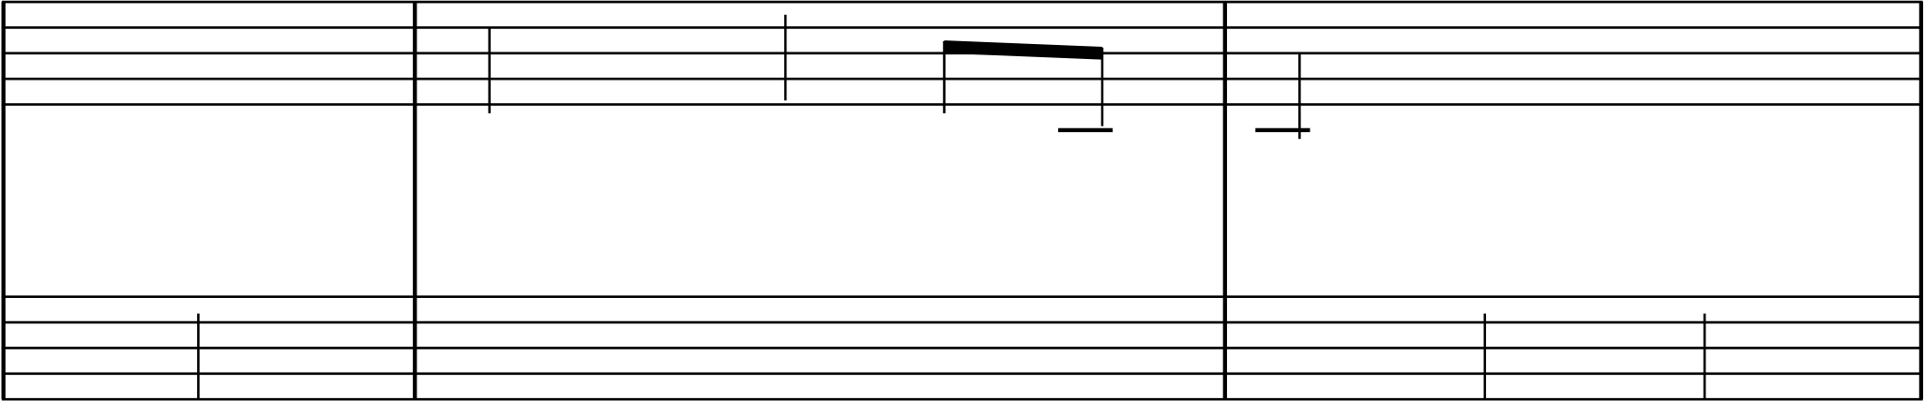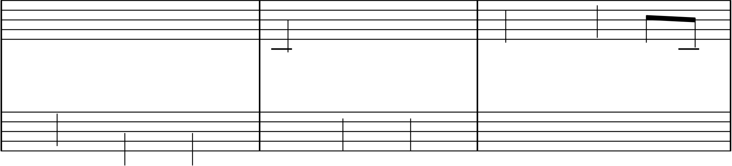

**The More We Get Together**   
 Music by Marx Augustin

Arranged by Julie A. Lind

**Happily**

|  |  |  |  |  |  |  |  |  |  |  |
| --- | --- | --- | --- | --- | --- | --- | --- | --- | --- | --- |
| & 34  { ? 34 mf | Œ | **3** | œj | œ | œ | - | **1** | Œ | Œ | - |
| œ™ |
| œ  geth - |
| The | more | we | get | to | er, | to |
| œ | ∑ | Œ | œ | œ |
| **2** |

*3*

|  |  |  |  |  |  |  |  |  |  |  |  |  |
| --- | --- | --- | --- | --- | --- | --- | --- | --- | --- | --- | --- | --- |
| & { ? | geth | - | er, | ∑ | to - | **1** | Œ | Œ | œ™ | œj œ | | œ |
| œ  geth - |
| er, | the | more | we | get | to - |
| œ | œ | œ | Œ | œ | œ | ∑ | |
| **1** |

*6*

|  |  |  |  |  |  |  |  |  |  |  |  |  |  |  |  |  |  |  |  |  |  |  |  |  |  |  |  |  |  |  |  |  |  |  |  |  |  |  |  |  |  |  |  |  |  |  |  |  |  |  |  |  |  |  |  |  |  |  |  |  |  |  |  |  |  |  |  |  |  |  |  |  |  |  |  |  |  |  |  |  |  |  |  |  |  |  |  |  |  |  |  |  |
| --- | --- | --- | --- | --- | --- | --- | --- | --- | --- | --- | --- | --- | --- | --- | --- | --- | --- | --- | --- | --- | --- | --- | --- | --- | --- | --- | --- | --- | --- | --- | --- | --- | --- | --- | --- | --- | --- | --- | --- | --- | --- | --- | --- | --- | --- | --- | --- | --- | --- | --- | --- | --- | --- | --- | --- | --- | --- | --- | --- | --- | --- | --- | --- | --- | --- | --- | --- | --- | --- | --- | --- | --- | --- | --- | --- | --- | --- | --- | --- | --- | --- | --- | --- | --- | --- | --- | --- | --- | --- | --- | --- | --- |
| {   |  |  |  |  |  |  |  |  |  | | --- | --- | --- | --- | --- | --- | --- | --- | --- | |  | | | |  | | | | | |  | | | |  | | | | | |  |  | | |  | | | | | |  |  | | |  | | | | | | œ  get   |  |  |  | | --- | --- | --- | | h - | er | the | | | | | |  |  |  |  |  |  | | --- | --- | --- | --- | --- | --- | | hap | - | pi | - | er | we'll | | œ | œ | | | | | | | |  | |  |  |  |  |  | | | |  | |  |  |  |  |  |  |  | |  | |  |  |  | | |  |  | |  | | | | | | |  |  |   This arrangement Copyright © 2022 Julie A. Lind www.PianoSongDownload.com |

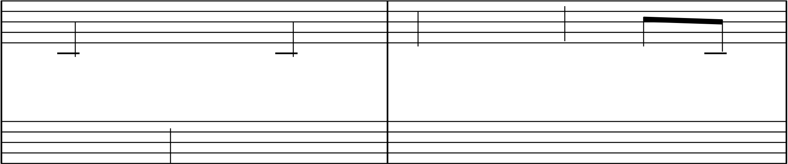

2   
 *8*

|  |  |  |  |  |  |  |  |  |  |  |  |  |  |  |  |  |  |  |  |  |  |  |  |  |  |  |  |  |  |  |  |  |  |  |  |  |  |  |  |  |  |  |  |  |  |  |  |  |  |  |  |  |  |  |  |  |  |  |  |  |  |  |  |  |  |  |  |  |  |  |  |  |  |  |  |  |  |  |  |  |  |  |  |  |  |  |  |  |  |  |  |  |  |  |  |  |  |  |  |  |  |  |  |  |  |  |  |  |  |  |  |  |  |  |  |  |  |  |  |  |  |  |  |  |  |  |  |  |  |  |  |  |  |  |  |  |  |  |  |  |  |  |  |  |  |  |  |  |  |  |  |  |  |  |  |  |  |  |  |
| --- | --- | --- | --- | --- | --- | --- | --- | --- | --- | --- | --- | --- | --- | --- | --- | --- | --- | --- | --- | --- | --- | --- | --- | --- | --- | --- | --- | --- | --- | --- | --- | --- | --- | --- | --- | --- | --- | --- | --- | --- | --- | --- | --- | --- | --- | --- | --- | --- | --- | --- | --- | --- | --- | --- | --- | --- | --- | --- | --- | --- | --- | --- | --- | --- | --- | --- | --- | --- | --- | --- | --- | --- | --- | --- | --- | --- | --- | --- | --- | --- | --- | --- | --- | --- | --- | --- | --- | --- | --- | --- | --- | --- | --- | --- | --- | --- | --- | --- | --- | --- | --- | --- | --- | --- | --- | --- | --- | --- | --- | --- | --- | --- | --- | --- | --- | --- | --- | --- | --- | --- | --- | --- | --- | --- | --- | --- | --- | --- | --- | --- | --- | --- | --- | --- | --- | --- | --- | --- | --- | --- | --- | --- | --- | --- | --- | --- | --- | --- | --- | --- | --- | --- | --- | --- | --- | --- | --- | --- | --- |
| { *10*   |  |  |  |  |  |  |  | | --- | --- | --- | --- | --- | --- | --- | |  | | |  | | | | |  | | |  | | | | |  | | |  | | | | |  | | |  | | | | | be. 'Cause | | | |  |  |  | | --- | --- | --- | | your | friends | are |   œ | | | | |  | | |  |  | | | | ? |  |  |  |  | | | |  |  |  |  |  |  |  | |  |  |  |  | |  |  | |  | | | | |  |  |   { *12*   |  |  |  |  |  |  |  |  | | --- | --- | --- | --- | --- | --- | --- | --- | |  | | | |  | | | | |  | | | |  | | | | |  |  | | |  | | | | |  |  | | |  | | | | | œ  my   |  |  |  | | --- | --- | --- | | y | friends | and | | | | | |  |  |  | | --- | --- | --- | | my | friends | are |   œ | | | | | |  | |  |  |  |  | | | |  | |  |  |  |  |  |  | |  | |  |  |  |  |  |  | |  | | | | | |  |  | | | | | | | | | |
| & { *14* ? | œ | Œ | œ | œ™ | œj | ∑ | œ | œ |
| to- |
| your | friends. | The | more | we | get |
| Œ | œ | Œ |
| {   |  |  |  |  |  |  |  |  |  |  |  |  | | --- | --- | --- | --- | --- | --- | --- | --- | --- | --- | --- | --- | |  | | | |  | | | | |  | |  | |  | | | |  | | | | |  | |  | |  |  | | |  | | | | |  | |  | |  |  | | |  | | | | |  | |  | | œ  get   |  |  |  | | --- | --- | --- | | h - | er | the | | | | | |  |  |  |  |  |  | | --- | --- | --- | --- | --- | --- | | hap | - | pi | - | er | we'll | | œ | œ | | | | | | |  |  | | --- | --- | | be. | ™ | | |  | | |  | |  |  |  |  |  | | |  |  |  | |  | |  |  |  |  |  |  |  |  |  |  | |  | |  |  |  | | |  |  |  |  |  | |  | | | | | | |  |  | | | | | | | | | | | | |