What we should do differently:

Communication - we should have been better at planning what each member was doing.

We should set up frequent team meetings to discuss the project.

We should have managed our time better so it was easier to finish the work on time.

We should have applied the concepts taught in the theoretical classes.

What we did right:

Creation of a to-do list to be more organized.

Detailed UI mockups.

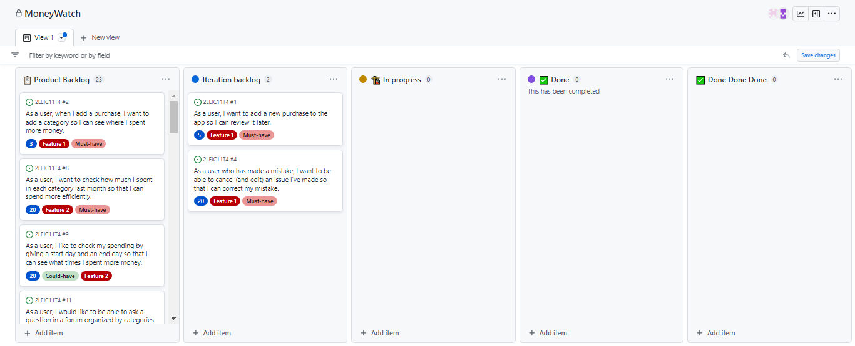Team spirit and willingness to work.