Robotics Lab: HOMEWORK 1

Building your robot manipulator

Davide Busco
Matricola: P38000177
Introduction

The goal of this homework is to build ROS packages to simulate a robotic manipulator arm into the Gazebo environment.
The Homework is made up of 4 main points:

1. Create the description of your robot and visualize it in Rviz

2. Add transmission and controllers to your robot and spawn it in Gazebo

3. Add a camera sensor to your robot

4. Create a ROS publisher node that reads the joint state and sends joint position commands to your robot
1. Create the description of your robot and visualize it in Rviz

(a) Download the arm_description package from the repo
https://github.com/RoboticsLab2023/ arm_description.git into your catkin_ws

In order to do this I can use the git clone command in my bash like shown in Figure 1.
This command will make a clone of the repository in the path catkin_ws/src/arm.
Figure 1

“arm” is the folder where all the packages will be grouped.

(b) Within the package create a launch folder with a launch file named display.launch that loads the URDF as a robot_description ROS param and starts the robot_state_publisher node, the node_state_publisher node, and the rviz node. Launch the file.
Remember: To visualize your robot in rviz you have to change the Fixed Frame and add the RobotModel plugin.

First of all I create the launch folder inside the arm_description folder. (Figure 2)

Figure 2

Then I create the display.launch file in the /launch folder with the command touch. (Figure 3)
Figure 3
Then I write in the display.launch file the following lines: (Figure 4)
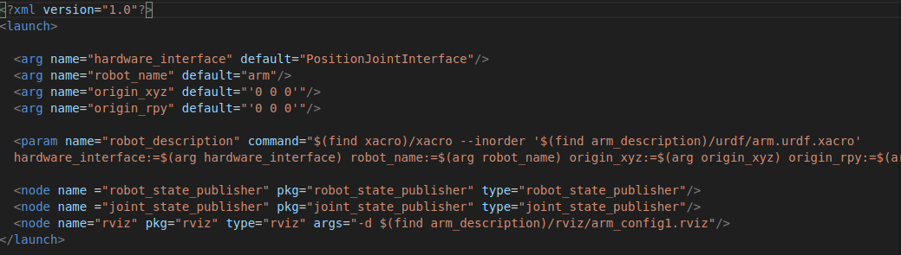Figure 4
Running the roslaunch display.launch command, the file will be executed and it also starts Rviz.
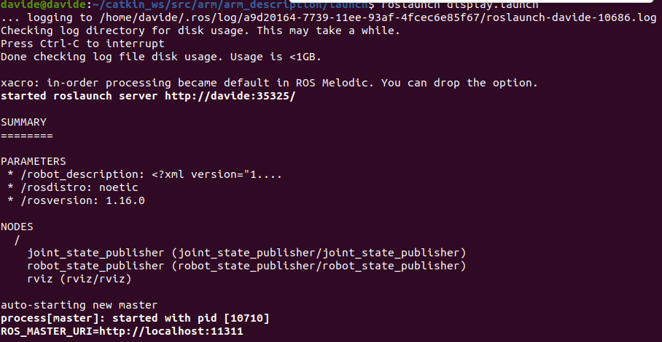Figure 5
Rviz opens with a blank screen. In order to visualize the robot I have to both change the fixed frame and Add the module Robot Model.
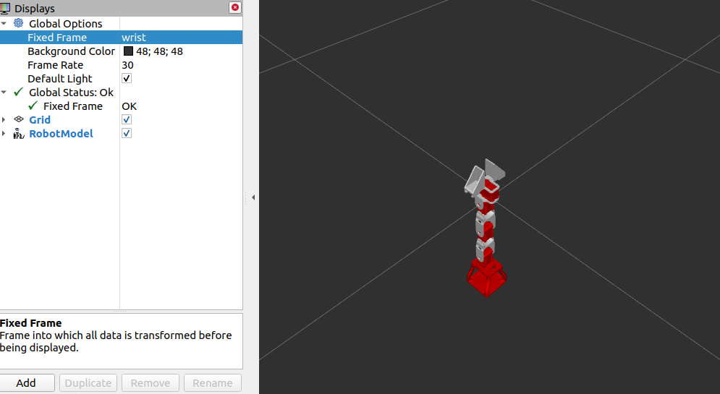Figure 6
Optional: save an .rviz configuration file, that loads the robot model by default, and give it as argument to your node

It is possible to save a configuration and load it with a command in the launch file.
So to do this let’s save a configuration in Rviz at file/Save Config As

I saved it in a new folder named rviz in the arm_description folder.

Now I have to write a line in the launch file that allows me to load the config at launch time:
Let’s just edit a bit the last line.
”<node name="rviz" pkg="rviz" type="rviz" args="-d $(find arm_description)/rviz/config_file.rviz"/>”

It is just necessary to change the “config_file.rviz” with the name of the saved configuration. In my case it is arm_config1.rviz .

<node name="rviz" pkg="rviz" type="rviz" args="-d $(find arm_description)/rviz/arm_config1.rviz"/>

(c) Substitute the collision meshes of your URDF with primitive shapes. Use <box> geometries of reasonable size approximating the links. Hint: Enable collision visualization in rviz (go to the lateral bar > Robot model > Collision Enabled) to adjust the collision meshes size

In order to do this I have to change in the URDF/xacro file the lines in the collision geometry section. Like it is shown in Figure 7, in the collision section it’s specified the “mesh” and in that case the collider is made from the mesh file of the base_link stl file.
My goal is to make a collider from a simple shape like a box.
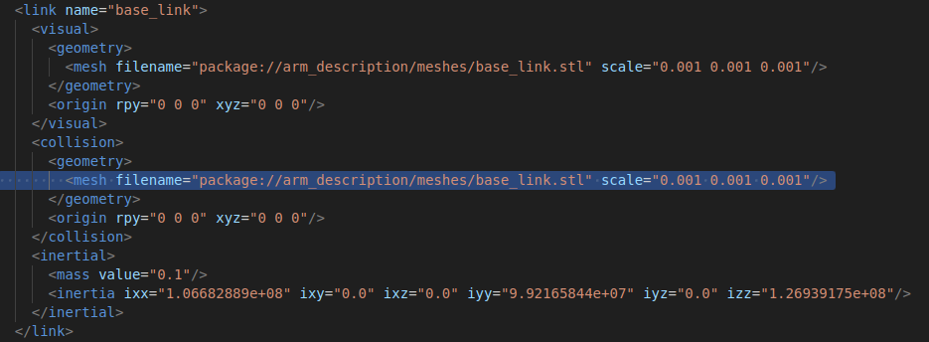Figure 7

Changing this line and writing it like shown in Figure 8 it will change the mesh of the collider of the base_link in a simple box with proper defined dimensions.

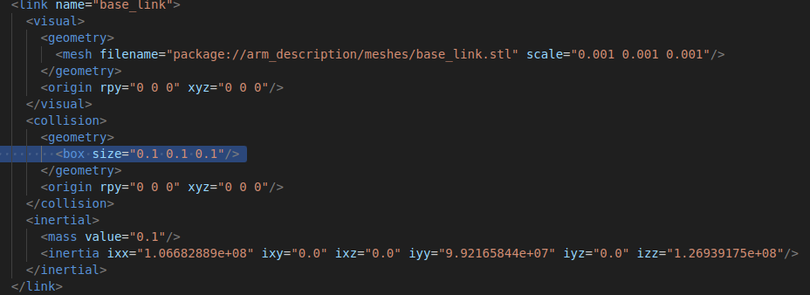Figure 8
It is also possible to visualize it in rviz by restarting it.
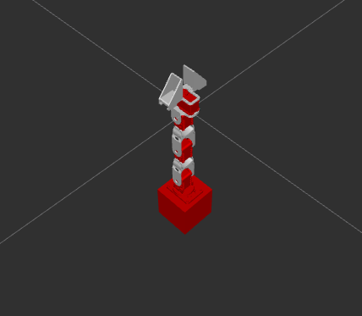Figure 9

Of course now I have to do this for each link using the proper dimensions.

Final result:

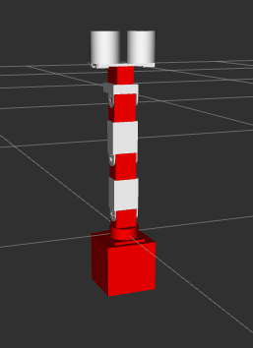

Figure 10

Notice that for some pieces I also chose to use the cylinder mesh.

(d) Create a file named arm.gazebo.xacro within your package, define a xacro:macro inside your file containing all the <gazebo> tags you find within your arm.urdf and import it in your URDF using xacro:include. Remember to rename your URDF file to arm.urdf.xacro, add the string xmlns:xacro="http://www.ros.org/wiki/xacro" within the <robot> tag, and load the URDF in your launch file using the xacro routine

I created the arm.gazebo.xacro file and edited it by cutting and pasting inside of it all the gazebo tags from the URDF file.
In the URDF file now I have to add the include instruction like that:

Figure 11
Now to launch it from the display.launch file I add this line in the display.launch file:
Figure 12
2. Add transmission and controllers to your robot and spawn it in Gazebo

(a) Create a package named arm_gazebo
In order to do this I use the catkin_create_pkg command. (Figure 13)
Figure 13
(Every time you create a new package it is important to launch the command source setup.bash)

(b) Within this package create a launch folder containing an arm_world.launch file
Figure 14
Figure 15

(c) Fill this launch file with commands that load the URDF into the ROS Parameter Server and spawn your robot using the spawn_model node. Hint: follow the iiwa_world.launch example from the package iiwa_stack: https://github.com/IFL-CAMP/iiwa_stack/tree/master. Launch the arm_world.launch file to visualize the robot in Gazebo

arm_world.launch in Figure 16.

Figure 16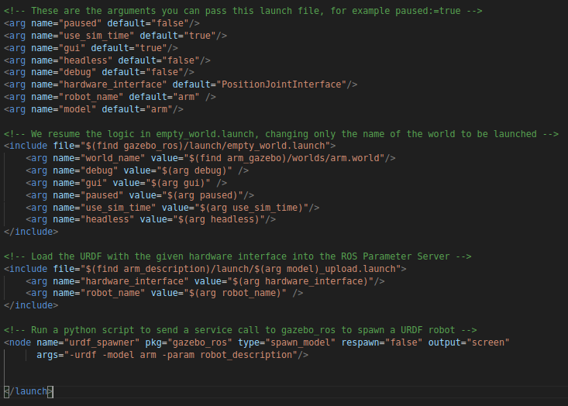
Then I also made a file arm.world (Figure 17) in the worlds folder in arm_gazebo and the arm_upload.launch (Figure 18) in the launch folder inside the arm_description.

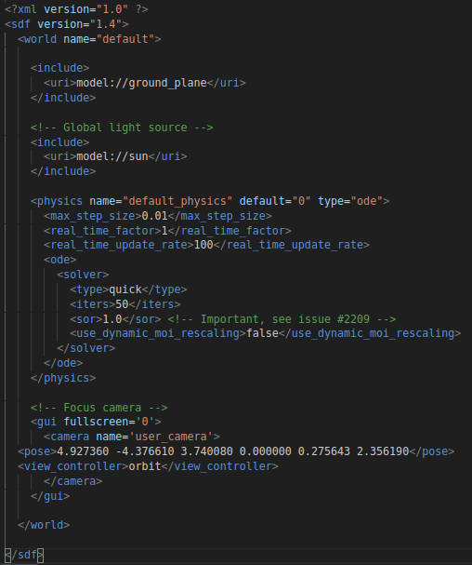Figure 17
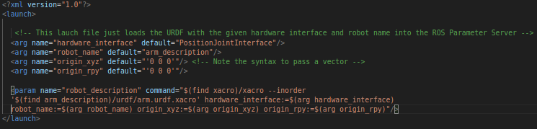Figure 18

(d) Now add a PositionJointInterface as hardware interface to your robot: create an arm.transmission.xacro file into your arm_description/urdf folder containing a xacro:macro with the hardware interface and load it into your arm.urdf.xacro file using xacro:include. Launch the file.

Figure 20
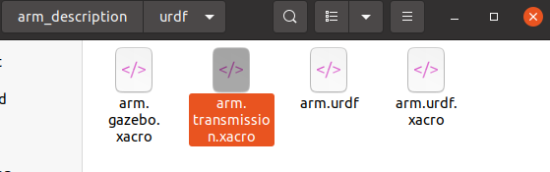Figure 19
(e) Add joint position controllers to your robot: create an arm_control package with a arm_control.launch file inside its launch folder and an arm_control.yaml file within its config folder

I created the package with the catkin_create_pkg command (Figure 21)
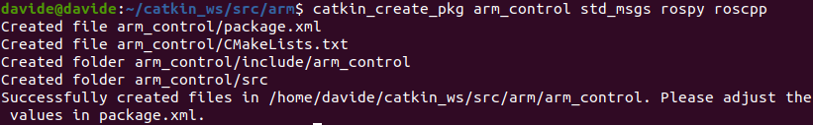Figure 21

Then I create the config folder (Figure 22) with the arm_control.yaml file (Figure 23) in it.
Figure 22
Figure 23
Then I create the launch folder (Figure 24) with the arm_control.launch file (Figure 25) in it.
Figure 24
Figure 25

(f) Fill the arm_control.launch file with commands that load the joint controller configurations from the .yaml file to the parameter server and spawn the controllers using the controller_manager package. Hint: follow the iiwa_control.launch example from corresponding package

Figure 26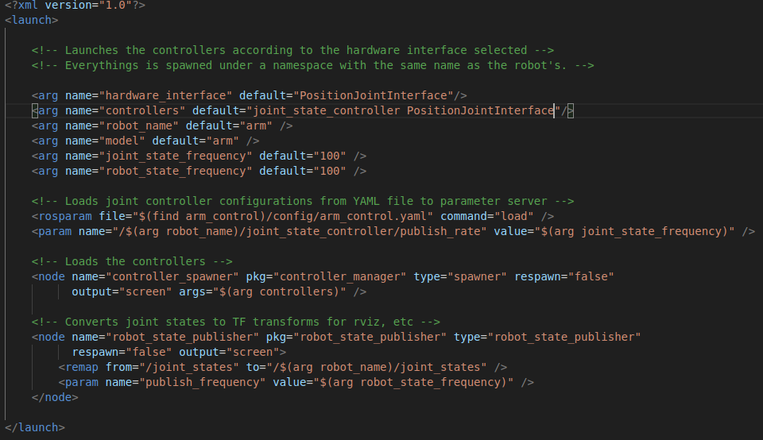
(g) Fill the arm arm_control.yaml adding a joint_state_controller and a JointPositionController to all the joints

JointPositionController in (Figure 27)
Figure 27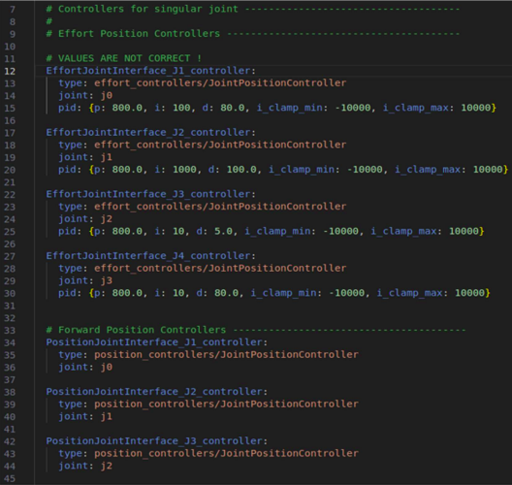
joint_state_controller in (Figure 28)
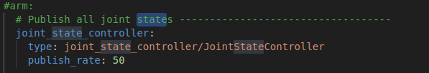Figure 28

(h) Create an arm_gazebo.launch file into the launch folder of the arm_gazebo package loading the Gazebo world with arm_world.launch and spawning the controllers within arm_control.launch. Go to the arm_description package and add the gazebo_ros_control plugin to your main URDF into the arm.gazebo.xacro file. Launch the simulation and check if your controllers are correctly loaded

The file arm_gazebo.launch in Figure 29
Figure 29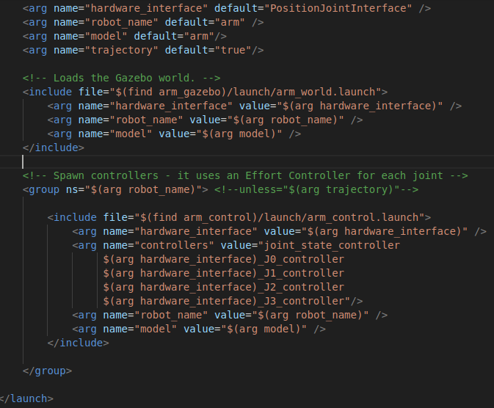
Added the gazebo_ros_control plugin in the arm.gazebo.xacro (Figure 30)

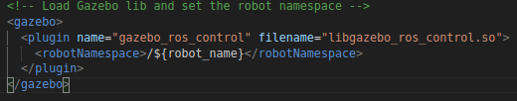Figure 30

- Launch the simulation and check if your controllers are correctly loaded

From the Figure 31 it is possible to see that the control is active and it is working since the robot has been in position for more than 5 minutes.
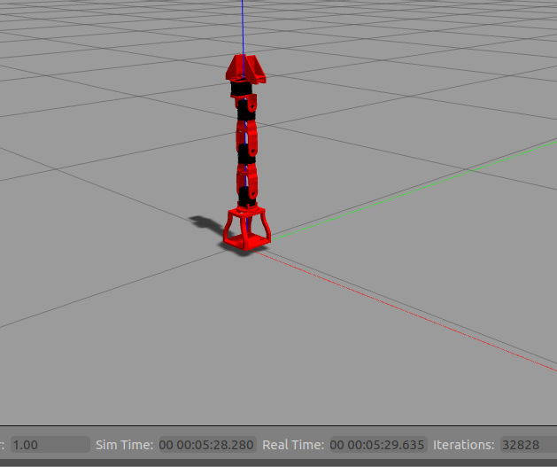Figure 31
3. Add a camera sensor to your robot

(a) Go into your arm.urdf.xacro file and add a camera_link and a fixed camera_joint with base_link as a parent link. Size and position the camera link opportunely

In order to do this I add a camera link and a camera joint to the arm.urdf.xacro file like shown in (Figure 32)
In Figure 33 the camera module is the little white cubic box.

EXTRA STUFF:
In the end of this report there is an extra stuff section. In that section I reported some extra things that I enjoyed to do just to try new things.
In that case I enjoyed my self by changing the cubic camera mesh with a real camera mesh.

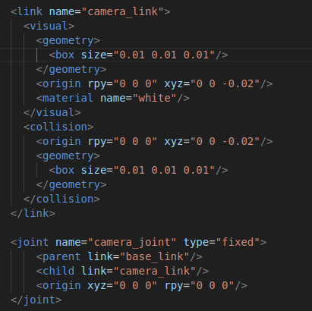Figure 32
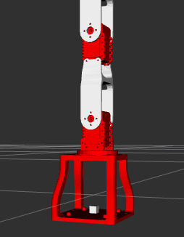Figure 33

(b) In the arm.gazebo.xacro add the gazebo sensor reference tags and the libgazebo_ros_camera plugin to your xacro (slide 74-75)
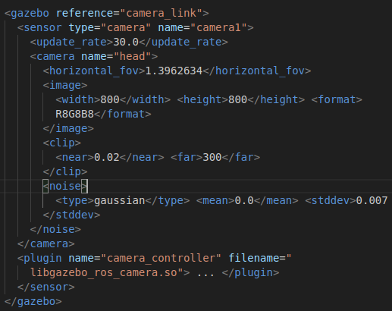Figure 34

(c) Launch the Gazebo simulation with using arm_gazebo.launch and check if the image topic is correctly published using rqt_image_view

While trying to launch the arm_gazebo.launch I encountered this error. So I installed to ros*controller* package to solve it.
Figure 35
Figure 36
So now I can launch arm_gazebo.launch and in a new bash I launch the comand rqt_image_view to check if the camera works.
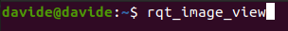Figure 37

So the camera works as you can see in Figure 38
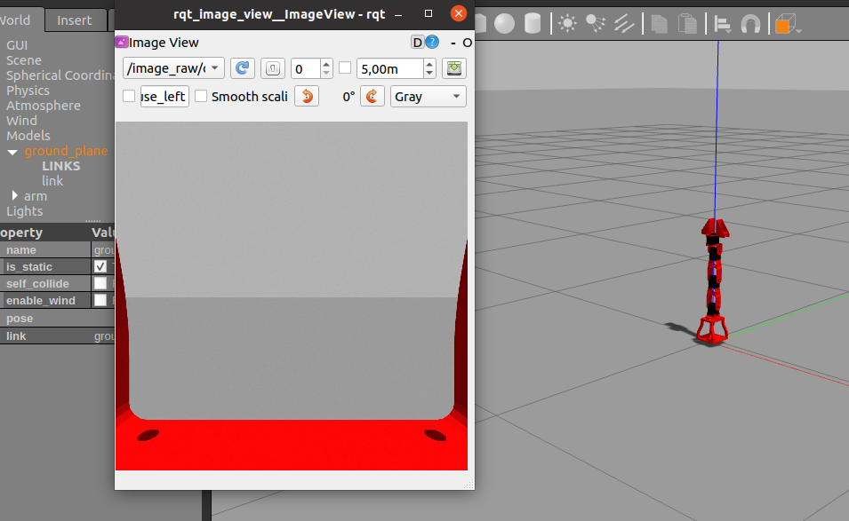Figure 38

(d) Optionally: You can create a camera.xacro file (or download one from https://github.com/ CentroEPiaggio/irobotcreate2ros/blob/master/model/camera.urdf.xacro) and add it to your robot URDF using <xacro:include>

In order to do this I commented all I have done in the previous points.
Then I downloaded the camera.urdf.xacro file from GitHub in arm_description/urdf folder.
Now I have to write some lines in the arm.urdf.xacro in order to include the new file.
Figure 39

4. Create a ROS publisher node that reads the joint state and sends joint position commands to your robot

(a) Create an arm_controller package with a ROS C++ node named arm_controller_node. The dependencies are roscpp, sensor_msgs and std_msgs. Modify opportunely the CMakeLists.txt file to compile your node. Hint: uncomment add_executable and target_link_libraries lines
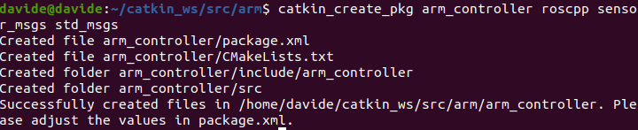Figure 40
Figure 41
Figure 42
Figure 43
(b) Create a subscriber to the topic joint_states and a callback function that prints the current joint positions (see Slide 45). Note: the topic contains a sensor_msgs/JointState

I created a subscriber node in the arm_controller_node.cpp file with a callback function that prints the current joint positions of every joint. (Figure 44)

Figure 44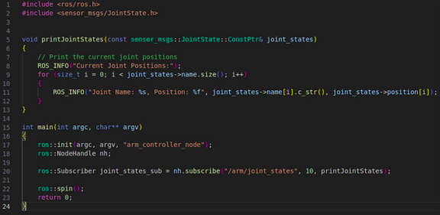
(c) Create publishers that write commands onto the controllers’ /command topics (see Slide 46). Note: the command is a std_msgs/Float64

Then in the same file I added 4 publishers (one for each joint) that write commands onto the controllers’ /command, so the final C++ code is:
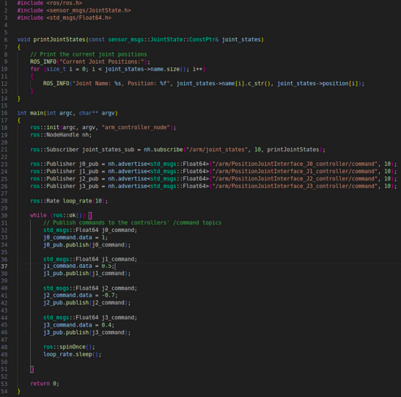

Figure 45

In Figure 46 it is possible to see how the manipulator looks after the execution of the node.
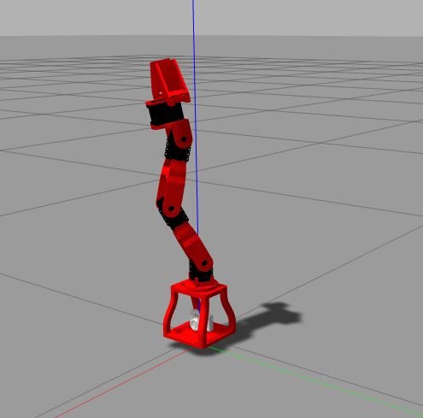Figure 46
To run the cpp file I have to launch to command rosrun arm_controller arm_controller_node
Extra Stuff

1) Topic Graph

In order to do this I typed the rqt_graph command.
In that way I have an overview of the entire project to have a look if everything is fine. (Figure 47)
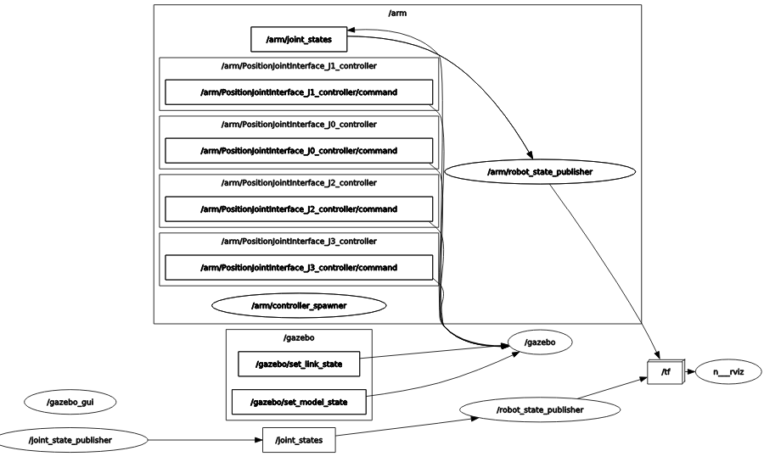Figure 47
2) New Camera Shape

Just for fun I changed also the box mesh of the camera with a real looking one.
In order to do this I downloaded an .stl file from thingiverse and saved it in my arm_description/meshes folder.
Then inside the arm.urdf.xacro file I edited the camera section like in Figure 48.
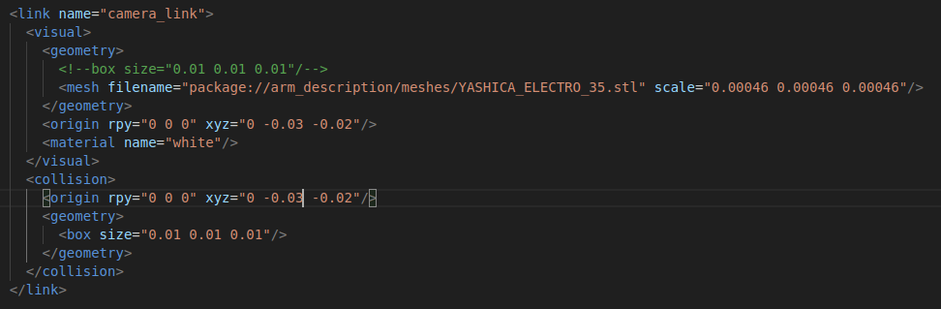Figure 48

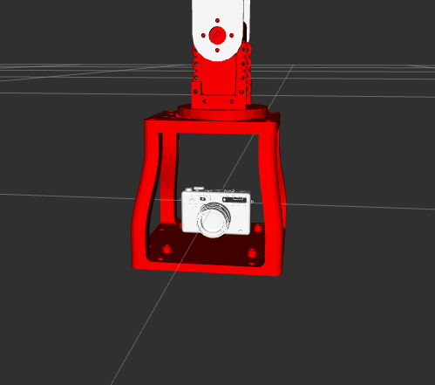Figure 49

3) Sending commands to the robot through command line

To do that first of all let’s check the rostopic list like in Figure 50
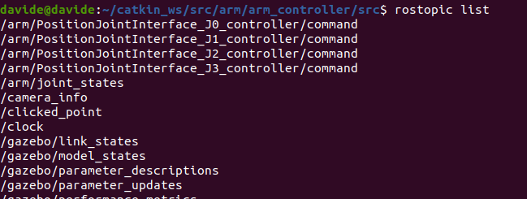Figure 50

Here it’s possible to see the topics that I’m going to use to send commands to the manipulator:
- /arm/PositionJointInterface_J0_controller/command
- /arm/PositionJointInterface_J1_controller/command
- /arm/PositionJointInterface_J2_controller/command
- /arm/PositionJointInterface_J3_controller/command

So for example let’s run this lines: (Figure 51)

rostopic pub /arm/PositionJointInterface_J1_controller/command std_msgs/Float64 "1"
rostopic pub /arm/PositionJointInterface_J2_controller/command std_msgs/Float64 "2"
That is the result (Figure 52)
Figure 51
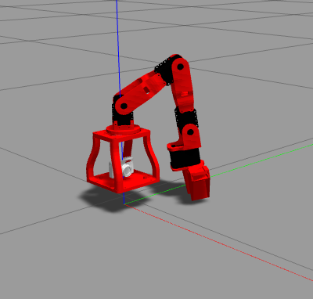Figure 52

MEMBERS OF THE GROUP

Davide Busco
Giuseppe Saggese
Davide Rubinacci
Pietro Falco

