Q6:

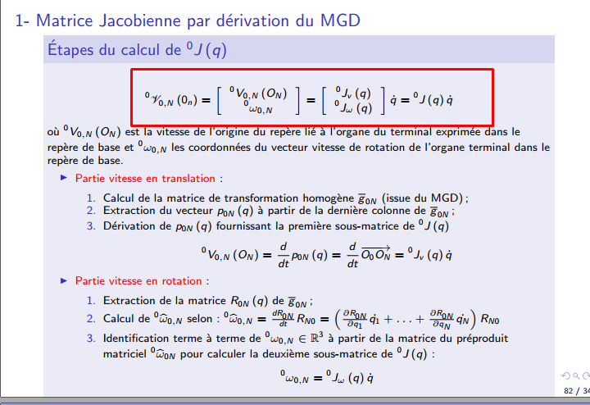

Q7

<http://www.isir.upmc.fr/UserFiles/File/Bidaud/Cours%20Robotique%20834(1).pdf>

q = qi

xi = [0.4500, -0.1500, 0.7500, 0, -0.5000, 1.5000]

xf = [-0.4096, 0.1768, 0.3889, 0.3536, 0, 1.5607]

**Manipulabilité**

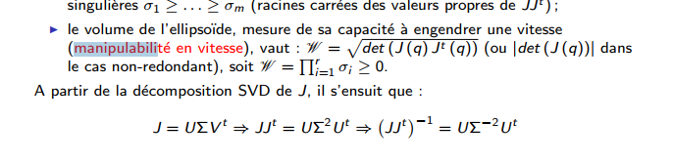

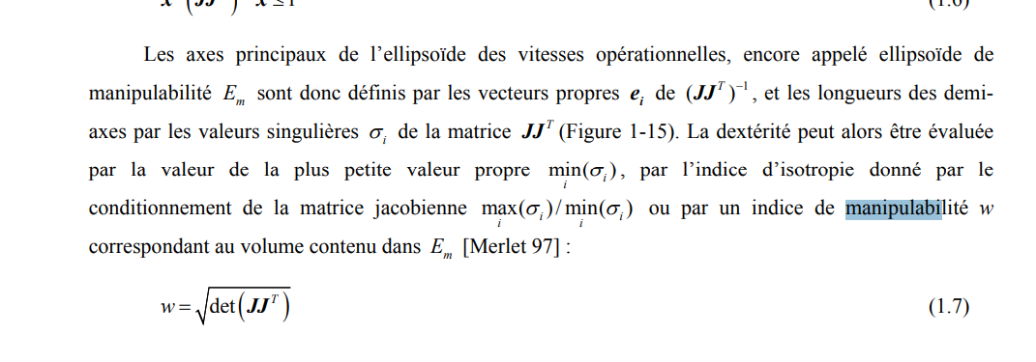

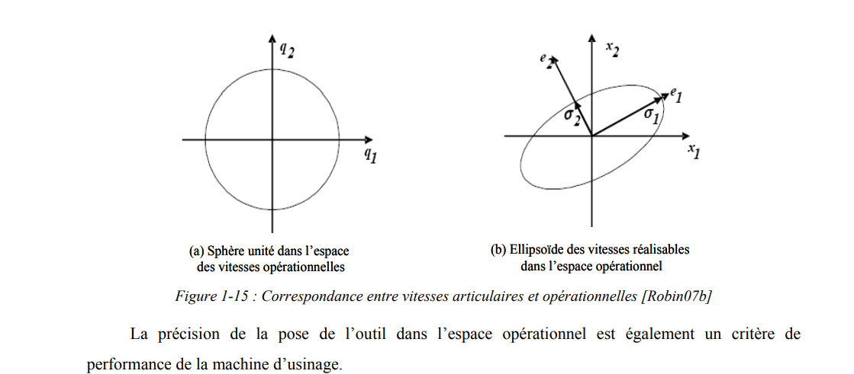

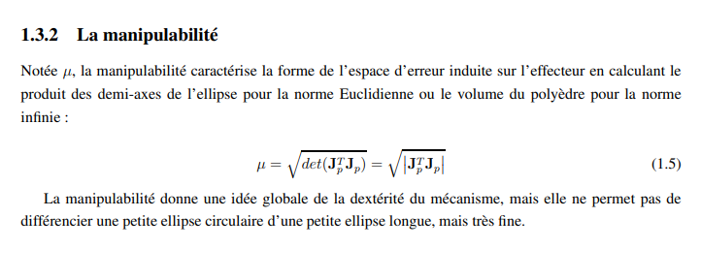

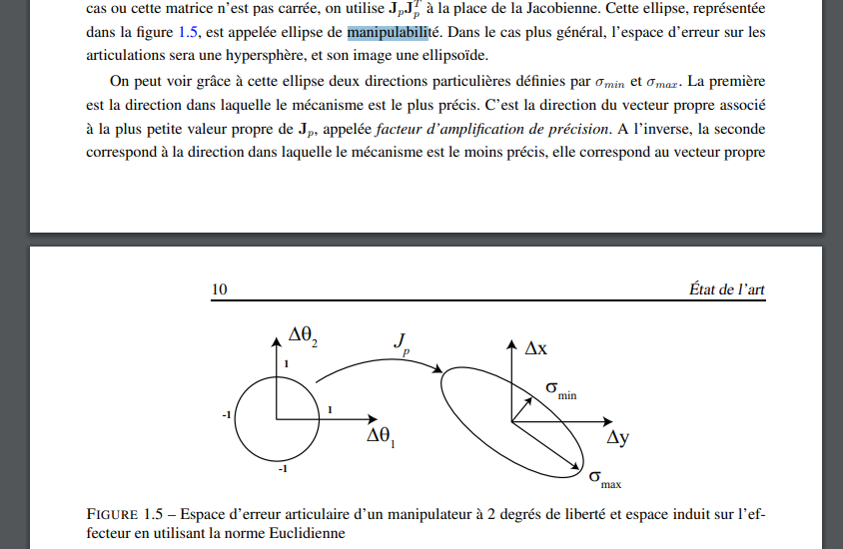

<https://pdfs.semanticscholar.org/9024/efd173dc21eb92e8e1226125034770be307c.pdf>

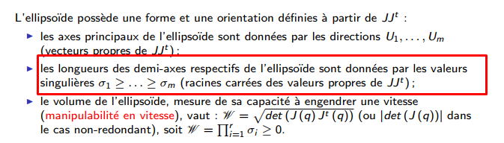

**DRAW ELIPSE**

[x,y,z] = ellipsoid(xc,yc,zc,xr,yr,zr,n) generates a surface mesh described by three n+1-by-n+1 matrices, enabling surf(x,y,z) to plot an ellipsoid with center (xc,yc,zc) and semi-axis lengths (xr,yr,zr).

