Title
Author/Authors (Antonio Boffa, Davide Montagno B.)
Email (a.boffa@studenti.unipi.it, d.montagnobozzone@studenti.unipi.it)

ML or AA1 course (exam code), Academic Year:…
Date: xx/yy/xyzz
Type of project: B

Notes to you:

- Language can be English or Italian (spelling and clarity are essential)
- Use word if you like, but latex is better. Anyway you will send a PDF file!
- Font 11 at least ! (here font 12 for clarity) ← Mandatory
- Type of project : can be A/B/C
  - A (new NN simulator with your code, in that case specify the programming language) or specify A with CM
  - B (comparing existing simulators, specify which ones)
  - C (ad hoc prj, refer our agreement email and date)

- Pages: up to 8 [1 student case], up to 10 pages for 2/3 students project [standard case]: use appendix for large or other tables or plots (if needed); the pages out of the limit will be not read and therefore not evaluated!!! ← Important

- See the instructions in the slides of the lecture for the project description!

Abstract – SIGMOIDE RELU MICHELI.
Insert here few rows (up to 5) summarizing the developed project (used model for the cup, validation technique, novelties if any) ….

1. INTRODUCTION
In this project, we compare 3 kinds of models. First of all, we compare two different kinds of really important and famous frameworks for Neural Network: Keras[1] and Pytorch[2]. We want to show our journey from having any previous knowledge of the frameworks to being able to write a fully working Multi-Layer Perceptron (MLP) with two different shapes. For each of these two frameworks, we use two different structures of MLP to better understand how they work and how to extend them. */*Develop this has been really tough because of the two frameworks are different.
Finally, we compare the approach based on Neural Network against a completely different approach in Machine Learning, we were curious about how to deal with Support Vector Machines (SVM) and so we choose it; since we are dealing with a regression task we use a different kind of SVM called Support Vector Regression (SVR) implemented by scikit-learn[3].
Talking about the task, we have 20 features and 2 target values, each of these are real numbers (comes from sensors), no any other assumption of the data has been done. The choice of these three models has been done to test all parts of course and to solve in the best way possible the given task. We have found interesting patterns in the target values, about this it will be discussed later in this report. CAPITOLO []
In order to test our models we used Hold-out technique to split, initially, the data and then to validate the model, we used k-fold cross-validation and grid search.
The developed code is in Python 3.7, it is completely automatized; from the main script the user can interact with the models by choosing either if he wants to cross-validate or test one particular instance of a single model, or all of those. All the code is available on Github [4].

2. Method
First of all, we choose some main functionality that we were sure to be common to all the model, they are: data import, data visualization, loss function (Mean Euclidian Distance), validation schema and test schema.
Once we choose how to organize the shared part, we start to implement it:
- For data import and other small tasks of numeric values manipulation, we use numpy library [5].
- For both plotting learning curves and results of the predictions in a 2D plot we use matplotlib [6].
- Since the results on the Blind Set will be evaluated using the Mean Euclidian Distance, we use it too as a loss in order to have more similar results. About the implementation of this function, for Keras we use the one provided by the framework. For Pytorch we implement it by ourself using tensors. For SVM, we just use this function to evaluate the results using numpy instead of tensors.
- As activation function for the MLP we used and tested both Sigmoid and Rectified Linear Unit (ReLU)
- About the preprocessing, we haven’t done any kind of it in the beginning, not even plotting the targets in a 2D plot. We did it in the end; more detail will be discussed in section 3.
- We choose Mini batch learning, the size of the batch is chosen in the validation phase.
- At the beginning of the project, we split the dataset into two parts, the first one consists of 95% of the entire dataset; the second one of 5%. The latter is used to test all the three models at the end of the validation process to choose the best one and give a true estimation of its generalization error.
- As validation schema, we use K-Fold cross-validation implemented by scikit-learn to not have any bias from the choose of the validation set. We use k = 10 because for each fold we have 90% of the dataset for training and 10% for validation.

We started using Keras with TensorFlow backend [7] considering 3 hidden-layer perceptron and a quite small amount of units per layer. We also experimented a “pyramid” shape, where at each level there are fewer units than the previous one.
For the Pytorch model, we decided to implement a 2 hidden-layer perceptron and a quite small amount of units per layer without any particular shape. In both Neural Network models all the connection between a level and its next one are dense.
As we said in the Introduction chapter, together with the MLP we wanted to experiment a different approach to Machine Learning, and so we started to look for a good SVM framework to use. We found out that the best one is libsvm [8]. Instead of using it, we use the scikit-learn implementation based on libsvm. It provides a better integration in Python and the other utilities of scikit.
Since we are dealing with a regression task we use SVR,

Each figure/table should be referenced as in the following, see Fig. 1.
Do not use figure/table without a number. Do not write “see the next figure” (which one?).
Tables and plots have always a caption. All of the Figures and Tables should be cited in order, including those in the Appendix. (which should be cited as, for example, Fig. A.1, and Table A.1).

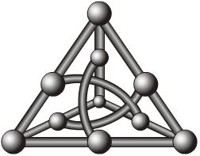

Figure 1. Do not insert a picture of your neural network (unless it is innovative)

3. Experiments
What you have found: The results should be the larger part of the report.
Data import
Tuning dei paramentre
SIGMOIDE vs RELU

3.1 KERAS MLP

3.2 PYTOCH MLP

3.3 SCIKI LEARN SVR
Svm vs svr
Problema multiclass regression
On our own then library

3.4 MONK’S RESULTS
In this subsection report only plots and tables, comment only if needed.
[*] Lack of results in this part invalidates the report. Both for A and B prj.
Please report:
- Performance (see Table 1) and learning curves (MSE and accuracy plots for the 3 MONK’s tasks, see Fig. 2 as an example filled with the plot for the MONK2).
- Used hyper-parameters

Table 1. Average prediction results obtained for the MONK’s tasks.
Task | #Units, eta, lambda, .. | MSE (TR/TS) | Accuracy (TR/TS) (%)
MONK 1 |  | … | …
MONK 2 |  | … | 100%/100%
MONK3 |  | … | …
MONK3 (reg.) |  | … | …

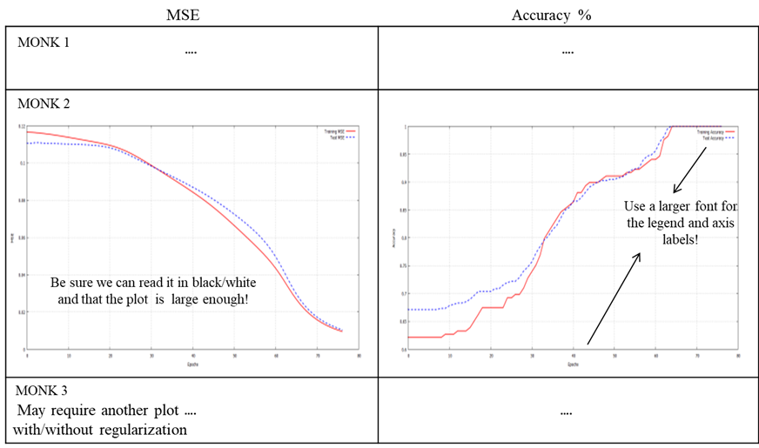

Figure 2. Plot of the MSE and accuracy for the 3 MONK’s benchmarks.
[Be sure it will be easy to read them in Black&White (after print)]

3.5 CUP RESULTS

Always include:
- Details of the Validation schema (model selection and evaluation schema): Splitting TR/VL/(internal)TS (% data for each set and/or the K values of the k-fold CV) [*]
- Screening phase: Type of preliminary trials pursued (often summarized by text)
- Schema and range of explored hyper-parameters (values used for the grid search, possibly a table) [*]

- Grid search: TABLES of results TR/VL/(TS) with MEE [*]. At least the most performant cases. Tables/Plots can be used also to show some relevant trends for specific hyper-parameters changes (if you think it is significant)
- Provide an estimation of the (training) computing time (and of your HW resources)
- Repeat and compare if you are comparing different models/algorithms/approaches (or different variants of the approach that you think are significant).
- Define how you selected the FINAL model used on the blind test set [*]. Which is it among the candidates and why? Also write the hyper-param. of the final model [*]. MINIMIZING ERROR LOSS ON CHOOSING MODEL.
- Report for the FINAL model used on the blind test set the TABLE with MEE for TR (training), VL (validation) and TS (internal TS) in the original scale [*][*]. Note again that you must have an internal test evaluation (see the note IV above)
- Plot the learning curve TR/(VL)/TS for the FINAL model [*] (the final model is unique)
- Discussion (what you found more relevant in your experiments)

[*] = Lack of results in this part invalidates the report. Both for A and B prj.

Further explanations and notes:
A good experimental report contains a list of observed facts supported by experimental evidence:
  - Report of used setting (replicability), and of the procedure for model selection and validation/assessment
  - Report accurate results in numerical and graphical form (clear tables/plots with measures of training, validation and test errors)
  - Make a selection of the evidences that you think are important but for those show with graphs / tables etc, e.g. by plots varying the hyperparameters values
  - Make critical remarks (+/-) on the effect of your choices (and, if necessary, their agreement with the theory of ML or report and discuss unusual evidences)
  - Note that the relative position between the different cases is interesting (not the absolute performance)
  - Learning curve to show the TR, Val/Test error with the progress of training: Curve with LMS (loss used for training) and measure of final error curve (e.g. accuracy for classification) can be different

4. Conclusions

What you have drawn and also:
BLIND TEST RESULTS: name of the result files and your nickname

Acknowledgements
If any.
I/we agree to the disclosure and publication of my name, and of the results with preliminary and final ranking.

References
PYTHORCH (BOOK)
From where you are taking information, where a reader can find details, credits, sources .... See any paper bibliography to take examples. The items here should be numbered at the number should be used in the text. Double check the bibliography!!!
In particular, always include (with a uniform style):
Authors, Title, Journal/Proceedings/Editor, Volume, Pages, Year (URL if needed)
E.g.:
[1] A. Micheli, A.; Sperduti, A.; Starita, A.; A. M. Bianucci: Analysis of the Internal Representations Developed by Neural Networks for Structures Applied to Quantitative Structure–Activity Relationship Studies of Benzodiazepines. J. Chem. Inf. Comput. Sci., 41, 202–218, 2001.
[2] A. Micheli, A. Sperduti, A. Starita, A.M. Bianucci: Design of New Biologically Active Molecules by Recursive Neural Networks, Proc. Int. Joint Conference on Neural Networks, 4, 2732–2737, 2001.

[1] https://keras.io/
[2] https://pytorch.org/
[3] https://scikit-learn.org/stable/
[4] https://github.com/aboffa/MachineLearningProject
[5] https://numpy.org/
[6] https://matplotlib.org/
[7] https://www.tensorflow.org/api_docs/python/tf/keras/backend
[8] https://www.csie.ntu.edu.tw/~cjlin/libsvm/
[9]
[3] https://scikit-learn.org/stable/auto_examples/svm/plot_rbf_parameters.html

APPENDIX. A.

If needed, insert here (only) TABLES, GRAPHS, PLOTS that are not essential in the main sections, or that are too large.
Take care: The report can be read without reading the appendix.
These parts may be out of the maximum 8/10 pages, without a specific limit (but should be reasonable!).

Please see FAQs in the PRJ lecture: report the mean result over the different initialization, not just the best result. Moreover, remember that the MSE does not include the penalty term.
General note on plots in the report: to be comparable, use a point for each epoch (defined as the total number of training data): if you are using on-line or mini-batch provide the mean over an epoch for each point in the plot.
The internal test set (see the note IV) results can be or can be not present during the grid search according to your decisions on the data splitting/cross-validation approach. Hence I’m using the notation (TS) therein.
The ”internal test set” is a set of data drawn by yourself from the provided data for the model development (according to your TR/VL/TS data splitting/cross-validation approach). It is needed to use an internal test set to compare your results with the blind test results for our didactics aims. The test set results can be or can be not obtained in this phase, depending on the cross-validation schema that you use. In any case report the value also in this table as a summary.
The validation set plot can be available or not for the final training depending on your usage of data. Hence I’m using the notation (VL) therein. However, the results for VL must be provided in the tables for the final model according to the results obtained by the model selection phase. See point 8! Note: please do not use footnotes in your report!

