interphAIse for battery coating discovery
Relevance to physical sciences. Reactions between a cathode and a solid electrolyte can form resistive layers and degrade batteries. Protective coatings must suppress reactions, maintain contact and conduct lithium. Surface termination, strain and disorder complicate prediction. We test whether large language models (LLMs) can help scientists choose which coating to calculate next.
Where the LLM acts. Haiku 5.5 and DeepSeek V3.2 choose candidates and revise choices from numerical feedback. Humans set objectives; code scores candidates and enforces budgets. Materials Project and pymatgen screen 141 structures against LiCoO₂ at 4 V in sulfide, chloride and LLZO electrolytes for coating stability, contact reactions and an electronic-insulation proxy.
How exploration is tested. Four policies test an upfront shortlist, sequential choices without results, and iterative choices with correct or shuffled feedback. The 810 runs comprise 720 LLM and 90 shared random runs: 30 per model, policy and environment, with ten evaluations each. Success means finding a candidate passing frozen criteria; exhaustive tables provide ground truth.
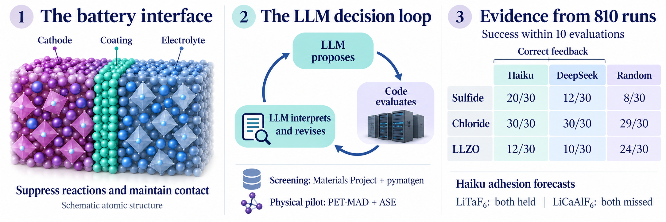
Conceptual illustration; atoms are schematic. Screening success does not establish improved battery performance.
Main results. On sulfide, Haiku succeeds in 20/30 runs with correct feedback versus 2/30 without results and 6/30 with shuffled feedback; both contrasts survive Holm correction. DeepSeek shows the same direction (12/30 versus 2/30 and 3/30), without corrected significance. Chloride reaches 30/30 for every LLM policy and 29/30 for random. On LLZO, DeepSeek’s upfront shortlist reaches 20/30 versus Haiku’s 1/30, but iterative search reaches only 10/30 and 12/30, respectively, versus random’s 24/30. Starting knowledge and useful adaptation are distinct capabilities.
Prospective physical test. A separate Haiku pilot evaluates six interfaces using PET-MAD S 1.6.0, trained on r²SCAN, with ASE/UPET. Using LiNbF₆ as reference, Haiku selects LiTaF₆ and LiCaAlF₆ and forecasts adhesion before calculation. Both LiTaF₆ forecasts hold; both LiCaAlF₆ forecasts miss. The electrolyte is correctly predicted as the weaker contact, with relaxed adhesion of 1.63, 1.58 and 0.74 J/m², respectively. Selection order is unchanged.
Potential for impact. Battery-interface researchers could delegate candidate triage and forecast drafting, then review numerical checks and recorded decisions. This could reduce repetitive screening work and guide expensive follow-up; time savings remain unmeasured.
Innovativeness. Beyond an exhaustive material ranking, we make the selection strategy itself testable, combining controlled feedback experiments with prospective atomistic forecasts to examine when chemical intuition helps or misleads.
Novelty. LLM chemistry tools already exist, including ChemCrow. Our original tooling connects frozen feedback benchmarks with forecasts recorded before physical calculations. Shared tasks, decision traces and offline replay let others compare new policies and investigate failed chemical analogies.
Limits and next steps. Human-level judgment and superior coatings are unproven; model comparisons are descriptive because reasoning compute was unmatched. Polar interfaces remain provisional, the proxy admits questionable LLZO candidates, and transport and cycling are untested. Stronger chemistry baselines and higher-fidelity validation are next.

