LLM Guided Battery Coating Discovery
interphAIse • Project overview • 22 October 2026
Protective coatings are an important strategy for improving solid-state batteries. Direct contact between a cathode and an electrolyte can cause unwanted reactions and decomposition, producing resistive layers that degrade performance. A coating should suppress these processes while conducting lithium ions and maintaining contact with both materials. [1] Predicting its behaviour is difficult: crystal orientation, surface termination, lattice strain and atomic disorder can change interface properties, while accurate quantum-mechanical calculations become expensive for large interface models.
interphAIse investigates whether an LLM can take over part of the scientist's intuition: proposing coating candidates, predicting their behaviour and revising choices from computational feedback. Humans define the objective and validation rules; Haiku 5.5 decides what to test next. We use Materials Project structures and energies, pymatgen-based thermodynamic screening at 4 V, and a band-gap filter for electronic insulation. Selected coatings receive atomistic follow-up using the PET-MAD 1.6 r²SCAN machine-learning interatomic potential, ASE and GPU calculations on Niflheim.
Following an initial 50-structure benchmark, we studied 141 candidate structures across three battery environments in 450 runs. In the sulfide environment, iterative selection found an acceptable coating within ten evaluations in 20/30 runs, compared with 2/30 without numerical feedback, 6/30 with shuffled feedback and 8/30 for random search. In LLZO, random search performed better: 24/30 versus 12/30 for the iterative LLM. The chloride task was near ceiling. These controls show that useful feedback can improve decisions, while chemical priors can also mislead.
The PET-MAD follow-up compared LiNbF₆, LiTaF₆ and LiCaAlF₆, giving weaker-contact adhesion values of approximately 1.63, 1.58 and 0.74 J/m². The LLM correctly forecast both LiTaF₆ values but overestimated both LiCaAlF₆ values; its selection order stayed unchanged. The project demonstrates bounded, testable scientific decision-making, not equivalence to human expertise. The interfaces remain formally polar, the Nb–Ta difference is smaller than documented construction sensitivities, and lithium transport and battery cycling remain untested.
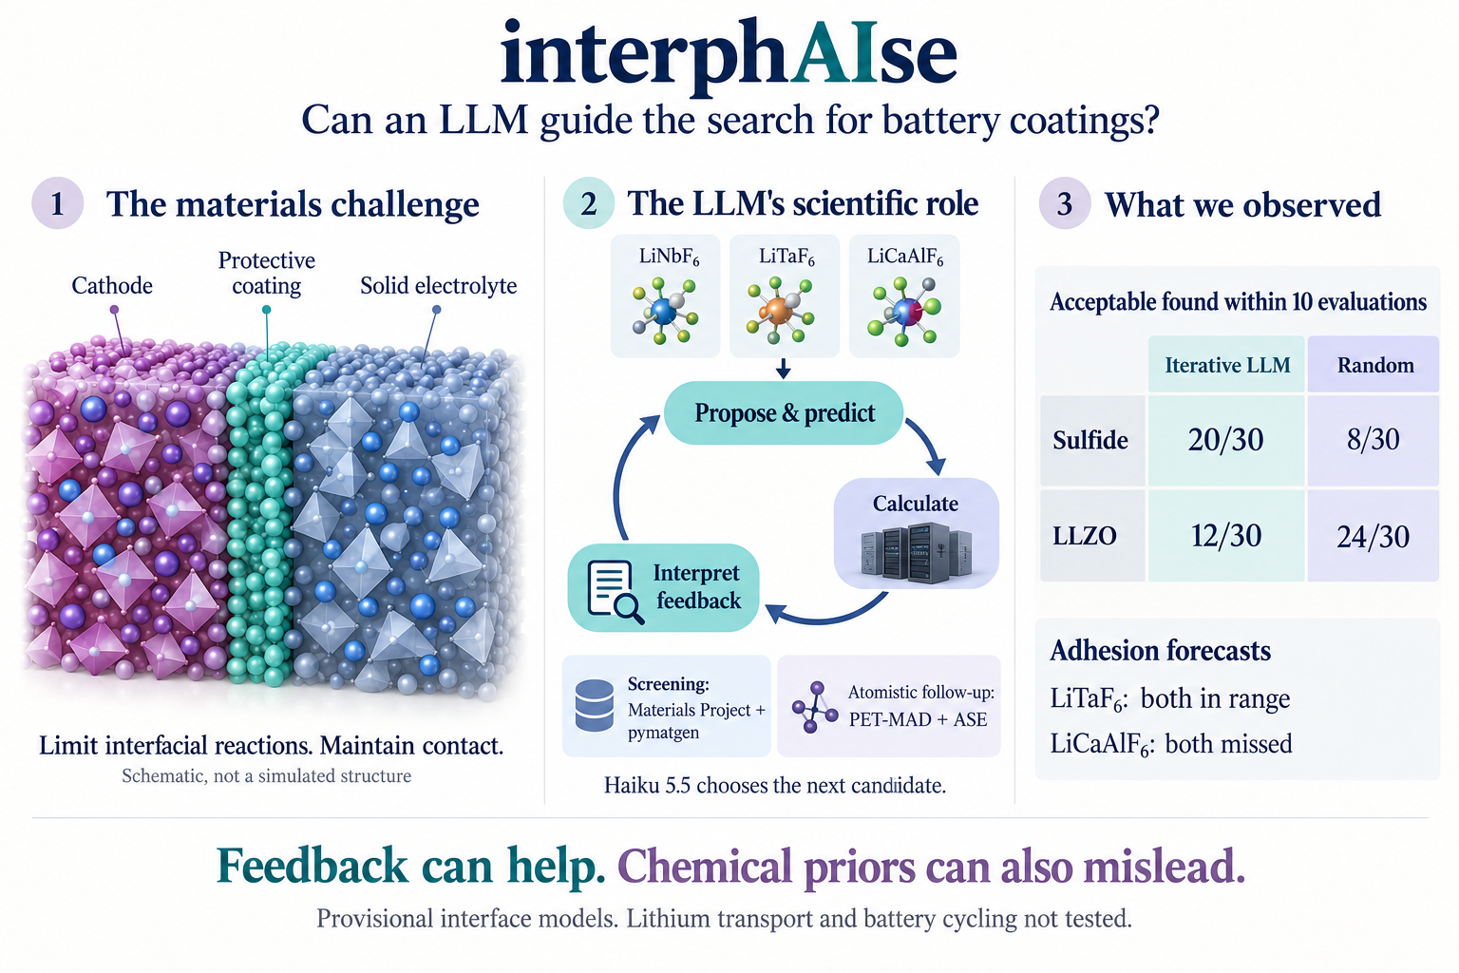
Conceptual illustration. The atomic motifs are schematic, not the computed structures.
[1] Background: Xiao et al., Joule (2019)

