Muscle synergies – Treadmill Walking
Sex-dependent differences during treadmill walking
Group 15 - Valentina Forestiere, Miriam D’Onofrio, Simona Di Biase, Tania-Marie Gomes Da Silva

Abstract — This study investigates the extraction of muscle synergies in male and female subjects to discern potential sex-specific differences in the coordination of muscles during treadmill walking. Electromyographic (EMG) signals from relevant muscle groups are processed using filtering and advanced algorithms to identify and analyze synergistic muscle activation patterns. The findings contribute valuable insights into the nuanced motor control mechanisms underlying walking in males and females.
Keywords — Locomotion, sEMG, Muscle Synergies, NNMF, sex-dependent differences

Introduction
Muscle synergy can be defined as the coordinated recruitment of a group of muscles with specific activation balances or specific activation waveform [1]. While diverse research and clinical methodologies exist for assessing muscle synergies, motorized treadmills have emerged as the prevailing and simplified approach. These devices enable the examination of human locomotion, facilitating the differentiation between walking and running locomotor modes. In recent years, multiple studies have emphasized on the behavioral changes between these two actions, particularly on the patterns of neuromuscular activation in working muscles and EMG activation patterns of the lower limb [2, 3]. However, little information has been collected regarding the potential differences between male and female subjects during clinical tests.
Indeed, the exploration of sex-dependent differences in treadmill walking and their repercussions on muscle synergies constitute an ongoing area of interest. Sex-specific characteristics are often eluded from precise quantification during the dynamic process of walking. Nevertheless, prior research has reported that females exhibited a greater hip flexion and lower knee extension at touchdown compared to their male counterparts, resulting in heightened mechanical joint power during the propulsive phase [4]. Indeed, distinctions in hip, knee and ankle-joint kinematics, body height-dependent preferred speed as well as step frequency have been previously identified [5].
Yet, few studies have analyzed the way in which females and males activate muscles to produce locomotion. Existing studies on this subject have presented conflicting outcomes: some stated that sex had no influence on the way muscles were activated during either walking or running, while others have demonstrated that females had a higher and earlier muscle activation than males. However, these investigations often fall short by neglecting a great number of muscles, most of them only taking a range from one to eight muscles. Therefore, the analysis of the coordination between muscle groups during gait cycles is limited.
The aim of this study is the analysis of sex-dependent differences between males and females during treadmill walking, considering 13 ipsilateral muscles: gluteus Medius (ME), gluteus Maximus (MA), Tensor Fasciae Latae (FL), Rectus Femoris (RF), Vastus Medialis (VM), Vastus Lateralis (VL), SemiTendinosus (ST), Biceps Femoris (BF), Tibialis Anterior (TA), Peroneus Longus (PL), Gastrocnemius Medialis (GM), Gastrocnemius Lateralis (GL) and Soleus (SOL).

Materials and Methods

Participants
All participants were healthy and regularly active young adults (height 173 ± 10 cm, body mass 68 ± 12 kg, age 28 ± 5 years). Out of these 30 participants, 15 were women and 15 were men. None of them was using orthotic insoles, had any history of neuromuscular or musculoskeletal disorders, or any head or spine injury at the time of the measurements or in the previous 6 months. Before beginning the experimental protocol, all subjects completed a self-selected warm-up running on a treadmill, lasting from 3 to 5 minutes.

Experimental Protocol
Subjects were asked to walk at 1.4 m/s and run at 2.8 m/s on a single-belt treadmill (mercury, H-p-cosmos Sports & Medical GmbH, Nussdorf, Germany) equipped with a pressure plate recording the plantar pressure distribution at 120 Hz (FDM- THM-S, zebris Medical GmbH, Isny im Allgäu, Germany). The chosen speeds were defined following the average comfortable locomotion speeds reported in the scientific literature.

Data Acquisition
Muscle activity from 13 ipsilateral (right side) muscles was monitored in this study, including gluteus Medius (ME), gluteus Maximus (MA), Tensor Fasciae Latae (FL), Rectus Femoris (RF), Vastus Medialis (VM), Vastus Lateralis (VL), SemiTendinosus (ST), Biceps Femoris (BF), Tibialis Anterior (TA), Peroneus Longus (PL), Gastrocnemius Medialis (GM), Gastrocnemius Lateralis (GL) and Soleus (SOL). Electrodes were positioned on the muscles [6, 7].
After the warm-up, participants underwent a minimum of 60 seconds of habituation for treadmill recordings. Each locomotion type and participant were recorded for approximately 60 seconds using a 16-channel wireless bipolar EMG system (Wave Plus wireless EMG with PicoEMG transmitters including 3D accelerometers, Cometa srl, Bareggio, Italy) with a 2kHz acquisition frequency. Foam-hydrogel electrodes with snap connectors (H124SG, Medtronic plc, Dublin, Ireland) were used for the recordings.
For each participant, one treadmill walking and one treadmill running trial were collected. The gait cycle breakdown, involving foot touchdown and lift-off timing, was determined by processing plantar pressure distribution data from the treadmill’s integrated plate. Treadmill recordings were segmented by applying a previously published algorithm [8] to the plantar pressure distribution data, recorded through the plate integrated in the treadmill.
Anonymous information about the participants were collected and integrated in the metadata, which contained: code (participant number), sex, age, height and mass. There was additional data at disposal, including the breakdown of the gait cycle and the raw surface electromyography (sEMG) signals, in a file named “CYCLE_TIMES.mat”. The former was defined as a structured dataset with 60 fields, each corresponding to a trial and subject. Each field was organized as a N × 2, where N represented the number of gait cycles recorded per trial. In this configuration, the first column contained the touchdown incremental times in seconds while the second column contained the duration of each stance phase in seconds.
Concurrently, the second dataset present in the file “RAW_EMG.mat”, was also structured with 60 fields, each for one trial and subject. The fields took the shape of an N × M matrix, with N indicating the number of sEMG samples acquired during each trial and M the number of columns. The first column of this matrix was the incremental time in seconds. The remaining 13 columns featured the raw EMG data extracted from the ME, MA, FL, RF, VM, VL, ST, BF, TA, PL, GM, GL, and SOL muscles, respectively.

Data Processing and Envelope Extraction
Data processing was performed using MATLAB (Matworks Inc, Novi, USA). Since the aim of this work is to find sex-dependent differences during walking on a treadmill, the analysis was carried out on the part of the dataset made of treadmill walking trials.
First, the data were reorganized in two structures, one containing the information for the females and the other for the males. Each structure was formed by 15 substructures, one for each subject, and was used to contain the signals extracted and processed for the specific subject. Afterwards, the raw signals underwent a series of processing steps. Due to a different number of samples for each subject’s EMG signal, the gait cycles were time-normalized to 1000 samples and the first 49 gait cycles of each trial were extracted. Then, they were band-pass filtered between 35 Hz and 400 Hz through a 9th order Butterworth digital filter in order to remove low-frequency motion artifacts and noise outside the EMG bandwidth.
To enhance the mitigation of motion artifacts, an amplitude-based algorithm was devised to refine the electromyographic (sEMG) signals. A threshold was established for each muscle, determined by the 99.96th percentile of its sEMG signal distribution. Subsequently, each peak amplitude within a given cycle was evaluated against this threshold, and if found to exceed it, the entire corresponding cycle was systematically excluded and replaced with the subsequent cycle in the signal sequence.
The determination of the optimal threshold at the 99.96th percentile was attained through an iterative process involving the evaluation of various percentiles. This systematic exploration encompassed multiple iterations until a percentile value was identified that ensured the retention of a minimum of 30 gait cycles in the analysis. To consider instances where both high and low amplitude motion artifacts coexisted within the same signal, if the peak amplitude of a cycle surpassed the previous threshold by a factor of 3, a recalibration of the threshold was undertaken. This recalibration involves establishing a lower threshold, derived from the 99.93rd percentile of the entirety of the muscle signal distribution. The effect of data processing is shown in a practical example in Fig. 1. Lastly the algorithm ensures that the number of gait cycles for each muscle is 30.
Subsequently to signal processing, they were high-pass filtered at 35 Hz with an 11th order Butterworth digital filter to further ensure the attenuation of low frequency noise components. The resultant signals underwent rectification and demeaning. To derive the envelope, a low-pass Butterworth filter of 5th order with a cutoff frequency set at 8 Hz was applied. Further normalization was executed by scaling the amplitude of each muscle signal to the unit interval [0, 1]. The envelope extraction steps are shown in Fig. 2.
Data processing

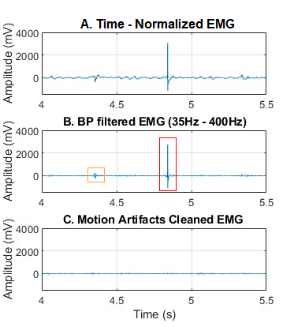

Fig. 1. Processing of Gluteus Maximum’s EMG signal of female subjects n. 30. A. Time - normalized signal, every cycle is 1000 samples, so 0.5 s. B. Band-Pass filtered signal (20-400 Hz). In red a high amplitude motion artifact, in yellow a low amplitude motion artifact, removed by lowering the threshold at 99.93 percentile as described in the upper paragraph. C. Signal free from motion artifacts.
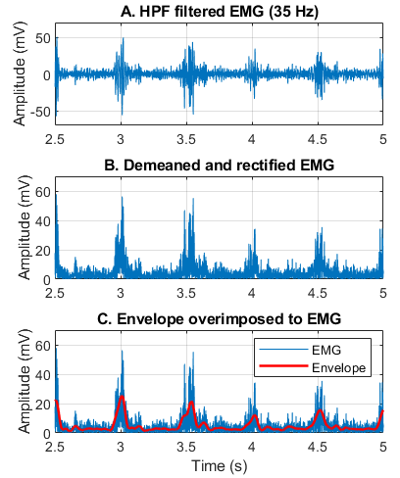
Envelope extraction
Fig. 2. Envelope extraction of Gluteus Maximum’s EMG signal of female subject n. 13. A. EMG after HP filtering at 35 Hz. B. Signal after removing the mean and taking the absolute value. C. Envelope in red, superimposed to the rectified EMG, obtained by applying a LP filter with 8 Hz as cut-off frequency.

Extraction of Muscle Synergies
Muscle synergies were extracted from the EMG envelopes using non-negative matrix factorization (NNMF) with the help of a custom library “myMuscleSynergyLibrary”. Muscle activation patterns ($M$) can be reconstructed by multiplying the muscle synergy weights ($W$) and synergy excitation primitives ($H$) such as follows:
$M= W*H+e$ | (1)
where $M$ is a m × t matrix representing the muscle activation patterns of m muscles at t time points, $W$ is a m × n matrix containing time independent muscle weightings with n being the number of muscle synergies, $H$ is a n × t matrix of time varying synergy excitation primitives and $e$ is a m × t matrix representing the reconstruction error of each muscle’s activation pattern at each time point [9].
The NNMF algorithm minimizes the residual between the initial matrix and its decomposition. In our case, it necessitated the specification of parameters such as the minimum (“minSyn”) and maximum (“maxSyn”) number of synergies to be extracted. These parameters served as key inputs in determining the dimensionality of the synergy space, ranging from 1 to 13.
The gait cycles were distributed in three subgroups, delineated by cycles 1-10, 11-20 and 21-30. This grouping would facilitate the exploration of temporal variations in muscle synergies during different phases of gait. An iterative application of the NNMF algorithm was performed for each subgroup considering female and male cohorts.

Choosing the Optimal Number of Synergies
The optimal number of muscle synergies was determined based on Variance Accounted For (VAF), which is widely used for the reconstruction accuracy after the factorization. It is defined as the uncentered Pearson’s correlation (in percentage) [10] :

VAF $=\left(1- \frac{\sum_{i=1}^{m}{}{(M_{i}- R_{i})}^{2}}{\sum_{i=1}^{m}{}M_{i}^{2}}\right) × 100$ | (2)

where M is the matrix before factorization, R the reconstructed matrix obtained as the product between W and H, and m is the number of muscles.
The optimal number of synergies for each subgroup was systematically determined by progressively exploring an increasing number of synergies. This iterative process continued until a VAF (Variance Accounted For) threshold of 90% was reached. Concurrently, an additional condition was imposed to ensure that the VAF_muscle (Variance Accounted For by individual muscles) for each individual muscle remained at a minimum of 75%.
For subsequent analysis, the median of the chosen numbers of synergies was selected, yielding a consistent count of 4 ± 0.69 synergies for the female cohort and 4 ± 0.78 for the male cohort, as shown in Fig. 3. Consequently, for each subgroup, the muscle synergies were analyzed using the specified synergy number, which is 4.
Median number of synergies

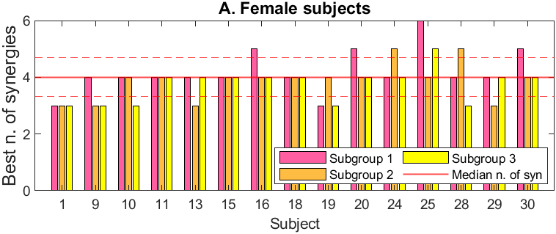
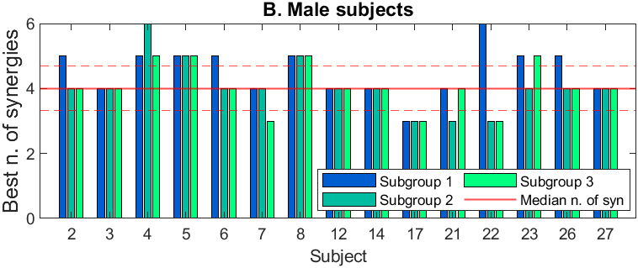
Fig. 3. Best number of synergies for each subgroup of each subject. For both cohorts the median n. of synergies is 4, lined in red, represented with standard deviation range. A. Female subjects. B. Male subjects.

Sorting of Muscle Synergies
The muscle synergies were reordered based on the similarity of weight vectors and with a reference subject, here defined as the female subject n.10 for both females and males. The similarity coefficient was computed as the value of the normalized cross-correlation at zero-lag between the reference subject and the compared subjects.

CC $= \frac{Rxy[0]}{\sqrt{(Rxx[0]Ryy[0}])}$ | (3)

This sorting was applied to both the weight vectors and the activation coefficients which were then stored in the structures, to plot the sorted muscle synergies.

Outlier detection and averaging
An algorithm was implemented to discern and eliminate outlier subjects manifesting subject-specific activations. This process involved a comparative analysis of muscle synergies against a reference subject. Signal averaging was performed across the three subgroups. Subsequently, the median subject was identified for both males and females and used as reference. Each subject's muscle weights and activations were individually compared to those of the reference through the computation of cross-correlation (3) similarity for each sorted synergy. Subjects exhibiting a coefficient below 0.70 for at least one synergy were classified as outliers and excluded from subsequent analyses. An example of similarity computation between synergies is shown in Fig.4.
The removed subjects were n.11, n.18 for female subjects and n.10 and n.13 for the male subjects. After the removal of the outliers, an average was performed on the remaining subjects, separately for the male and female groups. The mean was performed both for the muscle weight vectors and the muscle activations, with the aim of obtaining the features of a standard individual for both genders.
  - Statistical Testing

To assess the existence of statistically significant disparities between male and female populations, a rigorous statistical examination was conducted.

The comparison of muscle weights between the female and male population involved the utilization of the Wilcoxon test. The Wilcoxon rank-sum test is commonly used for the comparison of two groups of nonparametric (interval or not normally distributed) data, such as those which are not measured exactly but rather as falling within certain limits [11]. The test application was facilitated by the MATLAB function 'ranksum.' This function provides a p-value for a two-sided Wilcoxon rank sum-test, evaluating the null hypothesis that the data in question are drawn from distributions with equivalent medians, as opposed to the alternative hypothesis that they are not. It is crucial to note that this test assumes the independence of the two samples. A significance level of 5% was employed for the analysis, representing the threshold for rejecting the null hypothesis in favor of asserting significant differences between the male and female populations.

The assessment of dissimilarities between muscle activation signals from different cohorts was conducted through the application of the cross-correlation similarity coefficient (3). This coefficient quantifies the similarity between the average female and male muscle activations, providing a measure of the degree of correlation between the two datasets.

Outlier identification – Similarity coefficient

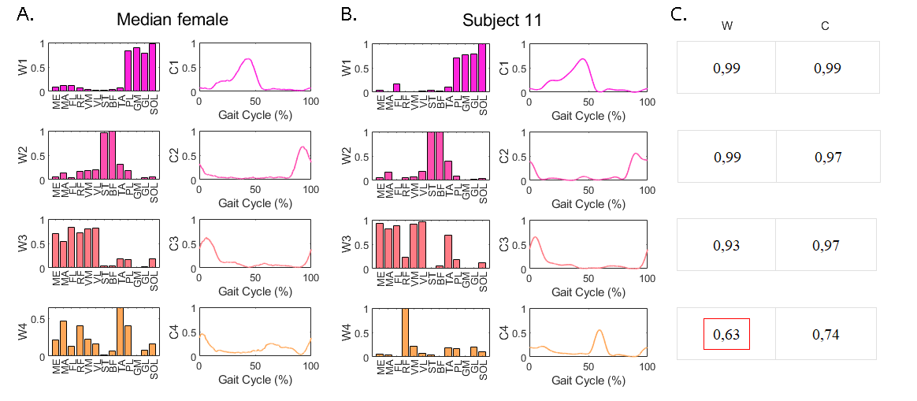
Fig. 4 Example of similarity coefficient between weight vectors (W) and muscle activations (C). A. Muscle synergies of median female subject. B. Muscle synergies of Subject 11, which was labeled as an outlier and removed before averaging. C. Value of similarity coefficient computed through cross-correlation for each synergy. In red is highlighted the similarity coefficient for weight vectors between the 4th synergy of Median and 11th subject. Since it is lower than the 0.70 threshold, it suggests a subject specific synergy.

Results
Following the execution of statistical and similarity testing, the average muscle weights and activations were graphically represented for both male and female cohorts, with superimposed error bars and standard error range, as shown in Fig. 5. As delineated in the previous chapter, Wilcoxon's rank-sum test was employed to discern the existence of statistically significant distinctions between the two groups. The resulting p-values derived from the application of the test exhibited a range from a minimum of 0.0011 to a maximum of 1. In five instances, the p-value fell below the predetermined threshold of 5%, indicative of a statistically significant difference between the male and female groups. Specifically, the associated p-values were as follows: 0.0048 for the MA in the first synergy, 0.0095 for the ST and 0.0011 for the BF in the second synergy, 0.0279 for the PL in the third synergy, and 0.0114 for the GM in the fourth synergy. These outcomes underscored the presence of statistically meaningful differences in muscle weights between the two groups. As shown in Fig. 5, statistically significant differences were highlighted with one or more asterisks, the quantity of which was determined by the corresponding p-value. The applied criterion dictates that a p-value below 0.05 is represented by one star on the graph, a p-value below 0.01 is indicated by two stars, and a p-value below 0.001 is annotated with three stars. Regarding muscle activations, a cross-correlation based comparison was conducted, revealing similarity coefficients of 0.995, 0.997, 0.993, and 0.979 for the four synergies, respectively. A visual inspection of the graphs confirmed a high correlation in the activation signals.

Discussion
Based on the obtained results, it can be asserted that the signals exhibit a high degree of correlation, and the weights demonstrate considerable similarity. Nevertheless, visible differences emerge in the activation patterns of specific muscles among female and male subjects. Particularly, the statistical analysis enlightened a greater activation of gluteus maximus (MA), biceps femoris (BF) and peroneus longus (PL) for females rather than males and a stronger activation of semitendinosus (ST) and gastrocnemius medialis (GM) for males rather than females. This suggests that women exhibit a higher propensity to activate three muscles that are crucial for ensuring stability, while men trigger muscles that are involved in flexion-extension movements. The difference in muscle activation between males and females may be attributed to a range of factors encompassing anatomical, physiological, and biomechanical aspects. For instance, alterations in pelvic structure and joint angles could influence the engagement of these muscles during walking. Furthermore, hormonal distinctions, such as elevated estrogen levels in females and testosterone levels in males, may affect muscular responses.

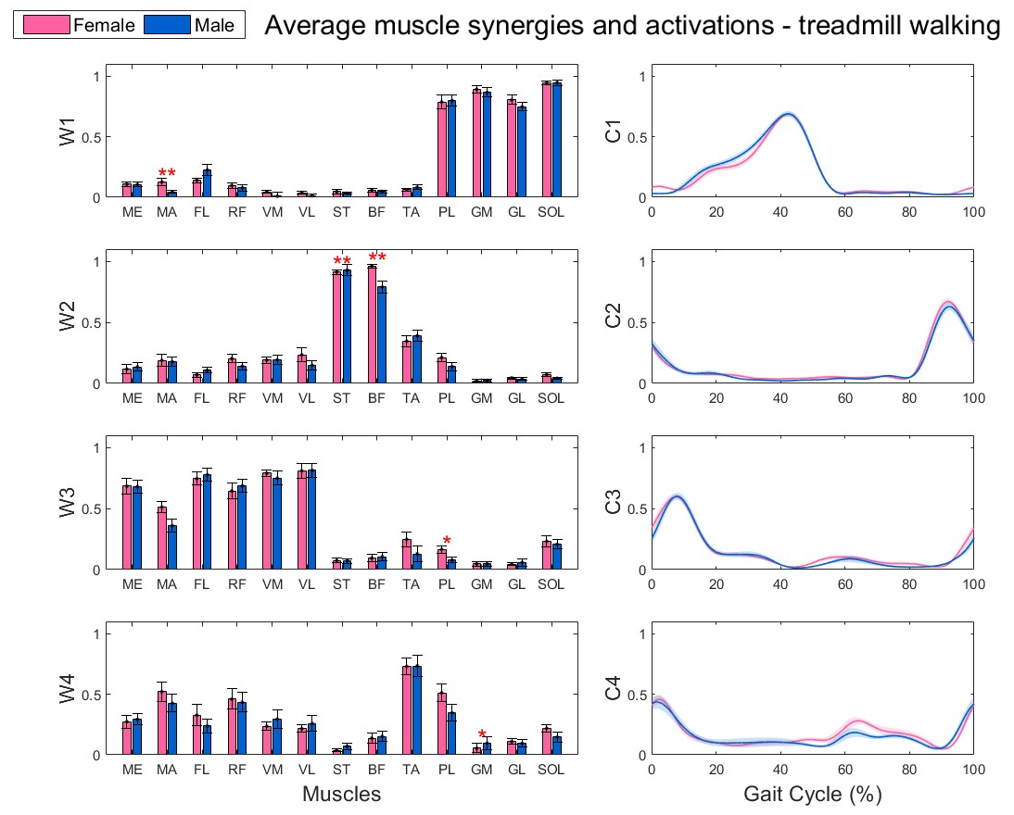
Despite the presence of certain statistically significant differences between the male and female cohorts, the majority of weight vectors and activation patterns remained unchanged between the two groups. Consequently, it can be inferred that the results exhibited no statistically meaningful sex-dependent differences.
Fig. 5. Muscle weight vectors (W) and activations (C) of the four muscle synergies for the average male subject, in blue, and female subject, in pink. The single red asterisk indicates a p-value lower than 0.005, while the double red asterisk shows a p-value smaller than 0.001. The muscle MA (Gluteus Maximus) in the first synergy, the ST (Semi Tendinous) and the Biceps Femoris (BF) present a big significant statistical difference (**) between the male and female cohorts. The PL (Peroneus Longus) in the third synergy, and the GM (Gastrocnemius Medialis) in the fourth synergy present statistical difference (*) between the male and female population.

References
- A. d’Avella, Muscle Synergies. In: Binder, M.D., Hirokawa, N., Windhorst, U. (eds) Encyclopedia of Neuroscience. Springer, Berlin, Heidelberg, 2009, pp 2509–2512 [Article]
- A. Saito, A. Tomita, R. Ando, K. Watanabe, H. Akima, Similarity of muscle synergies extracted from the lower limb including the deep muscles between level and uphill treadmill walking. Gait Posture. 2018 Jan;59:134-139 [Article] [PubMed]
- MM. Bach, A. Daffertshofer, N. Dominici, Muscle Synergies in Children Walking and Running on Treadmill. Front Hum Neurosci. 2021 May 10;15:637157 [Article] [PubMed]
- A. Santuz, L. Janshen, L. Brüll, V. Munoz-Martel, J. Taborri, S. Rossi, A. Arampatzis. Sex-specific tuning of modular muscle activation patterns for locomotion in young and older adults. PLoS One. 2022 Jun 3;17(6):e0269417. [Article] [PubMed]
- F. Moissenet, F. Leboeuf, S. Armand. Lower limb sagittal gait kinematics can be predicted based on walking speed, gender, age and BMI. Sci Rep 9, 9510 (2019) [Article] [PubMed]
- A. Santuz, A. Ekizos, L. Janshen, F. Mersmann, S. Bohm, V. Baltzopoulos, A. Arampatzis. Modular Control of Human Movement During Running: An Open Access Data Set. Front Physiol. 2018 Oct 29;9:1509 [Article] [PubMed]
- A. Santuz, T. Akay, W. Mayer, T. Wells, A. Schroll, A. Arampatzis. Modular organization of murine locomotor pattern in the presence and absence of sensory feedback from muscle spindles. The Journal of Physiology. (2019): 597.3147-3165. [Article]
- A. Santuz, Alessandro, A. Ekizos, and A. Arampatzis. A pressure plate-based method for the automatic assessment of foot strike patterns during running." Annals of biomedical engineering 44.5 (2016): 1646-1655 [Article] [PubMed]
- M. Rabbi, C. Pizzolato, D. Lloyd, C. Carty, D. Devaprakash, L. Diamond. Non-negative matrix factorisation is the most appropriate method for extraction of muscle synergies in walking and running. Scientific Reports.(2020) [Article]
- R. Ballarini, M. Ghislieri, M; Knaflitz, V. Agostini. An Algorithm for Choosing the Optimal Number of Muscle Synergies during Walking. Sensors (Basel). 2021 May 11;21(10):3311. [Article] [PubMed]
- S.C. Gad, in Comprehensive Toxicology (2010) [Extract] [Book]

