**CPU**: AMD Ryzen 5 3600X 6-Core Processor, 3,80 GHz

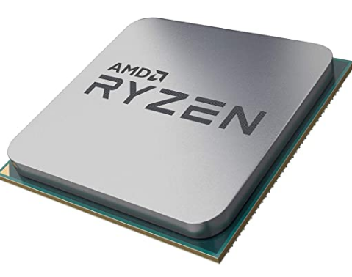

RAM: 32 GB (2x16GB) - 3000 MHz

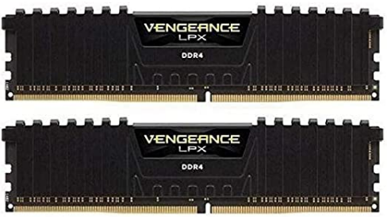

**HDD**: 1 TB (932 GB)

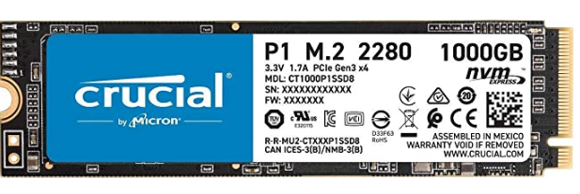

**GPU**: NVIDIA GeForce RTX 2070 SUPER 8GB

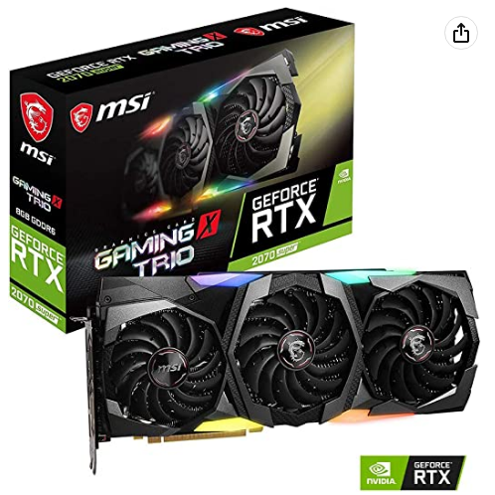

**SCHEDA MADRE**: MSI X570 MPG – Clock 4400 MHz

