Smart shopping assistant – Project Documentation

Paun David-Andrei

Table of contents:

- Short project description
- How it works
  - Use case and state diagrams
  - Internal implementation
    - Architecture overview
    - Authentication Flow
    - Search Pipeline
    - Semantic Cache
    - Multi-Layer Structured Data Extraction
    - Network Performance Under Load
    - Residential proxies
    - Frontend Architecture and User Interface
    - Database Schema
- Comparison with other similar projects (what makes it state of the art)

- Short project description

SmartShop is a full-stack AI-powered shopping assistant. Users describe what they want to buy in natural language; the system finds, scores, and ranks the three best products from live e-commerce pages. The architecture is designed as a zero-ledger, zero-PCI-DSS SaaS: the AI handles discovery, the user provides the card only at checkout, and card data never touches the database.

- How it works

In this project I am going to present what is the objective of this project using some diagrams, then we are going to go into detail about the internal implementation.

  - Use case and state diagrams

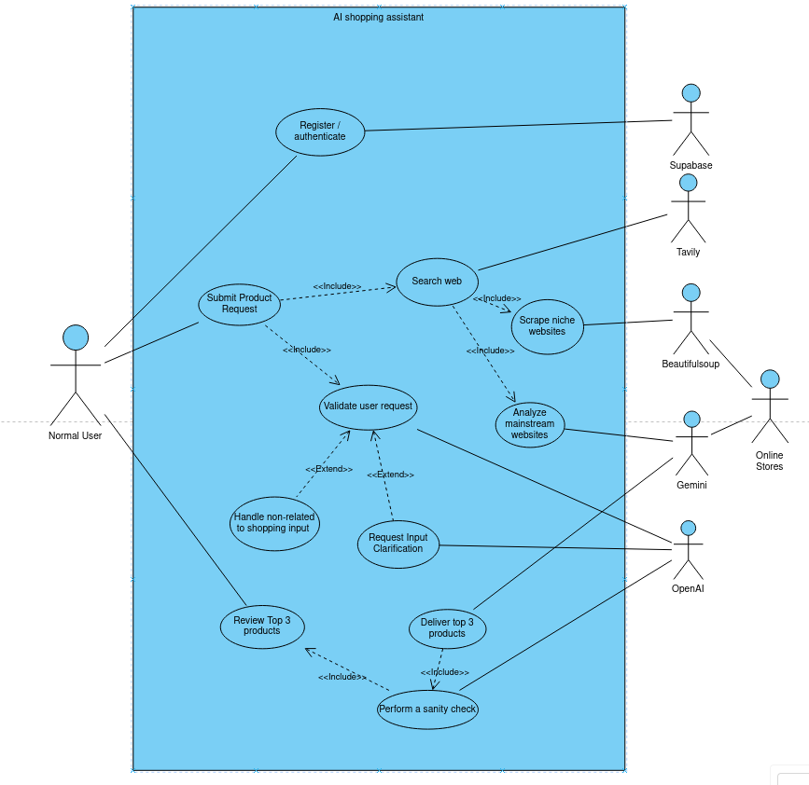

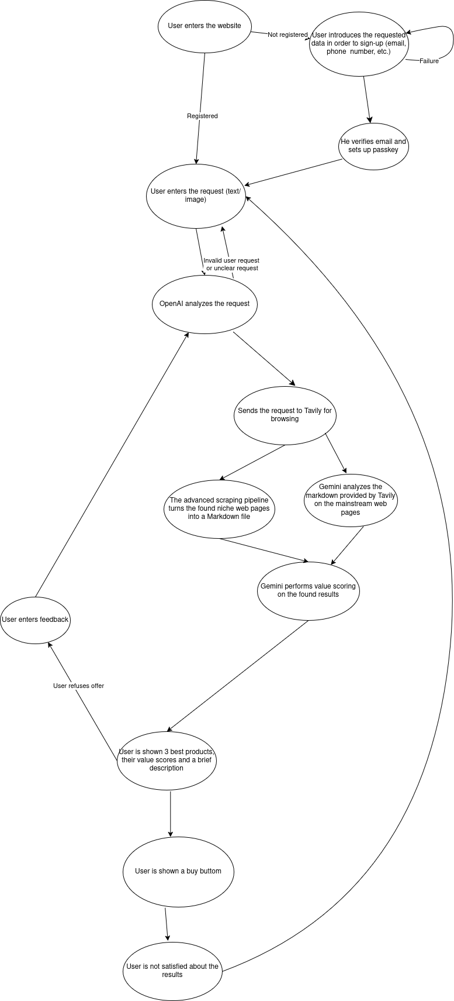

2.2 Internal implementation
2.2.1 Architecture overview

The tech stack of the project is the following:
- Frontend - Next.js 15 (App Router), TailwindCSS, TypeScript
- Backend - FastAPI (Python 3.14), Uvicorn
- Database - Supabase (PostgreSQL + pgvector)
- AI - Intent & Scoring - Gemini 2.5 Flash, openAI mini 4o
- AI - Embeddings - Gemini Embedding 001
- Web Search - Tavily (advanced search depth, optional domain filtering)
- Web Scraping - curl_cffi (browser fingerprinting) + BeautifulSoup ( content extraction)
extraction)
- Authentication - WebAuthn / Passkeys / QR code scan + OTP email via Supabase

Here is an illustration of the internal architecture:

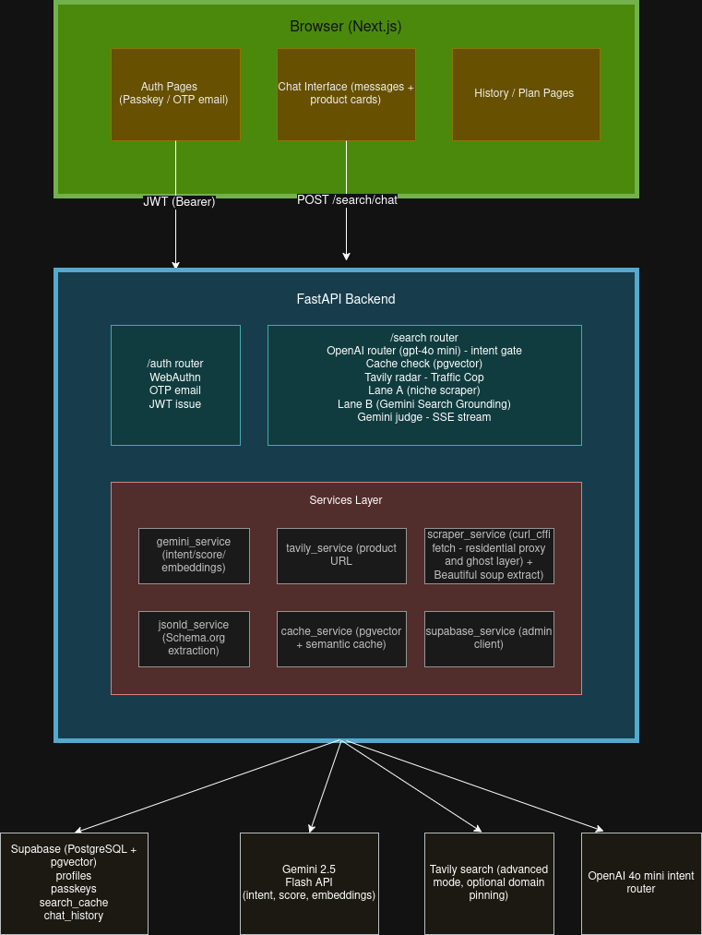

SmartShop uses a two-phase registration: email ownership is verified first (OTP), then a biometric passkey is enrolled. Login is entirely passwordless.

2.2.2 Authentication flow
It is performed in 5 steps as follows:
- Tell us about yourself: User starts by entering his email, phone number, and shipping address so the website knows where to send his orders.
- User checks his email: To make sure it’s really him, the website immediately sends a confirmation link to his inbox. The shipping details are safely paused in the background
- Click the confirmation link: User clicks the provided link. Once confirmed, his account is officially created!
- Set up easy login (No passwords needed!): Instead of forcing the user to create and remember a complex password, his phone or computer will ask him to use Face ID, Touch ID, or his own device PIN.
- The user is all set: His device creates a highly secure digital key (called a Passkey) that is safely linked to his account. He is now securely logged in and ready to shop

2.2.3 Search pipeline
Every user search request for a product passes through a five-stage pipeline. Each stage is independently failable with graceful degradation.
- INTENT CLASSIFICATION - Gemini - takes about 0.3 s
  - OpenAI reads the full conversation history and outputs a JSON object containing:
  - intent: CHAT | CLARIFY | SEARCH
  - localized_search_query - e.g. "rucsac laptop" (if the prompt is not in English, it uses local e-commerce terminology based on the details the user introduced when he logged in (country + city) )
  - local_domains - 3-5 regional e-commerce sites
  - is_refinement - true when user wants to find a cheaper alternative or he changed his preferences
  - search_globally - true for explicit global requests
  - is_mainstream – true if a product can be found on mainstream websites
  - collected_params - category, budget, preference
If it’s a search intent only, the algorithm goes to:
- Semantic cache check (pgvector)
  - Generates a 768-dim embedding of the search query.
  - Query pgvector with cosine similarity ≥ 0.92.
  - Cache hit → return immediately (from_cache=true)
  - Cache is BYPASSED when:
    - excluded_urls non-empty (user rejected items) or
    - is_refinement=true (budget/pref changed)
If it’s a cache miss, the algorithm goes to:
- Research Agent
Gemini looks on community recommendations, surface expert picks. It fetches some URL’s that Tavily might miss. Those URL’s are appended to the list of URL’s found by Tavily.
- Tavily Product Discovery
  - A tavily query is of the form {localized_search_query + " buy"}
  - the “buy” keyword is added such that tavily is listing pages rather than manufacturer brand sites
  - The algorithm uses the next approach:
    - Niche local
    - Mainstream local
    - Niche global
    - Mainstream global
The domain filter ("The Bouncer") acts as a hard gate. If a URL comes back from Tavily and its domain is not on on approved list of supported retailers, it is instantly discarded ("hard-dropped") before the system wastes any time, memory, or network calls trying to process it.
- Traffic cop and 2 lane browsing
  - The app is configured that mainstream URL links are processed exclusively by Gemini, eliminating the need for headless browsers like Playwright or Stagehand to fetch information, this is the lane B.
  - The niche URL’s go into the scraping pipeline, which extracts all the information necessary for value scoring, this is the standard lane, A.
  - Both lanes run in parallel. Results are merged. The output is top 10 URL’s for Gemini judge.

- Gemini Value Scoring
- Instead of asking the AI to review 10 products one by one (which is slow and expensive), the system bundles them all into a single request.
- The AI checks if the item is actually in stock. It does this by reading the hidden machine code on the website (JSON-LD) or by looking for the literal words "Add to Cart" or "Buy Now" on the page.
- The AI instantly throws out any product that is more than 20% over the user's maximum budget.
- AI models are notoriously bad at basic math. To fix this, the system lets the AI grade the products, but then standard Python code does the actual addition to ensure the final score is 100% accurate.
- Sometimes AI makes up fake web links. The system automatically deletes any link the AI invented that wasn't in the original list.
- If the Google Gemini API goes down and cannot score the products, the system has a backup plan: it just gives the user the cheapest options it found so the app doesn't crash.
- The final answer is saved to a database for 6 hours (Time To Live). If another user asks the exact same question 5 minutes later, the system just gives them the saved answer instantly instead of doing all the work again.
- Saving data to a database takes a fraction of a second. Instead of making the user wait for that to finish, the system shows the user their results immediately and saves the data in the background.
- Before delivering the results to the client, Gemini sendss a structured JSON to openAI for a quick sanity check. This sanity check is performed to check for hallucinated results.

2.2.4 Core Engine Operations: AI Scoring & Semantic Caching

1. Automated Evaluation Architecture
Every candidate product undergoes a multi-dimensional triage process within a single inference call. The evaluation scores the item across four distinct dimensions, which are subsequently aggregated into a unified value_score ($0-100$). This metric reflects the absolute value proposition of the product rather than a simple price sort.
Dimension | Weight | Measurement Metric
cost_efficiency | 40% | Algorithmic yield relative to the target budget. Remaining significantly under budget acts as a positive weight factor.
quality_confidence | 35% | Quantifiable trust signals including aggregate star ratings, review volume, technical specification density, and quality certifications.
logistics | 15% | Shipping fees, estimated transit times, and delivery feasibility to the target geo-location.
trust | 10% | Merchant reputation matrices and the structural flexibility of the return policy.

Baseline Score Anchors
- 40 (Unknown): Assigned when data is completely absent from the source page. This serves as a neutral baseline rather than a penalty penalty.
- 0 (Failure Rule): Applied when negative data flags are confirmed (e.g., confirmed out-of-stock, vendor anomalies, or price ceiling breaches).
- 100 (Peak Validation): Reserved for ideal data validation indicators (>=4.5 stars, substantial review counts, and active localized same-day delivery windows).

Mathematical Execution
To eliminate LLM arithmetic variations, dimension grading is decoupled from mathematical aggregation. The model outputs the individual dimensional arrays, and the production environment computes the final ranking deterministically:
value_score = (cost_efficiency * 0.40) + (quality_confidence * 0.35) + (logistics * 0.15) + (trust * 0.10)

2. The Purchasability Filter
Prior to the multi-dimensional scoring array execution, all content must pass a strict structural gate to filter out non-transactional material (e.g., manufacturer spec sheets, dead listings, or blogs). The system requires at least one verified signal tier:
- Tier 1 (Machine-Verified JSON-LD): The structured metadata block explicitly includes CONFIRMED AVAILABILITY: In Stock. When present, this metadata bypasses any requirement for button-text parsing.
- Tier 2 (String Literal Ingestion): The raw page layout must contain a functional action phrase matching standard transactional targets across localized boundaries (e.g., "Add to cart", "Adaugă în coș", "Cumpără", "In den Warenkorb").

3. Semantic Cache Control
To mitigate computational overhead and latency, highly similar query strings execute directly against a pgvector caching layer with a strict 6-hour Time-To-Live (TTL).

Cache Validation Thresholds
A cache hit is successfully registered only when all four conditions are met:
- Vector Proximity: The semantic embedding similarity between the incoming string and the cache index is >= 92.
- Category Isolation: The identified target product category matches exactly.
- Budget Alignment: The cached budget ceiling matches or sits within the boundaries of the active user parameters.
- Temporal Window: The database entry age does not exceed the 6-hour TTL ceiling.

Bypassing Mechanisms
The caching engine is explicitly invalidated and forced to execute a live crawl if:
- An explicit negative feedback loop is captured (e.g., interaction with the dissatisfaction control interface).
- A shifting intent vector is identified in successive inputs (e.g., refinement queries demanding lower absolute pricing tiers or modified product feature sets).
The following interactive tool allows developers to simulate how different grading profiles affect the final deterministic value_score computation, confirming how individual dimension anchors adjust the aggregate metric.

2.2.4 Multi-Layer Structured Data Extraction
The structural architecture uses a dual-layer strategy to normalize unstructured e-commerce web layouts into deterministic metadata headers before the main inference execution occurs.

- Layer 1 (extract_jsonld_facts):
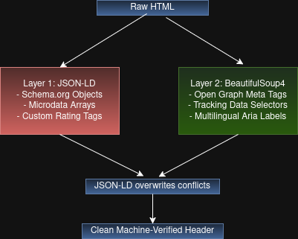
- Targets programmatic scripts (application/ld+json) and embedded microdata arrays. It serves as the authoritative tier for core pricing parameters, standard structural currency variables, and standardized availability links (schema.org/InStock).
- Layer 2 (extract_bs4_facts): Operates as a fallback array targeting open graph elements (og:price:amount), retailer identity tags (og:site_name), tracking scripts, and multi-language structural regular expressions parsing accessibility strings (e.g., matching string variations like "4.7 out of 5 stars" and "4.7 din 5 stele" simultaneously).
Both functions utilize localized in-memory optimization pools (@functools.lru_cache) to avoid processing overhead when identical product endpoints are simultaneously queried by separate client routines.

Logistics Resolution Strategy
Shipping fees and delivery criteria are parsed via a dual-path pipeline consisting of a deterministic local lookup or an autonomous multi-hop crawling loop.
- Deterministic Ingestion Matrix (logistics_data.py): Established domain records map base shipping costs, clear structural free-shipping ceilings, and locker fulfillment flags (e.g., easybox tracking) directly into the processing pipeline via absolute parameters.
- Autonomous Two-Hop Inversion Routine: Non-registered domains automatically route to a multi-hop parsing sequence:
  - Hop 1 (Policy Target Mapping): Structural text queries scan localized anchor links within footer segments for shipping keywords across regional language matrices (livrare, versand, delivery).
  - Hop 2 (Micro-Agent Extraction): A targeted inference pass converts structural shipping parameters and currency representations into localized numeric representations (e.g., normalising foreign currency parameters against fixed scaling baselines such as 1 EUR ≈ 5 RON).

2.2.6 Network Performance Under Load: Concurrency and Caching Architecture

Bloom Filter Memory Compression
The system must track previously scraped product pages to prevent redundant network requests. Storing 100,000 full URL strings requires approximately 5–10 MB of RAM. A Bloom filter compresses this tracking state into roughly 120 KB by recording a compact mathematical fingerprint of each URL.
- Capacity: 100,000 items
- Error Rate: 0.01 (1%)
- Memory Footprint: ~120 KB (bytearray of ~960k bits)
- False Negatives: Impossible. If a URL was added, it is definitively recognized.
- False Positives: ~1% at maximum capacity. A maximum of 1 in 100 unseen URLs is mistakenly treated as already scraped. This is operationally harmless, as the subsequent LRU cache miss routes the URL to the scraping queue regardless.
Hashing Implementation: The filter utilizes Kirsch-Mitzenmacher double-hashing. Two computationally inexpensive digests (MD5 and SHA-1) are computed once per URL. All $k$ hash positions are derived from these two digests using the formula (h1 + i * h2) % m, bypassing the need for multiple independent hash function executions.

2. Two-Level Scrape Cache (Bloom + LRU)
The Bloom filter acts as a probabilistic first gate ("probably scraped"). A secondary Least Recently Used (LRU) cache, backed by collections.OrderedDict, stores the actual extraction payloads for recently accessed pages. Repeated requests for hot items return instantaneously without network I/O.
Execution Flow:
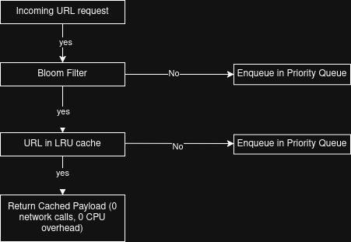
- Eviction Policy: The _LRUCache utilizes an ordered dictionary with move_to_end executed on every access (O(1)) and popitem(last=False) to evict the least-recently-used entry when the 2,000-page capacity is reached.
- Persistence: Extraction results are concurrently written to the scrape_cache database table with a 24-hour Time-To-Live (TTL). Cold-started server instances immediately benefit from URLs processed by preceding sessions.

3. CPU Deduplication via Parsing Caches
Parsing raw HTML using regular expressions, json.loads, and BeautifulSoup is a CPU-intensive operation. Repeated parsing of identical HTML payloads is mitigated using @functools.lru_cache(maxsize=256). This transforms redundant parsing executions into $O(1)$ dictionary lookups.
Python
@functools.lru_cache(maxsize=256)
def extract_jsonld_facts(text: str) -> dict:
...

@functools.lru_cache(maxsize=256)
def extract_bs4_facts(html: str) -> dict:
...
Immutability Contract: The cached dictionary must remain strictly immutable. Downstream processes requiring modifications to the extracted facts must create a copy of the dictionary prior to mutation.

4. Priority Queue Scraper Scheduler
Rather than applying a static delay between all scraping operations, a min-heap priority queue assigns specific weights and execution delays to each task. This ensures the system remains polite to target servers while prioritizing live user requests.
Priority Level | Queue Value | Post-Scrape Delay | Target Use Case
P1 — User Request | 1 | 0.0 s | Live search execution (immediate priority)
P2 — Retry | 2 | 0.5 s | Processing failed URLs for a second attempt
P3 — Prefetch | 3 | 1.0 s | Speculative database/cache warm-up operations
P4 — Cache Refresh | 4 | 2.0 s | Refreshing payloads nearing their TTL expiration
P5 — Background | 5 | 3.0 s | Background stock and pricing data synchronization
Task draining is handled concurrently by five asynchronous workers. A worker executing a P5 task (and its corresponding 3-second delay) does not block P1 tasks; the remaining workers independently continue to pull high-priority items from the heap.
2.2.7 Residential Proxies
When a target domain rejects the standard direct connection (returning HTTP 403, 429, or a soft-block challenge), the system autonomously escalates the request to a residential proxy network (e.g., IPRoyal). This acts as a critical safety net for mid-market or niche retailers that unexpectedly deploy strict Web Application Firewalls (WAFs).
Dynamic Geo-Routing Datacenter IPs are categorically identified and blocked by modern e-commerce security layers. To bypass this, the proxy request is routed through a legitimate residential IP geographically matched to the target URL's Top-Level Domain (TLD).
- The system dynamically generates a localized session ID (e.g., routing through country-RO for a .ro domain).
- The residential IP is paired with a specific TLS fingerprint (e.g., chrome120) to ensure the network signature perfectly matches the simulated browser environment.
The Self-Healing Learner (hostile_domains) Because residential proxies introduce additional latency and bandwidth costs, they are invoked lazily. To optimize future operations, the system incorporates a persistent learning mechanism:
- Detection: When a direct connection fails, the domain is immediately flagged in the local memory cache.
- Persistence: The flag is asynchronously upserted to the hostile_domains table in the database.
- Prevention: On all subsequent requests (and across server restarts), the system queries this registry. If a domain is known to be hostile, the pipeline completely skips the doomed direct attempt and routes the request directly to the residential proxy, saving time and preventing IP reputation damage.

2.2.8 Frontend Architecture and User Interface
The presentation layer is engineered on Next.js 15 utilizing the modern App Router architecture. It enforces strict structural integrity through TypeScript and manages highly responsive, utility-first styling via TailwindCSS. The application routing is logically partitioned into two distinct execution contexts based on the user's authentication state.

Authentication and Onboarding Routing
The unauthenticated routing tier manages the secure user onboarding and verification pipeline. The login architecture transitions users from standard email identification to secure, hardware-backed biometric passkey authentication.
For new users, the registration flow operates as a multi-step pipeline: capturing initial shipping parameters, executing One-Time Password (OTP) verification, and seamlessly bridging into WebAuthn passkey enrollment. The system also maintains a dedicated fallback handler for magic link verifications, culminating in a final post-registration plan selection interface.

Authenticated Application State
The primary application tier is strictly guarded by JSON Web Token (JWT) validation. It serves two primary views: the active conversational interface and a historical audit trail displaying the user's previous 50 search turns in reverse chronological order.

Core Chat Interface and State Management
The central conversational UI is designed for continuous context preservation. The full dialogue history is maintained within the component's state and re-transmitted to the backend on every interaction, ensuring the LLM never loses conversational continuity.
To optimize bandwidth and reduce API latency, media uploads are intercepted at the client layer. Images are aggressively compressed into the WEBP format locally within the browser before being base64-encoded and passed to the backend vision models.
Dynamic Refinement and Serialization: The interface includes sophisticated feedback loops to guide the AI's search parameters. A contextual "Not satisfied?" trigger appears beneath product sets; activating this automatically injects rejection context into the input field and appends the currently excluded_urls to the payload. This strict exclusion list forces the backend scraping pipeline to bypass previously rejected domains on the next iteration.
Furthermore, client-side serialization intercepts previous assistant messages before they are sent back to the server. Complex product sets are condensed into price-enriched string summaries (e.g., "Here are the top 3 products I found: 1. ASUS VivoBook -1799 RON..."). This specific data compression acts as a semantic anchor, enabling the AI to execute a "Dynamic Budget Drop" and aggressively narrow its price filters during follow-up refinement requests.

Dynamic Product Visualization
Extracted search results are synthesized into highly dense, interactive product cards designed for rapid analytical scanning.
- Data Hierarchy: Each card displays the unabbreviated product title, the verified price, and a definitive Value Score badge dynamically color-coded based on its threshold (green for scores ≥80, yellow for ≥60, and red for <60).
- Metric Visualization: The four foundational scoring dimensions: Cost Efficiency, Quality, Logistics, and Trust, are rendered as independent color-coded progress bars.
- Progressive Disclosure: To prevent cognitive overload, the AI's complex reasoning text is initially truncated to three lines. Users can expand the full analytical breakdown for each card independently, handled via isolated component state mapping.
- Conversion Anchors: Every card is equipped with verified external routing to the vendor ("View Product") alongside architectural provisions for future automated checkout integration.

Theming and Historical Auditing
The application ensures total environmental adaptability with comprehensive Dark Mode support utilizing Tailwind's native variants, persisting the user's theme selection directly in localStorage.
For session continuity, the History view provides an immutable audit of past queries. Each historical card isolates the exact user prompt, the AI-classified intent badge (Search, Clarify, or Chat), and the precise timestamp. Crucially, for historical searches, the interface reconstructs the original product rows, allowing the user to review the ranked items, their historical prices, and their computed value scores long after the initial query was executed.

2.2.9 Database Schema
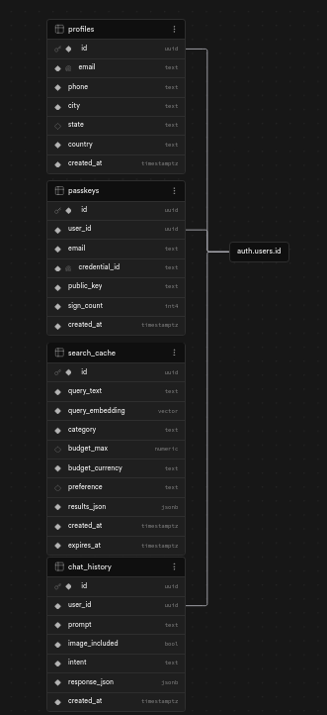
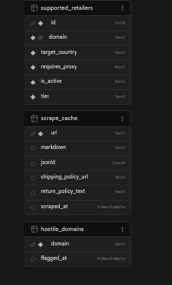

The tables are grouped into logical architectural domains: User Management, Search & Interaction, and the Scraping Engine.

1. User Management & Authentication
These tables handle user profiles and passwordless WebAuthn flows. Notice that profiles.id, passkeys.user_id, and chat_history.user_id all tie back to a central auth.users.id reference.
profiles
Stores localized user data for routing and shipping calculations.
Column | Type | Description
id | uuid | Primary Key.
email | text | User's registered email address.
phone | text | User's phone number.
city | text | Target city for logistics scoring.
state | text | Target state/region.
country | text | Target country for regional availability.
created_at | timestamptz | Timestamp of profile creation.
passkeys
Manages the WebAuthn credentials for secure, passwordless device logins.
Column | Type | Description
id | uuid | Primary Key.
user_id | uuid | Foreign Key referencing auth.users.id.
email | text | Associated email for the credential.
credential_id | text | Unique identifier generated by the authenticator.
public_key | text | Stored public key for challenge verification.
sign_count | int4 | Tracks authentication frequency/cloning prevention.
created_at | timestamptz | Timestamp of passkey registration.

2. Search & Interaction Data
These tables support the semantic caching engine and the conversational interface.
search_cache
Powers the $O(1)$ semantic cache lookups to bypass the scraper pipeline for duplicate queries.
Column | Type | Description
id | uuid | Primary Key.
query_text | text | The raw text of the user's search.
query_embedding | vector | pgvector embedding for $\ge 92\%$ similarity matching.
category | text | Isolated product category constraint.
budget_max | numeric | Upper limit for budget validation.
budget_currency | text | Currency for the budget ceiling.
preference | text | Additional user constraints or styles.
results_json | jsonb | The pre-calculated Top 3 ranked results.
created_at | timestamptz | Creation timestamp.
expires_at | timestamptz | Enforces the 6-hour TTL cache expiration.
chat_history
Maintains the context window for ongoing user sessions.
Column | Type | Description
id | uuid | Primary Key.
user_id | uuid | Foreign Key referencing auth.users.id.
prompt | text | The exact user input.
image_included | bool | Flag indicating multimodal input.
intent | text | The parsed routing intent (e.g., SEARCH vs. CHAT).
response_json | jsonb | The structured response returned to the client.
created_at | timestamptz | Timestamp of the interaction.

3. Scraping Engine & Infrastructure
These tables manage the domain traffic cop, WAF evasion fallbacks, and the raw extraction cache.
supported_retailers
The deterministic registry used to route traffic and apply hardcoded rules.
Column | Type | Description
id | int8 | Primary Key.
domain | text | The retailer's root domain (e.g., emag.ro).
target_country | text | Geo-localization constraint.
requires_proxy | bool | WAF flag. If true, routes directly to Lane B / residential proxy.
is_active | bool | Feature toggle for the retailer.
tier | text | Classification of the retailer's importance or security level.
scrape_cache
The persistence layer for the extraction phase, preventing redundant network I/O.
Column | Type | Description
url | text | Primary Key. The exact scraped endpoint.
markdown | text | Raw BeautifulSoup extraction output.
jsonld | jsonb | The MACHINE-VERIFIED DATA authoritative schema payload.
shipping_policy_url | text | Hop 1 discovery result for logistics.
return_policy_text | text | Hop 2 extraction payload for the trust scorer.
scraped_at | timestamptz | Timestamp to manage the 24-hour TTL eviction.
hostile_domains
The self-healing registry. Populated automatically when a direct fetch hits a 403 or 429.
Column | Type | Description
domain | text | Primary Key. The specific domain blocking direct access.
flagged_at | timestamptz | Timestamp of the last detected WAF block.

3 Comparison with other similar projects (what makes it state-of-the-art)

SmartShop focuses on purchase validation, not just product discovery. While most shopping assistants help users find products, SmartShop attempts to verify that the product is actually purchasable, in stock, ships to the user, and offers good overall value.

Feature | SmartShop | Amazon Rufus | Perplexity shopping | Google Shopping
Multi-retailer search | yes | Amazon only | yes | yes
Speciality retailer discovery | yes | limited | limited | limited
Shipping and logistics analysis | yes | partial | no | partial
Return policy analysis | yes | partiial | no | partial
Purchasability validation | yes | yes | partial | partial
Hallucinated URL verification | yes | no | no | no
Cross-model validation | yes | no | no | no
Country-aware recommendations | yes | limited | limited | limited

Amazon Rufus
Rufus is deeply integrated into Amazon's ecosystem and has excellent access to Amazon inventory, reviews, and product data. However, it is primarily optimized for products sold on Amazon and does not actively search independent retailers or niche stores.

Perplexity Shopping
Perplexity excels at web search and summarizing product information from multiple sources. However, it focuses mainly on discovery and research rather than validating shipping conditions, logistics, or retailer trustworthiness.

Google Shopping / Gemini
Google provides excellent product coverage through merchant feeds and search indexing. SmartShop differs by emphasizing retailer validation, logistics analysis, and overall purchase experience rather than primarily ranking products by visibility and popularity.

SmartShop's Key Difference
Most shopping agents answer:
"What products should I consider?"
SmartShop attempts to answer:
"What products can I realistically buy right now, from a trustworthy retailer, within my budget, and with acceptable shipping and return conditions?"

