SMART SHOPPING ASSISTANT
Paun David Andrei
Project specifications
Project Overview
The purpose of this project is the implementation of an autonomous “Agentic
commerce” platform, where users can make product requests (text and/or image), after
which an AI agent autonomously searches through various online stores, calculates the
best value and executes the final checkout process using single-use virtual cards.
Key features:
•
•
Text and Image recognition: the AI agent must be able to recognize both text and
images and interpret them
Value scoring: the app always chooses the best product by calculating a value
score from 1 to 100 depending on:
◦
◦
◦
◦
Cost efficiency: based on the base price, shipping cost and market delta
Product quality confidence: based on average rating and review volume
Logistics and convenience: delivery time and in-stock status
Trust and risk mitigation: Check if the product is sold directly by the provider
or a 3rd party
•
•
Agentic search: Uses Tavily API to find products across the web without being
blocked and Jina to retrieve the content of the opened tab and turn it into a
Markdown file
Automated checkout: The user has to choose between the 3 best options, then
after he chooses an option, the app automates the checkout process, creating a
virtual card and then autocompletes with the virtual card details.
Master-Ledger architecture: Whenever an user wants to buy something, a virtual
card is created, and after the purchase, it is destructed
•
•
Additional verification: Whenever an user buys something, he has to confirm by
passkey
How it works:
•
Whenever an user creates an account, he has to introduce his phone number, email address
and shipping address, verify the email and phone number, set up a passkey, and a balance is
created for him in the database.
•
•
User types the request and optionally adds some pictures
Gemini processes the user input

•
•
•
It sends the request to Tavily to identify the highest quality products
Jina converts the content of the web pages into readable Markdown files
Gemini applies the value scoring function on all the products and displays the top
3
recommendations to the user
•
•
•
•
The user selects one of the 3 items
User verifies himself by providing a passkey
Lithic creates a virtual card
Stagehand autocompletes with the requested payment details (card details,
shipping address, etc.)
•
If checkout is successful, Lithic destroys the virtual card, otherwise it is destroyed
manually and the user is shown the other best products in case of an out of stock
situation, or in case of a captcha failure, it is provided a link to the respective
website to manage the payment process by himself

Use case diagram:
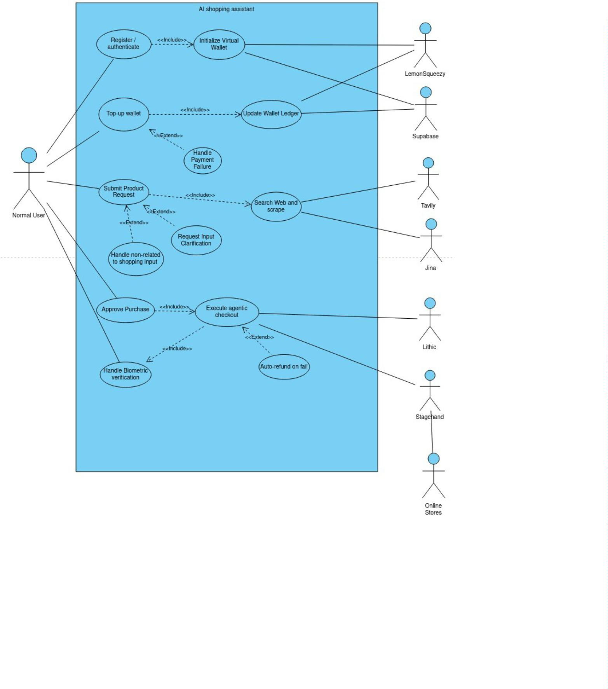

State diagram:
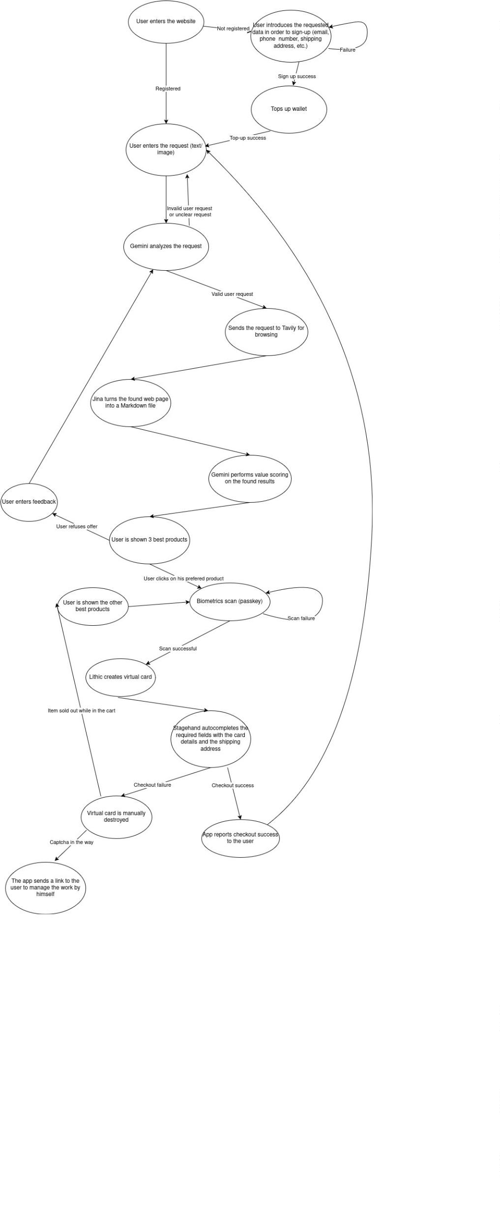

Programming languages and API’s:
•
•
Frontend
◦
Next.js, TypeScript, Tailwind CSS, Lucide React
Backend
◦
◦
◦
Python 3.12+
FastAPI
Pydantic (for data validation)
•
•
Databases
◦
◦
◦
Supabase (PostgreSQL)
SQL
Supabase Auth (for user login)
API’s
◦
◦
◦
◦
Lithic API - for generating virtual cards in the ledger architecture
LemonSqueezy API
Tavily API - provides AI-optimized web results
Jina Reader API – Converts website URL’s into clean Markdown
•
•
AI tools
◦
Gemini 1.5 Flash – the core LLM for request recognition, image processing
and value scoring
◦
◦
Stagehand – automates only the checkout part of the process
Model Context Protocol (MCP)
Deployment
◦
◦
◦
Vercel for frontend
Railway for backend
Supabase
Financial Projections (Estimated Operating Costs)
MVP Phase (0 to ~100 Users)
•
•
Fixed Infrastructure: ~$5.00 / month (Vercel Free, Supabase Free, Railway
Developer Plan).
Variable API Cost: ~$0.075 USD (~0.35 RON) per successful agentic checkout.

Large Scale Phase (1,000+ Active Users)
•
•
Fixed Infrastructure: ~$70.00 / month (Vercel Pro, Supabase Pro, Railway
Scaled RAM).
Variable API Cost: ~$0.075 USD (~0.35 RON) per successful agentic checkout.

