Report 3: Attack, Explain, Compare Pipeline
AI Explanation Reliability Under Attack

1. Goal
Build the core measurement of the project and validate it on a subset: for each successful attack, compare the Grad-CAM explanation of the clean image with the explanation of its attacked version, and decide whether the attacked explanation counts as deceptive using the threshold that was locked before any attack explanation was examined.
What is measured: explanation similarity between two heatmaps (SSIM, with IoU and correlation as supporting metrics). It is not a measure of whether a person finds an explanation plausible, nor of whether Grad-CAM is faithful to the model's reasoning. There is no user study, so no conclusion about human trust is drawn.

2. Work Completed
- Added two supporting metrics to src/metrics.py: IoU of the top 20% salient pixels and Pearson correlation, with NaN returned for degenerate heatmaps rather than an invented value.
- Built src/pipeline.py, which attacks an evaluation subset, explains each successfully attacked image and its clean original, compares them, and flags deceptive cases against the locked threshold read from results/calibration/threshold.json.
- Ran it on the first 1,000 evaluation images for all six attack configurations: 5,050 successfully attacked images were compared.
- Saved per-image and per-configuration result tables, and a figure of before/after examples chosen by fixed rules, including a deceptive case.
- Validated the pipeline with known-answer metric tests, a determinism check and a before/after check of the refactored attack code (section 5).
- Updated the README with the new parameters, results and limitations.

3. Methods and Parameters
Item | Setting
Subset | The first 1,000 images of the 9,000-image evaluation split (never a calibration image). 903 were classified correctly before attack.
Compared images | Only successful attacks: classified correctly before the attack and misclassified after it
Attacks | Unchanged from the Checkpoint 3 summary and the midterm report: FGSM and PGD at epsilon 0.01, 0.03, 0.05; PGD uses 10 steps, step size 2.5 x epsilon / 10, random start; seed 0 per configuration
Heatmaps | Grad-CAM on layer4[-1], min-max scaled to [0, 1], resized to 32x32 (as before)
Class explained | Each image's own top-1 prediction: the correct class for the clean image, and the model's (wrong) prediction for the attacked image. This is the explanation a user would see for each input, and it matches the rule used in calibration.
SSIM (primary) | skimage structural_similarity, data_range 1.0, 7x7 window
IoU (supporting) | Top 20% of pixels of each heatmap: pixels at or above the 80th percentile of that heatmap's own values. If that percentile is 0, only positive pixels are kept. IoU = intersection / union of the two masks.
Correlation (supporting) | Pearson correlation of the two flattened 32x32 heatmaps; NaN if either is constant
Deceptive rule | SSIM(clean heatmap, attacked heatmap) >= 0.9802, the 25th percentile of the noise-floor distribution, locked in commit 1a45546. IoU and correlation never decide this.

4. Results
Explanation similarity on the subset (SSIM and Pearson range up to 1.0 for identical heatmaps; IoU is 0 to 1):
Attack | Epsilon | Attacked images | SSIM mean | SSIM median | IoU mean | Pearson mean | Deceptive
FGSM | 0.01 | 709 | 0.525 | 0.580 | 0.394 | 0.562 | 0 (0.0%)
FGSM | 0.03 | 822 | 0.487 | 0.532 | 0.366 | 0.511 | 0 (0.0%)
FGSM | 0.05 | 826 | 0.439 | 0.484 | 0.341 | 0.466 | 0 (0.0%)
PGD | 0.01 | 887 | 0.627 | 0.685 | 0.440 | 0.657 | 2 (0.2%)
PGD | 0.03 | 903 | 0.653 | 0.694 | 0.459 | 0.689 | 1 (0.1%)
PGD | 0.05 | 903 | 0.646 | 0.683 | 0.455 | 0.682 | 0 (0.0%)

Every configuration has more than the 500 attacked images the plan asks for (smallest: 709). No IoU or correlation value was undefined. For comparison, the noise-floor median SSIM from random noise of the same per-pixel size was 0.994.
Descriptive observations (this subset only; confidence intervals and tests come with the full-scale run):
- Attacked explanations differ far more from the clean ones (median SSIM 0.48 to 0.69) than explanations under random noise of the same size (median 0.994).
- FGSM: mean SSIM falls as epsilon rises (0.525, 0.487, 0.439). PGD shows no downward trend (0.627, 0.653, 0.646).
- At every epsilon, PGD explanations stay more similar to the clean ones than FGSM explanations do.
- Only 3 of 5,050 attacked explanations (0.06%) reach the deceptive threshold, all from PGD. Pairs with SSIM of at least 0.9 are more common for PGD (5.6% to 7.0%) than for FGSM (0.6% to 3.0%).
- IoU and correlation order the six configurations the same way SSIM does, so the supporting metrics corroborate it.
These are observations about explanation similarity in this controlled setting. They are not yet conclusions about the hypotheses.
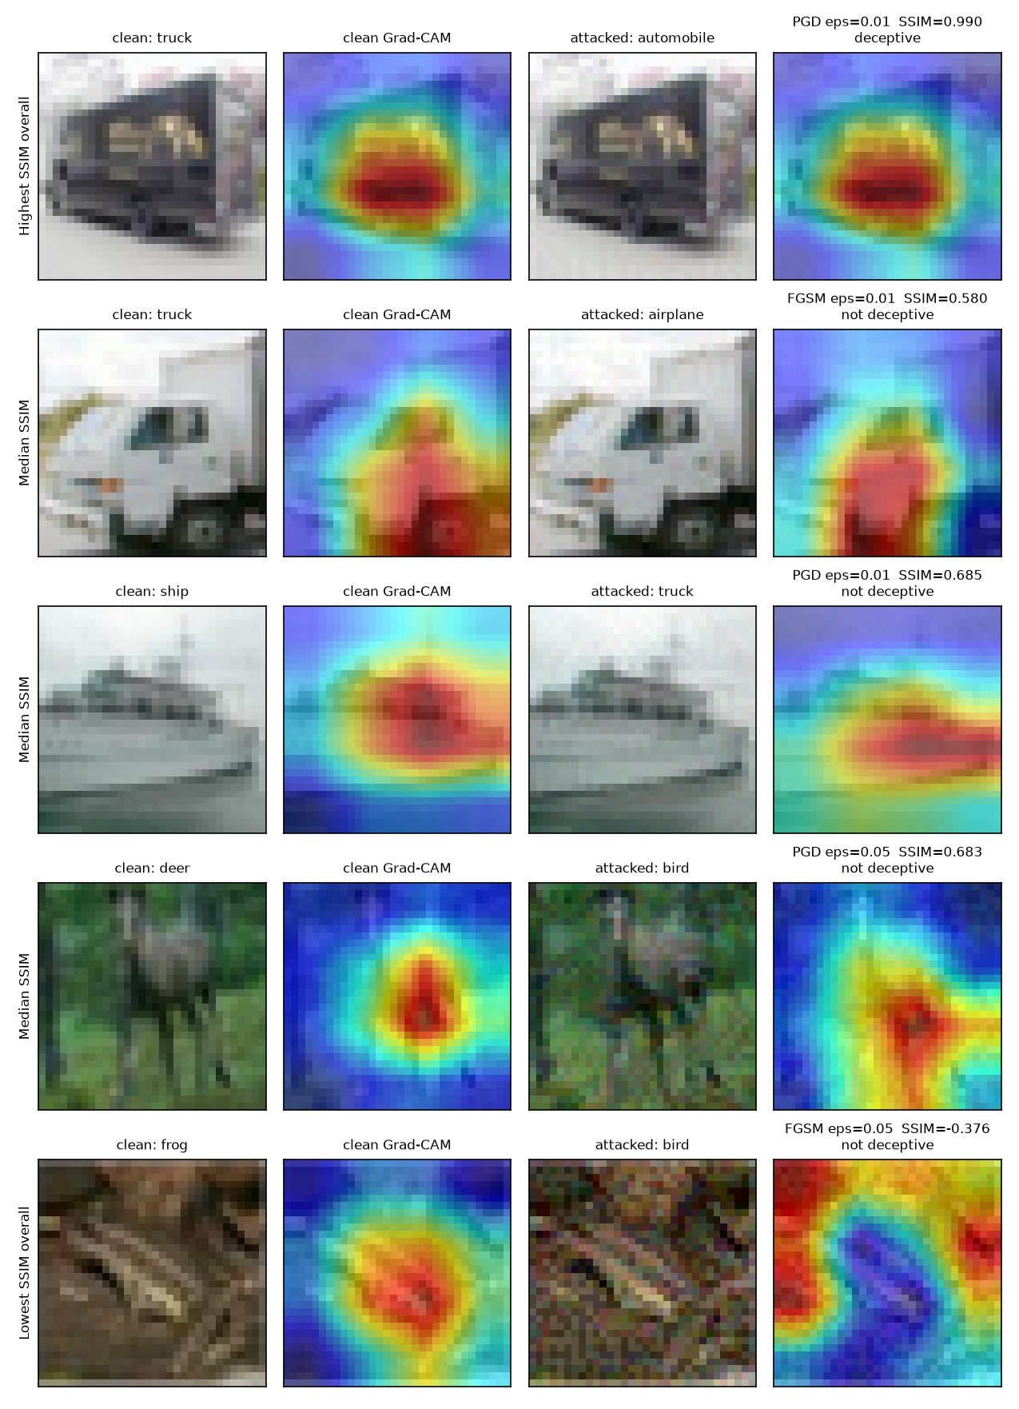
Figure 1. Clean and attacked image with their Grad-CAM overlays. Rows are chosen by fixed rules: the highest SSIM overall (a deceptive case), the median example of FGSM 0.01, PGD 0.01 and PGD 0.05, and the lowest SSIM overall.
Code excerpts
Selecting successful attacks and applying the locked threshold (src/pipeline.py):
success = ((clean_pred == labels) & (adv_pred != labels)).numpy()
... "ssim": ssim, "deceptive": ssim >= threshold,

The fixed top-20% rule used for IoU (src/metrics.py):
threshold = np.percentile(heatmap, 100 * (1 - top_fraction))
return heatmap >= threshold if threshold > 0 else heatmap > 0

5. Validation of the Pipeline
- Known-answer metric tests: identical heatmaps give SSIM 1, IoU 1 and correlation 1; two independent random maps give SSIM about 0, correlation about 0 and IoU 0.11, which is the chance level for two random 20% masks; opposite halves give IoU 0; constant or empty maps return NaN.
- Determinism: two runs on 100 images produced byte-identical per-image tables.
- Refactor check: the attack code was changed to expose the attacked images. On 250 images, the numbers of successful attacks were identical before and after (176, 205, 206, 221, 226, 226).
- Order of work: the pipeline code was committed (cc55399) before the 1,000-image results (6a9d95e), and the threshold is read from the locked file, not typed into the code.
- The IoU rule was checked on clean calibration heatmaps only, before any attacked heatmap was compared: none of 905 had a zero 80th percentile and the mask always had 205 to 213 of 1,024 pixels.
Repository (private): github.com/Davidfaleye360/explanation-reliability-under-attack. Environment and pinned library versions are unchanged (README, requirements.txt); the pipeline command is python -m src.pipeline --subset-size 1000 --device mps.

6. Challenges and How They Were Resolved
- Defining the top 20% of a heatmap. Heatmaps with many exact zeros or ties would make a percentile rule ambiguous. I measured this on clean heatmaps only, found none, kept the plan's rule, and added a documented safeguard. No degenerate case occurred in the 5,050 comparisons.
- Which class to explain for an attacked image. Explaining the original class and explaining the new prediction give different heatmaps. I chose the model's top-1 prediction, because that is what a user would see and it matches how the threshold was calibrated. The other choice was not examined and is listed as a limitation.
- Keeping earlier results valid while changing the attack code. The check above showed the refactor changed nothing.
- A strict threshold. Deceptive explanations are very rare under the locked rule (0.06%). The rule is not changed after seeing results; the full similarity distributions will be reported alongside the deceptive rate. Still open.

7. Limitations
- Heatmap similarity is not human-perceived plausibility and not explanation faithfulness.
- The Grad-CAM map is natively 4x4 and upsampled, so heatmaps are coarse and smooth.
- Results use a 1,000-image subset and one attack seed, with no confidence intervals yet.
- One dataset, one model, two attacks and three strengths.
- The explained class for attacked images is the wrong prediction; heatmaps for the original class were not examined.

8. Timeline and Next Steps
Checkpoint | Status | Completed
1. Foundation | Done | Sep 4, rerun Sep 9
2. Full training + Grad-CAM | Done | Sep 27
3. Attacks + calibration | Done | Oct 6
4. Attack, explain, compare (subset) | Done | Oct 7
5. Full-scale results and analysis | Next
6. Final report and video | Planned

Checkpoint 5 next steps:
- Run the pipeline on all 9,000 evaluation images for the six configurations.
- Write src/analyze.py: per-configuration tables with confidence intervals, plus charts of SSIM and deceptive rate against epsilon for FGSM and PGD, and SSIM distributions with the locked threshold marked.
- Evaluate H1, H2 and H3 against the full results, including the possibility of no clear trend, and write a first-draft interpretation limited to this setting.

