Report 1: Foundation
AI Explanation Reliability Under Attack

1. Project Summary
This project investigates whether Grad-CAM explanations for an image classifier remain visually convincing (“deceptive”) or visibly degrade when an adversarial attack successfully causes a misclassification. Using CIFAR-10 and a CIFAR-adapted ResNet-18, the project will compare Grad-CAM heatmaps before and after FGSM and PGD attacks at three perturbation strengths, and quantify how attack strength and type affect explanation similarity (SSIM, IoU, and correlation).

2. Checkpoint 1 Goal
Set up the repository structure, build a working CIFAR-10 data pipeline, and confirm the model training loop runs end-to-end. This checkpoint is a foundation/sanity check — it is not the full training run to target accuracy (that is Checkpoint 2).

3. Work Completed
- Initialized a private GitHub repository with the full planned directory structure (src/, data/, results/, reports/, notebooks/).
- Wrote the project plan (PROJECT_PLAN.md) documenting hypotheses, methodology, metrics, and the checkpoint schedule.
- Implemented src/model.py: a ResNet-18 adapted for 32×32 CIFAR-10 input (3×3 stride-1 stem conv, no initial max-pool, in place of the ImageNet-sized stem).
- Implemented src/train.py: CIFAR-10 loading via torchvision, training-time augmentation (random crop with padding, random horizontal flip), Adam optimizer, per-epoch train/test loss and accuracy logging, best-checkpoint saving, and automatic loss/accuracy curve plotting.
- Ran a short validation training job (2 epochs) to confirm the full pipeline works without errors, then independently re-ran it end-to-end (fresh data download included) to confirm the pipeline is reproducible.

4. Evidence
GitHub repository:
github.com/Davidfaleye360/explanation-reliability-under-attack
Commit history (7 commits):
bbfb081 Update Checkpoint 1 training curve with user-run results
fe75609 Add Report 1 draft (Foundation checkpoint)
41aaed6 Add Checkpoint 1 validation training curve
714e1eb Add --device override flag; default num_workers to 0
0df6abc Remove assistant-facing notes from project plan
5cd6536 Add project plan, repo scaffolding, and CIFAR ResNet-18 training script
1ab4e25 Initial commit
Validation training run (2 epochs, CIFAR-10, ResNet-18), reproduced independently:
Epoch | Train Loss | Train Acc | Test Loss | Test Acc
1 | 1.3787 | 0.4967 | 1.0773 | 0.6190
2 | 0.8976 | 0.6814 | 0.8519 | 0.7168

Test accuracy reached 71.7% after only 2 epochs (well above the 10% random-guess baseline for 10 classes), with loss decreasing and accuracy rising smoothly across both epochs — confirming the data pipeline, augmentation, model, optimizer, and checkpointing all function correctly together. This run was executed independently end-to-end (including a fresh CIFAR-10 download) to confirm the pipeline is reproducible, not just a one-off result. This is a short sanity run, not the full training job; Checkpoint 2 will run to convergence to reach the 85–93% target range.
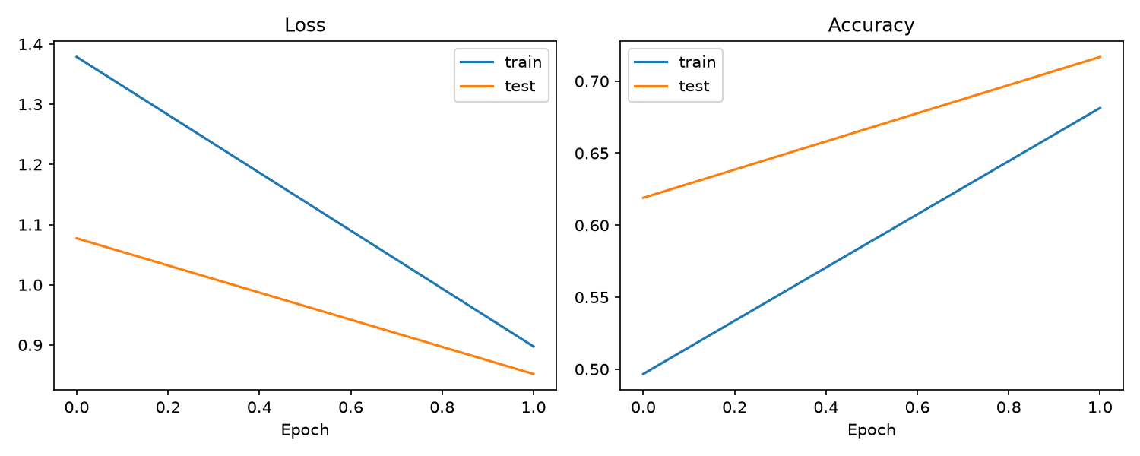
Figure 1. Training and test loss/accuracy over 2 validation epochs.

5. Next Steps (Checkpoint 2)
- Run full training to reach the 85–93% test accuracy target.
- Integrate Grad-CAM (pytorch-grad-cam) targeting the final convolutional layer.
- Generate and visually sanity-check Grad-CAM heatmaps across all 10 classes.

