Report 4: Full-Scale Results and Analysis
AI Explanation Reliability Under Attack

1. Goal
Run the full comparison on every evaluation image for all six attack configurations, quantify the results with confidence intervals, and write a first-draft interpretation of the three hypotheses. The measured quantity is explanation similarity: how similar the Grad-CAM heatmap of an attacked image is to the heatmap of its clean original. It is not a measure of whether a person finds an explanation plausible or of whether Grad-CAM is faithful to the model, and no user study was run, so no conclusion about human trust is drawn.

2. Work Completed
- Ran the attack, explain, compare pipeline on all 9,000 evaluation images for FGSM and PGD at epsilon 0.01, 0.03 and 0.05. Of the 9,000 images, 8,198 were classified correctly before attack; 45,779 successfully attacked image-configuration pairs were compared.
- Wrote src/analyze.py: per-configuration statistics with bootstrap intervals, paired hypothesis tests, exact intervals on deceptive rates, and four charts.
- Evaluated H1, H2 and H3 against the data (section 5), including one exploratory pattern found after the results were seen.
- Reduced the pipeline's memory use so the full run fits comfortably, and proved the change altered nothing (section 6).
- Updated the README with the full results, charts and limitations.

3. Analysis Plan and Parameters
The statistical choices below were fixed in code and committed (062a60a) before the full-scale results existed (758107f). The attack, heatmap, SSIM, IoU, correlation and threshold settings are unchanged from Report 3 and are documented in the README.
Item | Setting
Data | All 9,000 evaluation images (never a calibration image); only successful attacks are compared (correct before, wrong after)
Intervals for means | Percentile bootstrap, 10,000 resamples, seed 0, 95%
H1: strength | Same images compared across epsilon levels (images successfully attacked at both): mean paired SSIM difference with bootstrap interval; Wilcoxon signed-rank p, Holm-adjusted within the hypothesis
H2: attack type | Same images compared under PGD and FGSM at each epsilon (images successfully attacked by both); same statistics
H3: deceptive rate | Count of attacked explanations with SSIM >= 0.9802 (locked), with exact Clopper-Pearson 95% intervals
Role of p-values | With thousands of images almost any difference is statistically significant, so effect sizes and intervals are what matter
Deceptive rule | Only the locked SSIM threshold decides it. Shares above other SSIM values are descriptive context only.

4. Results
4.1 Explanation similarity by configuration
Attack | Epsilon | Attacked | SSIM mean [95% CI] | SSIM median | IoU mean | Pearson mean | Deceptive
FGSM | 0.01 | 6,362 | 0.512 [0.505, 0.518] | 0.568 | 0.383 | 0.542 | 0 (0.000%)
FGSM | 0.03 | 7,479 | 0.493 [0.486, 0.499] | 0.546 | 0.372 | 0.522 | 0 (0.000%)
FGSM | 0.05 | 7,531 | 0.440 [0.433, 0.446] | 0.488 | 0.342 | 0.463 | 1 (0.013%)
PGD | 0.01 | 8,011 | 0.628 [0.623, 0.633] | 0.682 | 0.444 | 0.655 | 5 (0.062%)
PGD | 0.03 | 8,198 | 0.655 [0.651, 0.660] | 0.700 | 0.461 | 0.686 | 3 (0.037%)
PGD | 0.05 | 8,198 | 0.648 [0.643, 0.652] | 0.690 | 0.454 | 0.680 | 4 (0.049%)

For comparison, the noise-floor median SSIM under random noise of the same per-pixel size was 0.994. IoU and correlation order the configurations exactly as SSIM does, so the supporting metrics corroborate it.
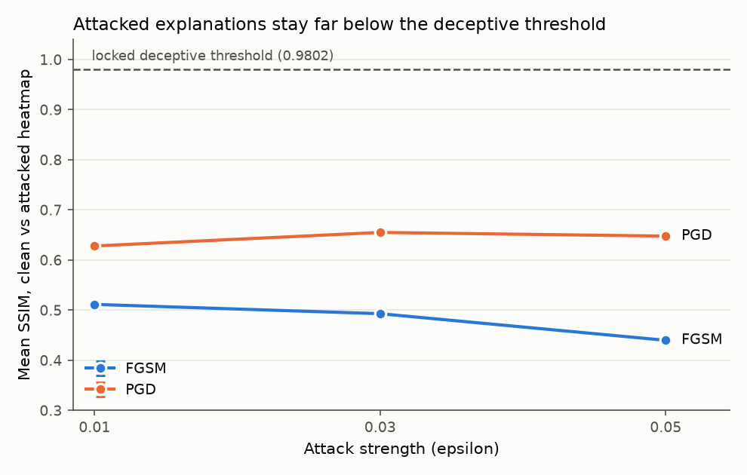
Figure 1. Mean SSIM between clean and attacked heatmaps (95% intervals are smaller than the markers at this sample size). The dashed line is the locked threshold.
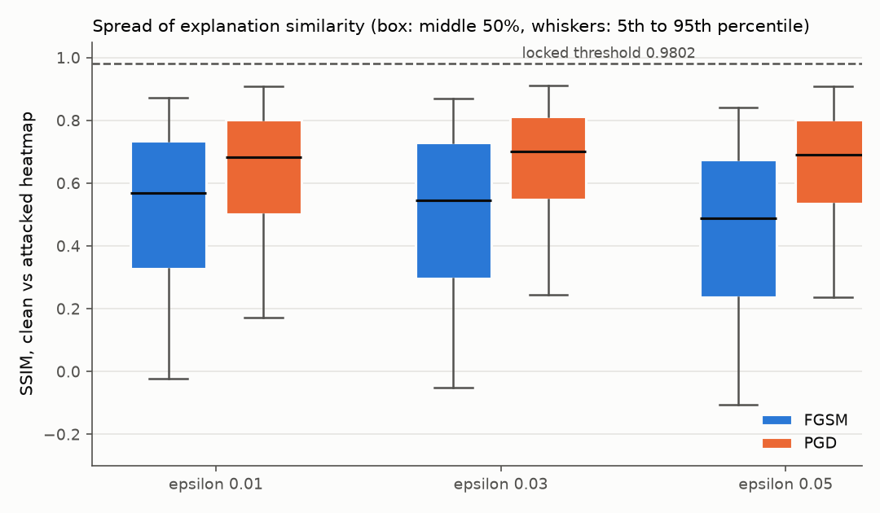
Figure 2. Spread of SSIM per configuration. Most attacked explanations are far from the threshold.
4.2 Deceptive explanations
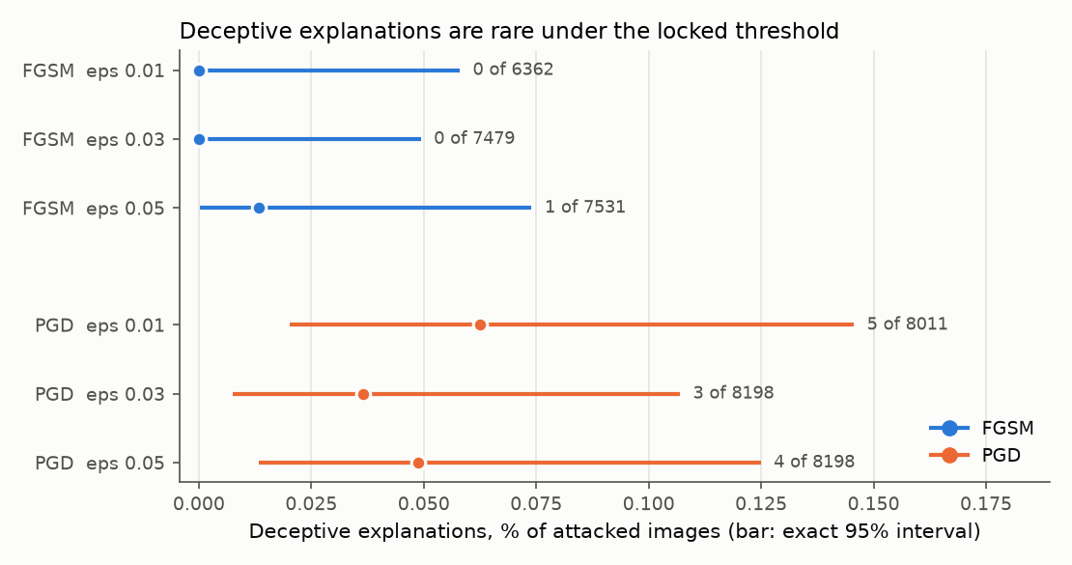
Figure 3. Deceptive explanations per configuration with exact 95% intervals. Labels give count of attacked images.
Across all 45,779 attacked pairs, 13 reach the locked threshold (0.028%), from 10 distinct images (one image is deceptive under three PGD settings, another under two). Twelve of the 13 are PGD. All 13 also have IoU of at least 0.78 and Pearson correlation of at least 0.98, so the supporting metrics agree. For context only: the share of attacked explanations with SSIM of at least 0.90 is 1.0% to 2.5% for FGSM and 6.1% to 6.8% for PGD.
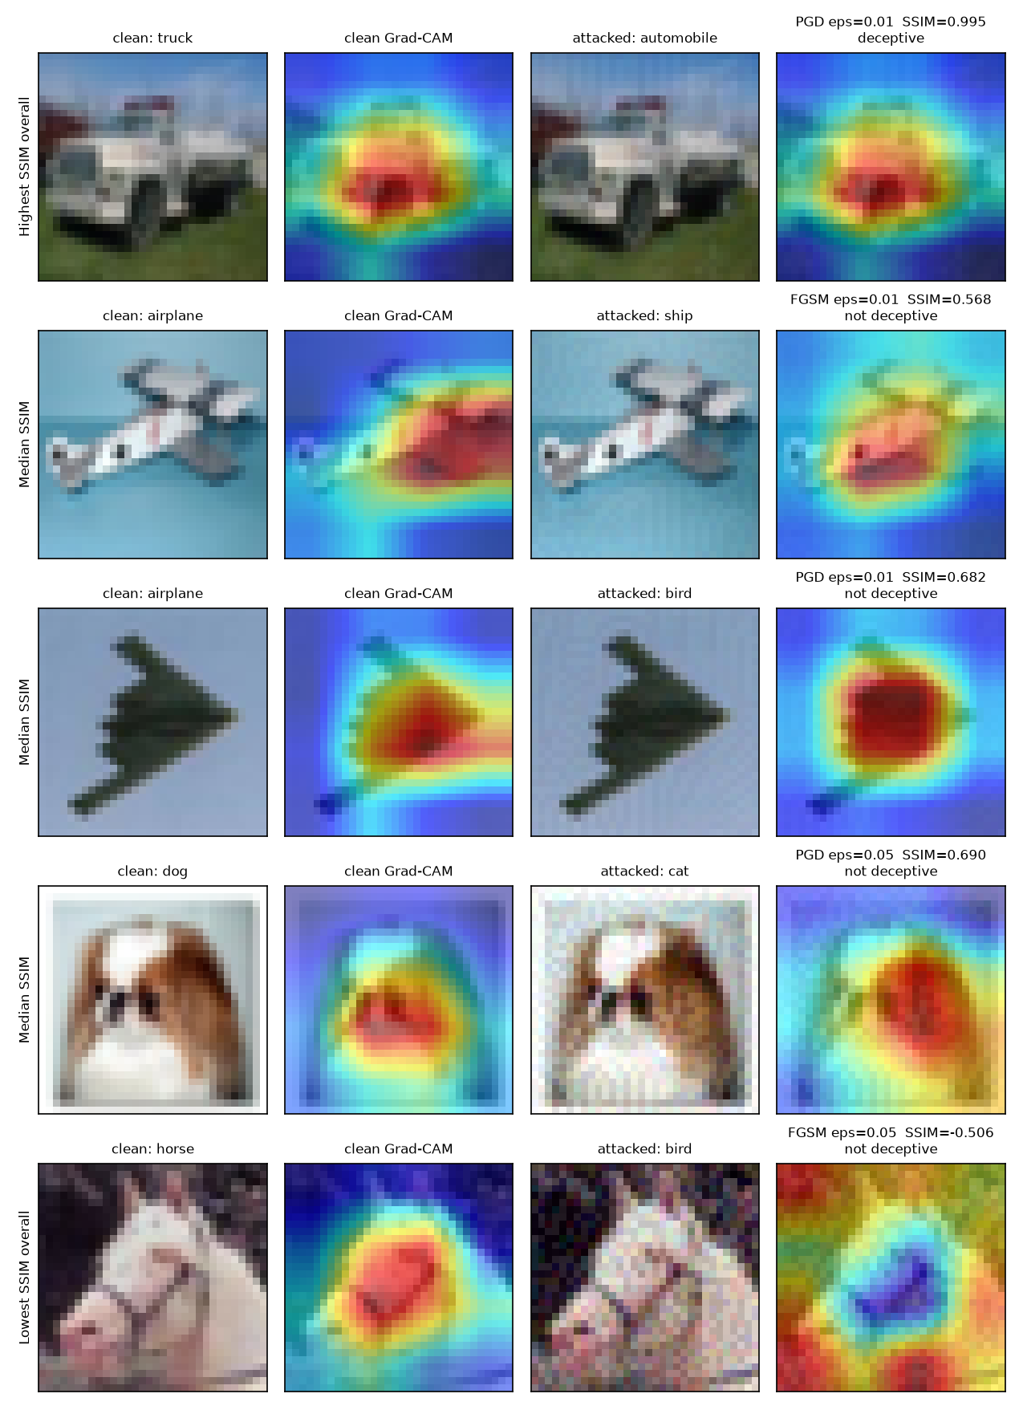
Figure 4. Examples chosen by fixed rules: highest SSIM overall (a deceptive truck-to-automobile case), the median example of three configurations, and the lowest SSIM overall.
4.3 Hypothesis tests (paired, same images)
Hypothesis | Comparison | Images | Mean SSIM difference [95% CI] | Holm p
H1 | FGSM: eps 0.03 minus 0.01 | 6,287 | -0.0351 [-0.0406, -0.0297] | < 0.001
H1 | FGSM: eps 0.05 minus 0.03 | 7,292 | -0.0499 [-0.0554, -0.0444] | < 0.001
H1 | FGSM: eps 0.05 minus 0.01 | 6,167 | -0.0824 [-0.0899, -0.0750] | < 0.001
H1 | PGD: eps 0.03 minus 0.01 | 8,011 | +0.0246 [+0.0215, +0.0277] | < 0.001
H1 | PGD: eps 0.05 minus 0.03 | 8,198 | -0.0073 [-0.0096, -0.0051] | < 0.001
H1 | PGD: eps 0.05 minus 0.01 | 8,011 | +0.0173 [+0.0136, +0.0211] | < 0.001
H2 | eps 0.01: PGD minus FGSM | 6,362 | +0.1041 [+0.0999, +0.1083] | < 0.001
H2 | eps 0.03: PGD minus FGSM | 7,479 | +0.1541 [+0.1484, +0.1597] | < 0.001
H2 | eps 0.05: PGD minus FGSM | 7,531 | +0.2015 [+0.1950, +0.2078] | < 0.001

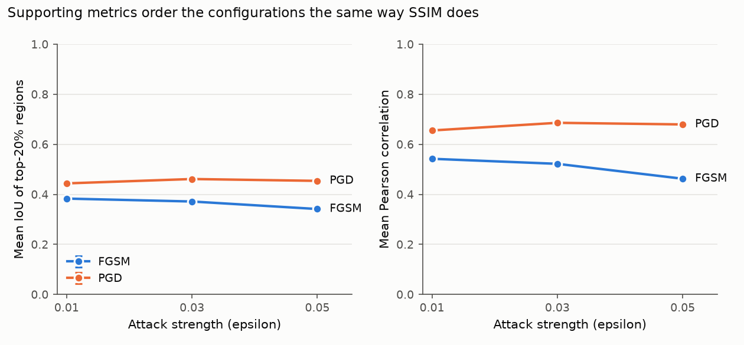
Figure 5. Supporting metrics (IoU of top-20% regions, Pearson correlation) follow the same pattern as SSIM.

5. First-Draft Interpretation of the Hypotheses
These statements apply to this controlled setting only: CIFAR-10, one ResNet-18, two attacks, three strengths, Grad-CAM on its last block, and similarity measured by SSIM. They are first-draft interpretations, to be finalized in the last checkpoint.
H1 (similarity decreases as attack strength increases): mixed.
It holds for FGSM: similarity falls at each increase in strength (-0.035, then -0.050, -0.082 overall, all intervals clear of zero). It does not hold for PGD: similarity rises from epsilon 0.01 to 0.03 (+0.025), dips slightly to 0.05 (-0.007), and ends higher than it started (+0.017). So stronger attacks do not generally produce less similar explanations; it depends on the attack.
H2 (PGD and FGSM behave differently at comparable strength): supported.
PGD explanations stay more similar to the clean ones than FGSM explanations at every strength, and the gap grows with strength (+0.104, +0.154, +0.202). I have not tested why. One candidate is that FGSM changes every pixel by the full epsilon while PGD's projected steps usually change the image less overall, but this is a guess to check, not a finding.
H3 (some successful attacks keep a highly similar explanation): supported in existence, but very rare under the pre-set strict threshold.
13 of 45,779 attacked pairs (0.028%) reach the threshold, so deceptive explanations do occur, but almost all successful attacks visibly change the heatmap (median SSIM 0.49 to 0.70). The practical reading, limited to similarity, is that in this setting an explanation-similarity check would flag nearly all attacks, with rare misses. This project does not test whether a human would notice the changes.
Exploratory pattern (found after seeing the results; not a pre-set test).
Truck-to-automobile and automobile-to-truck confusions are 12.8% of all successful attacks (5,843 pairs) but 11 of the 13 deceptive cases (84.6%). The deceptive rate is 0.188% (95% interval 0.094% to 0.337%) within those confusions versus 0.005% (0.001% to 0.018%) for everything else. A plausible reading is that two visually similar classes naturally highlight the same object region, so a similar heatmap may reflect the classes' similarity more than the attack. This rests on 13 cases and needs follow-up before it is claimed.

6. Validation
- Cross-check between two code paths: the pipeline's counts of successful attacks (6,362; 7,479; 7,531; 8,011; 8,198; 8,198) match, image for image, the independent attack evaluation run weeks earlier.
- Regression check: after the memory change, re-running the 1,000-image subset produced identical tables and a pixel-identical example figure (maximum pixel difference 0).
- Order of work: the threshold was locked first (1a45546), the pipeline code was committed before its results (cc55399, then 6a9d95e), and the analysis code was committed (062a60a) before the full-scale results (758107f). The exploratory section was added afterwards and is labelled as such in the code, tables and README.
- Charts were checked for readability, and the two series colors passed a colorblind-safety check (minimum separation 24.7 against a target of 8).
Repository (private): github.com/Davidfaleye360/explanation-reliability-under-attack. Commands: python -m src.pipeline --subset-size 9000 --device mps, then python -m src.analyze --n 9000.

7. Challenges and How They Were Resolved
- Memory at full scale. Keeping every attacked image for the example figure would have needed an estimated 2 GB. The pipeline now keeps only the few rows the figure uses; the regression check above shows nothing changed.
- A misleading first chart. My first deceptive-rate chart let wide error bars dominate, collided labels with the axis, and drew lines suggesting a trend across three tiny counts. I redrew it as one interval per configuration, with no connecting lines.
- Interpreting very rare events. With counts from 0 to 5, rates alone mislead, so every rate carries an exact interval and the text says how rare the effect is.
- A pattern noticed after the fact. Because the truck/automobile pattern was found after seeing the data, it is labelled exploratory everywhere and not used to support a hypothesis.

8. Limitations
- Explanation similarity is not human-perceived plausibility and not faithfulness; there is no user study.
- The Grad-CAM map is natively 4x4 and upsampled to 32x32, so heatmaps are coarse and smooth.
- One dataset, one model, two attacks, three strengths, and Grad-CAM only.
- Each configuration used a single attack seed (PGD uses a random start); variation across seeds was not measured. The intervals reflect sampling over images only.
- The same images are reused across configurations, so configurations are not independent samples; the paired tests compare the same images to account for this.
- The deceptive rate depends on the threshold, which depends on the chosen noise model. The explained class for an attacked image is the model's wrong prediction; explaining the original class was not examined.
- The checkpoint epoch was chosen using test accuracy on the same test set that supplies the evaluation images, so accuracy is slightly optimistic.

9. Timeline and Next Steps
Checkpoint | Status | Completed
1. Foundation | Done | Sep 4, rerun Sep 9
2. Full training + Grad-CAM | Done | Sep 27
3. Attacks + calibration | Done | Oct 6
4. Attack, explain, compare (subset) | Done | Oct 7
5. Full-scale results and analysis | Done | Nov 9
6. Final report and video | Next

Checkpoint 6 next steps:
- Finalize written conclusions on H1, H2 and H3 (supported, refuted or mixed), scoped to this setting, using the wording and limits above.
- Build a gallery of all 10 distinct deceptive images and clear degraded cases from the saved per-case tables, for the final report and video.
- Clean the repository and make sure the README reproduces the whole pipeline from a fresh setup; make sure the instructor can access the private repository.
- Record the final demo video covering the classifier, an attack, the before and after heatmaps, and the summary charts.
- If time allows, test the two open guesses (attack perturbation size as the reason PGD and FGSM differ; the truck and automobile pattern) as clearly labelled follow-ups.

