Report 2: Working Classifier + Explanations
AI Explanation Reliability Under Attack

Video Recording: https://docs.google.com/document/d/1Dc3ihv_UAQdtFlcBZlTQyawCtR14Uzjc01DU1kaEcNM/edit?usp=sharing
1. Checkpoint 2 Goal
Bring the classifier to the project's target accuracy range and integrate Grad-CAM so the model can generate visual explanations for its own predictions. Checkpoint 1 proved the pipeline mechanics worked on a short 2-epoch test; this checkpoint completes the real training run and adds the explanation half of the project.

2. Work Completed
- Ran the full 30-epoch training job (Adam optimizer, random-crop + horizontal-flip augmentation) to convergence.
- Reached 91.03% test accuracy at epoch 28 — within the 85–93% target range set in the project plan.
- Implemented src/gradcam_utils.py using pytorch-grad-cam, targeting the final residual block of the ResNet-18 (layer4[-1]) — the standard Grad-CAM target layer, since it is the last convolutional feature map before global average pooling.
- Generated Grad-CAM heatmaps for one correctly classified test image per class (10 classes) and visually confirmed every heatmap focuses on the actual object rather than the background.
- Saved the sample gallery to results/gallery/gradcam_samples.png.

3. Evidence
GitHub repository:
github.com/Davidfaleye360/explanation-reliability-under-attack
Commits since Report 1 (5 commits):
c643075 Switch gallery layout to a compact grid for easier report embedding
1f0b366 Complete Checkpoint 2: full training run + Grad-CAM sanity gallery
4027448 Add Grad-CAM wrapper targeting ResNet-18's final conv block
5c04aea Update Report 1 with user-run validation results
e34edd2 Update Checkpoint 1 training curve with user-run results
Full training run (30 epochs, CIFAR-10, ResNet-18):
Milestone | Train Loss | Train Acc | Test Loss | Test Acc
Epoch 1 | 1.3431 | 0.5087 | 1.1265 | 0.6016
Epoch 16 (target range reached) | 0.1930 | 0.9334 | 0.3056 | 0.9030
Epoch 28 (best) | 0.0908 | 0.9677 | 0.3624 | 0.9103
Epoch 30 (final) | 0.0816 | 0.9706 | 0.3647 | 0.9088

Best test accuracy reached 91.03% at epoch 28, comfortably within the 85–93% target range. Training accuracy continued climbing to 97% while test accuracy plateaued around 90–91% from roughly epoch 16 onward — a normal, mild amount of overfitting for this model size and epoch count, not a pipeline problem. The checkpoint used for all Grad-CAM work below is the epoch-28 best-test-accuracy save.
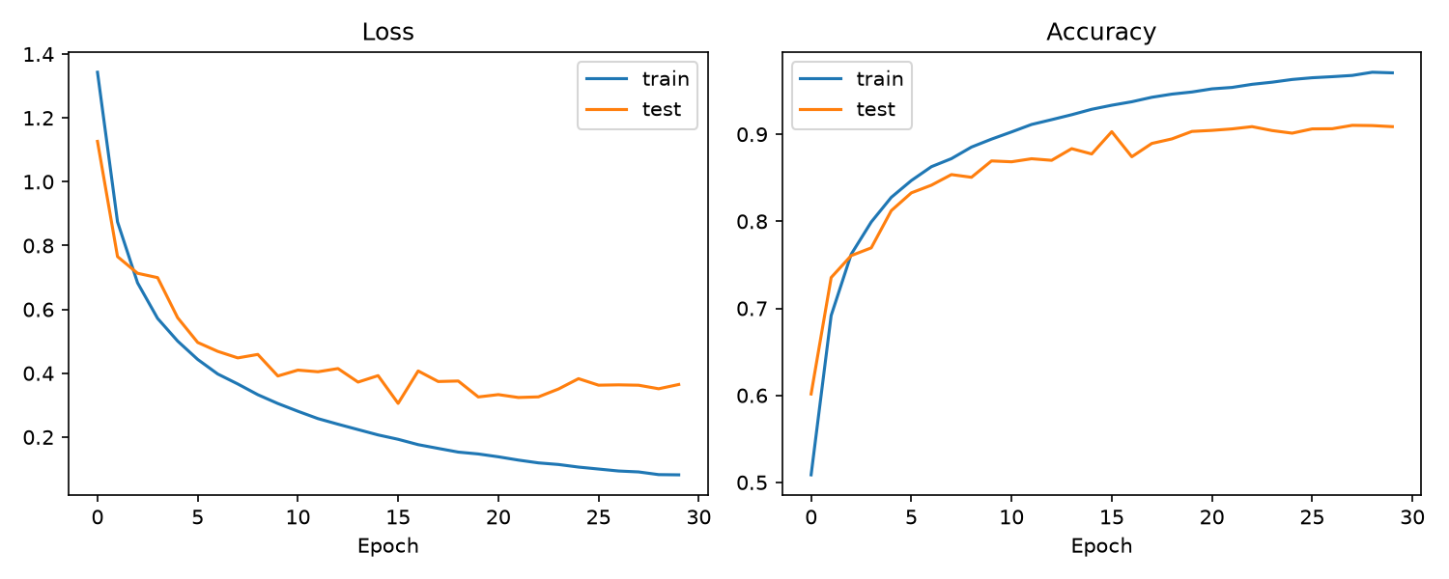
Figure 1. Training and test loss/accuracy across all 30 epochs.
Grad-CAM sanity check (one correctly classified example per class):
For every one of the 10 CIFAR-10 classes, the heatmap's warmest region sits on the actual object — the plane's nose and wings, the car's body, the bird's body, the cat's face, the deer's silhouette, the dog's head and torso, the frog's body, the horse's torso, the ship's hull, and the truck's cab and bed. None of the 10 heatmaps focus primarily on background. This confirms Grad-CAM is picking up genuine object-relevant features from this model, which is a necessary precondition before using it to judge whether explanations degrade under adversarial attack in later checkpoints.
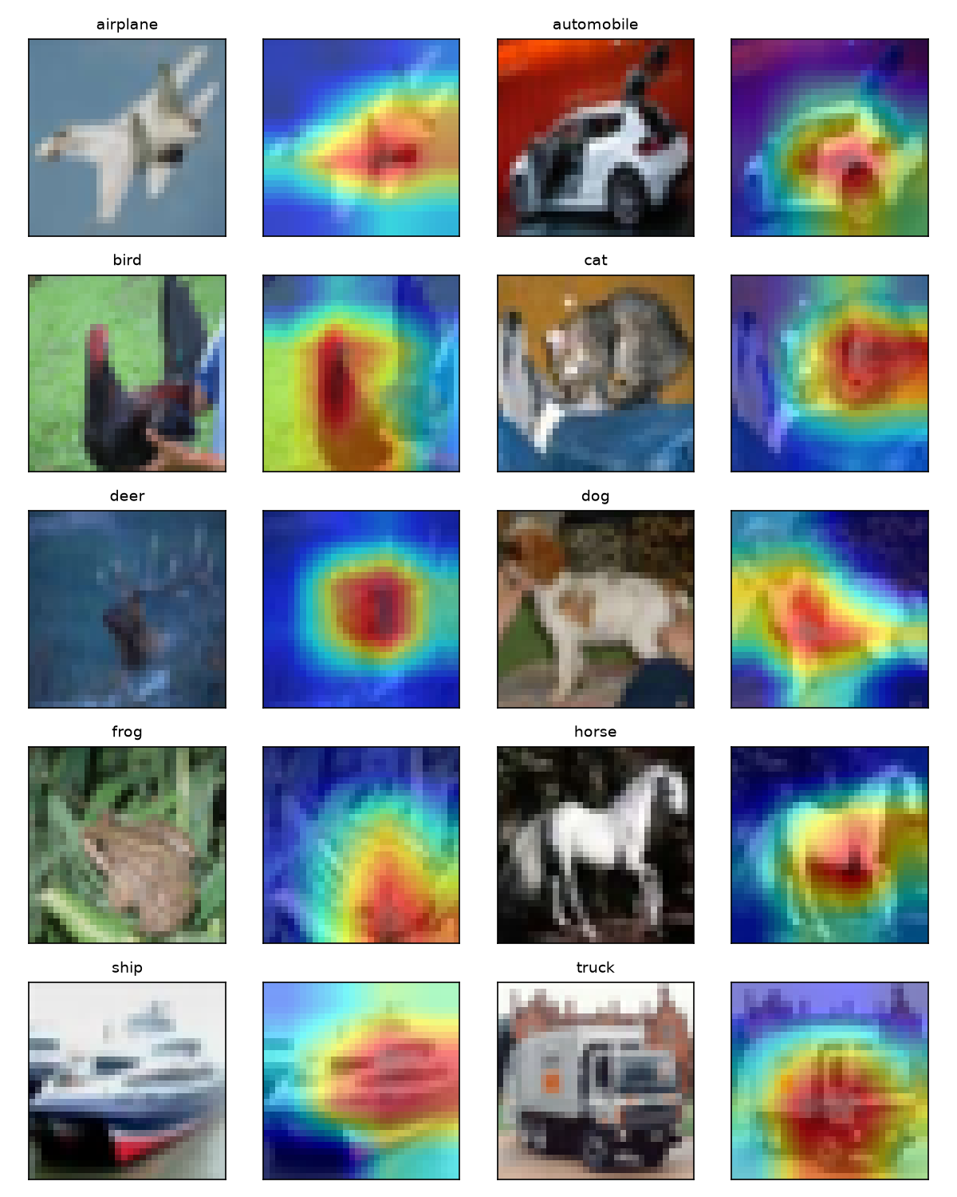
Figure 2. Original image and Grad-CAM overlay for one correctly classified example per class.

4. Next Steps (Checkpoint 3)
- Implement src/attacks.py wrapping torchattacks' FGSM and PGD at epsilon = {0.01, 0.03, 0.05} (6 configurations total).
- Run all 6 attack configurations on the test set and record attack success rate and adversarial accuracy per configuration.
- Implement src/calibration.py: build the clean-noise calibration set and compute the SSIM noise-floor distribution.
- Fix the deceptive-explanation threshold at the 25th percentile of that distribution — locked in before any adversarial Grad-CAM comparison is made.

