1. Read a xml file, change some values and write the xml in to new file

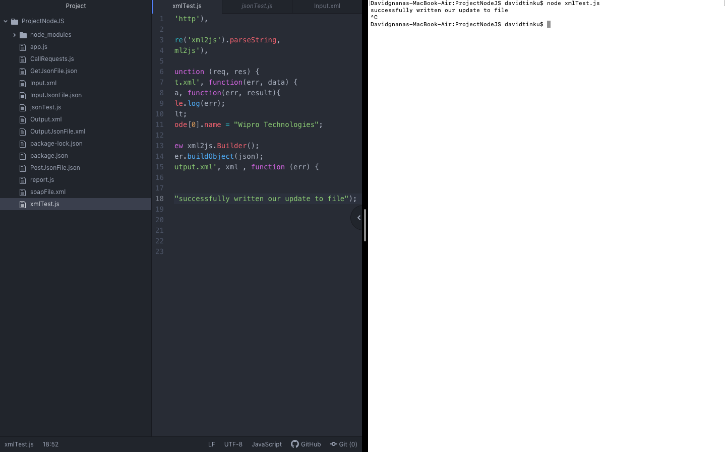

1. Read a JSON file, change some values and write the xml in to new file

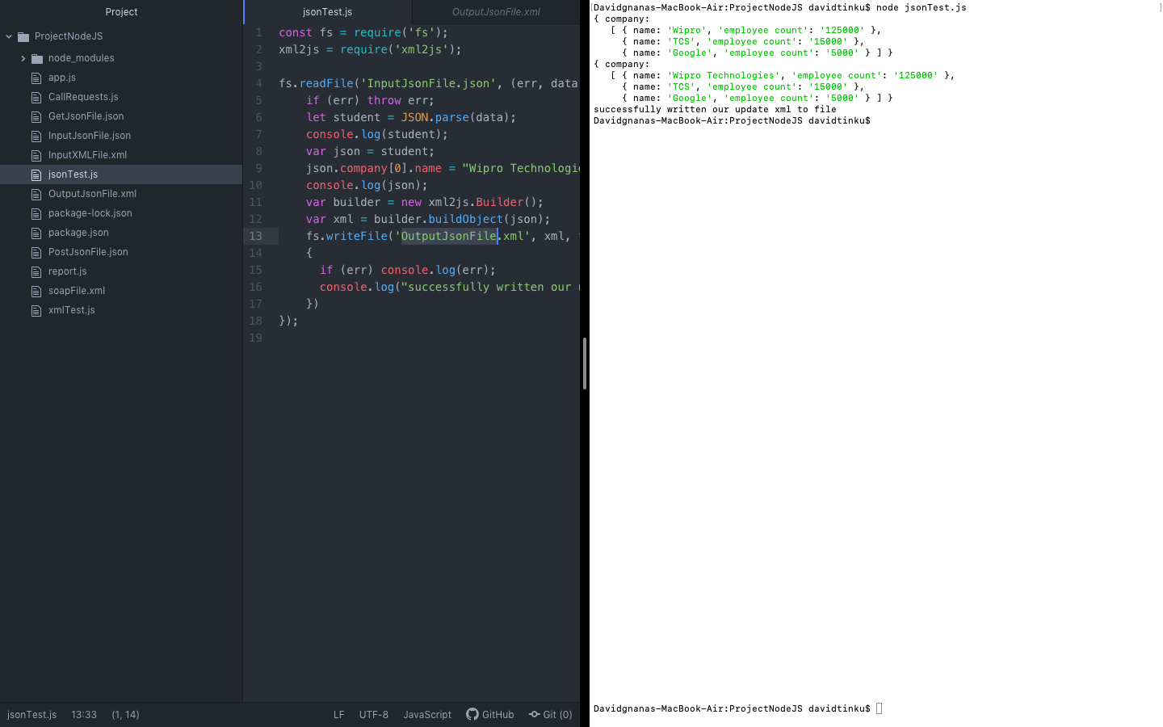

1. Make a SOAP call. Assert response status code and assert any one node value in response xml.

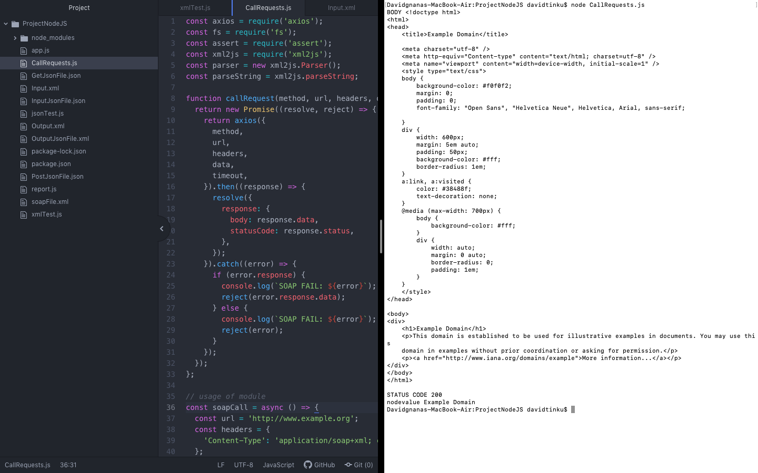

1. Make a GET call. Assert the response status code and userId

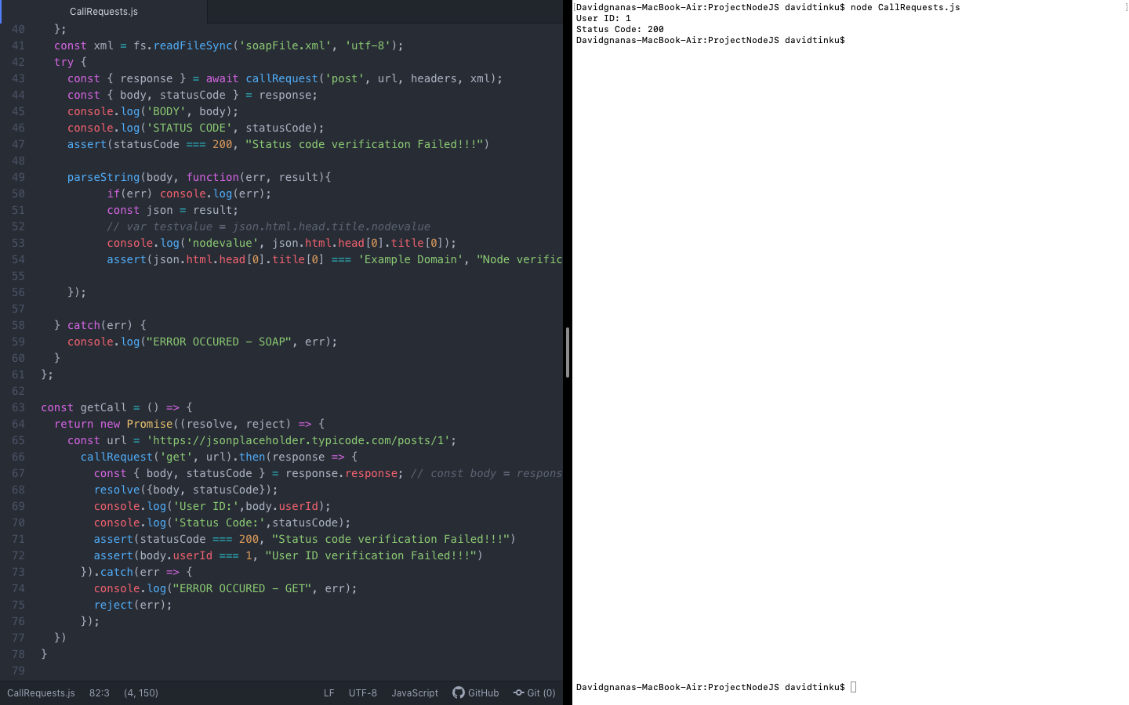

1. Make a POST call. Assert the response status code and id

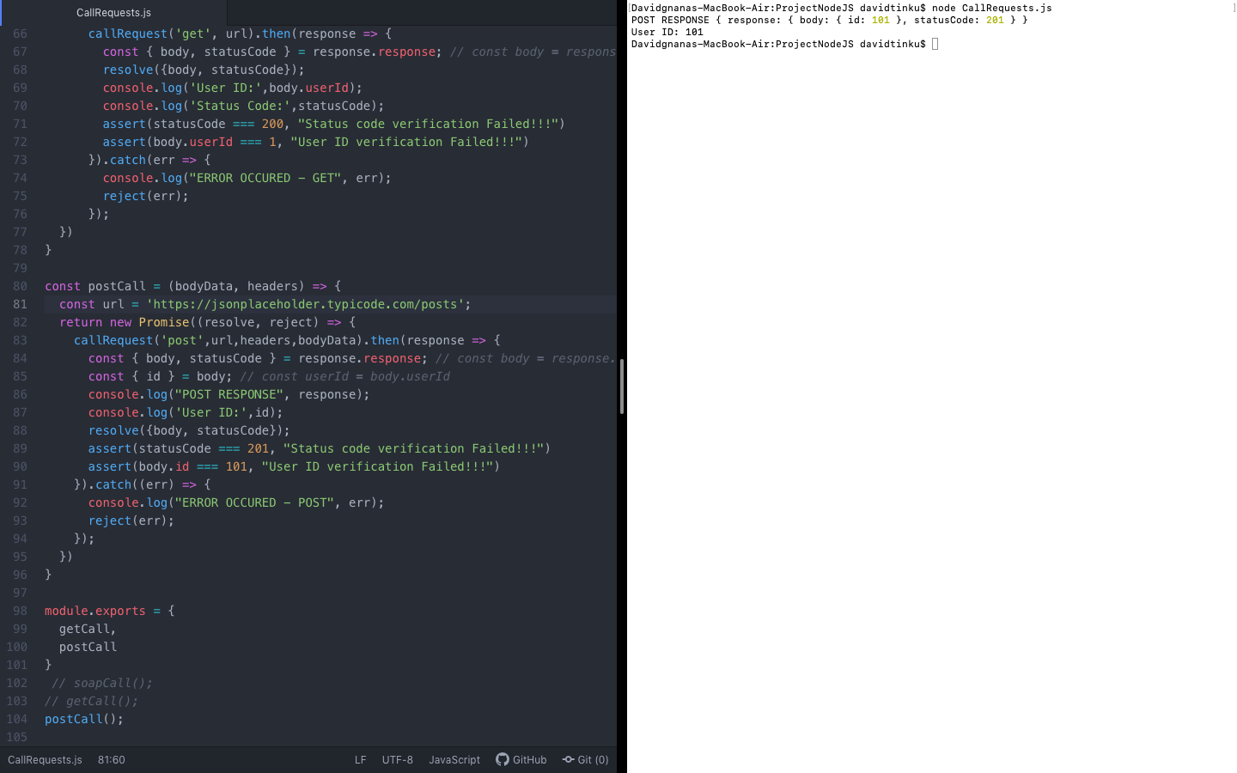

1. NodeJS-Cucumber framework for UI.

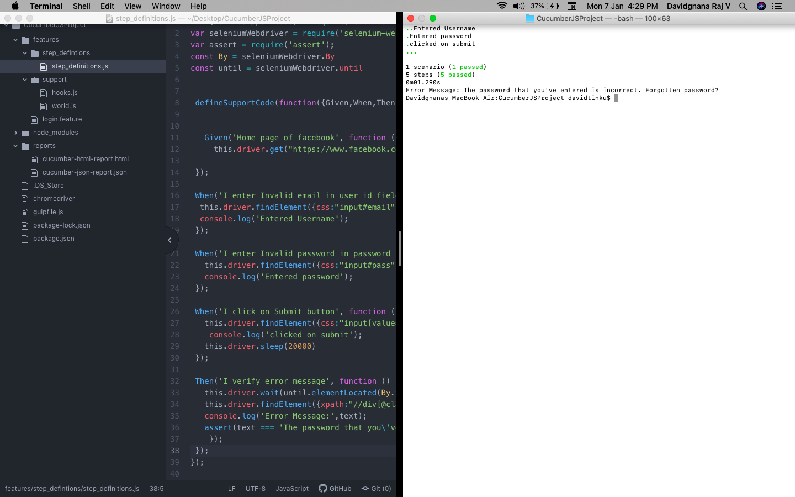

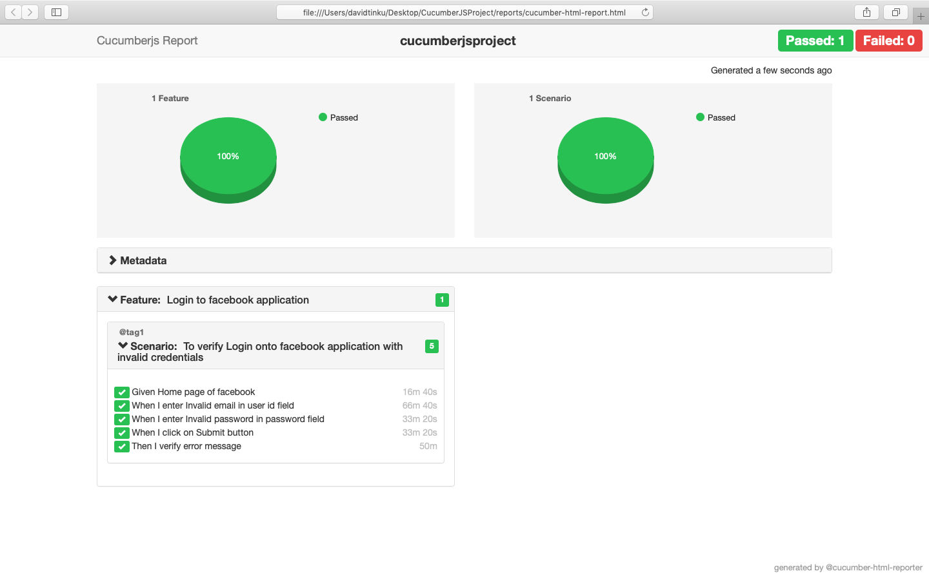

1. Create an API framework with questions 3,4 and 5. Framework should create a JSON/HTML report.

