ScamGuard Proposal
Introduction
ScamGuard designed to protect users from digital scams by analysing suspicious messages, emails, and links directly on their device. Its unique selling proposition lies in leveraging on-device Llama AI to provide real-time scam detection without requiring internet connectivity. Unlike existing cloud-based solutions, this application ensures complete user privacy while delivering fast, intelligent threat analysis.
Objective
The objective of this application is to identify and explain potential scams in user-provided content using on-device AI, enabling users to make informed decisions and avoid fraud without exposing sensitive personal data to external servers.
Proposed Solution
Provides a simple and intuitive interface where users can paste text messages, emails, or URLs for analysis. The main screens include a text input interface, a results dashboard, and an AI explanation panel. After submission, the system processes the input locally and returns a classification such as “Safe,” “Suspicious,” or “Likely a Scam,” along with a detailed explanation.
The application integrates Llama 3.2 as an on-device large language model to perform natural language classification, reasoning, and explanation generation. The model identifies common scam patterns such as urgency, impersonation, requests on a large deposit or for sensitive information. It also provides user-friendly explanations to help users understand why the content may be dangerous.
Key benefits of using Llama include real-time processing, offline functionality, and enhanced privacy. Since all data remains on the device, users are protected from data leaks and external tracking. The model also supports personalised responses, improving user trust and accessibility.
Safety and quality controls are implemented through structured prompts that limit unsafe outputs, predefined refusal conditions for ambiguous inputs, and local moderation filters. The system avoids providing harmful advice and instead focuses on risk awareness and prevention.
Technology Stack & Architecture
Technology Stack:
- Android Studio (Java/Kotlin)
- Google AI Edge SDK
- Llama 3.2 (on-device inference engine)
User Flow:
Home Screen:
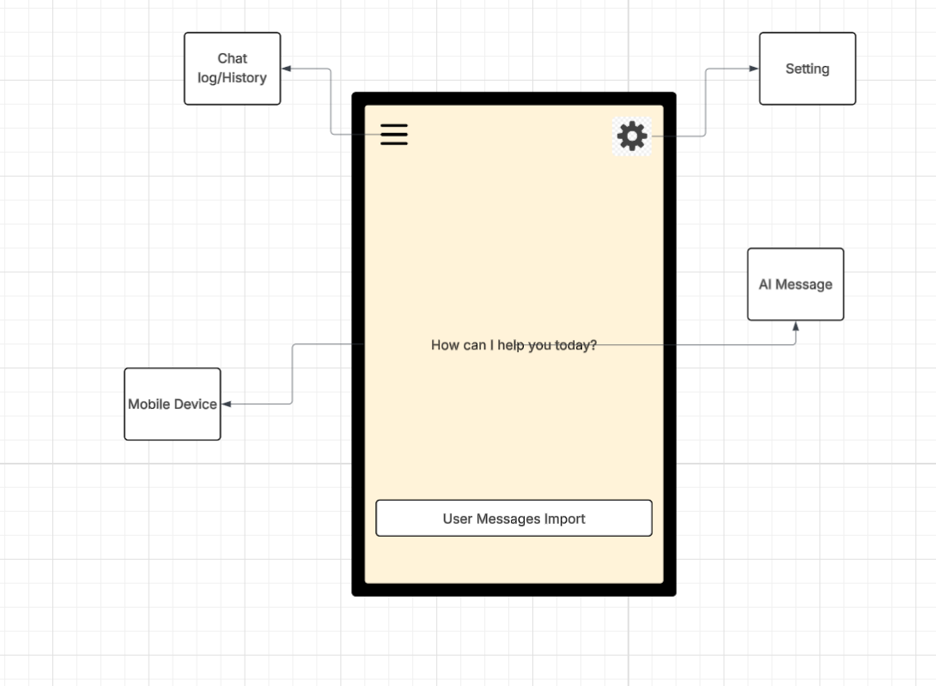
User after press the Message Import button:
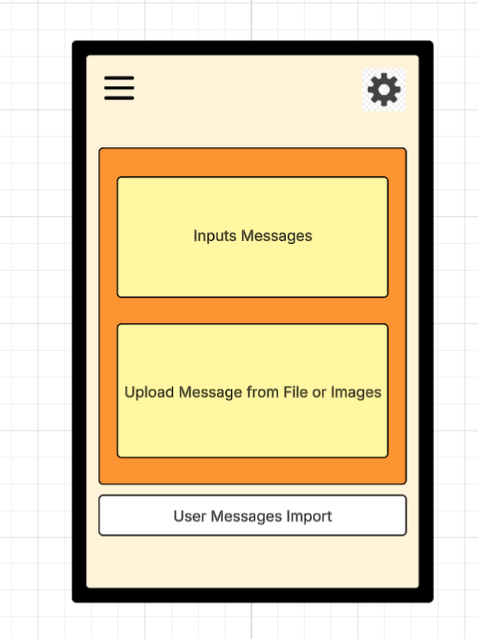
Message Import and Result screen:
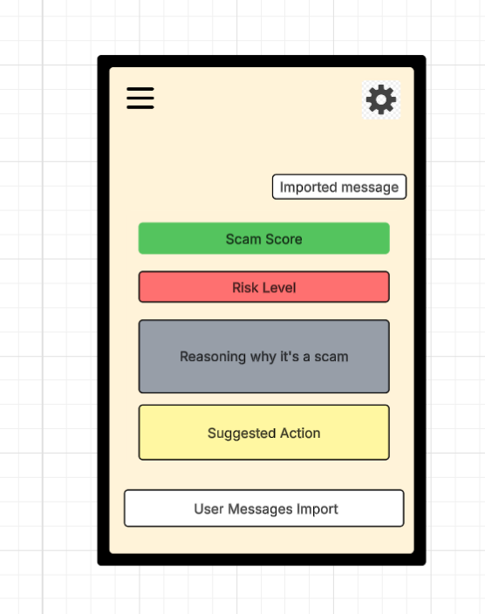
Deployment Mode:
On-Device
- All AI processing (Llama 3.2) runs directly on the user’s smartphone.
- No internet connection is required
- Provides maximum privacy, as sensitive messages are never sent externally.
- Offers low latency with near-instant responses.
- Limitation: constrained by device performance and model size optimisation.
Assumptions & Prerequisites:
- Device supports on-device AI processing
- Llama model is optimised for mobile deployment
- Users provide readable and relevant input data
Development Methodology
An Agile/Scrum methodology will be adopted to support iterative development and continuous testing of AI features. This approach allows rapid prototyping, frequent user feedback, and flexible adaptation to challenges associated with AI behaviour. Sprint cycles will focus on improving detection accuracy, UI usability, and system performance while managing risks related to AI reliability.
Conclusion
ScamGuard how on-device AI can enhance cybersecurity by providing private, real-time scam detection. By eliminating reliance on cloud services, the application ensures user data protection while delivering intelligent insights, representing a significant advancement in mobile AI-driven safety solutions.
LLM Declaration Statement
ChatGPT was used to give ideas of which types of applications can be developed with llama 3.2
Link: https://chatgpt.com/share/69c3d76d-d86c-8323-9998-375946949578
Github Link: https://github.com/Davidhuynh-tech/SIT305/tree/Task_4.0HD

