A Modality-Decoupled Framework for Childhood Asthma Detection: Evaluation of Fusion, Referral, Conflict Flagging and Explanation Faithfulness
David Olusegun Adekoya^{1,*}, R. S. Akinbo²
¹Department of Information Technology, Federal University of Technology Akure, P.M.B. 704, Akure 340110, Ondo State, Nigeria
²Department of Data Science, Federal University of Technology Akure, P.M.B. 704, Akure 340110, Ondo State, Nigeria
*Corresponding author: adekoyadift2020@futa.edu.ng | ORCID: D. O. Adekoya 0009-0006-2754-1589; R. S. Akinbo 0000-0003-3998-7116

ABSTRACT
Childhood asthma is often under-diagnosed where objective testing is unavailable. We examine a modality-decoupled framework in which Symptom, Pulmonary and Acoustic Agents are trained on separate cohorts and a Decision Agent combines their calibrated probabilities, refers borderline cases, flags disagreement between agents and composes an explanation. The prediction target is physician-diagnosed current asthma, not every clinically present case. No dataset contains all three modalities in the same children, so fusion was evaluated only between the Symptom and Pulmonary Agents in 6,329 children from NHANES 2007-2012 (805 with current asthma), and the Acoustic Agent was evaluated separately on 747 children (66 with asthma) in SPRSound. Fusion reached ROC-AUC 0.871, a small gain over the Symptom Agent (+0.008; 95% CI +0.001 to +0.016) and no better than a pooled-feature model (0.867). At a threshold set for 90% sensitivity, specificity was 0.516 and positive predictive value 0.213. The referral band and conflict flag were characterised but not shown to improve case finding beyond the pooled score, and deletion tests supported only the cited Symptom Agent attributions, not the rest of the composed explanation. An eleven-variable Symptom Agent held up adequately in a temporal check on NHANES 2015-2018 (ROC-AUC 0.727), which tests one component and not the framework. Fusion of all three modalities in the same patients was not evaluated, and the acoustic results rest on 66 children with asthma. The contribution is an evaluation of a modular design under patient-grouped splitting and training-fold-only fitting, not a demonstrated gain in accuracy or clinical utility.
Keywords: Childhood asthma; Clinical decision support; Explainable artificial intelligence; Model calibration; Multi-agent systems; Multimodal learning; Respiratory sound analysis; SHAP

1. INTRODUCTION
Asthma is among the most prevalent chronic respiratory conditions of childhood. The Global Burden of Disease Study 2021 estimates 95.7 million prevalent asthma cases among children aged 0–14 worldwide, an age-standardised rate of 4,758 per 100,000 [1]. Despite this burden, underdiagnosis can be substantial: school-based screening of 920 children aged 7–11 in a low socioeconomic population in Bogotá (709 returned questionnaires; 186 were clinically assessed) identified 122 children with asthma (17.2% of respondents), of whom 83 (68%) had not previously been diagnosed; the authors attribute this to limited access to health care in such communities [2].
Diagnosis is difficult for two reasons. First, asthma is episodic, so a child may present with normal lung function between exacerbations; wheezing status is consequently among the strongest observed predictors of subsequent diagnosis [3]. Second, objective confirmation requires spirometry, bronchodilator reversibility testing or fractional exhaled nitric oxide, which demand equipment, trained operators and child cooperation. Even in well-resourced specialist settings these pathways are not always completed: across four Swiss paediatric pulmonology clinics, overall adherence to an adapted European Respiratory Society diagnostic approach reached 77% (182 of 236 children) [4], a figure from specialist clinics that should not be read as an adherence rate in primary care. Where such equipment is absent, diagnosis can rest on clinical history and auscultation alone.
Machine learning has been applied to paediatric asthma prediction using survey [5], birth-cohort [3] and electronic health record data [6], and recent work has added SHAP-based explanation [5, 16]. Three limitations recur in the studies we reviewed. Most use a single tabular modality and discard the acoustic evidence a clinician obtains by auscultation, while acoustic models classify sounds without clinical context [3, 5-8]. The multimodal approaches we reviewed assume that every modality is measured on every patient and fuse by feature concatenation [9, 10]; we know of no public paediatric asthma cohort in which all three modalities are measured in the same children, and a model built on that assumption cannot run when a modality is missing. Finally, explanations in these studies are displayed as attribution maps and assessed qualitatively, if at all [7, 10], although attribution displays that are never tested against the model's behaviour have been criticised [13, 14].
We study a modality-decoupled design in which modality-specific agents are trained independently on separate datasets and combined at the level of calibrated probabilities. Its intended advantage is practical: no jointly labelled cohort is needed, and operation without one modality is designed behaviour. Whether the design also improves accuracy, and whether referral, disagreement flagging and composed explanations give measurable benefit, are empirical questions that this paper tests rather than assumes.
Because the available datasets share no participants, fusion can be evaluated only between the two modalities that NHANES measures in the same children, and the Acoustic Agent only on its own. Within that limit the study asks four questions. Does decision-level fusion improve discrimination over the strongest single modality and over a pooled-feature model? What do referral and conflict flagging contribute beyond the pooled score? Do the explanations describe the model that produced them? And how far do the findings hold for a later NHANES cohort, a missing modality and the small acoustic sample? The label also needs stating at the outset: the model predicts physician-diagnosed current asthma, so a child with symptoms who was never diagnosed is counted as a control, which matters for a study motivated by under-diagnosis (Section 3.2).
The study contributes an evaluation in which post-diagnosis variables are excluded, acoustic folds are grouped by child and preprocessing is fitted within training folds only; paired comparisons showing a small gain over the Symptom Agent and none over pooling; a direct characterisation of the referral and conflict mechanisms; a deletion test of Symptom Agent attributions; a temporal check of an eleven-variable Symptom Agent; and an acoustic evaluation whose limits are stated. Fusion of all three modalities in the same children was not evaluated and is not claimed.

2. RELATED WORKS
Related work falls into four groups: clinical machine learning for childhood asthma, respiratory sound analysis, multimodal and explainable systems, and referral of uncertain cases. Table 1 summarises the principal studies; all are from 2021 onward except where a methods citation requires the originating source.
Recent studies predict asthma-related outcomes in children from survey, birth-cohort and electronic health record data, with SHAP interpretation in some [5, 16]. Reported discrimination in the survey setting is moderate: a recent national-survey study reports AUC 0.765 internally with undersampling and 0.746 on a later survey year [5], and an EHR-based study of 9,934 children already diagnosed with asthma at ages 2-5 predicts persistence, not first diagnosis, and reports at least 81% sensitivity at 70% specificity [6].
A recurring methodological concern is the inclusion of variables that are consequences of, or immediately antecedent to, the outcome. The strongest predictor in [5] is prescription medication use, and those authors acknowledge the item cannot distinguish asthma medication from other prescriptions or exclude children already under treatment. The CHILD birth-cohort study reports AUROC 0.99 for its best model, a voting ensemble, but it uses data collected to age 4 to predict a diagnosis recorded at age 5, with wheezing status and atopy as the dominant predictors [3]. That is a short horizon relative to the outcome. Study design matters as much as feature choice. A single-centre study of 900 children aged 6–18 reports ROC-AUC 0.997 (gradient boosting and random forest) for distinguishing asthma from non-asthmatic chronic cough [17], but that figure describes a different task from detection in an unselected population. The cohort was balanced by design, 450 asthma against 450 non-asthma, whereas asthma prevalence in the NHANES cohort used here is 12.7%. The comparison arm consisted of children with chronic cough, so the model separates two pre-selected clinical groups from one hospital rather than identifying asthma among children who have not been referred. Artificially balanced case-control sampling raises apparent discrimination and makes reported precision non-transferable to an unselected setting like ours, where the ratio of non-cases to cases is roughly seven to one. We therefore evaluate at the observed prevalence of 12.7% and report PR-AUC alongside ROC-AUC (Section 3.4). Reported figures across this literature are not directly comparable unless the sampling design and the temporal and definitional relationship between features and outcome are stated. We exclude diagnosis-consequent variables by design (Section 3.2), although, as Section 4.3 shows, the symptom items that remain are themselves close to the diagnosis.
Paediatric lung-sound classification has been advanced by open annotated databases [18], by transformer architectures [7] and by audio foundation models [8]. An important distinction is obscured in parts of this literature: reported figures often describe classification of annotated sound events rather than assignment of a diagnosis to a child. The studies closest to ours classify wheeze versus other sounds [7, 9], and the most directly comparable study is titled as paediatric asthma detection and reports accuracy of 0.91 to 0.94 and AUC of 0.94 to 0.97 across five classifiers on SPRSound [8]. However, its task is binary classification of 2-second adventitious-sound segments. Its 80:20 stratified split is applied to clip embeddings, and no grouping by patient or recording is reported. Neither [7] nor [9] states whether recordings from the same child were kept within a single partition. Because segments and recordings from one child are strongly correlated, splitting below the patient level can inflate performance. We therefore evaluate at patient level with group-wise splitting throughout (Section 3.4); our acoustic figures address a different task from those studies and are not directly comparable with theirs.
Fusion of audio with tabular clinical data has been attempted in paediatric wheeze detection using a residual audio encoder alongside an MLP over tabular inputs [9], but that study collected no diagnostic information, so the benefit of fusion is demonstrated against a sound label rather than a diagnosis. Multimodal audio systems otherwise combine deep and handcrafted acoustic representations within the single audio modality [10]. In the studies reviewed here, explanation is displayed rather than validated: [7] applies Score-CAM and assesses it qualitatively, and [10] applies Grad-CAM, Integrated Gradients and SHAP without testing faithfulness. The multimodal systems reviewed here also assume that every modality is observed for every patient and fuse by feature concatenation, which precludes operation when a modality is missing.
Machine learning with a reject option, in which a classifier declines to predict on cases it judges too uncertain, is a well-developed area [19], and referral driven by predictive uncertainty has been shown to improve disease detection in retinal imaging [20]. The referral rule studied here is simpler: it refers the children whose fused probability lies nearest the operating threshold, and Section 4.6 tests directly whether it targets the cases the model gets wrong.
Table 1 condenses these studies to their data, methods, findings and the gap each leaves.
Table 1. Related studies by dataset, methodology, key findings and research gap.
Study and data | Methodology | Key findings | Research gap
Xie and Xu (2025) [5]; NHIS survey, 9,716 youths, external n = 4,919 | LR, SVM, RF, XGBoost and NN with resampling; LASSO and RF feature selection; SHAP | AUC 0.765 internal (undersampled), 0.746 on 2023 survey | Top predictor is prescription medication, which may reflect existing asthma treatment; cross-sectional; validation on a later survey year, not an independent cohort; explanation not tested
He et al. (2024) [3]; CHILD birth cohort, 1,754 children | Classical learners and ensembles on 132 variables from birth to age 4 | AUROC above 0.90 at ages 3 and 4, highest 0.99 (voting ensemble) at age 4; wheeze and atopy dominate | Short horizon to the age-5 outcome; questionnaire data; no external validation
Kim et al. (2025) [7]; 725 recordings, two Korean hospitals | AudioSet-pretrained AST; 80:20 split; Score-CAM | Wheeze vs other: accuracy 0.911, AUC 0.866 | Splitting unit not stated; no diagnosis; explanation assessed qualitatively
Kim et al. (2022) [9]; 287 recordings from 76 children | Residual audio encoder with MLP on tabular data; 80:20 split | Wheeze vs other: accuracy 0.912, AUC 0.891 | Single centre; splitting unit not stated; no diagnostic information collected
Zhang et al. (2022) [18]; SPRSound, 292 children, 2,683 recordings at release | Open database; digital stethoscope; event-level annotation | First open paediatric respiratory sound database | Patient diagnoses available for a subset only; single centre
Ehtesham et al. (2025) [8]; SPRSound, 3,319 labelled 2 s clips | HeAR embeddings with SVM, LR, RF, GB and MLP; 80:20 stratified split | Accuracy 0.91-0.94, AUC 0.94-0.97 across five classifiers, adventitious sound vs normal | Clip-level task, not patient diagnosis; split on clip embeddings, no patient or recording grouping reported
Gong et al. (2021) [21]; AudioSet | Convolution-free transformer over spectrogram patches | Strong general audio classification; the embedding model used here | Not clinical; the AudioSet configuration defaults to a 10.24 s input window
Saky et al. (2025) [10]; Asthma Detection Dataset v2, five respiratory classes (asthma, bronchial disease, COPD, healthy, pneumonia) | CNN-BiLSTM with handcrafted features; patient-level partition; Grad-CAM, IG, SHAP | Five-class accuracy 91.2%, macro AUC 0.987 | Audio only; explanation faithfulness not verified
Bose et al. (2021) [6]; EHR, 9,934 children | NB, LR, kNN, RF and XGBoost; 5-fold CV | Sensitivity at least 81% at 70% specificity | Predicts persistence, not detection; single centre

Taken together, these studies leave three gaps that the present work addresses in a limited way. Clinical models use a single tabular modality and, where explanations are shown, do not test them [5, 6, 16]. Acoustic models classify sounds or segments, often without stating the splitting unit, and are seldom linked to a diagnosis [7, 8, 9]. Multimodal models assume that every modality is observed for every patient [9, 10]. The framework studied here differs in three respects: it trains each modality on its own cohort and combines calibrated probabilities, so that no paired cohort is needed; it evaluates fusion only where the same children were measured; and it tests its explanations instead of displaying them. It does not claim to outperform the studies above on a common benchmark, because none of them shares its task, cohort or evaluation unit.

3. MATERIALS AND METHODS

3.1 Framework overview
The framework has three modality-specific agents and a Decision Agent. Each agent is a calibrated classifier trained on one modality and one cohort. It outputs an evidence bundle containing a calibrated probability, the features that contributed most to it, and a flag showing that its modality was observed. The Decision Agent receives the evidence bundles available for a child and combines the probabilities. It produces one of three outputs: asthma likely, asthma unlikely, or refer for review. It also raises a flag when two agents disagree materially and composes a short explanation. Agents never share data or features, and the Decision Agent is told explicitly which modalities are present. Decision-level fusion combines the calibrated probabilities with a logistic meta-learner and is contrasted with a flat pooled-feature model, which fits one classifier to the concatenated features. Referral withholds a classification for the 15% of children whose fused probability lies closest to the operating threshold. The conflict flag is raised when both modalities are observed and the Symptom and Pulmonary probabilities differ by more than 0.35; it is defined only for this pair because the Acoustic Agent shares no children with the others. The high-sensitivity operating point is the threshold at which sensitivity is closest to 0.90, in contrast to the default of 0.50.
Figure 1 shows the data-processing and modelling pipeline as two parallel lanes. In lane A, NHANES records for 6,329 children pass through exclusion of post-diagnosis variables, imputation and standardisation, and are divided into a symptom set of 14 items and a pulmonary set of 7 items. One calibrated agent is trained on each set, and the Decision Agent combines them. The result is evaluated by stratified five-fold cross-validation, paired bootstrap comparison and, for the eleven-variable Symptom Agent only, a temporal check on a later NHANES cohort. In lane B, SPRSound recordings are deduplicated and normalised, 58 handcrafted descriptors and a frozen 768-dimensional embedding are extracted, and a calibrated Acoustic Agent is trained and evaluated with patient-grouped cross-validation. The dashed box at the foot of the figure states that no child appears in both cohorts, so lane B is not connected to lane A.

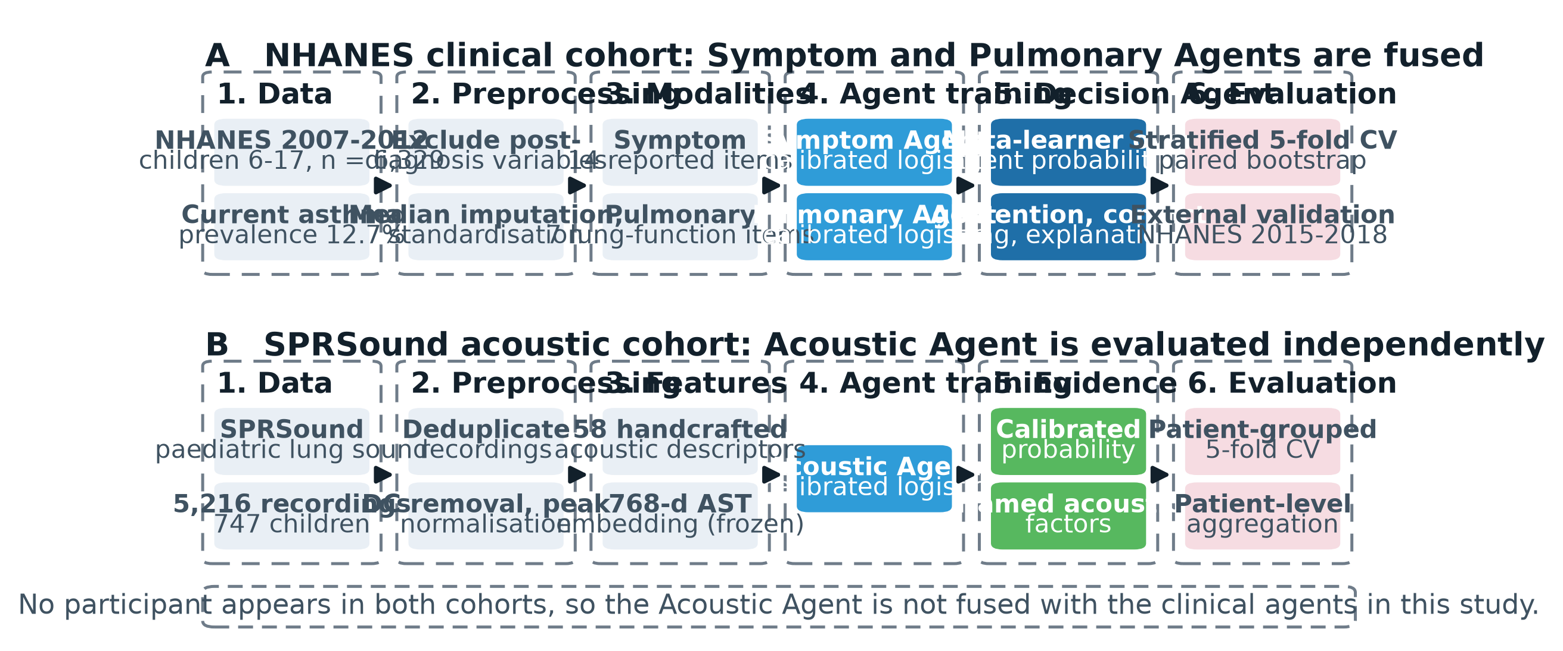
Figure 1. Data-processing and modelling pipeline. Lane A: NHANES children, whose Symptom and Pulmonary Agents are fused by the Decision Agent. Lane B: SPRSound children, whose Acoustic Agent is evaluated independently. No child appears in both cohorts.

Figure 2 shows how evidence flows through the framework. In panel A the Symptom and Pulmonary Agents, which are measured on the same children, each pass an evidence bundle to the Decision Agent. The Decision Agent combines the bundles with a logistic meta-learner. It refers the 15% of children whose fused probability lies nearest the operating threshold, and it flags a child as conflicted if the two agent probabilities differ by more than 0.35. The explanation is composed from the three largest Symptom Agent attributions together with the modality status and any conflict flag, and the output is one of the three decisions. In panel B the Acoustic Agent produces its own evidence bundle, which is evaluated on its own. The dashed arrow marks a connection that the design permits but that this study does not evaluate, because no cohort contains the same children measured both ways.
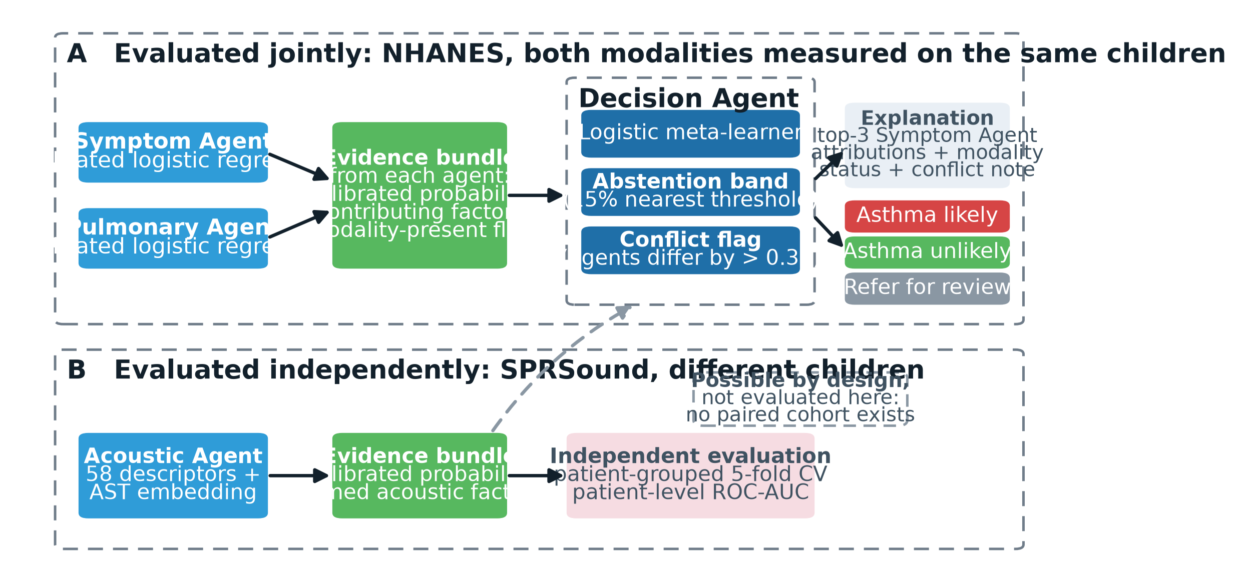
Figure 2. Evidence flow. Panel A: the Symptom and Pulmonary Agents, measured on the same children, pass evidence bundles to the Decision Agent, which combines them, refers borderline cases, flags disagreement and composes an explanation. Panel B: the Acoustic Agent is evaluated independently. The dashed arrow marks a connection permitted by the design but not evaluated in this study.

Taken individually, each agent is a conventional modality-specific classifier: the Symptom and Pulmonary Agents are regularised logistic models, and the Acoustic Agent is a logistic model over handcrafted features and spectrogram-transformer embeddings. What differs is the arrangement. The agents are trained on separate cohorts and never share a feature space, so no jointly-labelled dataset is required. Each agent keeps its own calibrated probability instead of contributing columns to a pooled vector, so agreement or disagreement between modalities can be read directly. The Decision Agent adds three mechanisms on top of the combination itself: referral of borderline cases, a disagreement flag and a composed explanation. A model that pools the same features can match the discrimination of this arrangement (Section 4.1). Whether the added mechanisms offer anything that a pooled model with the same output cannot is tested in Section 4.6, and the answer there is largely negative.

3.2 Clinical and physiological data
Data were drawn from the National Health and Nutrition Examination Survey (NHANES) [22], cycles 2007–2008, 2009–2010 and 2011–2012 (the respiratory questionnaire module was discontinued thereafter). The cohort was restricted to children aged 6–17 years.
The outcome was current asthma, defined as an affirmative response to doctor-diagnosed asthma (MCQ010) and to still having asthma (MCQ035). Controls were children never diagnosed. The label therefore records physician-diagnosed current asthma, not clinically present asthma: a child with asthma symptoms who has never been diagnosed is a control. This matters because the framework is motivated by under-diagnosis. The model learns to reproduce an existing diagnostic decision from symptoms, spirometry and background variables, so its positives are children who resemble those already diagnosed, and some of its apparent false positives may be undiagnosed asthma that the data cannot identify. Specificity and positive predictive value should be read with this in mind, and nothing here estimates how many undiagnosed cases the model would find. Children with former but not current asthma (n = 444) were excluded from the primary analysis. Their label is ambiguous for a detection task, since asthma in remission is neither a current case nor a clean control. Excluding them gives a cleaner contrast but narrows the intended population to children with no previous asthma diagnosis, the group a first-line case-finding step would address, and it leaves performance in children with a history of resolved asthma unknown.
Age at first diagnosis (MCQ025), asthma attack in the past year (MCQ040) and emergency care for asthma (MCQ050) were excluded because they are consequences of an existing diagnosis and would inflate performance without clinical meaning. The final cohort comprised 6,329 children, 805 with current asthma (12.7%).
NHANES uses a complex multistage probability design. The analyses reported here are unweighted: sampling weights, strata and primary sampling units were not used in model fitting, cross-validation, calibration or bootstrap intervals, and the three cycles were pooled without cycle-specific adjustment. The results therefore describe the analytic sample and not the US child population. NHANES oversamples some groups, so the sample composition differs from the population, and the 12.7% prevalence is a sample figure and not a national estimate. Children in the same sampling unit or household may be correlated, so bootstrap intervals that resample individual children are probably too narrow. Discrimination may be less affected by weighting than prevalence, calibration or predictive values, but this was not verified, none of these quantities was re-estimated under the survey design, and a population-level reading of the calibration and predictive-value figures is not justified.
The Symptom Agent used 14 features: wheeze in the past 12 months, number of wheeze attacks, exercise-induced wheeze, nocturnal dry cough, family history of asthma, household smoking, number of household smokers, age, sex, ethnicity, income-to-poverty ratio, household size, BMI and height. The wheeze items and nocturnal cough are core symptoms in the clinical diagnosis of asthma, which raises the diagnostic-incorporation issue examined in Section 4.3. The Pulmonary Agent used 7 features: FEV1, FVC, PEF, the FEV1/FVC ratio, height-normalised FEV1 and PEF, and log serum cotinine as an objective exposure biomarker. Spirometry or cotinine was available for 5,840 children (92.3%); 489 children (7.7%) had neither, which provides a natural missing-modality subgroup.

3.3 Acoustic data
The SPRSound paediatric respiratory sound database was used (CC BY 4.0). Recordings are 8 kHz mono, nominally 15.36 s, captured by digital stethoscope at multiple auscultation sites. After deduplication across challenge splits, 6,567 unique recordings were obtained; 6,177 carried a parseable patient identifier and 5,216 (747 children) carried a patient-level diagnosis.

Diagnosis | Children | Recordings
Pneumonia | 445 | 3,274
Bronchitis | 105 | 550
Control | 74 | 492
Asthma | 66 | 434
Other respiratory | 57 | 466

The 66 asthma cases are the binding constraint on this modality and are treated as such throughout.
Most of these children had pneumonia (445) or bronchitis (105), so the acoustic task is asthma against other respiratory conditions and controls and not detection in an unselected population.
The 58 handcrafted features were band-energy ratios over six physiologically motivated bands (60–150, 150–300, 300–600, 600–1200, 1200–2400, 2400–4000 Hz); spectral centroid, bandwidth, roll-off and flatness; zero-crossing rate; RMS energy; 13 MFCCs with standard deviations; onset strength and onset rate; and a wheeze-tonality measure defined as the ratio of peak to mean spectral magnitude within 100–1600 Hz, capturing the tonal character of continuous adventitious sound. Recordings were DC-removed and peak-normalised so that features reflect spectral shape rather than stethoscope pressure. In the band-energy ratio (Eq. 1), S(t,f) is the magnitude spectrogram and b a frequency band; the tonality measure (Eq. 2) is computed per frame t over the 100-1600 Hz range F.
Eb=t​f∈b​St,f2t​f​St,f2 (1)
Tt=maxf∈FSt,f1Ff∈F​St,f (2)
For the 768-dimensional deep embeddings, audio was resampled to 16 kHz and embedded with a frozen Audio Spectrogram Transformer pretrained on AudioSet [21]. As recordings exceed the pretrained model's default 10.24 s input window, overlapping windows were embedded and mean-pooled. The model was not fine-tuned: with 66 positive cases, fine-tuning would overfit.

3.4 Models and evaluation
All agents use L2-regularised logistic regression with median imputation and standardisation, wrapped in sigmoid calibration fitted on training data only. Calibration matters here because the Decision Agent compares agent probabilities directly; uncalibrated outputs would make one agent systematically dominant for reasons unrelated to evidence strength. The choice of a linear classifier is not assumed: random forests, gradient boosting and a feed-forward neural network were evaluated under identical folds and calibration, and are reported with Table 5. Sigmoid rather than isotonic calibration was used, isotonic regression being prone to overfitting at these sample sizes [23]; calibration is then measured rather than assumed [24].
$z_{ij}=\frac{x_{ij}−μ_{j}}{σ_{j}}$ (3)
$η_{a}\left(x_{i}\right)=β_{a0}+\sum_{j=1}^{p}{β_{aj}}z_{ij}$ (4)
$p_{a}\left(x_{i}\right)=\frac{1}{1+exp\left(A_{a}η_{a}\left(x_{i}\right)+B_{a}\right)}$ (5)
Here each feature of child i is standardised with the training-set mean μ and standard deviation σ of that feature, β are the logistic coefficients of agent a, and A and B are its sigmoid-calibration parameters fitted on training data. The clinical agents were evaluated by stratified five-fold cross-validation. The Acoustic Agent used stratified group five-fold cross-validation grouped on patient identifier, so recordings from one child never appear in both training and test partitions, and clip probabilities were averaged per child (Eq. 6, averaging over the recordings of child i) because the diagnosis concerns the child. Acoustic results are mean and SD across folds, since a single hold-out split is too unstable with 66 positive cases.
pi=1Rir∈Ri​pxr (6)
The Decision Agent is a logistic meta-learner over the agents' calibrated probabilities and an indicator that the pulmonary modality was observed, fitted within training folds only (Eq. 7), where σ is the logistic function, m is 1 when pulmonary data were observed and γ are fitted coefficients.
$p_{fused,i}=σ\left(γ_{0}+γ_{1}p_{sym,i}+γ_{2}p_{pul,i}+γ_{3}m_{i}\right)$ (7)
Referral withholds classification for the 15% of children whose fused probability lies closest to the operating threshold t (Eq. 8; Qα is the α-quantile, with α = 0.15, of the distance to t). Distance from the threshold was used rather than distance from the median prediction: at 12.7% prevalence the median predicted probability is about 0.05, so a quantile band would refer the model's most confident negatives instead of its borderline cases. The threshold is set for 90% sensitivity and fitted within training folds only. The conflict flag is raised when both modalities are observed and the Symptom and Pulmonary probabilities differ by more than τ = 0.35 (Eq. 9).
${refer}_{i}=1⇔\left|p_{fused,i}−t\right|≤Q_{α}\left(\left|p_{fused}−t\right|\right)$ (8)
${conflict}_{i}=1⇔\left|p_{sym,i}−p_{pul,i}\right|>τ \text{and} m_{i}=1$ (9)
The explanation combines the three largest Symptom Agent attributions with the modality status and any conflict flag. For the standardised linear agents the exact Shapley value [25] of feature j has a closed form (Eq. 10), where the bar denotes the mean of the standardised feature; attributions are on the log-odds scale of the linear predictor.
$φ_{aj}\left(x_{i}\right)=β_{aj}\left(z_{ij}−{\overset{‾}{z}}_{j}\right)$ (10)
Because the narrative is generated from the attributions, agreement between the two is guaranteed and uninformative. Faithfulness was therefore tested with the deletion measures of the ERASER benchmark [26] (Eqs. 11 and 12, Section 4.7). Comprehensiveness is the change in predicted probability when the cited features are replaced by their training medians (higher is better); sufficiency is the change when all other features are replaced (lower is better). Both are compared with replacing an equal number of randomly chosen features. Faithfulness here describes the relation between explanation and model, not plausibility to a reader [27], and the test applies to the Symptom Agent attributions only.
Performance was summarised by ROC-AUC, PR-AUC and the Brier score; accuracy was not used as a primary metric. PR-AUC is reported because ROC curves flatter classifiers at low prevalence (12.7% clinically, 8.8% acoustically), where the abundant negative class suppresses the false-positive rate [28].
Internal cross-validation does not establish transportability [29, 30], so an independent cohort was assembled from NHANES 2015-2016 and 2017-2018 (n = 4,111 children aged 6-17; 502 with current asthma, prevalence 12.2%), sharing no participants with the development cycles. NHANES retired the respiratory questionnaire and spirometry components after 2011-2012, so wheeze, nocturnal cough and FEV1/FVC are absent from later cycles and neither the full Symptom and Pulmonary Agents nor the Decision Agent can be evaluated out of era. Only a Symptom Agent re-fitted on the eleven variables measured identically in both eras (demographics, family history, household smoke exposure, anthropometry and serum cotinine) was validated. Imputation medians and scaling were estimated on development data alone, and the threshold was fixed on development out-of-fold predictions at 90% sensitivity. Discrimination, calibration intercept and slope, and the Brier score were reported [31], with percentile bootstrap intervals over 2,000 patient resamples. Reporting follows TRIPOD+AI [32, 33] and MINIMAR [34].
Models were compared with a paired bootstrap over patients, in which every model is scored on the same resampled children. This was preferred to DeLong's test [35] because the out-of-fold predictions come from separately fitted pipelines, and because the same procedure extends to the other contrasts reported. We used 10,000 resamples and report percentile intervals.
For the mechanisms of the Decision Agent we report the following, all from out-of-fold predictions. For referral, we report the size and asthma content of the referred group and the share of all classification errors that fall inside the referral band, compared with the share expected if the same number of children were referred at random. We also apply the same referral rule to the pooled-feature model. For the conflict flag, we test whether it carries information beyond the pooled-feature score by adding it to a logistic regression of the outcome on that score. Intervals are percentile bootstrap intervals over 4,000 resamples (2,000 for the odds ratio). The Decision Agent was run as a separate pipeline from the fusion analysis, with calibration and the meta-learner fitted again within folds, so its all-case ROC-AUC differs from that of the fusion analysis in the third decimal. Coverage was summarised by the number referred, the asthma cases in the band and the sensitivity among classified children, from which approximate case counts were derived.

4. RESULTS

4.1 Discrimination of the symptom, pulmonary and fused models
Table 2. Agent and fusion performance (n = 6,329).
Model | ROC-AUC | PR-AUC | Brier
Symptom Agent | 0.863 | 0.643 | 0.068
Pulmonary Function Agent | 0.646 | 0.238 | 0.106
Fusion (Decision Agent) | 0.871 | 0.657 | 0.068
Flat pooled-feature baseline | 0.867 | 0.655 | 0.067

Fusion reached ROC-AUC 0.871, against 0.863 for the Symptom Agent and 0.867 for the pooled-feature model (Table 2, Figure 3). Whether these differences exceed sampling noise is tested below.
The Pulmonary Agent's comparatively weak standalone performance (0.646) is consistent with asthma pathophysiology: lung function can be normal between exacerbations, so spirometry confirms obstruction when present but does not exclude asthma when absent.
The fused model is well calibrated (Brier 0.068), matching the flat baseline (0.067), and Figure 3(c) shows both tracking the diagonal closely. An earlier configuration of the meta-learner used class-weighting to balance the outcome classes, which fitted it to a 50/50 prior and inflated every fused probability (Brier 0.118); because its inputs are already calibrated probabilities, removing the class weighting restored calibration at no cost to discrimination.

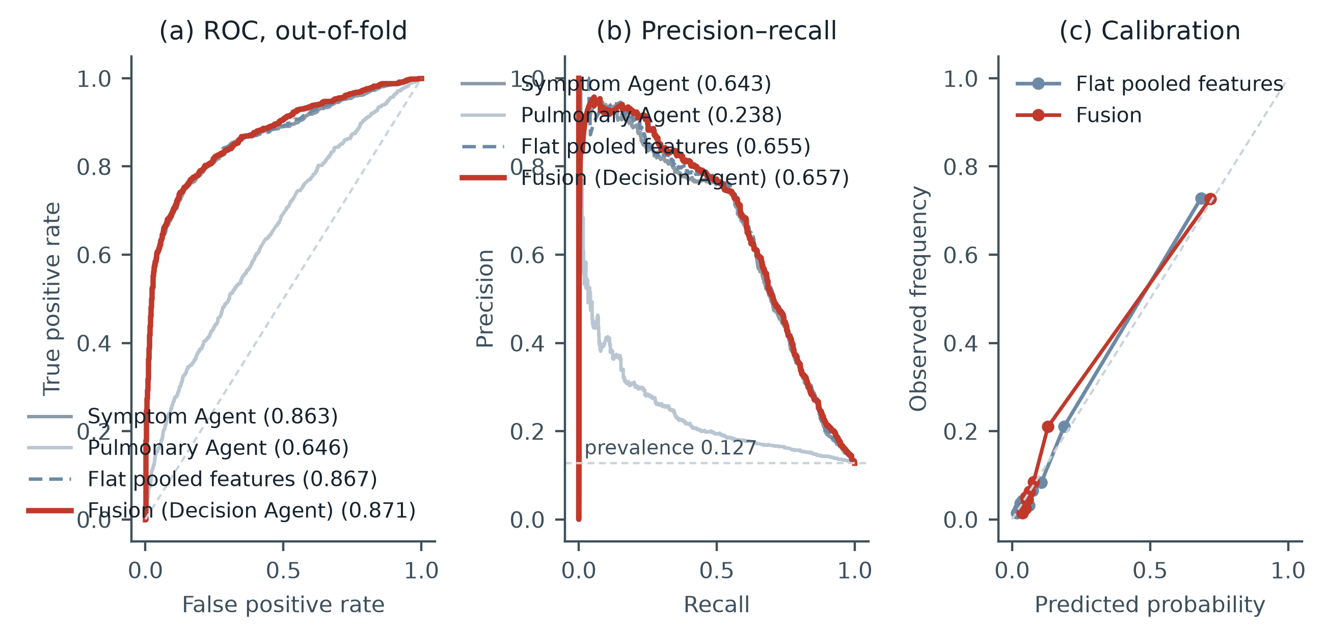
Figure 3. Clinical agent and fusion performance, out-of-fold (n = 6,329). (a) ROC: fusion and the flat baseline nearly coincide, both above the Pulmonary Agent alone. (b) Precision-recall, with the 0.127 prevalence floor marked. (c) Reliability curves in ten quantile bins: both models track the diagonal. The largest deviation is for fusion in one mid-range bin (predicted 0.13, observed 0.21); in the highest bin fusion is close to ideal (0.72, 0.73) and the flat model under-predicts slightly (0.68, 0.73).

A paired bootstrap over 10,000 resamples of the 6,329 children, scoring every model on the same resampled children, gave the contrasts in Table 3. Fusion exceeded the Symptom Agent by +0.008 (95% CI +0.001 to +0.016, p = 0.031), an interval that excludes zero. Against the pooled-feature model the difference was +0.004 (95% CI -0.001 to +0.009, p = 0.094), an interval that includes zero. Decision-level fusion therefore improves on the strongest single modality by a small margin whose interval only just excludes zero, and has not been shown to improve on a conventional pooled-feature model. The p-values are unadjusted for the three contrasts in Table 3. No claim of superior discrimination is made for the framework.
Table 3. Discrimination and paired contrasts on the NHANES cohort (n = 6,329; 805 with current asthma). Intervals are percentile bootstrap intervals over 10,000 paired resamples; contrasts score every model on identical resampled patients.
Model or contrast | ROC-AUC or difference | 95% CI | Interpretation
Symptom Agent | 0.863 | 0.846-0.879 | Single modality, reported history
Pulmonary Agent | 0.646 | 0.626-0.667 | Single modality, spirometry
Flat pooled-feature model | 0.867 | 0.851-0.883 | Baseline without agent structure
Decision-level fusion | 0.871 | 0.855-0.886 | Proposed framework
Fusion - Symptom Agent | +0.0081 | +0.0008 to +0.0158 | Distinguishable from zero (p = 0.031)
Fusion - flat model | +0.0041 | -0.0007 to +0.0088 | Not distinguishable from zero (p = 0.094)
Flat model - Symptom Agent | +0.0041 | -0.0005 to +0.0089 | Not distinguishable from zero (p = 0.085)

Because discrimination cannot separate the two designs, any justification for the Decision Agent has to come from what its mechanisms contribute. Section 4.6 tests that directly.

4.2 Operating points and classification performance
Discrimination measures ranking, not the decisions a deployed system would make. Table 4 and Figure 4 report the confusion structure at two operating points.
Table 4. Classification performance at two operating points (n = 6,329).
Metric | Default threshold (0.50) | High-sensitivity threshold (0.05)
TP | 408 | 724
FP | 125 | 2,671
FN | 397 | 81
TN | 5,399 | 2,853
Sensitivity | 0.507 | 0.899
Specificity | 0.977 | 0.516
PPV | 0.765 | 0.213
NPV | 0.932 | 0.972
Accuracy | 0.918 | 0.565
F1 | 0.610 | 0.345
Balanced acc. | 0.742 | 0.708

At the default 0.50 cut-off the model misses 397 of 805 children with asthma (sensitivity 0.507, specificity 0.977). Because the fused probabilities are calibrated to the observed 12.7% prevalence rather than to a balanced prior, comparatively few cases exceed 0.50 at all. Accuracy at this threshold is 0.918, but predicting no asthma for every child would score 0.873, so accuracy earns a margin of only 4.5 points and is a weak summary under class imbalance. For case finding in a setting where asthma is already under-diagnosed, the false-negative rate is the binding failure, because the children missed are those the system exists to identify. This is a property of the threshold and not of the model, and it shows why 0.50 is an unsuitable operating point for a calibrated case-finding tool.
Lowering the threshold to 0.05 recovers 90% of cases (sensitivity 0.899) and raises negative predictive value to 0.972, at the cost of specificity 0.516: about 48% of children without a diagnosis are referred for further assessment. Positive predictive value falls to 0.213, so four in five flagged children do not have a diagnosis. Whether that is acceptable depends on what a positive flag triggers: it is defensible if the consequence is a clinical review and indefensible if it is treatment. Both operating points are reported rather than the one that flatters the model, and the appropriate threshold is a clinical decision, not a statistical one.
At this high-sensitivity threshold the model behaves as a first-pass case-finding step for physician-diagnosed asthma that misses about one affected child in ten. Whether the referral burden is acceptable, and whether the flagged children include undiagnosed asthma, cannot be judged from these data (Section 3.2). A positive result indicates a need for assessment, not a diagnosis. Calibration is reported alongside discrimination because a probability consumed by a downstream decision layer must be calibrated as well as discriminative [24].

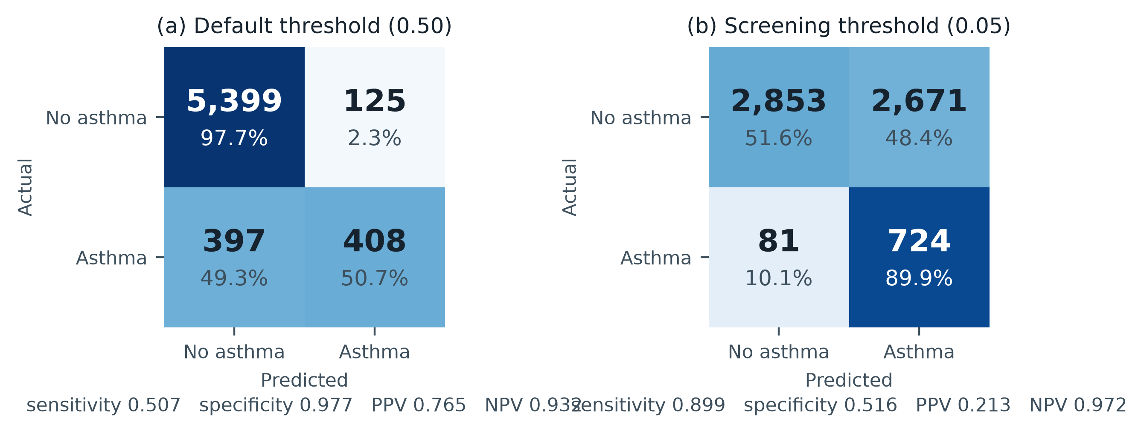
Figure 4. Confusion matrices at the default and 90%-sensitivity thresholds. Counts are absolute; percentages are row-normalised.

4.3 Feature attribution and diagnosis-proximal items
As Figure 5 shows, mean absolute SHAP values ranked wheeze attack frequency (0.094), wheeze in the past 12 months (0.089) and family history of asthma (0.089) highest, followed by exercise-induced wheeze (0.038). Odds ratios from the logistic Symptom Agent were consistent: wheeze in the past 12 months OR 2.46, family history OR 1.81, number of household smokers OR 1.37, exercise-induced wheeze OR 1.30.
These are established clinical predictors, which supports face validity, but they are also the items closest to the diagnosis itself. Wheeze frequency, recent wheeze, exercise-induced wheeze and nocturnal cough are symptoms that inform a physician's diagnosis, so the Symptom Agent may partly reproduce diagnostic criteria instead of identifying asthma independently of them. This diagnostic incorporation limits what the discrimination figures mean for under-diagnosed children, whose symptoms may not have been elicited or recognised. A finer sensitivity analysis that removes individual diagnosis-proximal items was not completed for this revision because the exported 14-column feature matrix was not available alongside the manuscript and stored predictions. The eleven-variable model of Section 4.8 therefore remains a coarse substitute: it omits all four symptom items and the spirometry variables and keeps demographics, family history, household smoke exposure, anthropometry and cotinine. Its cross-validated ROC-AUC was 0.733, against 0.867 for the full model (Table 12). Most of the discrimination therefore depends on diagnosis-proximal items, and the framework's performance should be read as performance given those items and not as an independent signal of asthma.

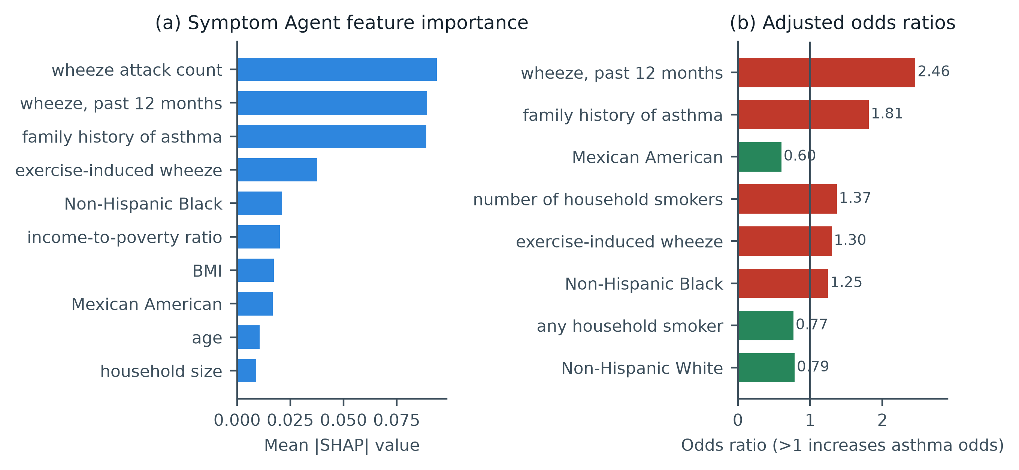
Figure 5. Symptom Agent attribution. (a) Mean |SHAP| for the ten strongest features; wheeze frequency, recent wheeze and family history dominate. (b) Odds ratios for the eight features furthest from unity, coloured by direction of effect (ethnicity per NHANES RIDRETH1).

4.4 Choice of classifier for the Symptom Agent
Table 5 tests whether the modest discrimination reflects the choice of a linear classifier. Random forests, gradient boosting and a feed-forward neural network were evaluated on the symptom feature set under identical folds, imputation, scaling and sigmoid calibration, so that the classifier is the only thing that differs. None improved on regularised logistic regression: 0.861, 0.853 and 0.861 mean fold ROC-AUC respectively against 0.868 (a mean of fold-level values, which is a different quantity from the 0.863 computed on pooled out-of-fold predictions in Table 2). All differences fall within fold-to-fold variation, whose standard deviation ranges from 0.019 to 0.028. Substituting the strongest alternative into the fusion lowered fused ROC-AUC from 0.871 to 0.865. These results suggest that the limiting factor is the information carried by fourteen symptom-modality items, most of them self-reported, and not the capacity of the model fitted to them, at least among the model families tried; the simpler classifier is retained because it is also the one whose coefficients admit exact Shapley attribution.
Table 5. Symptom-agent performance by model class (n = 6,329; identical folds and calibration). Fused ROC-AUC is reported for the logistic agent and for the strongest alternative.
Symptom-agent model | ROC-AUC (mean ± SD) | PR-AUC (mean ± SD) | Brier | Fused ROC-AUC
Logistic regression (reported) | 0.868 ± 0.023 | 0.654 ± 0.033 | 0.068 | 0.871
Random forest | 0.861 ± 0.025 | 0.657 ± 0.046 | 0.067 | 0.865
Gradient boosting | 0.853 ± 0.028 | 0.645 ± 0.040 | 0.069 | —
Neural network (64-32) | 0.861 ± 0.019 | 0.645 ± 0.057 | 0.069 | —

4.5 Acoustic Agent: representation comparison and two-stage architecture

Table 6. Acoustic representation comparison (747 children, 66 asthma; patient-grouped CV, patient-level aggregation).
Representation | ROC-AUC | PR-AUC
Handcrafted (58) | 0.683 ± 0.057 | 0.214
AST embeddings (768) | 0.730 ± 0.080 | 0.306
AST + PCA-32 | 0.658 ± 0.058 | 0.227
Combined | 0.732 ± 0.083 | 0.304
Combined + PCA-64 | 0.712 ± 0.062 | 0.225

Table 6 compares the five acoustic conditions. The prevalence floor for PR-AUC is 0.088; the combined model therefore represents a 3.4-fold lift. Dimensionality reduction lowered the point estimates, but within fold-to-fold variation (Section 4.5), so any conclusion about how the signal is distributed across embedding dimensions is tentative.
These conditions should not be read as ranked. Figure 6(a) shows fold-to-fold variability (SD 0.057-0.083) that is large relative to the differences between representations: the combined and AST-only conditions differ by 0.002, far inside one standard deviation, and even the handcrafted condition overlaps both. With 66 positive cases the study is not powered to separate them. We therefore report that the combined representation scored highest and use it as the default Acoustic Agent because it combines handcrafted and embedding information, without claiming it is superior to either component alone. All comparisons among acoustic representations are exploratory.
With 66 children with asthma, the acoustic evaluation supports much weaker conclusions than the survey analysis. The 434 asthma recordings come from those 66 children, about 6.6 recordings each, so they are not independent observations and the effective sample for asthma is closer to 66 than to 434. For that reason partitions are grouped by child and recordings are averaged per child. For the handcrafted representation, whose out-of-fold predictions are retained, a patient-level bootstrap interval (10,000 resamples) spans 0.614 to 0.754, a width of 0.140. The +0.050 between the combined and handcrafted representations is about 1.1 standard errors across five folds. Resolving a difference of this size would probably take many more affected children than 66; no formal power calculation was done.
Motivated by clinical reasoning — a clinician identifies sounds, then infers a diagnosis — a two-stage agent was also tested: acoustic event detection followed by patient-level diagnosis from the detected event profile. Table 7 gives the decomposition and Figure 6(b) plots it.

Table 7. Two-stage decomposition.
Component | Performance
Stage 1: CAS (wheeze/rhonchi) detection | ROC-AUC 0.799 ± 0.056
Stage 1: DAS (crackle) detection | ROC-AUC 0.751 ± 0.064
Stage 2 from event probabilities only | ROC-AUC 0.647 ± 0.083
Stage 2 from events + acoustic aggregate | ROC-AUC 0.717 ± 0.077
Stage 2 from acoustic aggregate only | ROC-AUC 0.724 ± 0.064

Event detection is accurate, but restricting stage 2 to event probabilities loses discrimination. This is interpretable: wheeze is not specific to asthma — bronchitis and pneumonia also produce adventitious sound — so event presence alone under-determines the diagnosis. The event layer is nevertheless retained in the framework because it supplies clinically nameable evidence for the explanation layer at negligible cost in discrimination (0.717 vs 0.724).

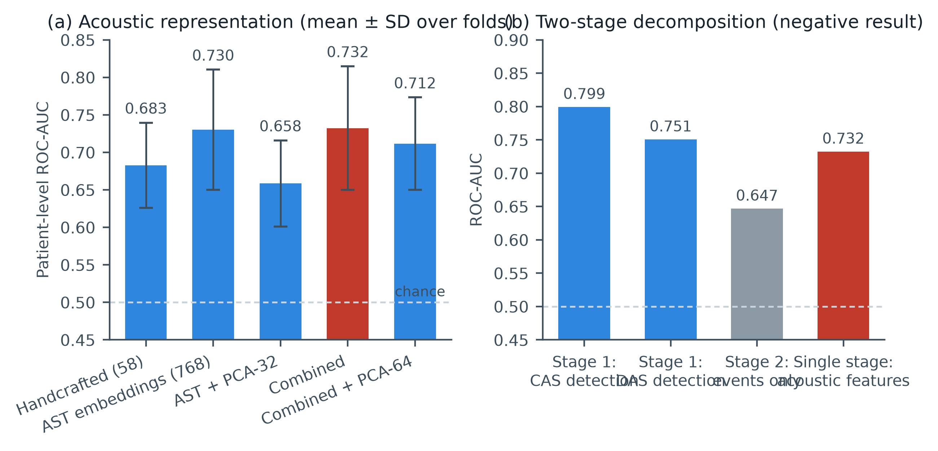
Figure 6. Acoustic Agent. (a) Patient-level ROC-AUC by representation (mean ± SD); combined is best but overlaps AST-only within one SD. (b) Two-stage decomposition: event detection is accurate, but restricting diagnosis to event probabilities loses discrimination.

4.6 Missing modality, abstention and conflict detection

Table 8. Performance by modality availability.
Condition | n | Fusion ROC-AUC | Symptom-only
Spirometry present | 5,840 | 0.873 | 0.865
Spirometry absent | 489 | 0.846 | 0.837

Table 8 reports performance by modality availability. Loss of an entire modality cost 0.027 ROC-AUC. The framework continues to operate rather than failing; its use in practice was not evaluated. Figure 7(b) shows fusion retains a small advantage over symptoms alone in both subgroups.
A higher AUC at a given coverage, or a high asthma prevalence in a flagged group, does not by itself show that a mechanism helps case finding. We therefore describe the groups themselves and compare each mechanism with what the pooled-feature model already provides.
The referral band contained 950 children (15.0%), of whom 41 (5.1% of the 805 with asthma; 95% CI 3.6% to 6.6%) had asthma (Table 9). Prevalence was 4.3% among referred and 14.2% among retained children, so the band consists mostly of low-risk children near the threshold. It held 15.9% (14.6% to 17.3%) of all classification errors against 15.0% expected for random referral, but that count is dominated by false positives. The reported sensitivities imply a different picture for missed cases: about 723 children with asthma were flagged positive without referral and about 709 with referral, so roughly 14 of the 41 cases in the band lay above the threshold and about 27 below it. About a third of the roughly 82 cases missed at the high-sensitivity threshold therefore fell inside the band, against 15% expected at random. These counts are derived from rounded rates, are approximate and carry no confidence interval; the overall error share above (15.9% against 15.0% expected) cannot be distinguished from chance, so the concentration of missed cases is a descriptive observation and not an established effect. The cost is 950 referrals, 909 of them for children without asthma, or about 35 referrals for each missed case brought to review.
Among classified children, sensitivity rose from 0.898 to 0.928, NPV from 0.972 to 0.977 and ROC-AUC from 0.872 to 0.884 (+0.012; +0.006 to +0.019). These figures exclude the 41 unclassified children with asthma and are not a gain in cases found: about 709 of 805 (88%) were flagged positive by the classified route, and the rest depended on clinical review. Specificity and PPV among retained children were not recomputed. Because the band holds the lowest-probability flagged children, whose asthma prevalence should be below that of flagged children overall, PPV would be expected to rise, but the size of the change is unknown; the direction of change in specificity depends on how the band's children without asthma split about the threshold, which is not reported. The pooled-feature model gave a similar profile under the same rule (AUC 0.867 to 0.883; 13.1% of errors in the band), so the rule is not specific to the Decision Agent. Because the band is symmetric about the threshold and a positive result already triggers assessment, referring the band flags the same children as lowering the threshold to the band's lower edge would; any advantage of referral over a lower threshold therefore depends on how review handles the band children above the threshold, which these data cannot show. Referral as defined removes low-risk borderline children and may concentrate some missed cases, but its effect on referral decisions and workload is untested, and a rule driven by predictive uncertainty as in [20] would need separate design and testing.
Table 9. Referral band under the Decision Agent and under the pooled-feature model with the same rule (n = 6,329). Counts marked approximate are derived from the reported rates. Operating points use the per-fold 90%-sensitivity thresholds of the Decision Agent pipeline and so differ slightly from Table 4; ROC-AUC is from the Decision Agent run (Section 3.4).
Quantity | Decision Agent (fusion) | Pooled-feature model | Random referral (expected)
Children referred (retained) | 950 (5,379 retained, 85.0%) | 950 (5,379 retained, 85.0%) | same number
Children with asthma in the band | 41 (5.1%) | 46 (5.7%) | about 15% of cases
Children without asthma referred | 909 | 904 | not applicable
Prevalence, referred / retained | 4.3% / 14.2% | 4.8% / 14.1% | 12.7% / 12.7%
Share of all errors in the band | 15.9% (14.6% to 17.3%) | 13.1% | 15.0%
Share of missed cases in the band | 27/82 = 32.9% (23.0% to 43.2%) | 30/89 = 33.7% (24.1% to 43.8%) | 15%
Cases flagged positive, all / classified | 723 / 709 | 716 / 700 | not applicable
ROC-AUC, all / retained | 0.872 / 0.884 | 0.867 / 0.883 | no change expected
Sensitivity, all / retained | 0.898 / 0.928 | 0.889 / 0.922 | no change expected
NPV, all / retained | 0.972 / 0.977 | 0.969 / 0.974 | no change expected
Specificity, retained | 0.513 | 0.476 | not applicable
PPV, retained | 0.240 | 0.224 | not applicable

The conflict flag was raised for 511 children (8.1%), including 374 of the 805 with asthma (46.5%); prevalence was 73.2% in flagged and 7.4% in unflagged children (Table 10). In 491 of the 511 the Symptom Agent gave the higher probability, the pattern of reported symptoms with unremarkable spirometry (asthma prevalence 75.2%); in the other 20 the Pulmonary Agent was higher (25.0%). The group is clinically coherent, since lung function can be normal between exacerbations, but it does not show that the flag improves decisions. The pooled-feature model at its own high-sensitivity threshold already classified every flagged child with asthma as positive (miss rate 0.0%, against 20.6% among unflagged children), and once the pooled score was known the flag added no detectable information (odds ratio 1.23, 95% CI 0.85 to 1.77, an interval wide enough not to exclude a modest effect; likelihood-ratio p = 0.31; AUC unchanged at 0.867). In these data it describes a group the score already identifies and did not find cases the score missed.
Table 10. Children flagged for inter-agent conflict (n = 6,329). The pooled-feature model is evaluated at its own 90%-sensitivity threshold.
Quantity | Conflict-flagged | Not flagged | Comment
Children | 511 (8.1%) | 5,818
Children with asthma | 374 | 431 | 46.5% of all cases are flagged
Asthma prevalence | 73.2% | 7.4% | cohort 12.7%
Symptom Agent probability higher | 491 (75.2% asthma) | - | reported symptoms with unremarkable spirometry
Pulmonary Agent probability higher | 20 (25.0% asthma) | -
Asthma cases missed by the pooled-feature model | 0.0% | 20.6% | share classified negative
Odds ratio for the flag beyond the pooled score | 1.23 (0.85 to 1.77) | - | p = 0.31; AUC 0.867 to 0.867

These analyses are statistical. They show that the referral band is dominated by low-risk children and that the flagged group is a high-prevalence subgroup already captured by the pooled score. Whether either mechanism changes clinical decisions, reduces missed cases in practice or improves outcomes would need a prospective study in which clinicians act on the outputs. Both mechanisms are retained as specified and characterised components, and no clinical benefit is claimed for either.

4.7 Explanation integration and faithfulness
Explanations were assembled from the top-3 attributions of the Symptom Agent together with modality-availability and conflict status, for example:
"Asthma likelihood 53% - asthma likely. Principal contributing factors: wheezing in the past 12 months (increasing risk); nocturnal dry cough (increasing risk); no family history of asthma (decreasing risk). Note: the clinical and Pulmonary Agents disagree materially; clinical review is recommended."
Because the narrative is generated from the attributions, asking whether it cites features the model used is true by construction and uninformative. We therefore evaluate faithfulness by deletion, against a control in which an equal number of randomly chosen features is manipulated.
$comp=\frac{1}{N}\sum_{i=1}^{N}{\left[p\left(x_{i}\right)−p\left(x_{i}^{\backslash R_{i}}\right)\right]}$ (11)
$suff=\frac{1}{N}\sum_{i=1}^{N}{\left[p\left(x_{i}\right)−p\left(x_{i}^{R_{i}}\right)\right]}$ (12)
Here R is the set of the three cited features for a child, the superscript ∖R marks the feature vector with those features replaced by training medians, the superscript R marks the vector with all other features replaced, and N is the number of children.

Table 11. Explanation faithfulness (top-3 cited features).
Metric | Cited | Random control | Ratio
Comprehensiveness (higher better) | 0.0991 | 0.0344 | 2.9×
Sufficiency (lower better) | 0.0189 | 0.0854 | 4.5×

Removing the cited features changed the predicted probability 2.9 times more than removing random features, and retaining only them nearly reproduced the full prediction (Table 11). Within the Symptom Agent, the cited features therefore account for the prediction in the deletion sense.
The scope of this test is narrow. It evaluated only the three Symptom Agent attributions. It did not evaluate the Pulmonary Agent attributions, the modality statement, the conflict note, the referral recommendation or the wording of the composed narrative, and it did not test whether clinicians understand or use the explanation. A linear model would be expected to pass the same test, so the result shows that the attributions describe the model that produced them, not that they are better than those of a pooled model. Median replacement has a further limit: it can create feature combinations that do not occur in real children, for example recent wheeze combined with a typical low number of wheeze attacks, and such combinations may exaggerate or understate the effect of deleting correlated features. Conditional or joint imputation would be a more realistic perturbation and was not used. Conclusions about explanation reliability are limited to this deletion test of Symptom Agent attributions.

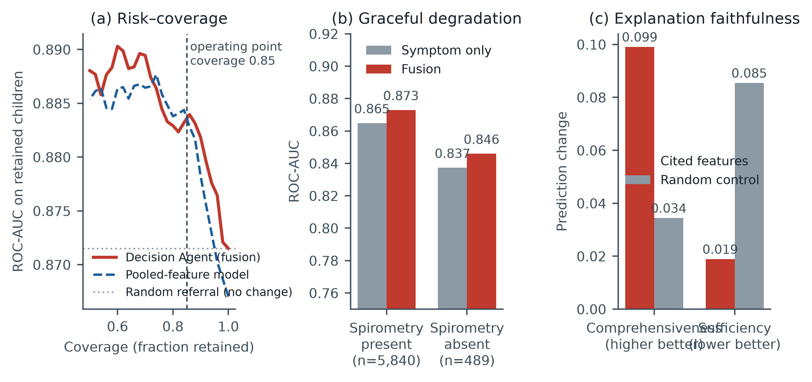
Figure 7. Decision Agent behaviour. (a) Risk-coverage under the referral rule of the Decision Agent (solid) and the same rule applied to the pooled-feature model (dashed); random referral leaves ROC-AUC unchanged (dotted). Discrimination among retained children rises to 0.884 at 85% coverage; Table 9 gives the composition of the referral band. (b) Degradation by modality availability. (c) Explanation faithfulness: deleting cited features changes predictions 2.9 times more than deleting random features.

4.8 Temporal validation of the reduced Symptom Agent (NHANES 2015-2018)
This analysis validates only the eleven-variable Symptom Agent. It does not validate the Pulmonary Agent, fusion, referral, conflict flagging or explanations, because the variables they need were retired after 2011-2012, and it should not be read as external validation of the framework.
Table 12 gives the full comparison. On 4,111 children sampled three to eleven years after the development cycles, ROC-AUC was 0.727 (95% CI 0.702-0.751) against 0.733 under internal cross-validation of the same eleven variables, a gap of less than 0.01, well inside the bootstrap interval. The Brier score was similar out of era (0.0988 against 0.1001). The two validation cycles gave similar results, 0.713 for 2015-2016 and 0.745 for 2017-2018, so the result does not appear to be carried by a single survey wave.
The calibration slope was 0.950 and the intercept -0.147, against ideal values of one and zero, and mean predicted risk was 0.128 against an observed prevalence of 0.122. Decalibration is a common failure of transported risk models [24], so the small calibration shift seen here is at least as relevant as the discrimination figure. The Decision Agent compares agent probabilities directly, so a model whose probabilities drifted would degrade fusion even where its ranking survived. The threshold fixed on development data likewise held its operating point, giving 91.4% sensitivity externally against 90.1% internally, with specificity unchanged at 0.249.
The full 21-variable model reached ROC-AUC 0.867 under internal cross-validation and the eleven transportable variables 0.733; the difference of 0.134 estimates what reported respiratory symptoms and spirometry contribute and argues for continuing to collect them. At 90% sensitivity the reduced model's specificity of 0.249 is too low to be useful alone. The analysis therefore supports transportability of one reduced component across survey eras within one national survey. It does not support generalisability of the framework, of the full model or to other populations.
Table 12. Temporal validation of the eleven-variable Symptom Agent; the 21-variable column is an internal reference and was not validated out of era. The development and validation cohorts share no participants. The fixed threshold is set once on development data at 90% sensitivity and applied unchanged.
Metric | Published internal (21 var) | Transportable internal (11 var) | Temporal 2015-2018 (11 var)
Children, n | 6,329 | 6,329 | 4,111
Asthma prevalence | 12.7% | 12.7% | 12.2%
ROC-AUC | 0.867 | 0.733 | 0.727 (0.702-0.751)
PR-AUC | 0.655 | 0.310 | 0.264
Brier score | 0.0669 | 0.1001 | 0.0988
Sensitivity at fixed threshold | - | 0.901 | 0.914
Specificity at fixed threshold | - | 0.249 | 0.249
Calibration slope | - | - | 0.950
Calibration intercept | - | - | -0.147

5. DISCUSSION

5.1 Interpretation of the fusion result
The main result is modest. Fusion improved only slightly on the Symptom Agent and matched, but did not exceed, a model that pooled the same features. We read this as a ceiling set by the information in the inputs and not by the fusion method: in these data reported symptoms carry most of the available signal, and replacing the logistic classifier with forests, boosting or a neural network did not help (Section 4.4).
The pulmonary modality contributes little alone and little in combination. One plausible explanation is that asthma is episodic and spirometry between exacerbations can be normal, so a normal result does not argue against asthma, while an abnormal one adds specificity that symptoms mostly already supply; other explanations, such as the quality or timing of survey spirometry, were not examined. The same reasoning would account for the conflict group, which was mostly symptomatic children with unremarkable spirometry whom the Symptom Agent already scores highly. A small gain from spirometry is what a cross-sectional design could show whether or not the decoupled architecture is useful, so it says little for or against the architecture. Whether larger multimodal gains reported elsewhere reflect added modalities that encode diagnosis-consequent information cannot be judged from these data.
The symptoms themselves raise a related problem. Because wheeze and cough items underlie diagnosis, a model built on them partly reproduces diagnostic practice, and removing them together with spirometry lowered ROC-AUC substantially (Section 4.3). The framework's discrimination is therefore largely the discrimination of diagnosis-proximal reporting. For under-diagnosis, the relevant question is whether a model finds asthma in children nobody has yet recognised, and a label that is itself a diagnosis cannot answer it; some false positives at the high-sensitivity threshold may be such children.

5.2 Relation to previous work
Higher headline figures in earlier studies are not evidence that those methods are better, and our lower figures are not evidence that our method is worse. The tasks, labels and evaluation protocols differ: classifying two-second sound segments [8] or wheeze against other sounds [7, 9] is a different task from assigning a diagnosis to a child, and the birth-cohort model [3] works over a short horizon with wheeze as its dominant predictor. Table 13 therefore compares methodological features and not performance. The closest comparator is Xie and Xu [5], who also predict youth asthma from national survey data, with validation on a later survey year (ROC-AUC 0.765 internally with undersampling, 0.746 on the later year); their strongest predictor, prescription medication in the past year, may reflect existing asthma treatment and is excluded here. Claims of superiority would require the same dataset and evaluation protocol, which none of these studies share.
Table 13. Methodological comparison with recently reported approaches. Study data and tasks are summarised in Table 1. Reported performance is omitted because tasks, labels and evaluation protocols differ; the table does not support claims of superiority.
Study | Splitting and leakage control | Independent validation | Explanation tested
This work | Post-diagnosis variables excluded; patient-grouped acoustic folds | Temporal check of the 11-variable Symptom Agent only (NHANES 2015-2018) | Deletion test of Symptom Agent attributions only
Xie and Xu [5] | Top predictor is prescription medication, which may reflect existing asthma treatment (acknowledged by the authors) | Later survey year (NHIS 2023, n = 4,919) | No, SHAP displayed only
He et al. [3] | Short prediction horizon; wheeze is the dominant predictor | No | No
Kim et al. 2025 [7] | Splitting unit not stated | No | No, Score-CAM assessed qualitatively
Kim et al. 2022 [9] | Splitting unit not stated | No | No
Ehtesham et al. [8] | Split on clip embeddings; no patient or recording grouping reported | No | No
Saky et al. [10] | Patient-level partitioning stated | No | No, three attribution methods, none verified
Bose et al. [6] | Predicts persistence among children already diagnosed at ages 2-5; not detection | No | No

5.3 What each component adds
Table 14 sets each component against the simpler alternative it would have to beat. None cleared that bar on the available evidence. What remains is narrower. Combining calibrated per-modality probabilities showed no detectable loss relative to pooling in the one setting where this could be tested (difference +0.004, 95% CI -0.001 to +0.009); the framework continues to run when spirometry is absent, with a lower ROC-AUC in those children (0.846 against 0.873 where spirometry was present; the two groups are different children); and the evidence bundle gives disagreement and explanation a defined place. Whether agents trained on different cohorts can be combined without loss was not tested, so the main motivation for decoupling, avoiding the need for paired cohorts, remains a design property that this study did not demonstrate at the patient level.
Table 14. Evidence for each component of the framework against a simpler comparator.
Component | Comparator | Result | Interpretation
Decision-level fusion | Symptom Agent; pooled-feature model | ROC-AUC +0.008 (+0.001 to +0.016) and +0.004 (-0.001 to +0.009) | Small gain over one modality; none shown over pooling
Missing-modality operation | Symptom-only; median-imputed pooled; simple average | Absent: 0.846 vs 0.841 vs 0.836; present: 0.873 vs 0.869 vs 0.865 | Runs without spirometry; fusion exceeds both simple comparators descriptively
Referral band | Random referral; same rule on pooled model | 15.9% of errors vs 15.0% random; 27/82 missed cases (32.9%, 23.0%-43.2%); 909 non-asthma referrals | Descriptive concentration with interval; retained specificity 0.513 and PPV 0.240; clinical effect untested
Conflict flag | Pooled-feature score | Odds ratio 1.23 (0.85 to 1.77); AUC unchanged | No detectable information added
Explanation composition | Random-feature deletion | Comprehensiveness 2.9 times, sufficiency 4.5 times lower | Faithful for Symptom Agent attributions; not compared with pooled model; clinical use untested
Acoustic representations | Handcrafted, AST and combined | 0.683, 0.730 and 0.732 (SD 0.06-0.08) | Not separable with 66 cases

The referral and conflict results illustrate a general point: a mechanism can describe a clinically coherent group without improving decisions beyond the score that already identifies it. The exact out-of-fold analysis placed 27 of 82 missed cases (32.9%, 95% CI 23.0% to 43.2%) in the 15% referral band, while the band contained 15.9% of all errors (95% CI 14.6% to 17.3%), close to the 15.0% random-referral expectation. It therefore offers a descriptive concentration of missed cases at the cost of 909 referrals of children without asthma; a direct lower-threshold comparison was not estimated from the stored outputs. Decision-curve analysis or a prospective study would be needed to judge whether that trade-off is worthwhile. Decision-curve analysis [37] or a prospective study would be needed to judge whether that is worthwhile. Children given a high asthma likelihood who carry no diagnosis were seen on inspection but not characterised; under the label discussed above, some may have undiagnosed asthma.

5.4 The acoustic evaluation and the scope of multimodality
The acoustic findings are the weakest part of the evidence. With 66 children with asthma, the patient-level bootstrap interval for the handcrafted representation is wide (Section 4.5), and the differences among handcrafted, AST and combined representations lie well inside fold-to-fold variation, so they should not be ranked. The comparison group is mostly children with pneumonia or bronchitis, which makes the task asthma against other respiratory disease and not detection in a general population, and recordings from one centre and device limit transfer. The event layer of the two-stage agent lost little discrimination (Section 4.5) and was kept for the nameable evidence it supplies, not because it was shown to help.
Most importantly, the clinical and acoustic cohorts come from different countries and share no children. The study shows fusion of two modalities within NHANES and acoustic classification within SPRSound. It does not show integration of symptoms, spirometry and lung sounds in one patient, and no figure here should be read that way.

5.5 Limitations
The label is physician-diagnosed current asthma, so undiagnosed children are controls, and the 444 children with former asthma were excluded. Symptom items that underlie diagnosis dominate the model, and only a coarse substitute for a sensitivity analysis was performed. The NHANES analyses were unweighted and ignore the survey design, so they describe the sample and not the US child population, and bootstrap intervals are probably too narrow. The clinical data are from 2007-2012, the outcome is parent- or self-reported diagnosis and not independent adjudication, and the temporal check covered only eleven variables; the ROC-AUC of 0.871 is an internally cross-validated figure and has not been reproduced on an independent cohort, a boundary that matters because external validation is often omitted and internal performance optimistic [36]. The faithfulness test covered Symptom Agent attributions under median replacement and nothing else. The referral band was fixed at 15% and not tuned, and the net clinical benefit of referral and conflict flagging is untested. The data come from the United States and China, and maternal risk models built on public benchmark data lost discrimination and calibration in Nigerian hospital records in our earlier study [38]; this framework has not been evaluated in such a setting.

6. CONCLUSIONS
We examined a modality-decoupled framework for childhood asthma detection and asked what its mechanisms add beyond simpler models. In 6,329 NHANES children, decision-level fusion of symptom and spirometry agents (ROC-AUC 0.871) improved slightly on the Symptom Agent (+0.008; 95% CI +0.001 to +0.016) and was not distinguishable from a pooled-feature model (+0.004; 95% CI -0.001 to +0.009). At a threshold set for 90% sensitivity, specificity was 0.516 and PPV 0.213; the default threshold found only half of cases and is unsuitable for case finding. The target was physician-diagnosed current asthma, and discrimination depends heavily on symptom items closely tied to diagnosis.
The referral band and conflict flag did not show benefit beyond the pooled score; referral concentrated some missed cases but required many referrals of children without asthma. Deletion tests supported the faithfulness of Symptom Agent attributions, and only those. An eleven-variable Symptom Agent showed similar discrimination and adequate calibration in NHANES 2015-2018, which is a temporal check of one reduced component. The Acoustic Agent was evaluated alone on 66 children with asthma, and its representations cannot be ranked.
The results support an evaluation, under patient-grouped splitting and training-fold-only fitting, of what each mechanism does and does not add. They do not support claims of improved accuracy, clinical utility, screening effectiveness or generalisability of the whole framework, and fusion of all three modalities in the same patients remains untested. Future work needs a cohort with questionnaire, spirometry and auscultation recorded in the same children, survey-weighted analysis, a label that captures undiagnosed asthma, and prospective assessment of whether referral and conflict flagging change clinical decisions.
Author contributions. David O. Adekoya: Conceptualization, Methodology, Software, Formal analysis, Investigation, Data curation, Visualization, Writing - original draft. Racheal S. Akinbo: Supervision, Validation, Writing - review and editing.
Funding. This research received no specific grant from any funding agency in the public, commercial or not-for-profit sectors.
Data availability. Both datasets analysed are publicly available. NHANES data are distributed by the National Center for Health Statistics at https://wwwn.cdc.gov/nchs/nhanes/, and the SPRSound database by its authors at https://github.com/SJTU-YONGFU-RESEARCH-GRP/SPRSound. The analysis code is available from the corresponding author on reasonable request.

ACKNOWLEDGEMENT AND DECLARATIONS
The authors thank the National Center for Health Statistics for the public release of the NHANES data, and the research group at Shanghai Jiao Tong University for the public release of the SPRSound database.
Use of artificial intelligence. The authors used an AI coding assistant (Anthropic Claude, via Claude Code) during this work. Its use comprised implementation of the analysis, figure and document-generation scripts from the authors' specifications, refactoring and debugging of that code, and language editing of the manuscript. It was not used to generate, simulate, impute or alter any data: every number reported here is produced by the listed scripts executing on the public NHANES and SPRSound datasets, and the scripts are enumerated in Appendix A so that the results can be regenerated independently. The study design, selection of methods, interpretation of results and all conclusions are the authors' own. The authors have reviewed and verified all AI-assisted code and text and take full responsibility for the integrity and accuracy of the published work.
Conflict of interest. The authors declare no conflict of interest.

REFERENCES
[1] J. Zheng et al., "Global, regional, and national epidemiology of allergic diseases in children from 1990 to 2021: Findings from the Global Burden of Disease Study 2021," BMC Pulmonary Medicine, vol. 25, Art. no. 54, 2025, doi: 10.1186/s12890-025-03518-y.
[2] D. Crispin-Cruz, A. Casas-Herrera, C. Rojas-Baez, C. Torres-Duque, and M. Gonzalez-Garcia, "Asthma underdiagnosis in children: A school-based screening in a low socioeconomic status population," Biomédica, vol. 45, no. 2, pp. 277-285, 2025, doi: 10.7705/biomedica.7138.
[3] P. He et al., "Early prediction of pediatric asthma in the Canadian Healthy Infant Longitudinal Development (CHILD) birth cohort using machine learning," Pediatric Research, vol. 95, no. 7, pp. 1818-1825, 2024, doi: 10.1038/s41390-023-02988-2.
[4] M. Sasaki et al., "Real-world feasibility of adapted European Respiratory Society asthma diagnosis guidelines for school-aged children," ERJ Open Research, vol. 12, no. 3, Art. no. 01246-2025, 2026, doi: 10.1183/23120541.01246-2025.
[5] M. Xie and C. Xu, "Predicting the risk of asthma development in youth using machine learning models," PLOS ONE, vol. 20, no. 11, Art. no. e0336591, 2025, doi: 10.1371/journal.pone.0336591.
[6] S. Bose, C. C. Kenyon, and A. J. Masino, "Personalized prediction of early childhood asthma persistence: A machine learning approach," PLOS ONE, vol. 16, no. 3, Art. no. e0247784, 2021, doi: 10.1371/journal.pone.0247784.
[7] B. J. Kim, J. H. Mun, D. H. Hwang, D. I. Suh, C. Lim, and K. Kim, "An explainable and accurate transformer-based deep learning model for wheeze classification utilizing real-world pediatric data," Scientific Reports, vol. 15, Art. no. 5656, 2025, doi: 10.1038/s41598-025-89533-9.
[8] A. Ehtesham, S. Kumar, A. Singh, and T. T. Khoei, "Pediatric asthma detection with Google's HeAR model: An AI-driven respiratory sound classifier," 2025, arXiv:2504.20124.
[9] B. J. Kim, B. S. Kim, J. H. Mun, C. Lim, and K. Kim, "An accurate deep learning model for wheezing in children using real world data," Scientific Reports, vol. 12, Art. no. 22465, 2022, doi: 10.1038/s41598-022-25953-1.
[10] S. M. A. I. Saky, M. R. Islam, M. S. Arefin, and S. Alam, "Explainable multi-modal deep learning for automatic detection of lung diseases from respiratory audio signals," 2025, arXiv:2512.00563.
[11] J. N. Acosta, G. J. Falcone, P. Rajpurkar, and E. J. Topol, "Multimodal biomedical AI," Nature Medicine, vol. 28, no. 9, pp. 1773-1784, 2022, doi: 10.1038/s41591-022-01981-2.
[12] S.-C. Huang, A. Pareek, S. Seyyedi, I. Banerjee, and M. P. Lungren, "Fusion of medical imaging and electronic health records using deep learning: a systematic review and implementation guidelines," npj Digital Medicine, vol. 3, Art. no. 136, 2020, doi: 10.1038/s41746-020-00341-z.
[13] C. Rudin, "Stop explaining black box machine learning models for high stakes decisions and use interpretable models instead," Nature Machine Intelligence, vol. 1, no. 5, pp. 206-215, 2019, doi: 10.1038/s42256-019-0048-x.
[14] M. Ghassemi, L. Oakden-Rayner, and A. L. Beam, "The false hope of current approaches to explainable artificial intelligence in health care," The Lancet Digital Health, vol. 3, no. 11, pp. e745-e750, 2021, doi: 10.1016/S2589-7500(21)00208-9.
[15] C. H. Han et al., "Machine learning-based early prediction of asthma in preschoolers: The COCOA birth cohort study," Pediatric Allergy and Immunology, vol. 36, no. 10, Art. no. e70223, 2025, doi: 10.1111/pai.70223.
[16] A. Chakraborty and A. K. M. R. Bashar, "The crucial role of machine learning models in predicting current childhood asthma: Model comparison, calibration and SHAP-based interpretation," Frontiers in Public Health, vol. 14, Art. no. 1823225, 2026, doi: 10.3389/fpubh.2026.1823225.
[17] G. Yorusun et al., "Performance analysis of artificial intelligence-based classification models for diagnosing asthma in children," Pediatric Allergy and Immunology, vol. 36, no. 12, Art. no. e70258, 2025, doi: 10.1111/pai.70258.
[18] Q. Zhang et al., "SPRSound: Open-source SJTU paediatric respiratory sound database," IEEE Transactions on Biomedical Circuits and Systems, vol. 16, no. 5, pp. 867-881, 2022, doi: 10.1109/TBCAS.2022.3204910.
[19] K. Hendrickx, L. Perini, D. Van der Plas, W. Meert, and J. Davis, "Machine learning with a reject option: a survey," Machine Learning, vol. 113, no. 5, pp. 3073-3110, 2024, doi: 10.1007/s10994-024-06534-x.
[20] C. Leibig, V. Allken, M. S. Ayhan, P. Berens, and S. Wahl, "Leveraging uncertainty information from deep neural networks for disease detection," Scientific Reports, vol. 7, Art. no. 17816, 2017, doi: 10.1038/s41598-017-17876-z.
[21] Y. Gong, Y.-A. Chung, and J. Glass, "AST: Audio spectrogram transformer," in Proc. Interspeech, 2021, arXiv:2104.01778.
[22] Centers for Disease Control and Prevention, National Center for Health Statistics, National Health and Nutrition Examination Survey, cycles 2007-2008, 2009-2010, 2011-2012, 2015-2016 and 2017-2018. Hyattsville, MD, USA. [Online]. Available: https://wwwn.cdc.gov/nchs/nhanes/
[23] A. Niculescu-Mizil and R. Caruana, "Predicting good probabilities with supervised learning," in Proc. 22nd International Conference on Machine Learning, 2005, pp. 625-632, doi: 10.1145/1102351.1102430.
[24] B. Van Calster, D. J. McLernon, M. van Smeden, L. Wynants, and E. W. Steyerberg, "Calibration: the Achilles heel of predictive analytics," BMC Medicine, vol. 17, Art. no. 230, 2019, doi: 10.1186/s12916-019-1466-7.
[25] S. M. Lundberg and S.-I. Lee, "A unified approach to interpreting model predictions," in Proc. Advances in Neural Information Processing Systems, 2017, pp. 4765-4774.
[26] J. DeYoung et al., "ERASER: A benchmark to evaluate rationalized NLP models," in Proc. 58th Annual Meeting of the Association for Computational Linguistics, 2020, pp. 4443-4458, doi: 10.18653/v1/2020.acl-main.408.
[27] A. Jacovi and Y. Goldberg, "Towards faithfully interpretable NLP systems: How should we define and evaluate faithfulness?," in Proc. 58th Annual Meeting of the Association for Computational Linguistics, 2020, pp. 4198-4205, doi: 10.18653/v1/2020.acl-main.386.
[28] T. Saito and M. Rehmsmeier, "The precision-recall plot is more informative than the ROC plot when evaluating binary classifiers on imbalanced datasets," PLOS ONE, vol. 10, no. 3, Art. no. e0118432, 2015, doi: 10.1371/journal.pone.0118432.
[29] C. L. Ramspek, K. J. Jager, F. W. Dekker, C. Zoccali, and M. van Diepen, "External validation of prognostic models: what, why, how, when and where?," Clinical Kidney Journal, vol. 14, no. 1, pp. 49-58, 2021, doi: 10.1093/ckj/sfaa188.
[30] E. W. Steyerberg and F. E. Harrell, "Prediction models need appropriate internal, internal-external, and external validation," Journal of Clinical Epidemiology, vol. 69, pp. 245-247, 2016, doi: 10.1016/j.jclinepi.2015.04.005.
[31] B. Van Calster, D. Nieboer, Y. Vergouwe, B. De Cock, M. J. Pencina, and E. W. Steyerberg, "A calibration hierarchy for risk models was defined: from utopia to empirical data," Journal of Clinical Epidemiology, vol. 74, pp. 167-176, 2016, doi: 10.1016/j.jclinepi.2015.12.005.
[32] G. S. Collins et al., "TRIPOD+AI statement: updated guidance for reporting clinical prediction models that use regression or machine learning methods," BMJ, vol. 385, Art. no. e078378, 2024, doi: 10.1136/bmj-2023-078378.
[33] G. S. Collins, J. B. Reitsma, D. G. Altman, and K. G. M. Moons, "Transparent reporting of a multivariable prediction model for individual prognosis or diagnosis (TRIPOD): The TRIPOD statement," Annals of Internal Medicine, vol. 162, no. 1, pp. 55-63, 2015, doi: 10.7326/M14-0697.
[34] T. Hernandez-Boussard, S. Bozkurt, J. P. A. Ioannidis, and N. H. Shah, "MINIMAR (MINimum Information for Medical AI Reporting): Developing reporting standards for artificial intelligence in health care," Journal of the American Medical Informatics Association, vol. 27, no. 12, pp. 2011-2015, 2020, doi: 10.1093/jamia/ocaa088.
[35] E. R. DeLong, D. M. DeLong, and D. L. Clarke-Pearson, "Comparing the areas under two or more correlated receiver operating characteristic curves: A nonparametric approach," Biometrics, vol. 44, no. 3, pp. 837-845, 1988, doi: 10.2307/2531595.
[36] L. Wynants et al., "Prediction models for diagnosis and prognosis of covid-19: systematic review and critical appraisal," BMJ, vol. 369, Art. no. m1328, 2020, doi: 10.1136/bmj.m1328.
[37] A. J. Vickers and E. B. Elkin, "Decision curve analysis: a novel method for evaluating prediction models," Medical Decision Making, vol. 26, no. 6, pp. 565-574, 2006, doi: 10.1177/0272989X06295361.
[38] D. O. Adekoya and R. S. Akinbo, "When benchmarks do not travel: External validation of maternal risk prediction models in Nigeria," Journal of Future Artificial Intelligence and Technologies, vol. 3, no. 3, pp. 484-506, 2026, doi: 10.62411/faith.3048-3719-448.

APPENDIX A — REPRODUCIBILITY

Script | Purpose
src/data/build_nhanes.py | Build clinical cohort from NHANES
src/data/extract_sprsound.py | Deduplicate and extract SPRSound audio
src/data/build_sprsound.py | Join recordings to patient diagnoses
src/agents/clinical_agent.py | Symptom/pulmonary models + SHAP
src/agents/extract_audio_features.py | 58 handcrafted acoustic features
src/agents/extract_audio_embeddings.py | Frozen AST embeddings
src/agents/train_audio_agent_embeddings.py | Representation comparison
src/agents/train_audio_agent_2stage.py | Two-stage ablation
src/fusion/fuse_clinical_modalities.py | Decision-level fusion, modality dropout
src/figures/make_pipeline_figure_v2.py | Figure 1, data-processing and modelling pipeline
src/figures/make_architecture_v2.py | Figure 2, evidence-flow diagram
src/figures/make_results_figures.py | Figures 3–7, all results plots
src/fusion/decision_agent.py | Abstention, conflict detection, explanation integration, faithfulness
src/experiments/model_comparison.py | Classifier comparison for the Symptom Agent
src/data/build_nhanes_external.py | Build the NHANES 2015-2018 validation cohort
src/experiments/external_validation.py | Temporal external validation
src/experiments/fusion_significance.py | Paired bootstrap of fusion contrasts
src/experiments/decision_mechanisms.py | Referral and conflict-flag analysis

