CHAPTER FOUR
IMPLEMENTATION AND RESULTS
4.0 System Overview
The system focuses on the classification of maternal health risk into two categories, low risk and high risk, using ensemble learning techniques. The implementation involved training multiple machine learning models including Random Forest (RF), XGBoost, Support Vector Machine (SVM), and LightGBM as base learners, which were combined through a stacking ensemble whose meta-learner is a soft-voting combination of XGBoost and Logistic Regression. The models were trained and validated on a combined maternal health dataset drawn from five sources to ensure accurate predictions and generalization to new patients. For the system to be efficient and effective in primary health centers with limited resources, it was designed to run on-device inference without requiring internet connectivity.
4.1 System Requirements
The implementation of the maternal triage classification system was carried out with specific hardware and software requirements as stated below.
4.1.1 Hardware Specification
The system was designed to run on resource-constrained devices commonly found in primary health centers:
Processor: A low-power, high-performance processor capable of handling multiple real-time inference tasks (ARM-based processors, Snapdragon, Apple M-series).
Memory: Sufficient RAM to handle data processing without computational complexity (minimum 4GB RAM, recommended 8GB).
Power: A reliable power source, such as a battery or direct power supply, with backup capabilities.
Camera/Sensors: High-precision measurement devices to ensure accurate vital sign collection.
Display: Easy-to-read interface for presenting results and recommendations to clinicians.
4.1.2 Software Specification
The software stack included multiple components to enable efficient model training and deployment:
Operating system: Flutter framework running on iOS/Android for cross-platform compatibility.
Database stack: Firebase Firestore for secure patient record management and offline synchronization.
Internet connection: Required for initial setup and cloud backup (optional for offline operation).
Integrated Development Environment (IDE): Visual Studio Code for model development and testing.
Libraries: scikit-learn, XGBoost, LightGBM, imbalanced-learn, SHAP, skl2onnx, and ONNX Runtime for inference.
Figure 4.1: Libraries imported for model development and analysis.
4.2 Data Analysis
The models used for the maternal triage classification system were analyzed sequentially within the development environment. Standard evaluation metrics such as accuracy, precision, recall, and F1-score were used to assess model performance.
4.2.1 Data Reading
A total of 19 clinical features were used across all models for proper examination of maternal health indicators. Below in Figure 4.2 is the image of how the dataset was loaded for model training and testing.
Figure 4.2: Dataset loading for model training and testing.
4.2.2 Data Processing
Across all models, 19 clinical features were utilized, comprising 12 base features and 7 engineered clinical features. Data preprocessing techniques such as label encoding and Min-Max feature scaling were applied to ensure uniformity in feature distribution.
The target variable (Risk Level) was encoded into numerical format as follows: low risk equals 0, and high risk equals 1.
Class imbalance was addressed using BorderlineSMOTE, which oversamples minority-class samples close to the decision boundary while avoiding noisy regions. This was applied only to the training dataset to prevent data leakage and ensure model generalization. Proper normalization of vital health indicators significantly improved pattern recognition across models. Figures 4.3 and 4.4 show the preprocessing and resampling stages respectively.
4.3 Discussion of Models
The base models employed for this project include Random Forest (RF), XGBoost, Support Vector Machine (SVM), and LightGBM. These models were selected due to their effectiveness in classification tasks and their diverse algorithmic approaches, ranging from non-linear kernel methods to bagging and boosting ensemble techniques. To further enhance predictive performance, a stacking ensemble approach was implemented. This method combines multiple base learners with a meta-learner to improve generalization and overall classification accuracy.
4.3.1 Model Training
In this phase, each model was trained using the cleaned and preprocessed dataset. The dataset was divided into training and testing sets using a stratified 70:30 split to preserve the class distribution. Approximately 70% of the dataset (1,253 records) was used for training, while the remaining 30% (538 records) was reserved for testing.
Figure 4.3: Data splitting into training and testing sets.
To address class imbalance, resampling using BorderlineSMOTE was applied only to the training dataset to prevent data leakage and ensure unbiased evaluation. Hyperparameter tuning for each model was carried out using cross-validation techniques such as GridSearchCV to optimize performance.
4.3.2 Random Forest
Random Forest was implemented as a bagging ensemble of decision trees, using feature randomness to improve generalization and reduce overfitting. It served as the first base learner in the stacking ensemble.
Figure 4.4: Random Forest model training using GridSearchCV.
4.3.3 XGBoost
XGBoost was implemented as a gradient boosting algorithm that combines multiple weak learners sequentially, with each tree correcting the residual errors of the previous trees. It is optimized for both computational efficiency and high accuracy.
Figure 4.5: XGBoost model training with early stopping.
4.3.4 Support Vector Machine
Support Vector Machine (SVM) was trained using a radial basis function (RBF) kernel to capture non-linear relationships within the dataset.
Figure 4.6: Support Vector Machine model training and prediction.
4.3.5 LightGBM
LightGBM was implemented as a histogram-based gradient boosting framework that grows trees leaf-wise, offering fast training and strong performance on tabular clinical data. It served as the fourth base learner in the stacking ensemble.
Figure 4.7: LightGBM model training.
4.3.6 Stacking Ensemble Classifier
A stacking ensemble approach was implemented to improve classification performance by combining multiple base learners with a meta-learner. In this model, Random Forest, XGBoost, Support Vector Machine, and LightGBM were used as base learners, while a soft-voting combination of XGBoost and Logistic Regression served as the meta-learner. The base learners were first trained on the training dataset; their prediction probabilities were then used to construct a new feature space, which served as input to the meta-learner. The soft-voting meta-learner learned how to optimally combine these predictions to produce the final classification output, leveraging the strengths of different algorithms while minimizing their individual weaknesses.
Figure 4.8: Stacking ensemble model with soft-voting (XGBoost + Logistic Regression) meta-learner.
4.4 Feature Importance Analysis
Understanding which features drive model predictions is essential for clinical interpretation and feature validation.
4.4.1 Mutual Information Analysis
Mutual Information (MI) measures the dependency between each feature and the target variable, indicating how much each feature reduces uncertainty about the maternal risk classification.
Figure 4.9: Feature Importance (Mutual Information Scores).
The top three most informative features are:
DiabetesRisk (0.440): The composite diabetes-risk score is the strongest predictor of maternal risk, combining blood glucose with diabetes history. This aligns with clinical knowledge that metabolic dysregulation strongly influences pregnancy complications.
BloodSugar (0.301): Blood glucose level is the second-most important feature. Elevated blood sugar during pregnancy is a critical risk indicator for gestational diabetes and other metabolic complications.
ShockIndex (0.266): The shock index (heart rate divided by systolic blood pressure) is the third-most informative feature, capturing combined cardiovascular stress that single vital signs do not reveal in isolation.
In contrast, features such as TachycardiaFlag (0.000), AgeRiskFlag (0.008), and PulsePressure (0.015) show minimal information gain, suggesting limited individual predictive power for risk classification in this dataset.
4.4.2 SHAP Feature Importance
SHAP (SHapley Additive exPlanations) values provide a more nuanced understanding of feature contributions by measuring each feature's average impact on model predictions.
Figure 4.10: SHAP Feature Importance (Mean Absolute SHAP Values).
The SHAP analysis reveals how features influence predictions across the two risk classes. DiabetesRisk and BMI emerge as the dominant drivers, followed by BloodSugar and SystolicBP. The directional SHAP values indicate that elevated metabolic and blood-pressure measurements push predictions toward the high-risk class, while values within normal clinical ranges push predictions toward the low-risk class, demonstrating the model's ability to differentiate risk levels through feature-specific patterns.
4.4.3 Pearson Correlation Analysis
Figure 4.11: Pearson Correlation Matrix.
The correlation matrix reveals relationships between features and potential multicollinearity. Strong correlations exist between SystolicBP and DiastolicBP and between the blood-pressure components and their derived features (PulsePressure and MAP), which is clinically expected. Moderate correlations appear between BloodSugar and PreexistingDiabetes and between BMI and BloodSugar, reflecting the established association between obesity, glucose dysregulation, and diabetes. The model's ability to achieve high accuracy despite these correlations demonstrates its effectiveness in extracting non-linear patterns from the maternal health data.
4.5 Data Visualization
This section presents the visualization and evaluation of the maternal triage classification models. Performance was assessed using confusion matrices, Receiver Operating Characteristic (ROC) curves, and precision-recall curves to provide a comprehensive evaluation across the two maternal risk categories: low risk and high risk. The evaluation was performed on the held-out test set of 538 records (305 low-risk and 233 high-risk cases).
4.5.1 Stacking Ensemble Performance
The Stacking Ensemble combines predictions from Random Forest, XGBoost, Support Vector Machine, and LightGBM as base learners, with a soft-voting XGBoost and Logistic Regression meta-learner. This approach leverages the strengths of multiple models to improve overall generalization. The confusion matrix in Figure 12 shows the classification performance across the two risk categories.
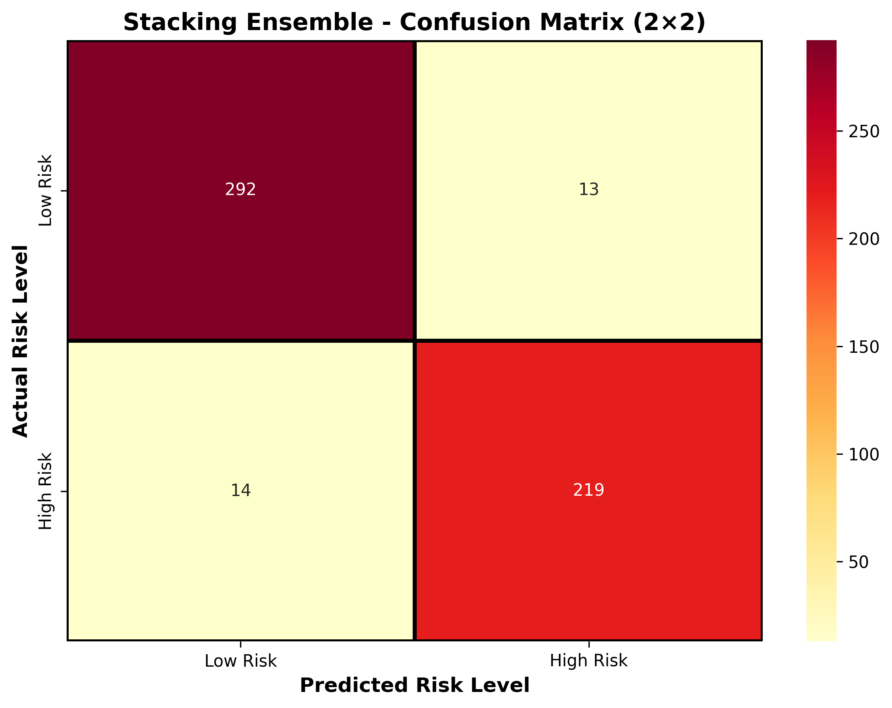
Figure 12: Stacking Ensemble Confusion Matrix.
Class-wise Calculations:
A. For Low Risk:
Where TP = 292, FP = 14, FN = 13.
$Precision (Low) = \frac{TP}{TP+FP} = \frac{292}{306} = 0.9542$
$Recall (Low) = \frac{TP}{TP+FN} = \frac{292}{305} = 0.9574$
$F1-Score (Low) = \frac{2·Precision·Recall}{Precision+Recall} = 0.9558$
B. For High Risk:
Where TP = 219, FP = 13, FN = 14.
$Precision (High) = \frac{TP}{TP+FP} = \frac{219}{232} = 0.9440$
$Recall (High) = \frac{TP}{TP+FN} = \frac{219}{233} = 0.9399$
$F1-Score (High) = \frac{2·Precision·Recall}{Precision+Recall} = 0.9419$
$Accuracy = \frac{TP_low+TP_high}{Total} = \frac{511}{538} = 0.9498 (94.98\%)$

Accuracy | Precision (Macro) | Recall (Macro) | F1-Score (Macro) | ROC-AUC
0.9498 (94.98%) | 0.9491 | 0.9487 | 0.9489 | 0.9860
Table 13: Stacking Ensemble Performance Metrics.
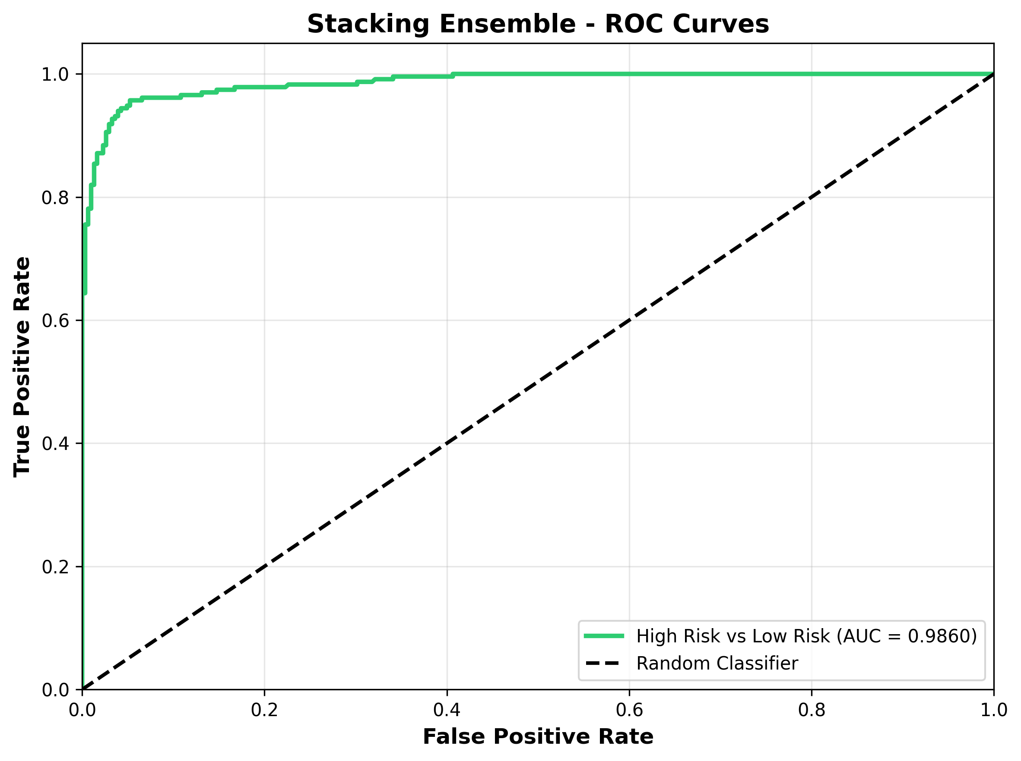
Figure 14: Stacking Ensemble ROC Curve.
The ROC curve shows that the Stacking Ensemble achieves strong discrimination between low-risk and high-risk pregnancies, with an Area Under the Curve (AUC) of 0.9860.
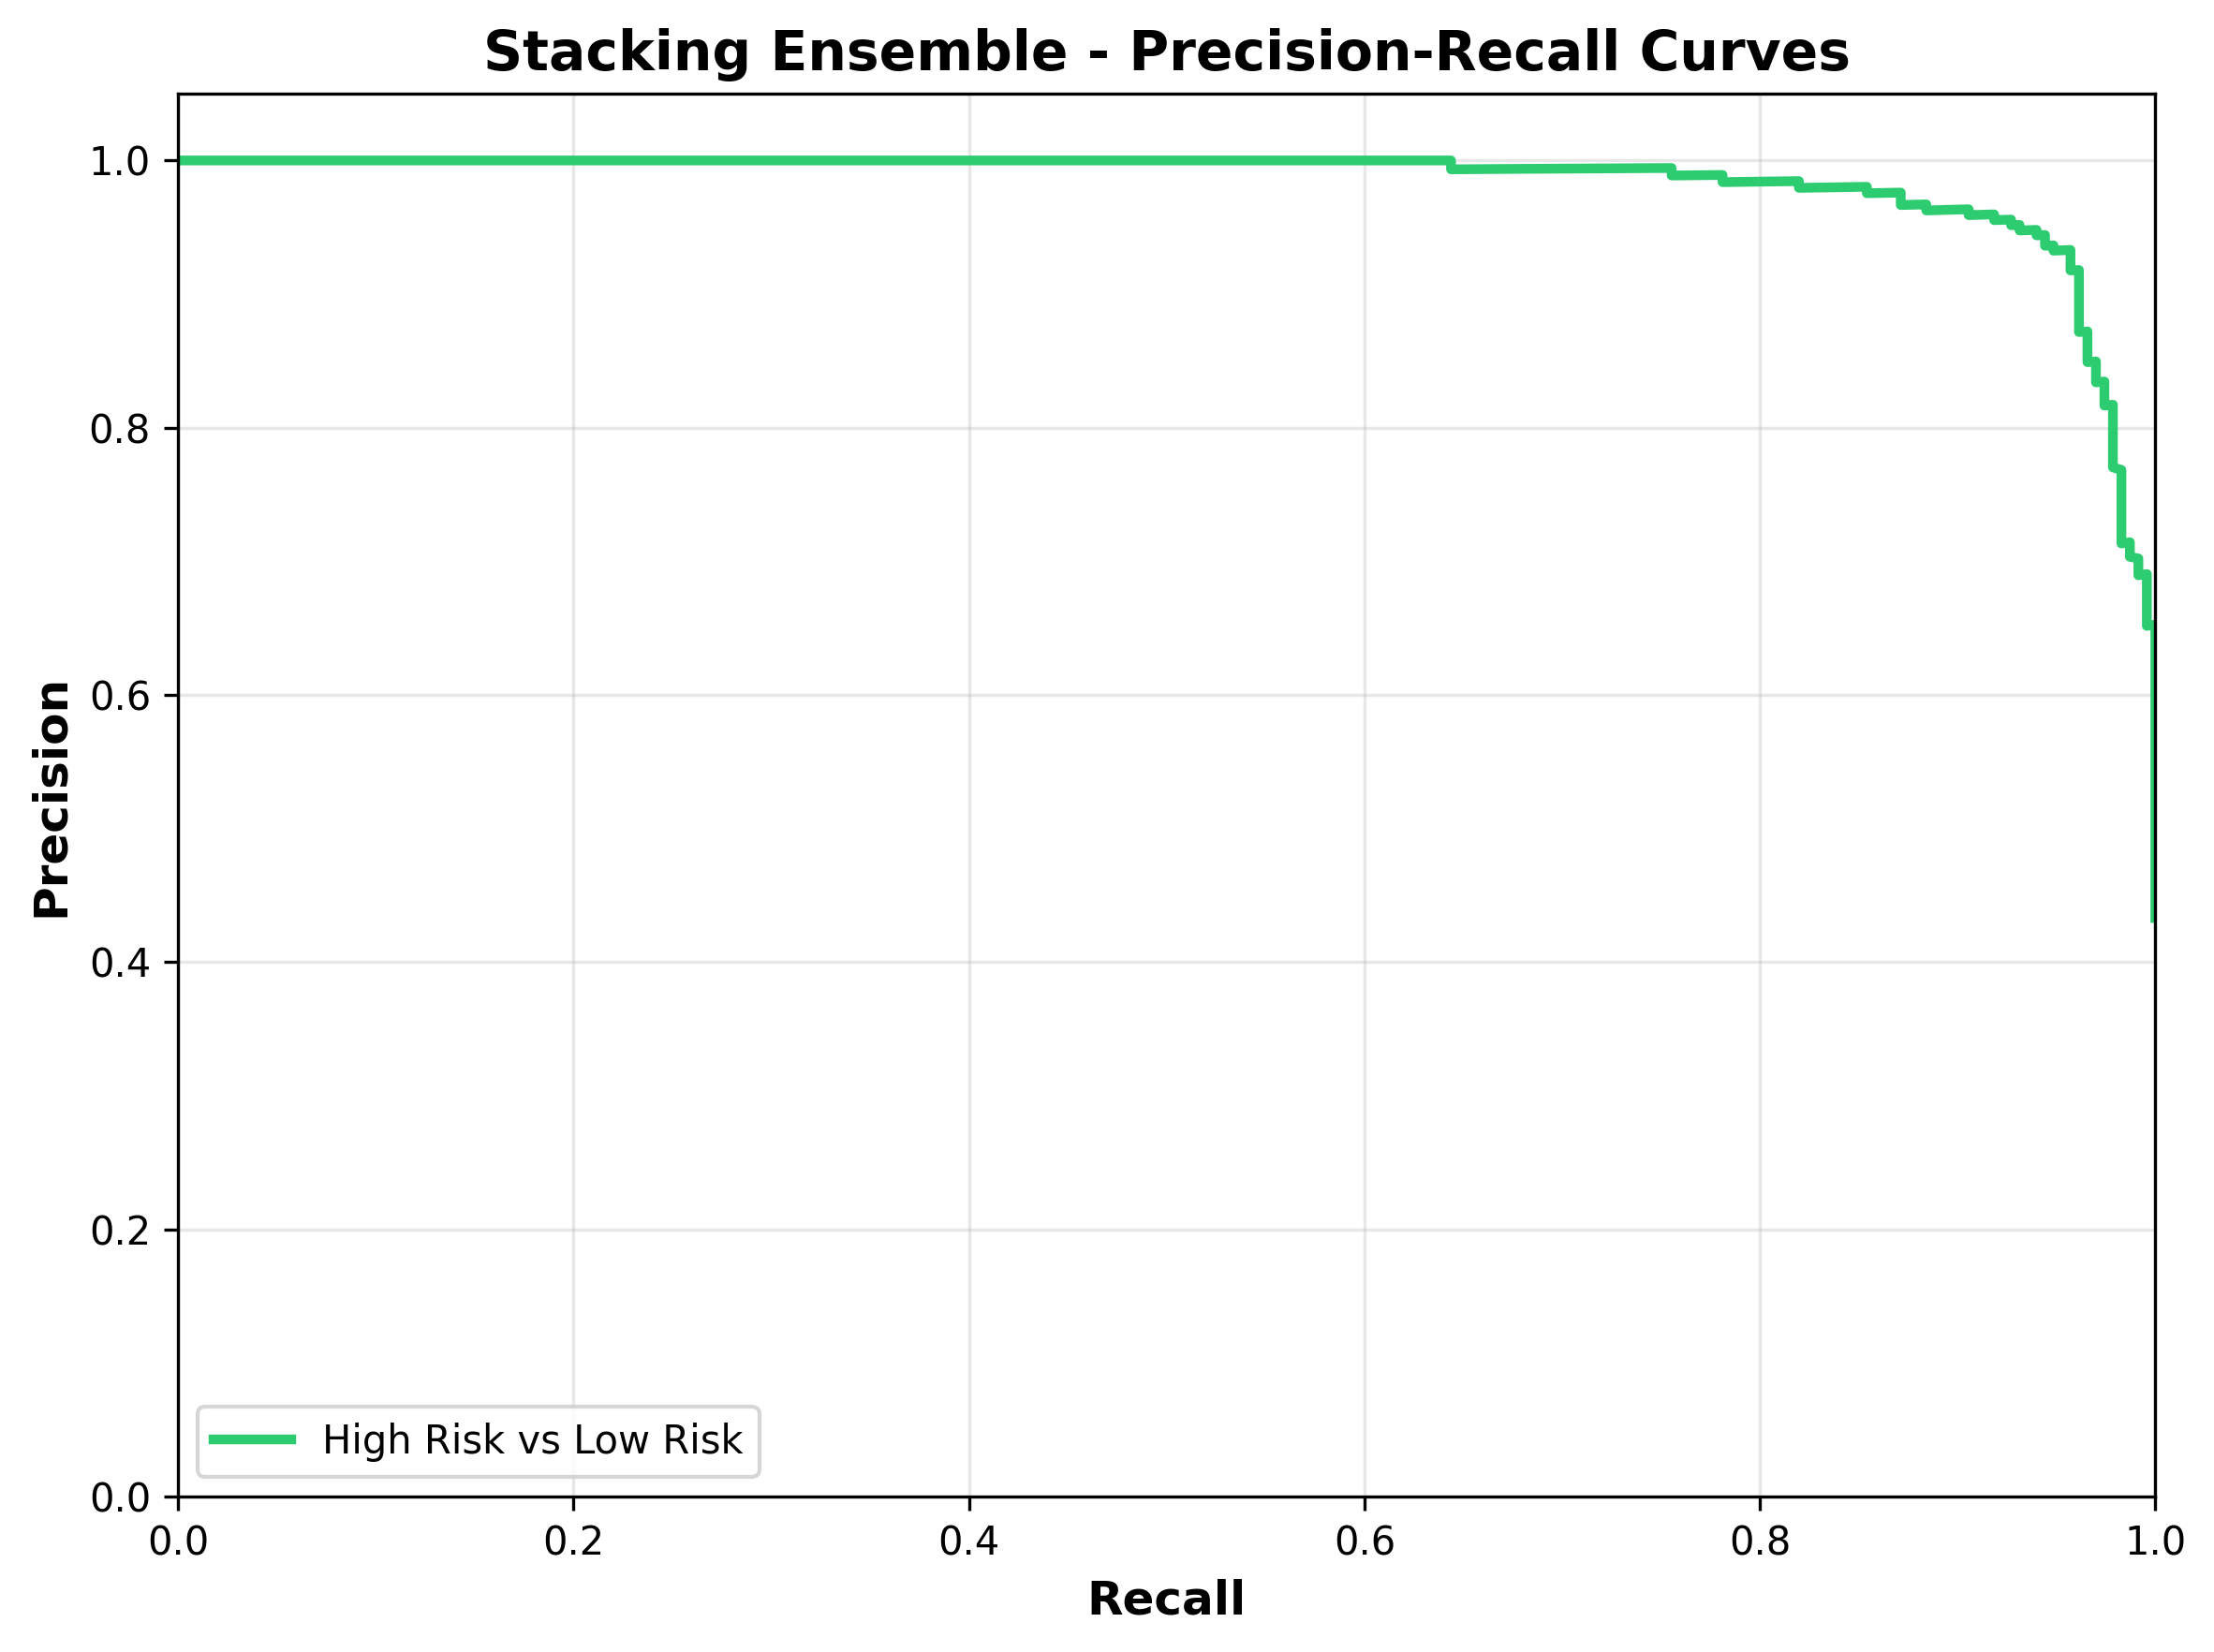
Figure 15: Stacking Ensemble Precision-Recall Curve.
The precision-recall curve confirms that the model maintains high precision across a wide range of recall values, indicating reliable positive predictions for the high-risk class.
4.5.2 Random Forest Performance
Random Forest was evaluated as a base learner in the stacking ensemble, demonstrating strong individual performance.
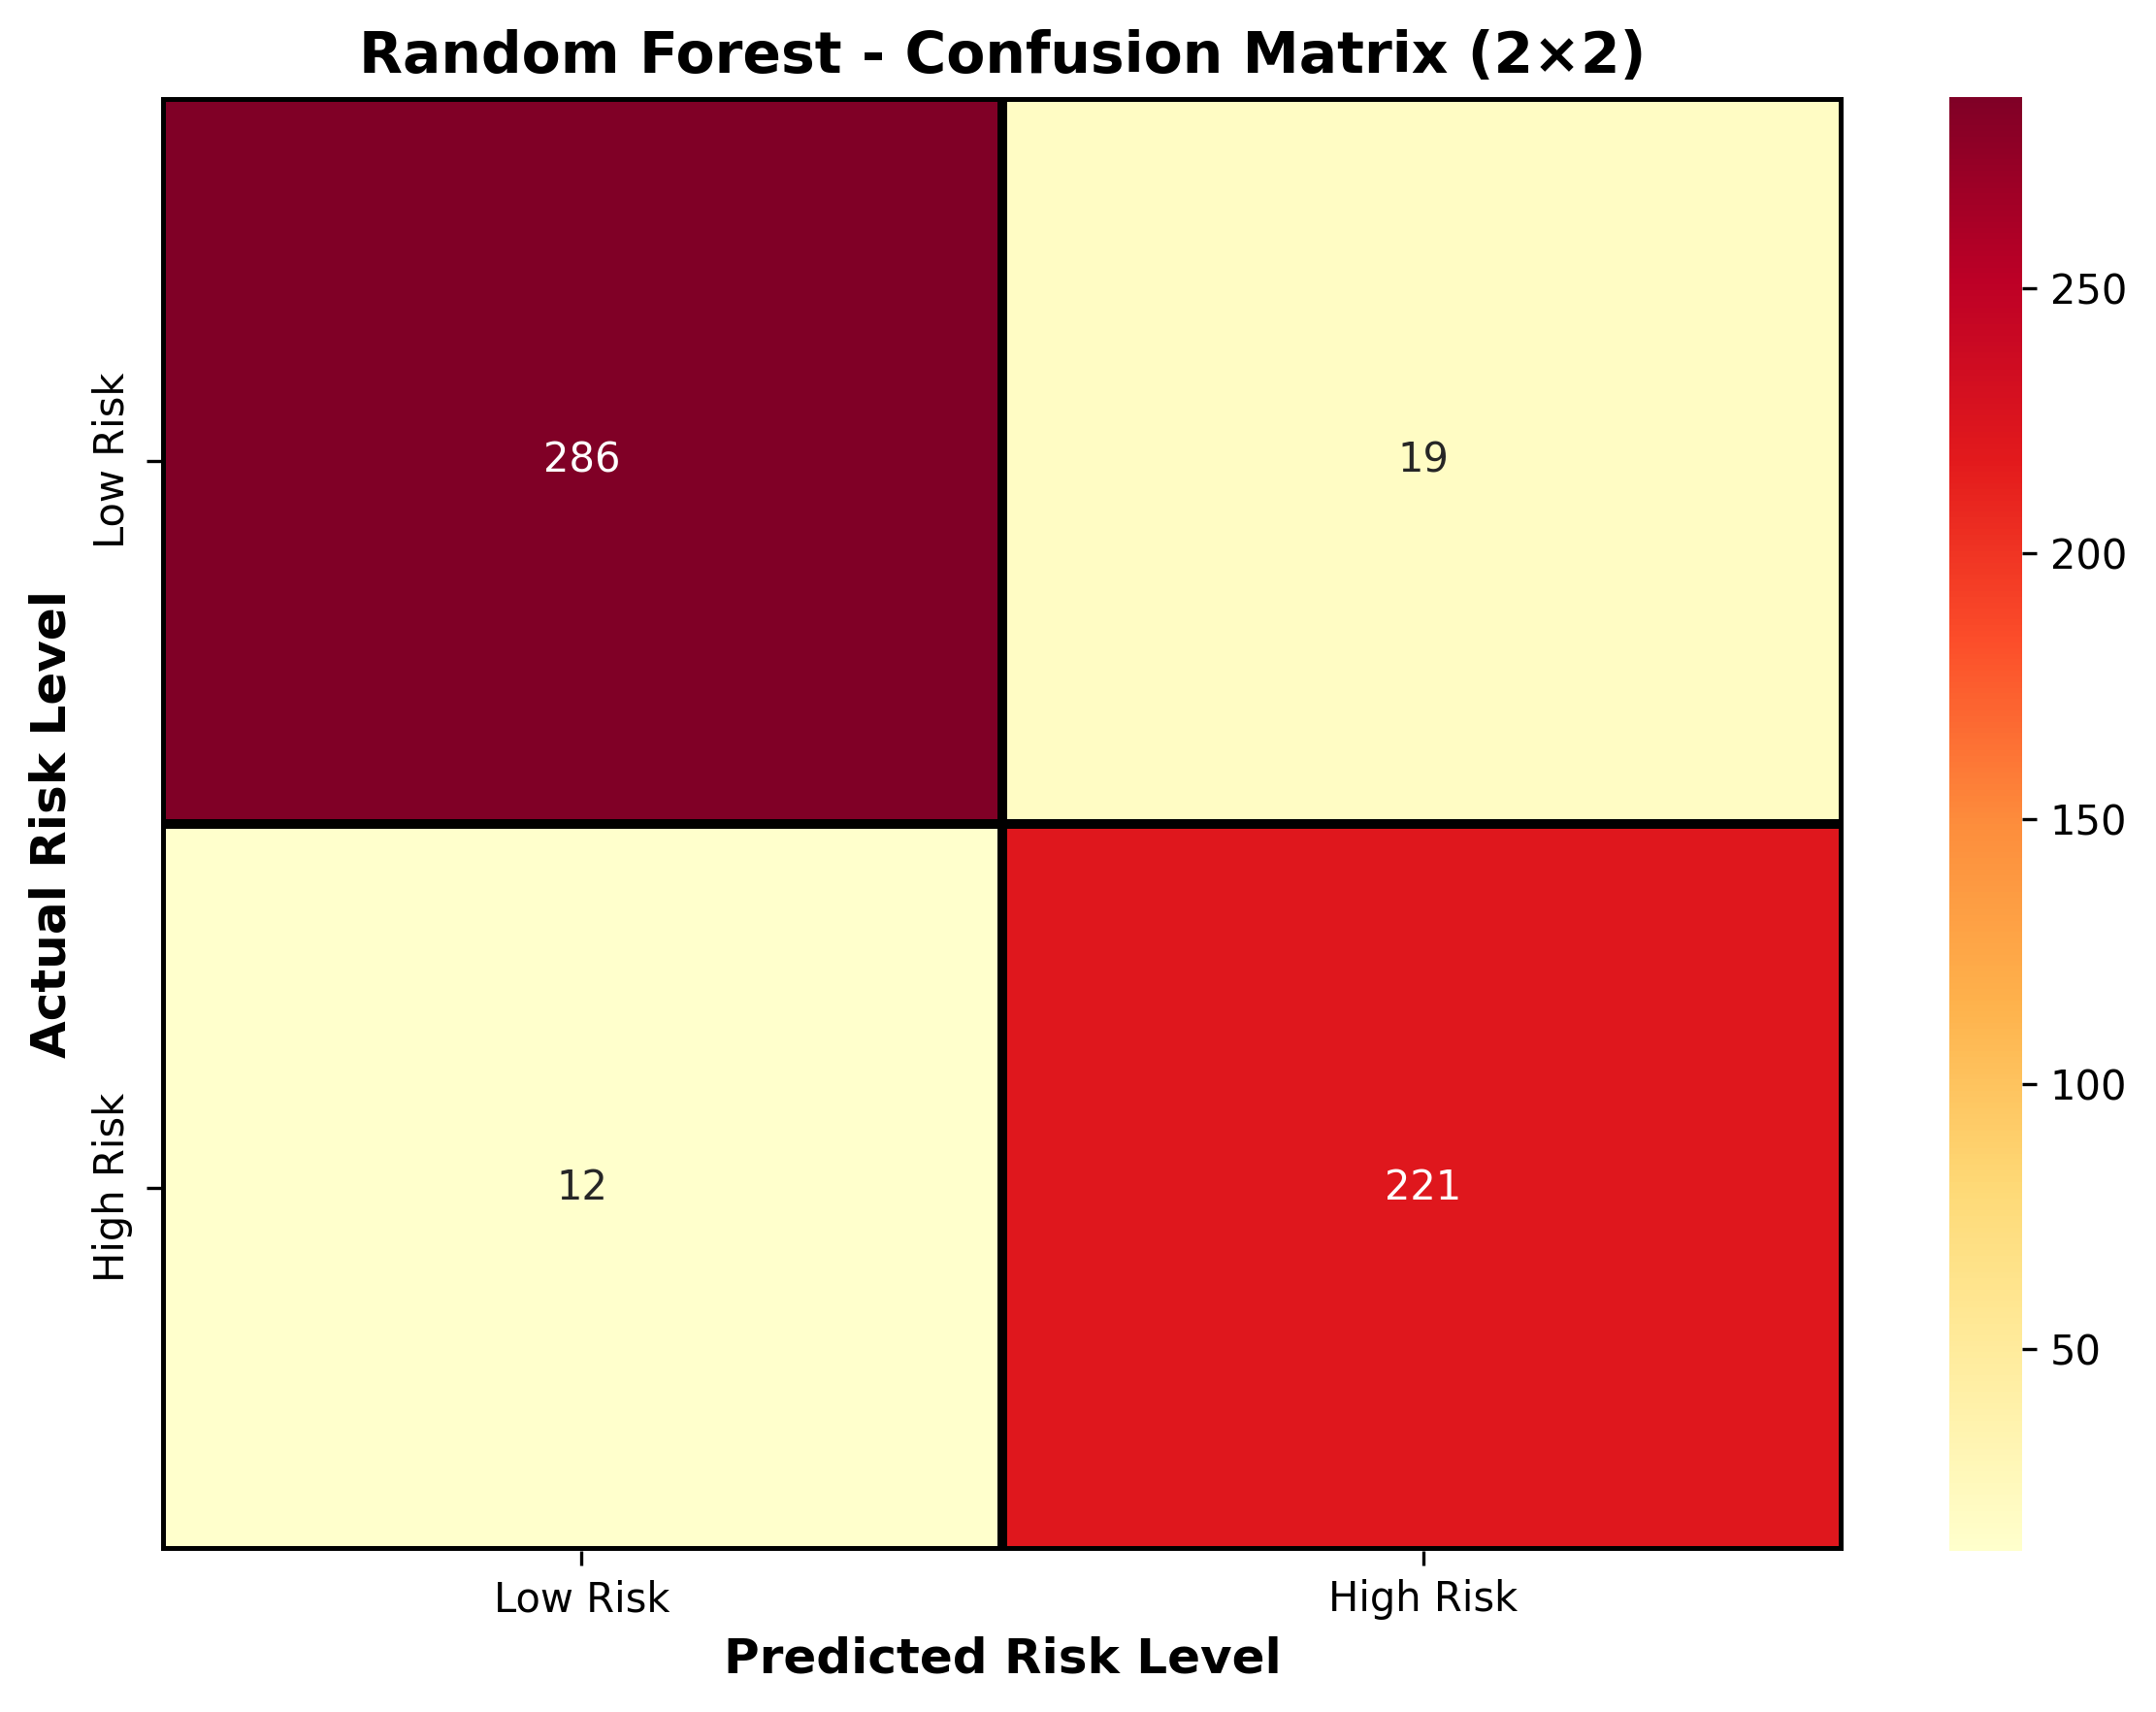
Figure 16: Random Forest Confusion Matrix.
Class-wise Calculations:
A. For Low Risk:
Where TP = 286, FP = 12, FN = 19.
$Precision (Low) = \frac{TP}{TP+FP} = \frac{286}{298} = 0.9597$
$Recall (Low) = \frac{TP}{TP+FN} = \frac{286}{305} = 0.9377$
$F1-Score (Low) = \frac{2·Precision·Recall}{Precision+Recall} = 0.9486$
B. For High Risk:
Where TP = 221, FP = 19, FN = 12.
$Precision (High) = \frac{TP}{TP+FP} = \frac{221}{240} = 0.9208$
$Recall (High) = \frac{TP}{TP+FN} = \frac{221}{233} = 0.9485$
$F1-Score (High) = \frac{2·Precision·Recall}{Precision+Recall} = 0.9345$
$Accuracy = \frac{TP_low+TP_high}{Total} = \frac{507}{538} = 0.9424 (94.24\%)$

Accuracy | Precision (Macro) | Recall (Macro) | F1-Score (Macro) | ROC-AUC
0.9424 (94.24%) | 0.9403 | 0.9431 | 0.9415 | 0.9828
Table 17: Random Forest Performance Metrics.
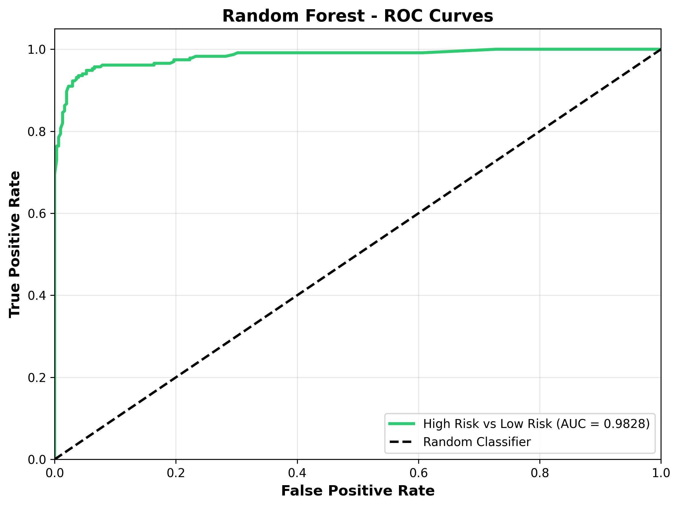
Figure 18: Random Forest ROC Curve.
The ROC curve shows that the Random Forest achieves strong discrimination between low-risk and high-risk pregnancies, with an Area Under the Curve (AUC) of 0.9828.
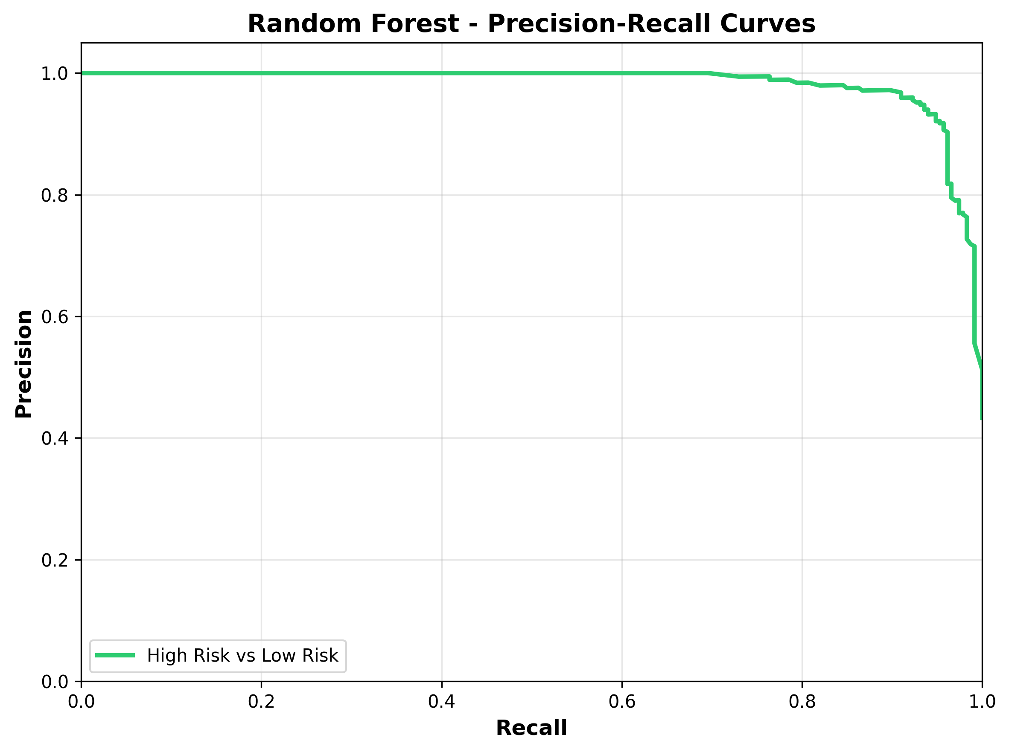
Figure 19: Random Forest Precision-Recall Curve.
The precision-recall curve confirms that the model maintains high precision across a wide range of recall values, indicating reliable positive predictions for the high-risk class.
4.5.3 XGBoost Performance
XGBoost was trained as a gradient boosting base learner for both computational efficiency and classification accuracy.
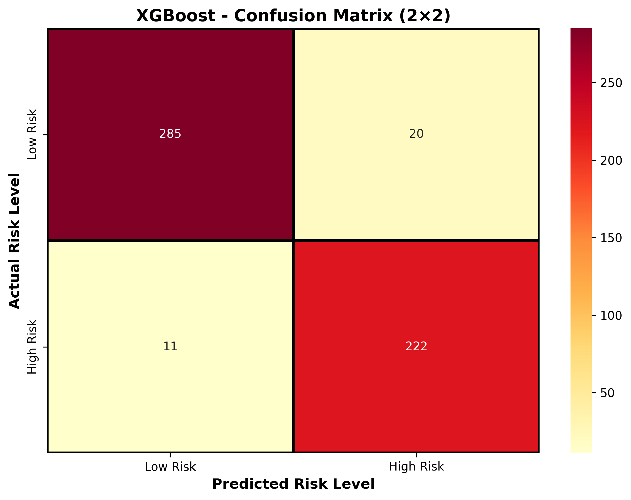
Figure 20: XGBoost Confusion Matrix.
Class-wise Calculations:
A. For Low Risk:
Where TP = 285, FP = 11, FN = 20.
$Precision (Low) = \frac{TP}{TP+FP} = \frac{285}{296} = 0.9628$
$Recall (Low) = \frac{TP}{TP+FN} = \frac{285}{305} = 0.9344$
$F1-Score (Low) = \frac{2·Precision·Recall}{Precision+Recall} = 0.9484$
B. For High Risk:
Where TP = 222, FP = 20, FN = 11.
$Precision (High) = \frac{TP}{TP+FP} = \frac{222}{242} = 0.9174$
$Recall (High) = \frac{TP}{TP+FN} = \frac{222}{233} = 0.9528$
$F1-Score (High) = \frac{2·Precision·Recall}{Precision+Recall} = 0.9347$
$Accuracy = \frac{TP_low+TP_high}{Total} = \frac{507}{538} = 0.9424 (94.24\%)$

Accuracy | Precision (Macro) | Recall (Macro) | F1-Score (Macro) | ROC-AUC
0.9424 (94.24%) | 0.9401 | 0.9436 | 0.9416 | 0.9858
Table 21: XGBoost Performance Metrics.
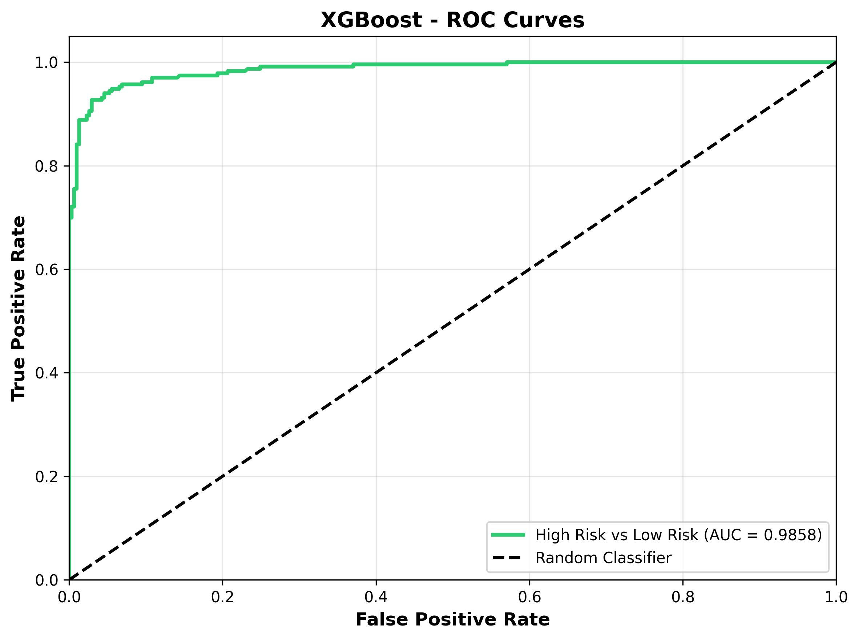
Figure 22: XGBoost ROC Curve.
The ROC curve shows that the XGBoost achieves strong discrimination between low-risk and high-risk pregnancies, with an Area Under the Curve (AUC) of 0.9858.
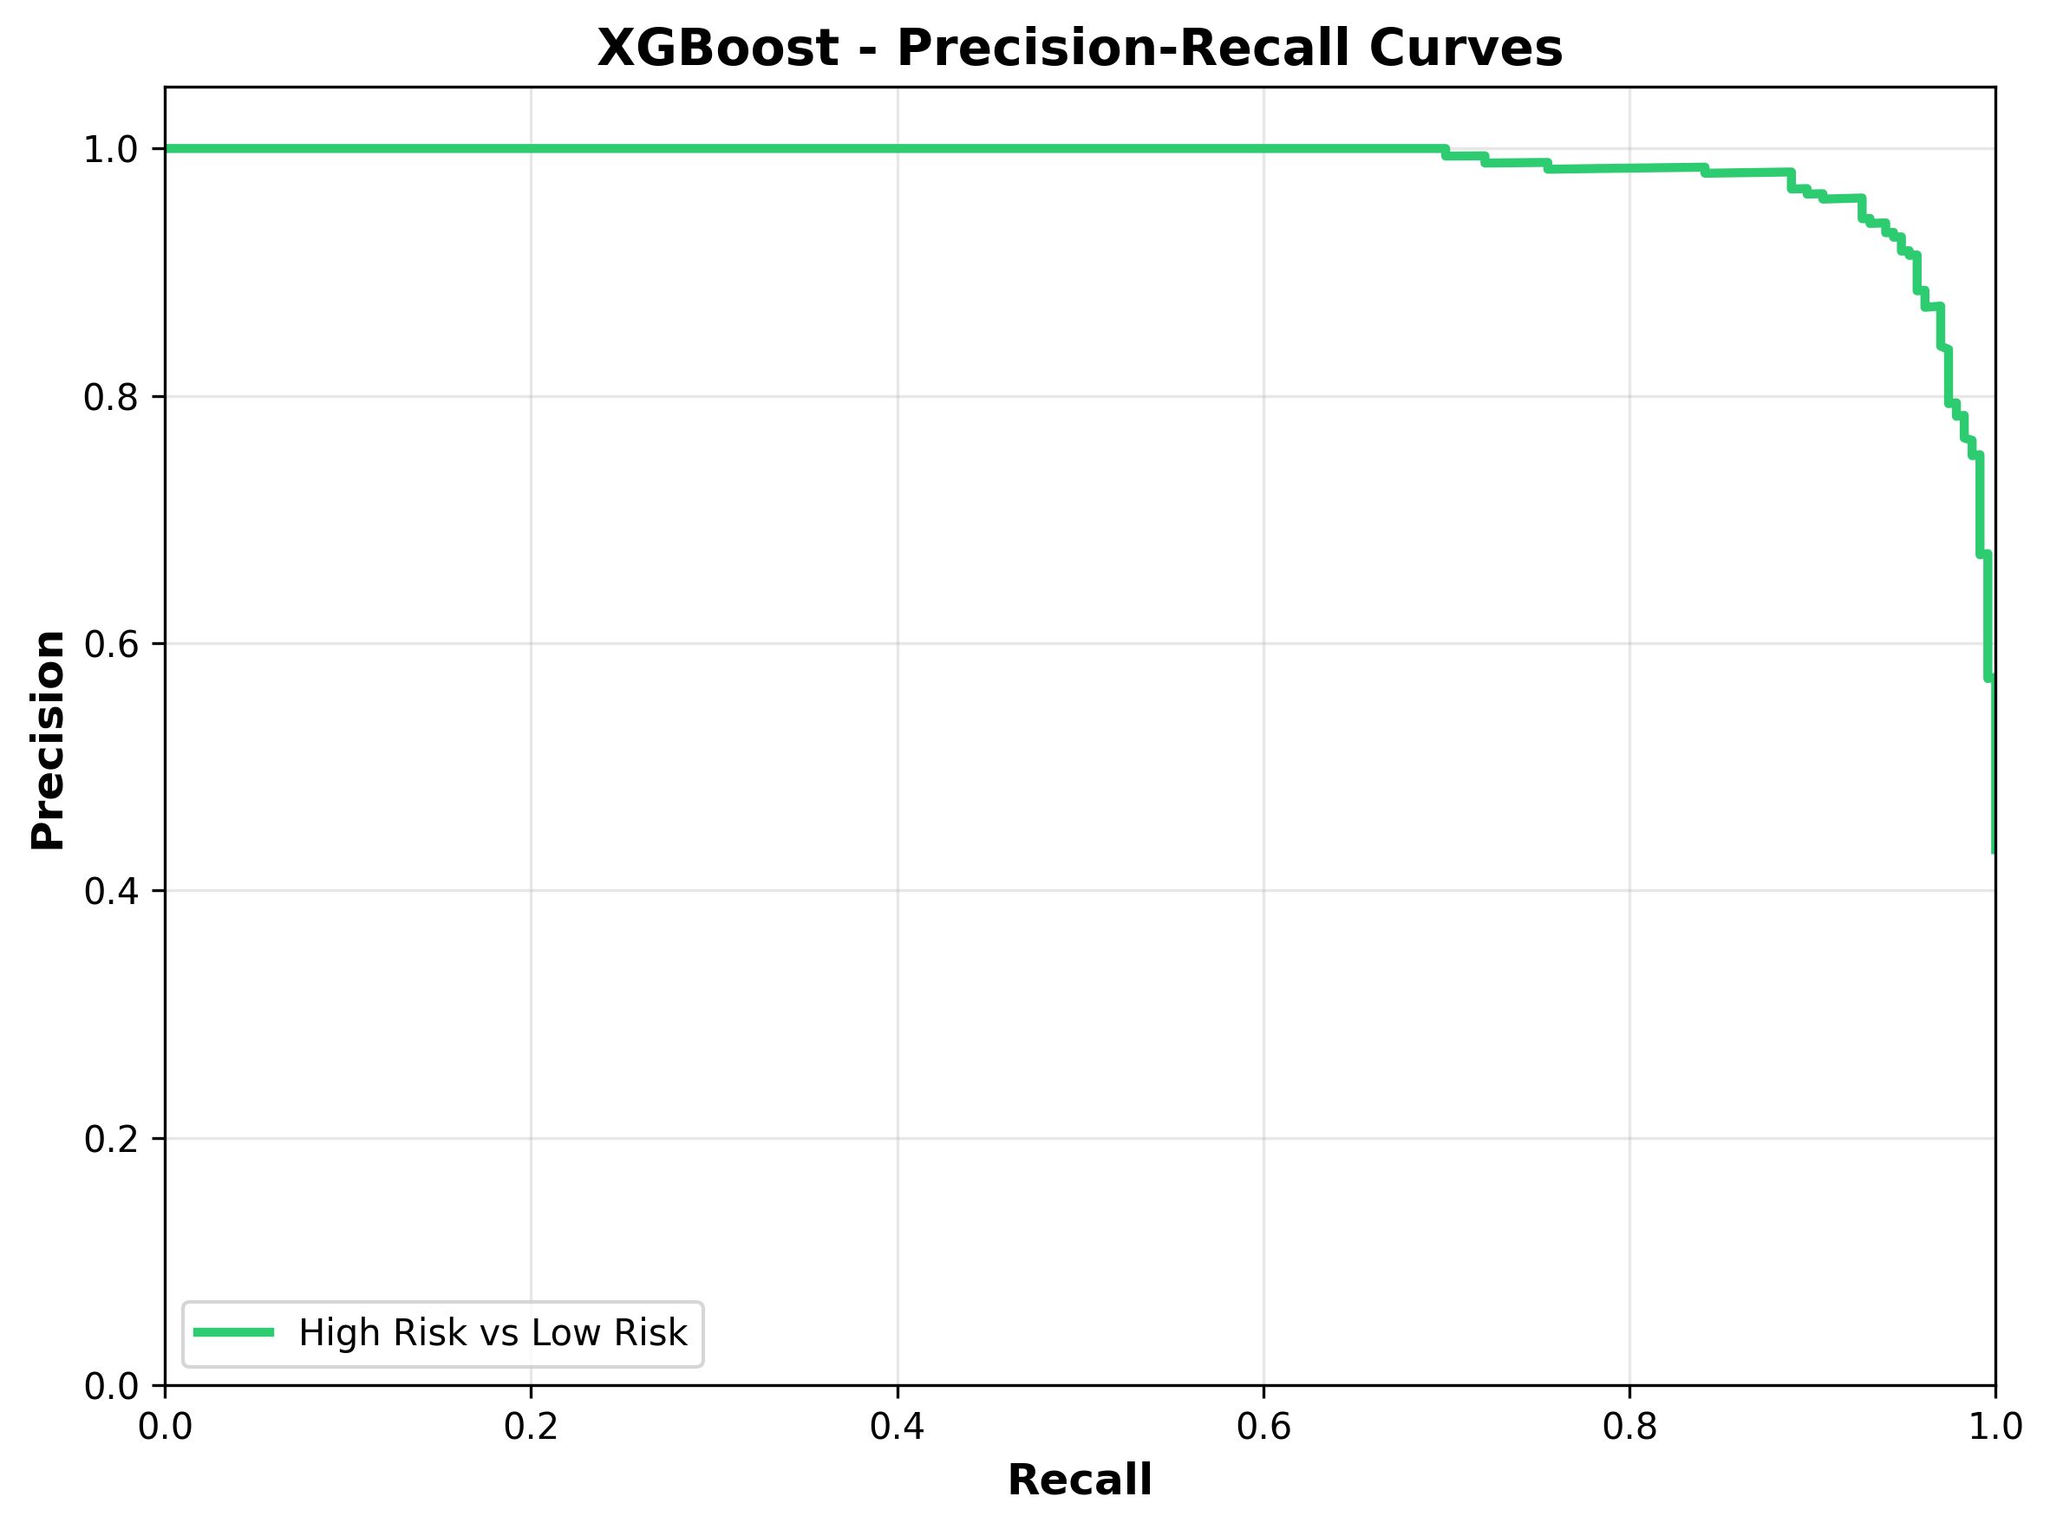
Figure 23: XGBoost Precision-Recall Curve.
The precision-recall curve confirms that the model maintains high precision across a wide range of recall values, indicating reliable positive predictions for the high-risk class.
4.5.4 Support Vector Machine Performance
Support Vector Machine was trained using an RBF kernel as the third base learner in the stacking ensemble.
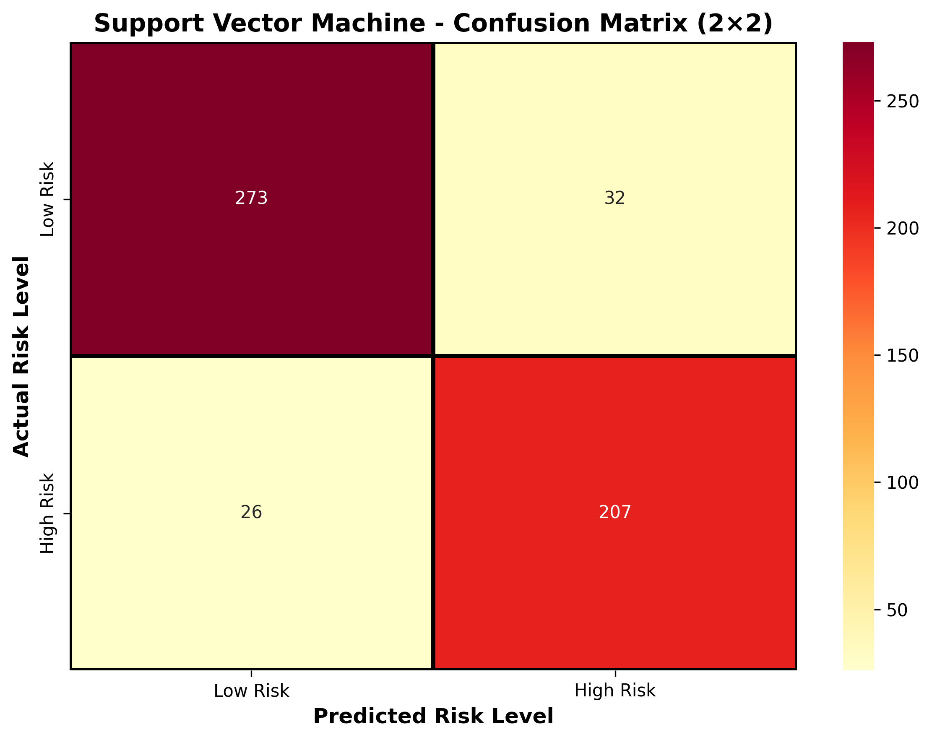
Figure 24: Support Vector Machine Confusion Matrix.
Class-wise Calculations:
A. For Low Risk:
Where TP = 273, FP = 26, FN = 32.
$Precision (Low) = \frac{TP}{TP+FP} = \frac{273}{299} = 0.9130$
$Recall (Low) = \frac{TP}{TP+FN} = \frac{273}{305} = 0.8951$
$F1-Score (Low) = \frac{2·Precision·Recall}{Precision+Recall} = 0.9040$
B. For High Risk:
Where TP = 207, FP = 32, FN = 26.
$Precision (High) = \frac{TP}{TP+FP} = \frac{207}{239} = 0.8661$
$Recall (High) = \frac{TP}{TP+FN} = \frac{207}{233} = 0.8884$
$F1-Score (High) = \frac{2·Precision·Recall}{Precision+Recall} = 0.8771$
$Accuracy = \frac{TP_low+TP_high}{Total} = \frac{480}{538} = 0.8922 (89.22\%)$

Accuracy | Precision (Macro) | Recall (Macro) | F1-Score (Macro) | ROC-AUC
0.8922 (89.22%) | 0.8896 | 0.8917 | 0.8905 | 0.9657
Table 25: Support Vector Machine Performance Metrics.
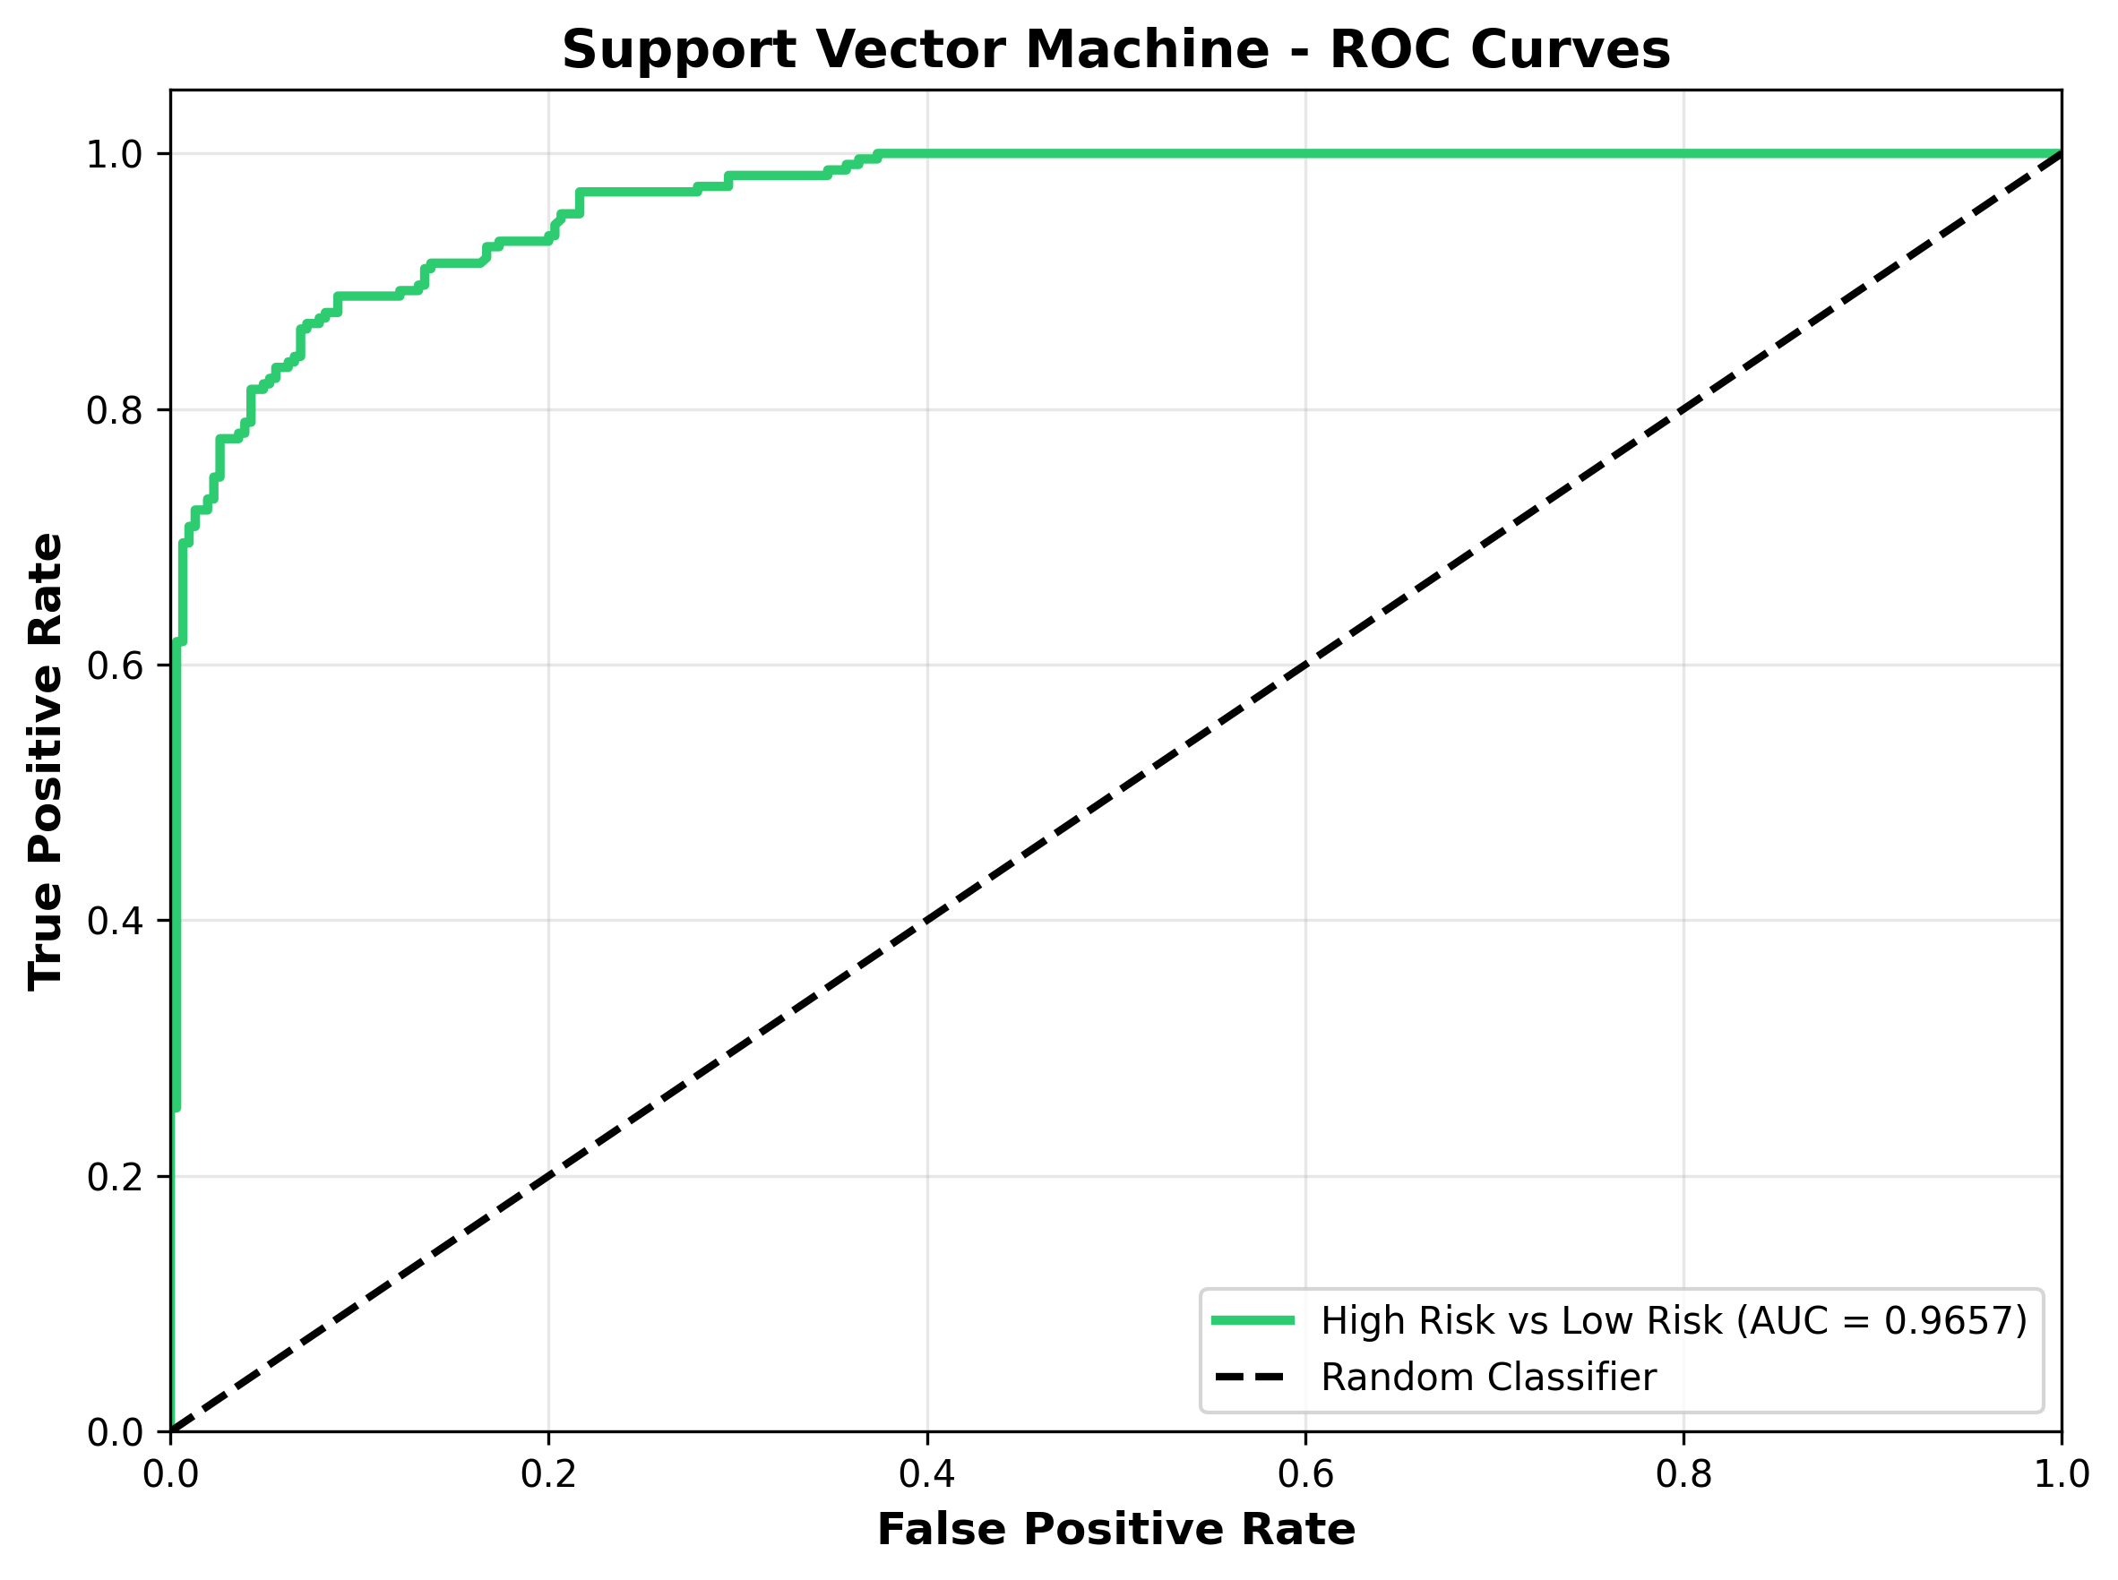
Figure 26: Support Vector Machine ROC Curve.
The ROC curve shows that the Support Vector Machine achieves strong discrimination between low-risk and high-risk pregnancies, with an Area Under the Curve (AUC) of 0.9657.
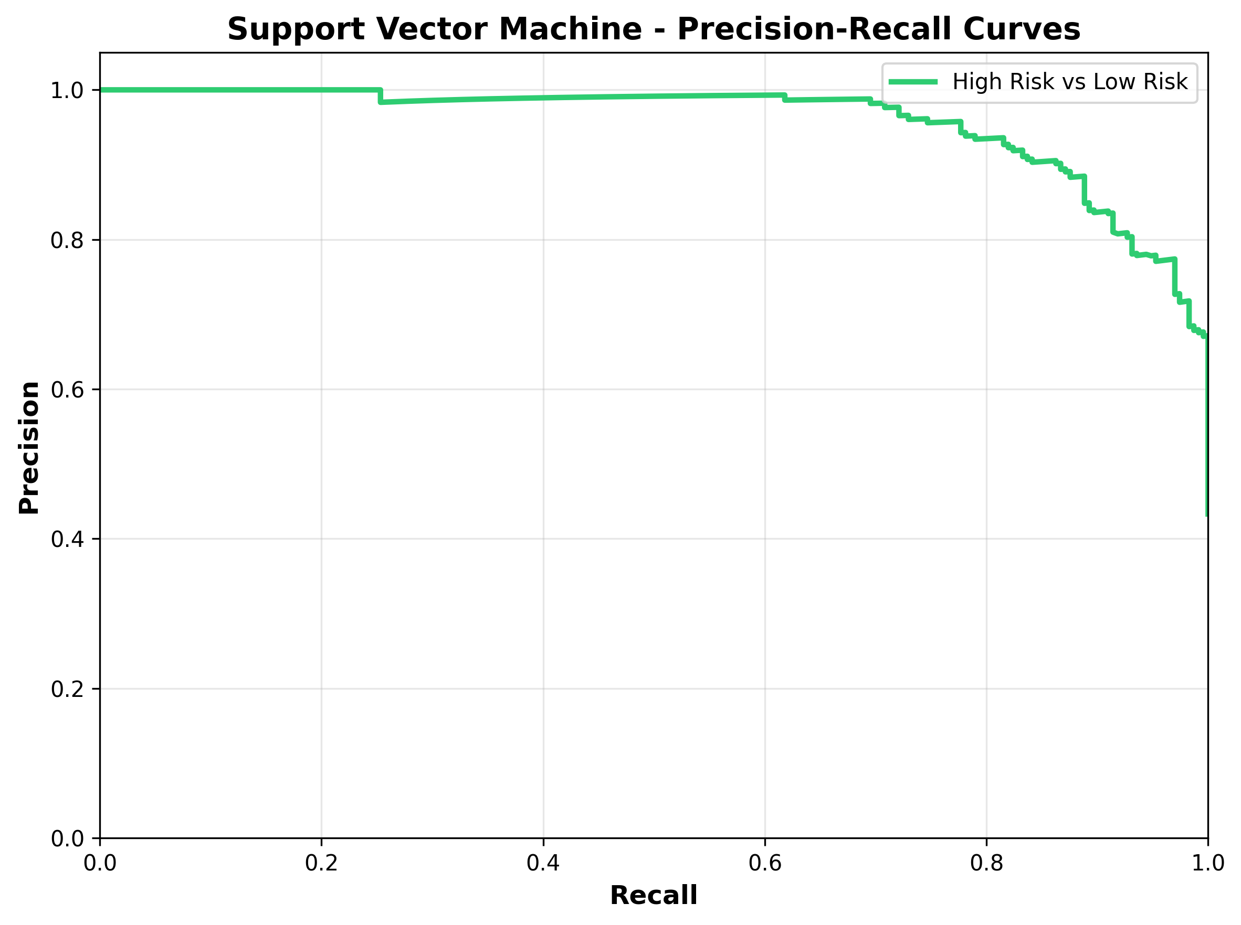
Figure 27: Support Vector Machine Precision-Recall Curve.
The precision-recall curve confirms that the model maintains high precision across a wide range of recall values, indicating reliable positive predictions for the high-risk class.
4.5.5 LightGBM Performance
LightGBM was trained as a histogram-based gradient boosting base learner, demonstrating the strongest individual base-learner performance.
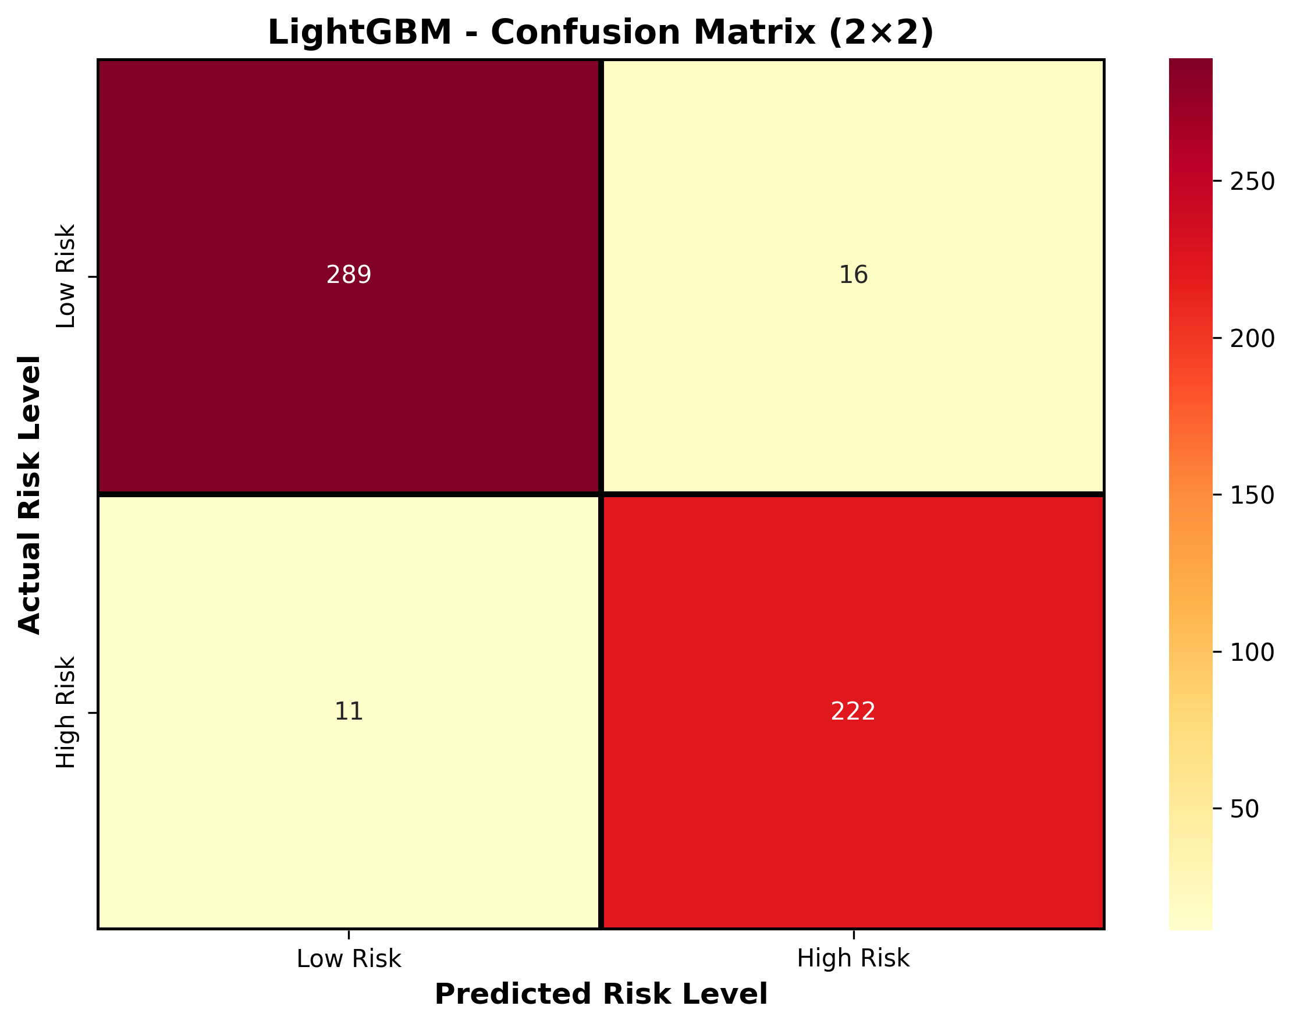
Figure 28: LightGBM Confusion Matrix.
Class-wise Calculations:
A. For Low Risk:
Where TP = 289, FP = 11, FN = 16.
$Precision (Low) = \frac{TP}{TP+FP} = \frac{289}{300} = 0.9633$
$Recall (Low) = \frac{TP}{TP+FN} = \frac{289}{305} = 0.9475$
$F1-Score (Low) = \frac{2·Precision·Recall}{Precision+Recall} = 0.9554$
B. For High Risk:
Where TP = 222, FP = 16, FN = 11.
$Precision (High) = \frac{TP}{TP+FP} = \frac{222}{238} = 0.9328$
$Recall (High) = \frac{TP}{TP+FN} = \frac{222}{233} = 0.9528$
$F1-Score (High) = \frac{2·Precision·Recall}{Precision+Recall} = 0.9427$
$Accuracy = \frac{TP_low+TP_high}{Total} = \frac{511}{538} = 0.9498 (94.98\%)$

Accuracy | Precision (Macro) | Recall (Macro) | F1-Score (Macro) | ROC-AUC
0.9498 (94.98%) | 0.9481 | 0.9502 | 0.9490 | 0.9875
Table 29: LightGBM Performance Metrics.
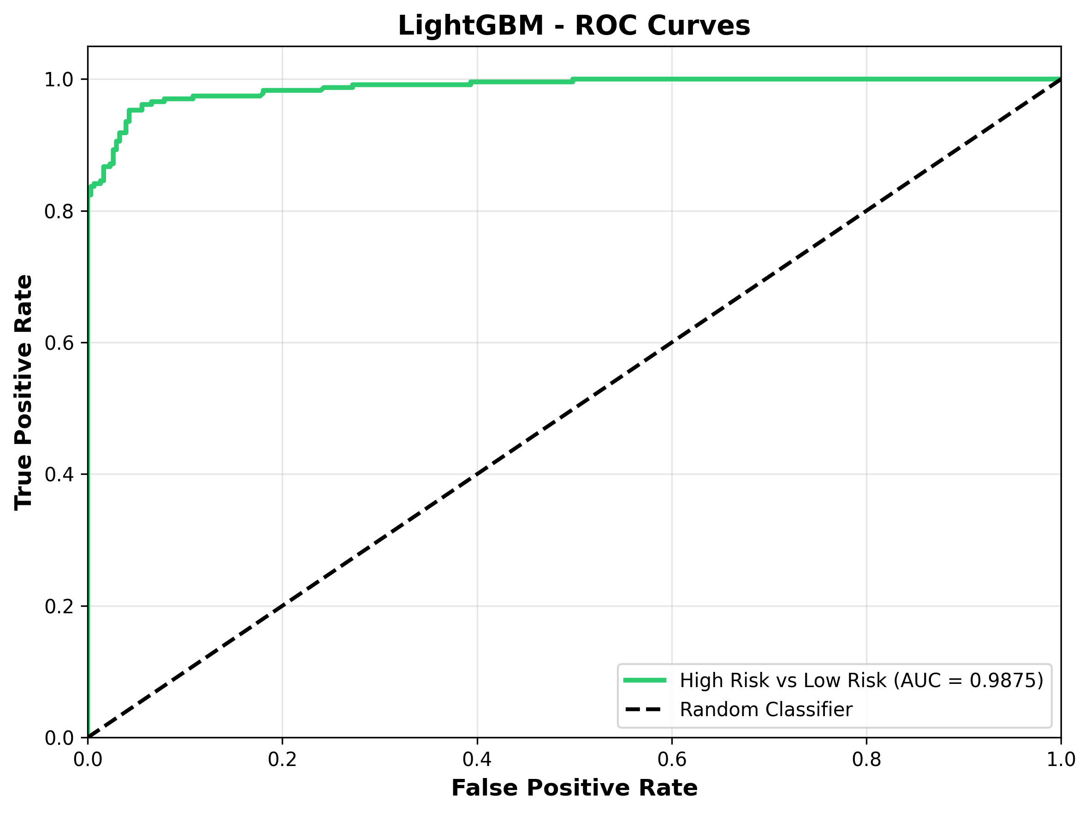
Figure 30: LightGBM ROC Curve.
The ROC curve shows that the LightGBM achieves strong discrimination between low-risk and high-risk pregnancies, with an Area Under the Curve (AUC) of 0.9875.
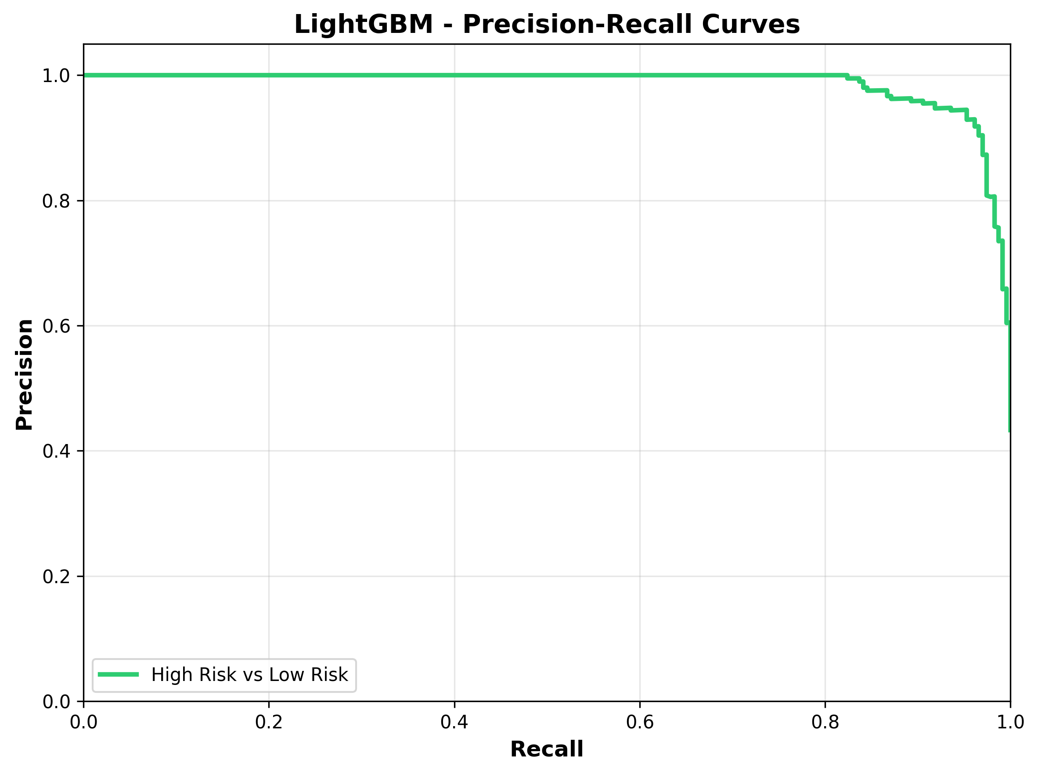
Figure 31: LightGBM Precision-Recall Curve.
The precision-recall curve confirms that the model maintains high precision across a wide range of recall values, indicating reliable positive predictions for the high-risk class.
4.5.6 Model Comparison and Performance Analysis
Model | Accuracy | Precision | Recall | F1-Score | ROC-AUC
Stacking Ensemble | 0.9498 (94.98%) | 0.9491 | 0.9487 | 0.9489 | 0.9860
LightGBM | 0.9498 (94.98%) | 0.9481 | 0.9502 | 0.9490 | 0.9875
Random Forest | 0.9424 (94.24%) | 0.9403 | 0.9431 | 0.9415 | 0.9828
XGBoost | 0.9424 (94.24%) | 0.9401 | 0.9436 | 0.9416 | 0.9858
Support Vector Machine | 0.8922 (89.22%) | 0.8896 | 0.8917 | 0.8905 | 0.9657
Table 32: Comprehensive Model Comparison.
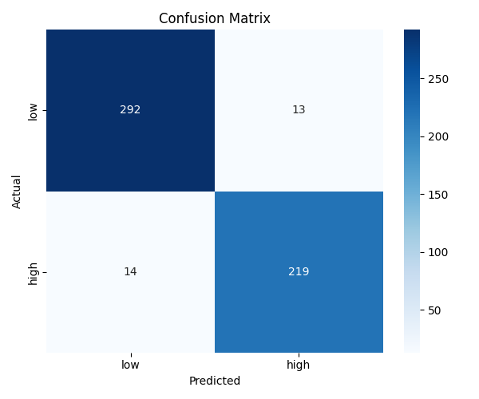
Figure 33: Comprehensive Model Performance Comparison.
The Stacking Ensemble achieved the highest overall performance with an accuracy of 94.98% and an AUC of 0.986, demonstrating robust generalization through the combination of four diverse base learners and a dual meta-learner. LightGBM matched the ensemble's accuracy as the strongest individual base learner, while Random Forest and XGBoost both achieved 94.24% accuracy. Support Vector Machine recorded the lowest accuracy at 89.22% but still maintained strong discrimination (AUC 0.9657). The analysis demonstrates that the stacking ensemble provides the most balanced and reliable performance for this binary maternal triage classification task, and its decision threshold was further optimized using Youden's Index to maximize sensitivity for the clinically critical high-risk class.
4.6 Mobile Application Implementation and SHAP-Based Explainability
Following model conversion to the ONNX format, a Flutter mobile application was developed to provide offline-capable maternal risk triage with SHAP-based local explanations. The application implements a complete workflow from patient data entry through risk classification to explainable output delivery.
Figure 34: Onboarding and Authentication Screens, showing the welcome screen, assessment explanation, clinical disclaimer, and login page.
The onboarding screens introduce the application's value proposition and establish that the tool supports rather than replaces clinical judgment. Authentication ensures only authorized healthcare workers can access patient data.
Figure 35: Main Triage Dashboard Screen, showing summary cards for emergency, urgent, and stable cases, plus the active queue and resolved patients.
The dashboard provides at-a-glance statistics of the current patient load and displays patients awaiting triage sorted by urgency level.
Figure 36: Input and SHAP-Based Local Explanation Screen, showing clinical reasoning text, a bar chart of SHAP values, and a table of key risk factors with directional effects.
This screen is the core contribution to explainability. The SHAP values pre-computed during training are retrieved and displayed in three complementary formats. Natural-language clinical reasoning explains why the patient is classified as high or low risk, a bar chart visualizes the magnitude of each feature's contribution, and a table lists each feature with its SHAP value and a directional arrow indicating whether it increased or decreased the risk prediction.
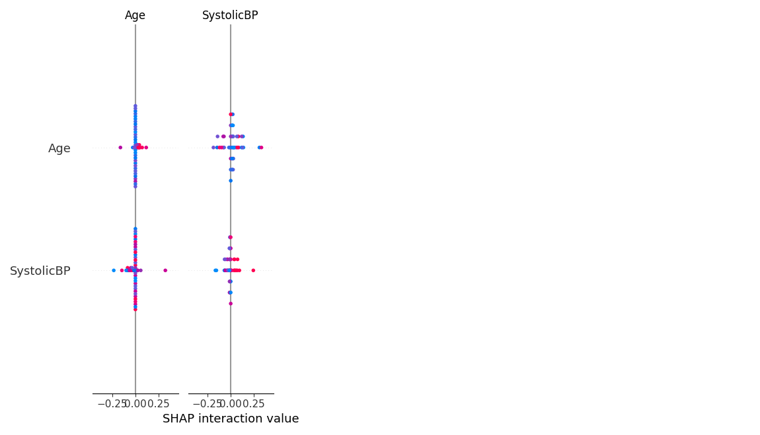
Figure 37: Global SHAP summary for the deployed binary model (19 features).
Figure 38: Assessment History Screen and Educational Library Screen.
The educational screen shows trimester navigation tabs and curated educational resources including videos and illustrated guides. The integration of SHAP explanations directly within the mobile application enables healthcare workers to understand why each patient received a specific risk classification, without requiring specialized machine-learning knowledge.

