READER SELECTIVITY IN MULTI-PATHOLOGIST CERVICAL CYTOLOGY ANNOTATIONS: AN ANALYSIS OF RIVA AND A NEGATIVE RESULT FOR READER-AWARE CORRECTION
David Adekoya [co-authors, affiliations and corresponding author to be confirmed]
ABSTRACT
Background. Datasets with several independent pathologist annotations are appearing, but most training pipelines still treat an unmarked cell as negative and assume readers are interchangeable. RIVA, a public set of conventional Pap-smear patches, explicitly assumes equal expertise across its four pathologists.
Methods. We analysed 386 RIVA patches independently annotated by four cytopathologists (959 patches, 115 patients in total). Points were matched across readers at a radius of 1.85 percent of image size (7,470 matched cells; the dataset paper reports 7,507). We measured how often each reader marked cells that others marked, by cell class and local density; checked with image features whether solo marks sit on cell-like objects; simulated single-reader labelling and compared naive training with propensity-weighted positive-unlabelled corrections (frozen ResNet18 and DINOv2-small features, slide-grouped five-fold cross-validation, three seeds); and compared model confidence with a head trained on the share of readers who marked a cell as a deferral signal.
Results. Readers differed markedly: of cells that at least one other reader marked, annotator_1 marked 69 percent and annotator_4 41 percent; for lesion cells the figures were 45 and 19 percent, against 62 to 82 percent for non-lesion cells. Between 47 and 70 percent of solo marks scored as cell-like, against 4 percent of background. Corrections using reader identity or a constant rate lowered lesion average precision by 0.016 to 0.030 under the two-reader reference; a correction using predicted class and a density proxy was not distinguishable from naive training (+0.019 [-0.003, +0.049] with ResNet18; +0.005 [-0.017, +0.028] with DINOv2-small). Combining confidence with predicted reader agreement lowered error among accepted cells by 0.016 [0.011 to 0.022] at 50 percent coverage, against a reference defined by the same readers.
Conclusions. Reader selectivity in RIVA depends on cell class and density, contradicting an equal-expertise assumption, but simple propensity corrections did not reliably help a linear detector on frozen features. We report this as a negative result with the limitations of a small, single-source dataset.
Categories: Artificial Intelligence, Medical Imaging, Pathology, Cytology, Obstetrics and Gynaecology
Keywords: cervical cytology, Pap smear, inter-observer variability, multi-reader annotation, positive-unlabelled learning, annotation noise, deferral, RIVA dataset
1 INTRODUCTION
Cervical cytology screening depends on pathologists identifying abnormal cells in Pap-smear images, and automated detection of those cells is an active research area. Training such detectors needs cell-level labels, which are costly to obtain and vary between readers. Many public datasets are labelled by one reader, or by a consensus whose construction is not documented in a form that lets others examine individual readers.
A common modelling choice is to treat any cell that a reader did not mark as a negative example. If readers mark only a subset of the cells they could mark, this choice teaches the detector that some real cells are background. The size of that effect depends on how readers choose what to mark, and that choice is rarely measured.
RIVA, a recent open dataset of conventional Pap-smear patches, provides a rare opportunity: a subset of its patches was annotated independently by four cytopathologists, and a larger subset by one of the same four [1]. The dataset paper models agreement under the assumption that all pathologists share the same level of expertise.
This paper asks three questions of the RIVA annotations. (1) How do the four readers differ in which cells they mark, and does that depend on the cell's class and on local density? (2) Does training on single-reader labels lose detection performance for lesion cells compared with training on multi-reader consensus, and can propensity-weighted positive-unlabelled corrections recover it? (3) Is a head trained on the share of readers who marked a cell a better deferral signal than model confidence?
We report that reader selectivity depends strongly on class and density, that about half to two thirds of solo marks sit on cell-like objects, that reader-identity corrections reduced lesion average precision, that a class-aware correction using only available information was not distinguishable from naive training, and that a graded-agreement deferral signal gave a small gain against a reference that is partly circular. The contribution is a documented characterisation of reader behaviour in a new public dataset and a negative result for a plausible correction, not a new detector.
2 RELATED WORKS
Annotator models. Estimating annotator reliability and a latent truth from several noisy labellers has a long history [2,3]. Yan et al. [4] let annotator accuracy depend on the input, and Tanno et al. [5] estimate annotator confusion matrices jointly with the classifier. These methods were developed for classification labels; our setting has point annotations and an unobserved set of cells that readers could have marked.
Incomplete annotations in detection. Treating unannotated regions as unlabelled rather than negative is the positive-unlabelled view of detection [6], applied to cell detection in histopathology by Zhao et al. [7]. Bekker et al. [8] formalise labelling propensities that depend on covariates. In cervical cytology, methods address incomplete cell labels with slide-level supervision and pseudo-labelling (for example Li et al. [9]).
Multiple readers in pathology. Variability Matters [10] studied 120 pathologists and scored annotator conformity on a control set; repeated labelling with expectation-maximisation aggregation has been applied to object detection [11]. Most pipelines resolve disagreement by consensus before training.
Cervical cytology datasets. RIVA adds multi-reader point annotations on conventional smears [1]; an ISBI 2026 challenge used it for detection and eight-class classification, and participant reports focus on detector design (for example Kogan and Rios [12]). We found no prior analysis of individual reader behaviour in RIVA.
Our contribution sits between these threads: we apply reader-behaviour analysis and a propensity-weighted correction in a dataset with known reader identities, and report that the correction did not reliably help.
Table 1. Summary of reviewed studies.
Study | Approach | Setting | Limitation for the present question
Dawid and Skene [2] | EM estimate of observer error rates and latent truth | Categorical labels from several observers | No point labels; observers assumed independent given the truth
Raykar et al. [3] | Joint classifier and annotator sensitivity and specificity | Crowd labels, including medical images | Per-annotator rates do not depend on class or density
Yan et al. [4] | Annotator accuracy depends on the input | Classification with several annotators | Not a detection or point-annotation setting
Tanno et al. [5] | Annotator confusion matrices estimated with the classifier | Image classification with noisy labels | Classification labels only
Yang et al. [6] | Unannotated regions treated as unlabelled in detection | Natural-image detection with missing boxes | No reader identities; no medical data
Zhao et al. [7] | Positive-unlabelled cell detection | Histopathology with incomplete annotations | One labelling process; no per-reader model
Bekker et al. [8] | Labelling propensity depends on covariates | Positive-unlabelled classification | Propensity must be known or estimated; not detection
Kang et al. [10] | Annotator conformity scored on a control set | 120 pathologists, cell detection | Filters annotators rather than modelling their selectivity
Tschirschwitz et al. [11] | EM aggregation of repeated labels | Object detection with repeated labels | Aggregation, not reader-specific selectivity
Perez Bianchi et al. [1] | Confidence model from agreement, equal expertise assumed | RIVA | Does not model individual readers

3 DATA
RIVA. RIVA contains 959 mini-patches of 1,024 x 1,024 pixels cut from whole-slide scans of conventional Pap smears from 115 patients, scanned at 40x [1]. Each cell is marked by a nucleus point and one of eight categories: SCC, HSIL, ASCH, LSIL, ASCUS (lesion), and INF, ENDO, NILM (non-lesion). In our copy of the annotation file the inflammation label appears as INFL. The release totals 26,158 point annotations, which we confirmed.
Readers and subsets. Annotations are stored per patch under the keys annotator_1 to annotator_4. In the downloaded file 386 patches contain all four readers (17,716 annotations per the Zenodo record) and 573 contain one reader (8,442 annotations per the Zenodo record), with 143, 137, 144 and 149 single-reader patches for annotators 1 to 4. The dataset paper describes a workflow in which the first patches were given to all annotators and the rest were split evenly across annotators, in Label Studio with independent projects per reader and shuffled patches.
Grouping. Patch names encode diagnostic category, slide number and patch number (for example LSIL_45_3). We grouped patches by category and slide number for cross-validation; whether a slide number is unique across categories and whether one slide equals one patient are assumptions we could not verify.
Access and licence. The dataset is on Zenodo [13] (doi 10.5281/zenodo.17288879), checksum verified against the record. The licence wording differs between sources: the paper states CC BY-NC-ND 4.0, the Zenodo record lists CC BY 4.0, and the packaged licence file states CC BY-NC 4.0. We treated use as non-commercial and did not redistribute images or modified data. No clinical outcome, HPV status or biopsy result is available, so there is no reference standard independent of the readers.
4 METHODS
Cell matching. Coordinates are stored as percentages of image width and height. On each four-reader patch we pooled all points and clustered them with DBSCAN [14] (minimum one point, radius 1.85 percent of image size), so that points from different readers within the radius form one matched cell. The radius was chosen so that the total number of matched cells approximated the 7,507 unique cells reported for this subset (1.5 percent gave 7,779; 2.0 percent gave 7,392; 1.85 percent gave 7,470). Reader-behaviour statistics were computed at 1.5, 1.85 and 2.0 percent; the simulated experiment used 1.85 percent. Figure 1 gives an overview of the three analyses.
Reader behaviour. For each reader we computed the share of cells marked by at least one other reader that the reader also marked, overall, by cell class group (lesion if the majority label among marks was SCC, HSIL, ASCH, LSIL or ASCUS; otherwise non-lesion) and by patch density (dense if a patch had at least 25 matched cells). We computed the share of each reader's marks with no other-reader mark within the radius, and, among cells at least two other readers marked, the cells a reader skipped. A zero-truncated mixture of real and spurious cells was fitted by maximum likelihood to examine reader-specific marking probabilities; we report why its two-type structure is inadequate in Section 5.
Image check. We cut 64 x 64 pixel crops centred on matched cells and on background points at least 5 percent of image size from any mark, embedded them with a frozen ImageNet ResNet18 [15] (112 pixel input), and trained a logistic classifier of cells marked by three or four readers against background with five-fold cross-validation grouped by patch. Solo marks were scored out of fold, and a score threshold was set at the 10th percentile of consensus-cell scores.
Simulated single-reader experiment. Candidates were all matched cells plus eight random background points per patch (10,379 candidates, 3,088 background). The reference label was a cell marked by at least two readers (also reported at three). Within each training fold, one reader was drawn at random per patch and only that reader's marks were treated as labels; all other candidates were unmarked. A linear classifier on frozen features (ResNet18 at 112 pixels, or DINOv2-small [16] at 224 pixels, features standardised on training data) was trained with Adam (300 full-batch steps, learning rate 0.05, weight decay 0.001). Methods: naive (unmarked as negative); propensity-weighted positive-unlabelled with a non-negative risk guard using a constant rate, a per-reader rate, or a rate by reader, predicted class (a classifier trained on cells the chosen reader marked) and a density proxy (whether the reader's mark count in the patch exceeded that reader's median); a diagnostic variant using true class and density, which real single-reader data would not have; and an oracle trained on consensus labels. Marking rates were estimated on training patches as the probability that a reader marked a cell that at least two other readers marked.
Evaluation. Cross-validation grouped by category and slide (five folds), three random reader assignments, out-of-fold scores pooled. For lesion cells, candidates were lesion cells plus background. We report AUROC, average precision and recall at 5 percent false-positive rate. Intervals are 95 percent percentile intervals from 300 bootstrap resamples of slides with trained models held fixed.
Deferral. A ridge regression head predicted the share of readers who marked a cell (out of fold). Deferral signals ranked candidates by distance to the decision threshold (confidence), by predicted share near 0.5 (predicted disagreement), and by the mean of the two ranks; random ranking was the floor. We report error among accepted cells at 50 to 100 percent coverage, and bootstrapped differences between the combined signal and confidence alone.
Software and runs. Python with scikit-learn and PyTorch on CPU. The full pipeline reads the dataset archive in place and runs in about two minutes with ResNet18 and six minutes with DINOv2-small.
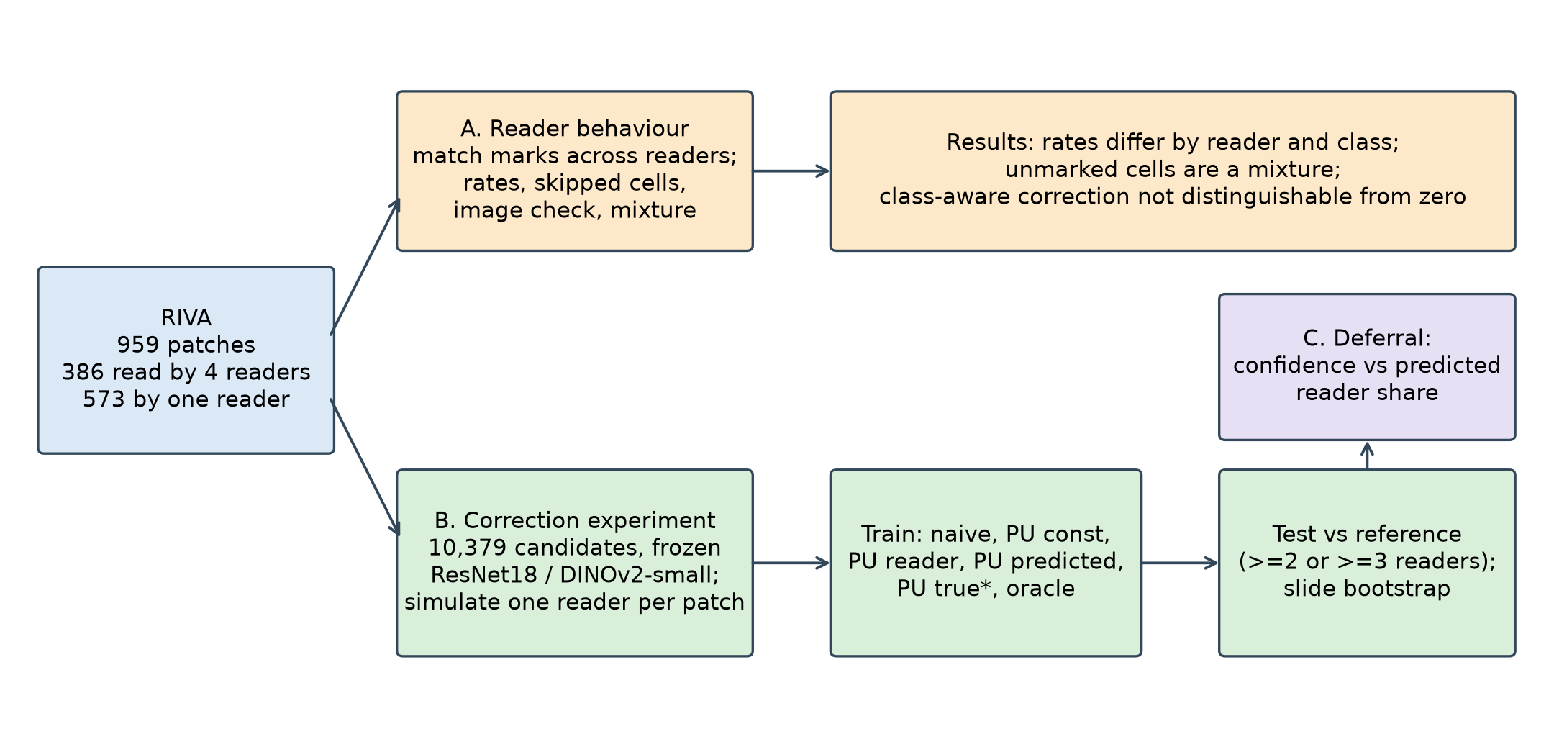
Figure 1. Study design. Marks from the four readers are matched into cells and used for three analyses: (A) reader behaviour, (B) a simulated single-reader correction experiment with frozen image features, and (C) deferral.
5 RESULTS
5.1 Readers differ in what they mark
On the 386 four-reader patches the matching produced 7,470 cells at a radius of 1.85 percent (merged groups under 1 percent). Of these, 38 percent were marked by one reader, 17 percent by two, 17 percent by three and 28 percent by all four (Figure 2). Table 2 and Figure 3 summarise each reader's behaviour.
Table 2. Share of cells marked by at least one other reader that the reader also marked, by cell class group and patch density (radius 1.85 percent). Lesion rates are lowest for annotators 3 and 4 and are nearly flat for annotator_2.
Reader | Marked others' cells, all | Lesion cells | Non-lesion cells (INFL / other) | Dense / sparse patches | Marks with no other reader nearby
annotator_1 | 69% | 45% | 81% / 82% | 68% / 70% | 23%
annotator_2 | 60% | 58% | 56% / 64% | 54% / 66% | 21%
annotator_3 | 51% | 29% | 57% / 67% | 46% / 56% | 10%
annotator_4 | 41% | 19% | 42% / 62% | 37% / 46% | 4%

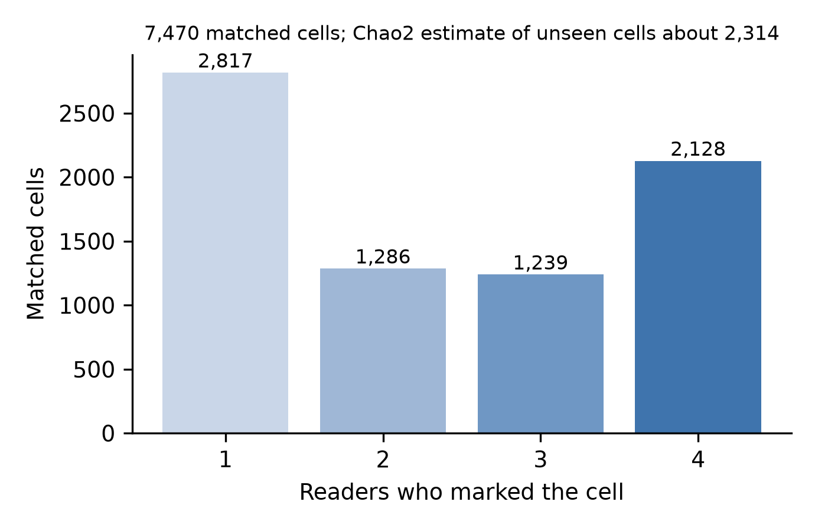
Figure 2. Number of readers who marked each matched cell (radius 1.85 percent of image size, 7,470 cells). The Chao2 estimate puts the number of cells no reader marked at about 2,300.
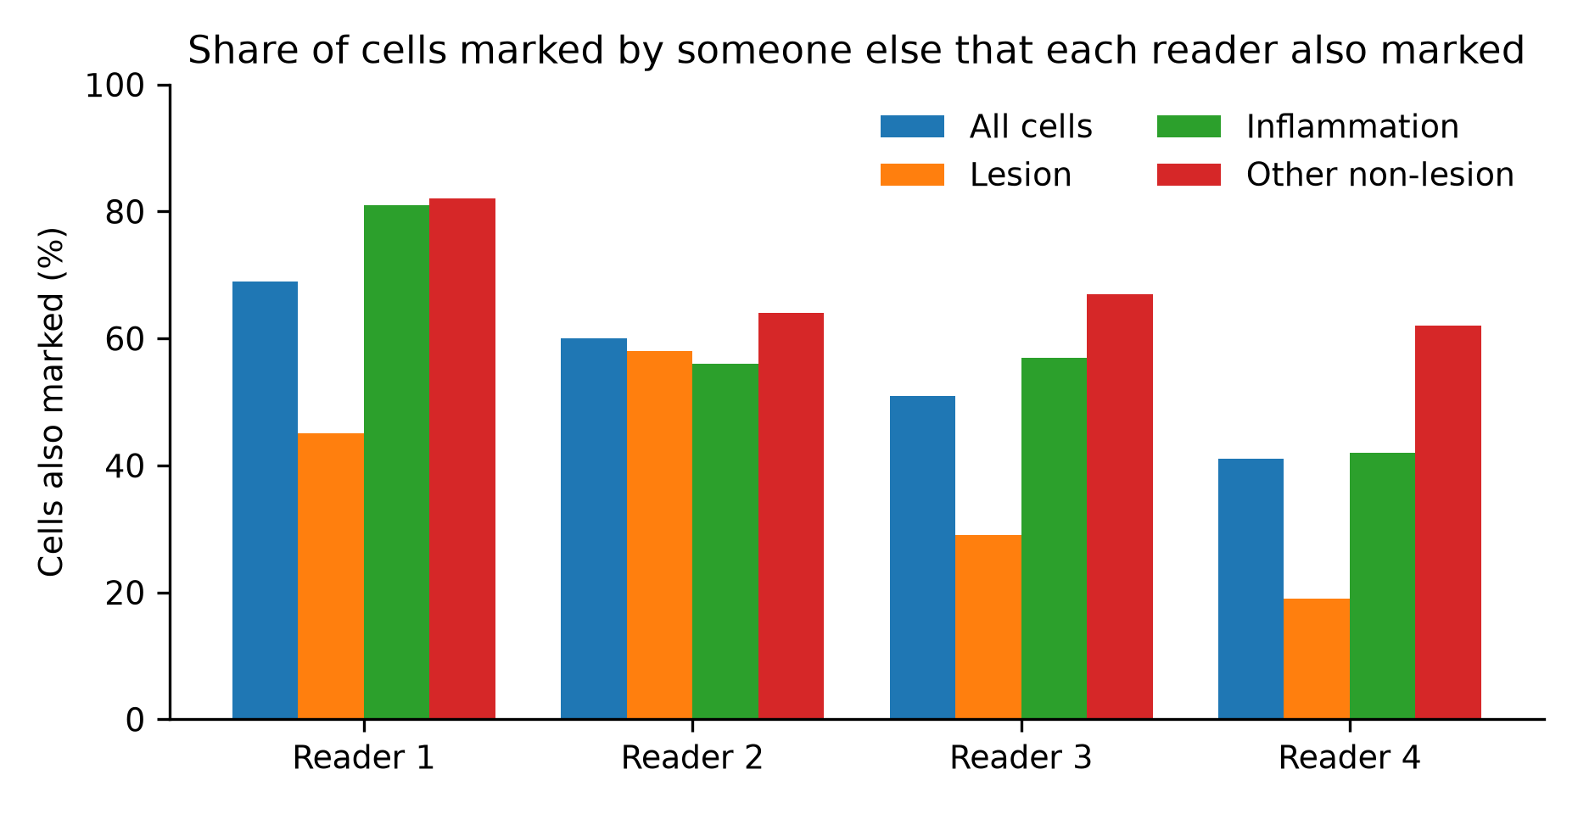
Figure 3. Share of cells marked by someone else that each reader also marked, by cell class group.
Among cells that at least two other readers marked, annotator_4 skipped 1,622 (699 of them called lesions by the majority) and annotator_3 skipped 1,040 (468 lesion-called); annotator_1 skipped 344 and annotator_2 805, most of them non-lesion. Marks that fall just outside the radius (1.85 to 4 percent from another reader's mark) were only 1 to 4 percent of each reader's marks, so a stricter matching radius does not explain the lesion gap. Figure 4 (left) shows the skipped cells by reader. A capture-recapture (Chao2) lower bound [17] suggested roughly 2,300 cells that no reader marked, about a quarter of the estimated total; this estimate assumes independent readers and is indicative only.
5.2 Solo marks mostly sit on cell-like objects
A zero-truncated mixture of real and spurious cells separated reader styles (probability of marking a real cell for non-lesion in sparse patches versus lesion in dense patches: annotator_1 0.97 to 0.90, annotator_4 0.82 to 0.62) but assigned almost every solo mark to the spurious type. Figure 5 shows the fitted probabilities and the fit to the readers-per-cell distribution. That follows from its two-type structure, and it did not fit the observed readers-per-cell distribution (three-reader cells: 1,239 observed, 1,440 expected). The image check was therefore used. A classifier separated consensus cells from background well (median score 1.0 versus 0.0; 4 percent of background above the threshold of 0.81). The share of solo marks above the threshold (Figure 4, right) was 57 percent for annotator_1 (1,174 solo marks), 47 percent for annotator_2 (1,021), 52 percent for annotator_3 (392) and 70 percent for annotator_4 (116). A first run in a notebook, using a subsample of crops, gave 53 to 73 percent; these figures use all crops. Between about half and two thirds of solo marks therefore sit on cell-like objects, against 4 percent of background, which is more consistent with selective labelling than with marks on empty background for those marks, though not for all of them. A cell-like score shows that a cell is centred at the mark, not that it should have been marked.
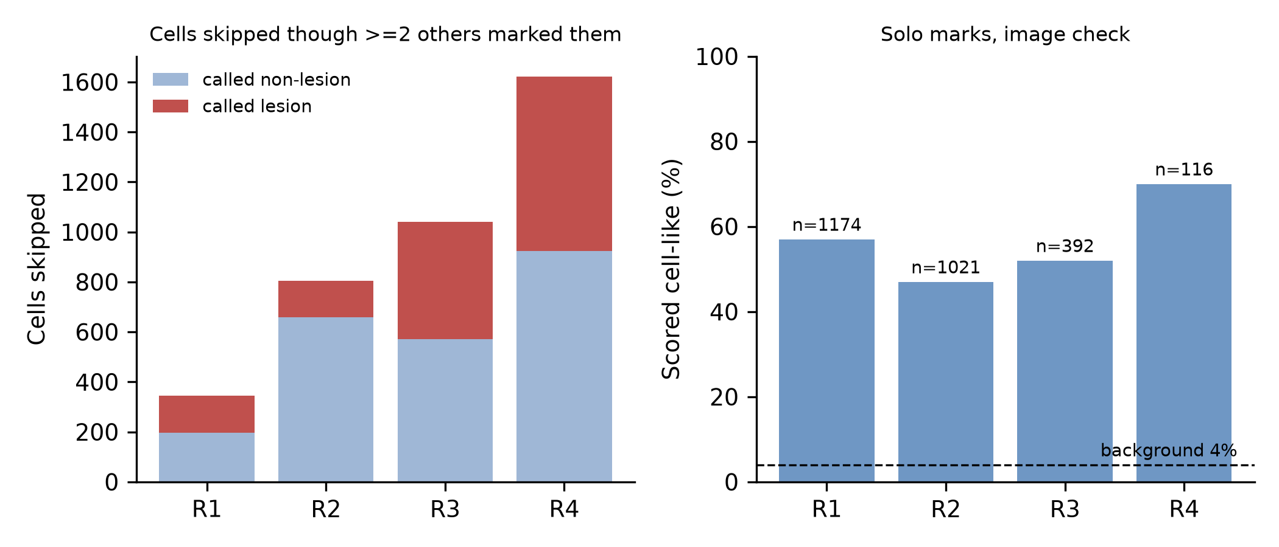
Figure 4. Left: cells skipped by each reader although at least two other readers marked them, split by whether the cell was called lesion. Right: share of each reader's solo marks that the image check scored as cell-like; the dashed line is the share of background points above the same threshold.
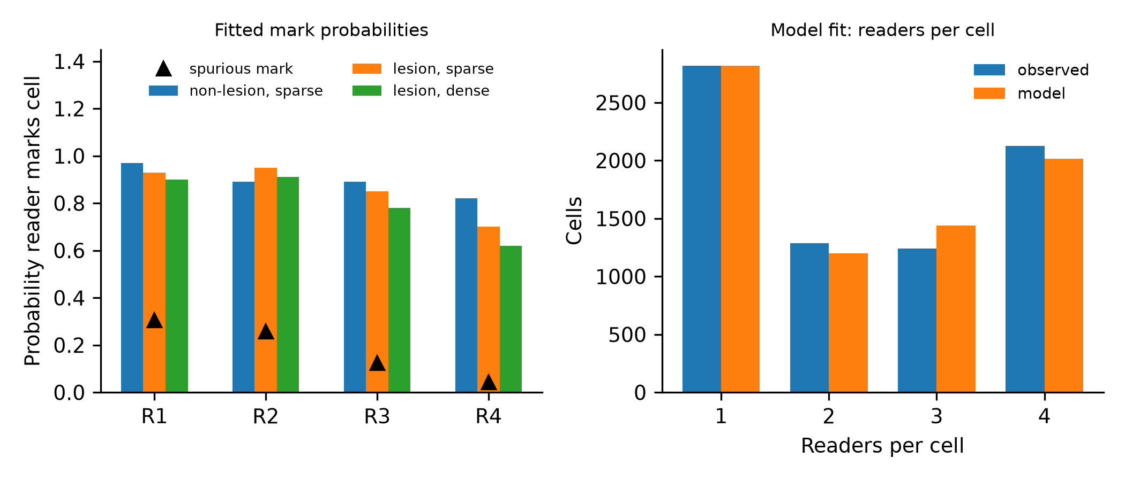
Figure 5. Zero-truncated mixture of real and spurious cells. Left: fitted probability that each reader marks a real cell (by class and patch density) and a spurious one. Right: observed against model-expected numbers of readers per cell.
5.3 Reader-aware correction
Table 3 and Figure 7 give lesion-cell average precision relative to naive training, with the two-reader reference. Naive lesion average precision was 0.616 (ResNet18) and 0.635 (DINOv2-small); training on consensus labels gave 0.652 and 0.667, so the possible gain is about 0.04. Figure 6 shows lesion average precision for every method.
Table 3. Change in lesion average precision relative to naive training (95 percent slide-level bootstrap intervals; models held fixed). The class-aware correction is not distinguishable from naive training; corrections using only reader identity or a single rate are worse. In an earlier run on a different machine the class-aware correction gave +0.026 [+0.003, +0.056] with ResNet18, so its interval crossed zero between runs.
Method | ResNet18 | DINOv2-small
Predicted class and density proxy | +0.019 [-0.003, +0.049] | +0.005 [-0.017, +0.028]
Per-reader rate only | -0.030 [-0.049, -0.010] | -0.027 [-0.049, -0.009]
Constant rate | -0.025 [-0.040, -0.009] | -0.016 [-0.033, -0.002]
Predicted class and density proxy, three-reader reference | +0.022 [-0.003, +0.058] | +0.015 [-0.019, +0.052]

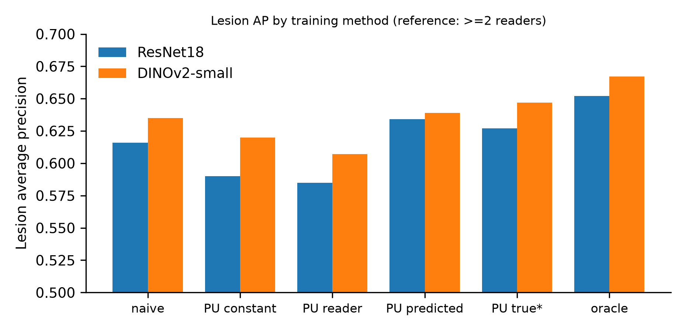
Figure 6. Lesion average precision by training method under the two-reader reference, with frozen ResNet18 and DINOv2-small features. PU true* and oracle are reference points that use information not available in practice.
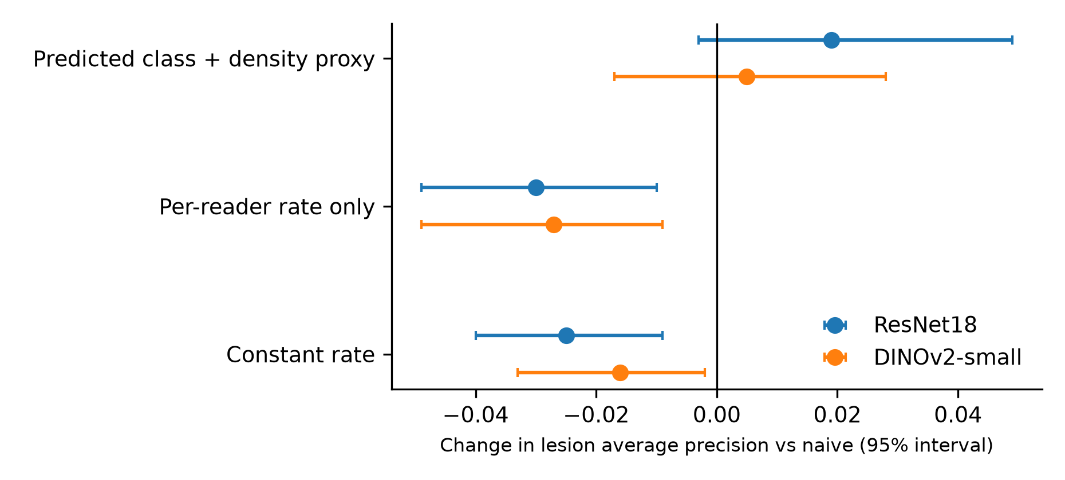
Figure 7. Change in lesion average precision relative to naive training with 95 percent slide-level intervals, two features and three corrections.
5.4 Deferral
Table 4 and Figure 8 give the error among accepted cells at each coverage for model confidence, predicted reader disagreement, their combination and random ranking.
Table 4. Error among accepted cells (reference: marked by at least two readers; error at full coverage 0.227 and 0.218). The combined signal lowered error relative to confidence by 0.016 [0.011 to 0.022] and 0.015 [0.010 to 0.021] at coverage 0.5, and by 0.004 at coverage 0.9 (intervals exclude zero). The disagreement head's predictions correlated 0.76 and 0.78 with the true share of readers who marked a cell. Because the reference is defined by the same readers, part of this gain is circular.
Coverage | Signal | ResNet18 | DINOv2-small
0.5 | Confidence | 0.091 | 0.083
0.5 | Predicted disagreement | 0.078 | 0.071
0.5 | Both (mean rank) | 0.076 | 0.068
0.5 | Random | 0.229 | 0.221
0.7 | Confidence | 0.146 | 0.136
0.7 | Both (mean rank) | 0.134 | 0.127
0.9 | Confidence | 0.201 | 0.193
0.9 | Both (mean rank) | 0.197 | 0.189

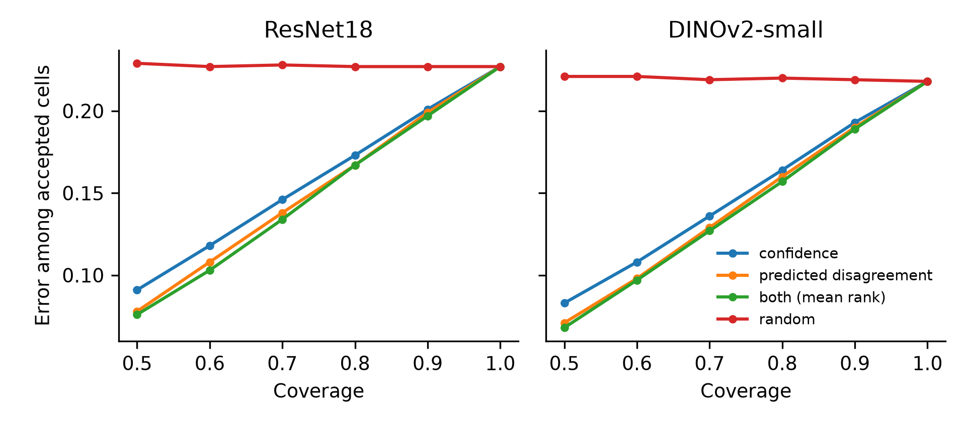
Figure 8. Error among accepted cells against coverage for four deferral signals, two features.
6 DISCUSSION
Readers are not interchangeable. The four pathologists differ in how selectively they mark, and the difference depends on cell class and density. The pattern is not a single reader being sloppy: annotator_4 marks few cells that others do not (4 percent of marks) but skips many that others mark, especially lesion cells in dense patches, while annotators 1 and 2 add marks that no one else made. A model of agreement that assumes equal expertise cannot represent this, and a consensus built by majority vote hides it.
Selective labelling, not noise on background. Between half and two thirds of solo marks sit on objects that look like consensus cells, and the label-only mixture's reading of them as spurious was a product of its structure. We therefore describe reader differences as selective labelling. We cannot say which reader is right: the dataset has no independent reference, and a cell marked by one reader may be a real cell that others missed or a cell they judged not worth marking.
Why the correction did not help. Treating unmarked cells as unlabelled is principled [18,19], and the oracle gap shows there is something to recover (about 0.04 average precision on lesion cells). A correction that knew each cell's true class and local density recovered only about a third of that gap in the final runs (lesion average precision 0.627 and 0.647 against naive 0.616 and 0.635 and oracle 0.652 and 0.667), and real single-reader data does not provide the class of an unmarked cell. Replacing it with a predicted class and a density proxy gave an effect that was not distinguishable from zero, and stronger features reduced it further. Corrections that used only reader identity or one rate were worse than doing nothing, which is a caution for the common practice of reweighting by annotator. Plausible reasons include that the rate estimates are coarse, that omission is confounded with disagreement about class, and that a linear head on frozen features has little capacity to benefit.
Deferral. Combining model confidence with a head trained on graded reader agreement gave lower error among accepted cells than confidence alone, consistently across coverages and feature sets. Selective classification [20] and learning to defer [21] rely on model confidence or a learned rejector; here the rejector is trained on graded reader agreement. The reference is defined by the same readers, so this shows that the model can anticipate where the four readers would split, which is its stated purpose, not that deferred cells are the ones a pathologist would get right.
What this means for dataset users. Multi-reader datasets should be distributed with reader identities, as RIVA does, and analyses should report reader-level behaviour before collapsing to consensus. Single-reader subsets of the same readers are not equivalent to consensus labels for lesion cells.
7 LIMITATIONS
No independent reference. Consensus is defined by the same four readers. We cannot tell omission from judgement, and the deferral evaluation is partly circular. Biopsy, HPV or adjudicated consensus would be needed.
Small, single-source dataset. 386 four-reader patches from 115 patients in one laboratory with four readers. Intervals are slide-level bootstrap intervals [22] and conditional on fixed models, so they understate training variance. One analysis changed from borderline to not significant between two machines.
Not a full detector. Candidates came from the readers' own marks plus random background, so there was no cell proposer, and the 573 real single-reader patches were not used. Features were frozen ImageNet or DINOv2-small encoders on 64-pixel crops with a linear head; a fine-tuned detector or a pathology foundation model could change the effect sizes either way.
Matching and class definitions. Cell matching radius was calibrated to the published cell count, and the lesion group was defined by the majority label among the readers who marked the cell. Class-specific rates therefore depend on readers' own labels.
Image check. Cell-like scores come from a small frozen encoder and an arbitrary threshold; 30 to 53 percent of solo marks were not cell-like and we cannot say whether they are off-centre marks, unusual cells or spurious marks.
Grouping assumptions. We assumed slide numbers within a diagnostic category identify slides and that one slide corresponds to one patient.
Licence. Three different licence statements exist for RIVA; we used it for non-commercial research and did not redistribute it.
8 CONCLUSION
In RIVA, four pathologists differ in which cells they mark, and the differences depend on cell class and density, contradicting an assumption of equal expertise. About half to two thirds of solo marks sit on cell-like objects, so single-reader unmarked cells are better described as unlabelled than as negative. Propensity corrections based on reader identity or a single rate did not help a linear detector and lowered lesion average precision; a class-aware correction using predicted class was not distinguishable from naive training. A head trained on graded reader agreement gave a small, consistent deferral gain against a reference that shares the readers. These results are limited by dataset size, the absence of an independent reference and the simplicity of the detector; they argue for reporting reader-level behaviour in multi-reader pathology datasets and for caution when reweighting labels by annotator.
DECLARATIONS
Data availability. The RIVA dataset is public (Zenodo, doi 10.5281/zenodo.17288879). Derived arrays (candidate table and embeddings) can be regenerated from it with the released script.
Code availability. The analysis code, the text outputs reported here and the figure scripts are available under the MIT licence at https://github.com/Davidic-02/riva-reader-selectivity (commit 155ebe3). The repository does not contain the RIVA images or annotations.
Ethics. Secondary analysis of a public, de-identified dataset. The dataset paper reports approval by the Hospital Bernardino Rivadavia institutional review board with a waiver of consent. No new data were collected.
AI assistance. An AI assistant (Claude, Anthropic) was used to draft analysis code, to run and summarise the analyses, and to draft this text. The authors are responsible for the content and must verify every number, citation and claim before submission. [Adapt to the target journal's policy on AI-assisted writing.]
Competing interests. [To be completed.]
Funding. [To be completed.]
REFERENCES
1. Perez Bianchi P, Anselmo S, Vasquez Currie M, et al.: RIVA: An image dataset of conventional Pap smear cytology with multiple independent annotations. Sci Data. 2025, 12:1991. 10.1038/s41597-025-06280-2
2. Dawid AP, Skene AM: Maximum likelihood estimation of observer error-rates using the EM algorithm. Appl Stat. 1979, 28:20-28. 10.2307/2346806
3. Raykar VC, Yu S, Zhao LH, et al.: Learning from crowds. J Mach Learn Res. 2010, 11:1297-1322.
4. Yan Y, Rosales R, Fung G, Subramanian R, Dy J: Learning from multiple annotators with varying expertise. Mach Learn. 2014, 95:291-327. 10.1007/s10994-013-5412-1
5. Tanno R, Saeedi A, Sankaranarayanan S, Alexander DC, Silberman N: Learning from noisy labels by regularized estimation of annotator confusion. Proc IEEE/CVF Conf Comput Vis Pattern Recognit (CVPR). 2019, 11236-11245. 10.1109/CVPR.2019.01150
6. Yang Y, Liang KJ, Carin L: Object detection as a positive-unlabeled problem. Proc Br Mach Vis Conf (BMVC). 2020. 10.5244/C.34.74
7. Zhao Z, Pang F, Liu Y, Liu Z, Ye C: Positive-unlabeled learning for binary and multi-class cell detection in histopathology images with incomplete annotations. Mach Learn Biomed Imaging. 2022. 10.59275/j.melba.2022-8g31
8. Bekker J, Robberechts P, Davis J: Beyond the selected completely at random assumption for learning from positive and unlabeled data. In: ECML PKDD 2019. Lecture Notes in Computer Science. Springer, Cham; 2020. 71-85. 10.1007/978-3-030-46147-8_5
9. Li H, Sun Y, Zhu C, et al.: Large-scale cervical precancerous screening via AI-assisted cytology whole slide image analysis. arXiv. 2024, 2407.19512.
10. Kang C, Lee C, Song H, Ma M, Pereira S: Variability matters: evaluating inter-rater variability in histopathology for robust cell detection. In: ECCV 2022 Workshops. Lecture Notes in Computer Science. Springer, Cham; 2023. 552-565. 10.1007/978-3-031-25082-8_37
11. Tschirschwitz D, Benz C, Florek M, et al.: Drawing the same bounding box twice? Coping noisy annotations in object detection with repeated labels. arXiv. 2023, 2309.09742.
12. Kogan L, Rios MV: Detection and classification of (pre)cancerous cells in Pap smears: an ensemble strategy for the RIVA Cervical Cytology Challenge. arXiv. 2026, 2603.23742.
13. RIVA database. Zenodo. 2024. 10.5281/zenodo.17288879
14. Ester M, Kriegel H-P, Sander J, Xu X: A density-based algorithm for discovering clusters in large spatial databases with noise. Proc 2nd Int Conf Knowl Discov Data Min (KDD-96). AAAI Press; 1996, 226-231.
15. He K, Zhang X, Ren S, Sun J: Deep residual learning for image recognition. Proc IEEE Conf Comput Vis Pattern Recognit (CVPR). 2016, 770-778. 10.1109/CVPR.2016.90
16. Oquab M, Darcet T, Moutakanni T, et al.: DINOv2: learning robust visual features without supervision. Trans Mach Learn Res. 2024. arXiv:2304.07193
17. Chao A: Estimating the population size for capture-recapture data with unequal catchability. Biometrics. 1987, 43:783-791. 10.2307/2531532
18. Elkan C, Noto K: Learning classifiers from only positive and unlabeled data. Proc 14th ACM SIGKDD Int Conf Knowl Discov Data Min. 2008, 213-220. 10.1145/1401890.1401920
19. Kiryo R, Niu G, du Plessis MC, Sugiyama M: Positive-unlabeled learning with non-negative risk estimator. Adv Neural Inf Process Syst. 2017, 30. arXiv:1703.00593
20. Geifman Y, El-Yaniv R: Selective classification for deep neural networks. Adv Neural Inf Process Syst. 2017, 30. arXiv:1705.08500
21. Mozannar H, Sontag D: Consistent estimators for learning to defer to an expert. Proc 37th Int Conf Mach Learn (ICML). 2020. arXiv:2006.01862
22. Efron B, Tibshirani R: Bootstrap methods for standard errors, confidence intervals, and other measures of statistical accuracy. Stat Sci. 1986, 1:54-75. 10.1214/ss/1177013815

AUTHOR ACTION LIST - NOT PART OF THE MANUSCRIPT; DELETE THIS PAGE BEFORE SUBMISSION
1. Figures. Figures 1 to 8 are in the manuscript; the image files are in paper/figures/ in the repository. Check each figure against the numbers in the text, and regenerate them with src/make_figures.py if any result changes.
2. References still to confirm. All 22 were checked on 11 October 2026 against Crossref, arXiv, JMLR, AAAI and PubMed Central for authors, title and venue. Confirm on the publisher pages: end pages of references 2 and 17, the page range of reference 14, journal details of reference 16 (DINOv2, TMLR), and whether references 9 and 11 have a published version. Reference 13 has no author list on the Zenodo record; add the dataset creators if you want it in author-title form.
3. Reproduce the numbers. The reader-behaviour statistics (Table 2) and the mixture model were re-run from src/reader_behaviour.py and src/mixture_model.py and match; the image check differs from the first notebook run (47 to 70 percent against 53 to 73), and the manuscript uses the repository figures. Confirm the repository results are the ones you cite.
4. Authorship. Add co-authors, affiliations, corresponding author and the supervisor's position.
5. Target journal. Choose the journal, then apply its template, reference style, word limit and section names; check its fee and waiver options.
6. Licence. The three licence statements for RIVA differ. Ask the RIVA authors which applies, or state exactly what you did (non-commercial analysis, no redistribution of images or derived crops).
7. Code. The repository is public and cited in the Declarations (commit 155ebe3). If you change the code before submission, update the commit hash, and consider tagging a release.
8. Optional strengthening. Use the 573 real single-reader patches with a cell proposer; add a fine-tuned detector or a pathology foundation model; add an independent or adjudicated reference if one becomes available.
9. AI-assistance disclosure. Adapt the statement to the target journal's policy.
10. Words and sections. The brain tumour manuscript runs about 4,400 words; this draft is shorter. Check the journal's word limit before adding material.

