**OUTPUT**

**GIT:Created three branches in git main,branch1,branch2 and merged branch1 and branch 2 to main branch**

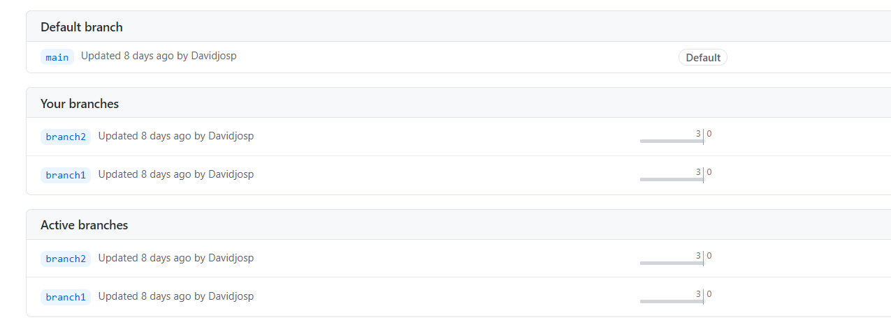

**LOCAL ENDPOINT_working:**

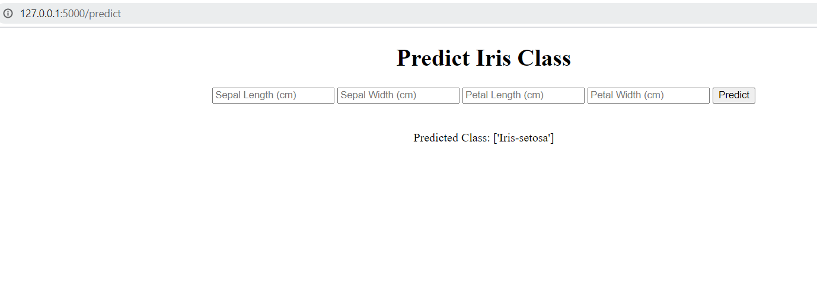

**Docker image:**

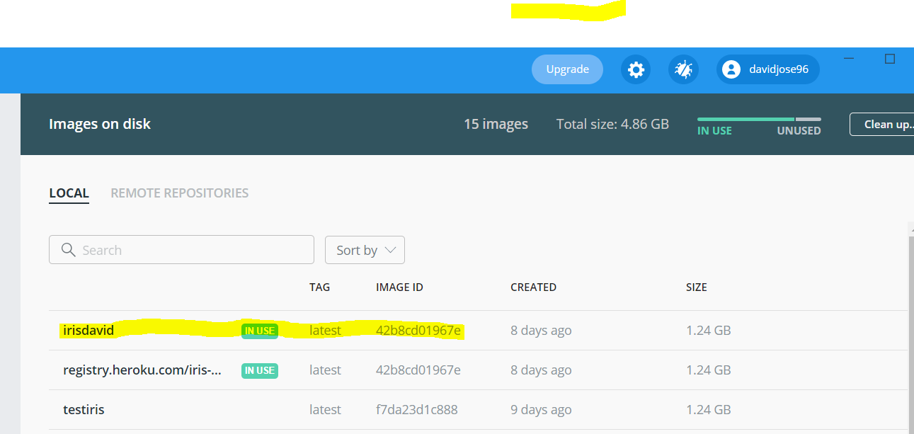

**I had taken permission to deploy in Heroku**

**Heroku app:**

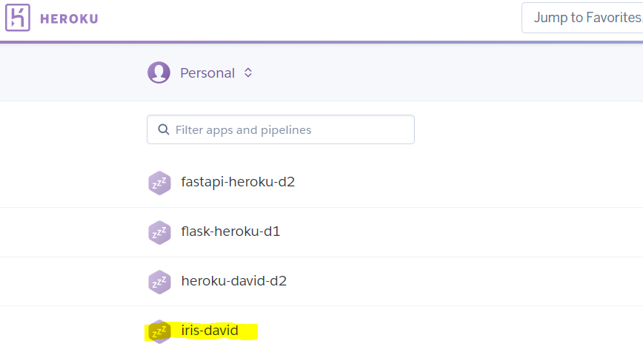

**Heroku output:**

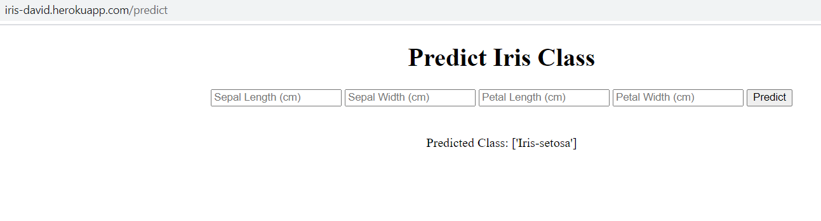

**Heroku app:**

[**https://iris-heroku-david.herokuapp.com/**](https://iris-heroku-david.herokuapp.com/)