David Lam

U00959333

ISM6225_Assignment 1: Documentation and Screenshots

01/22/2019

**Method 1: printPrimeNumbers**

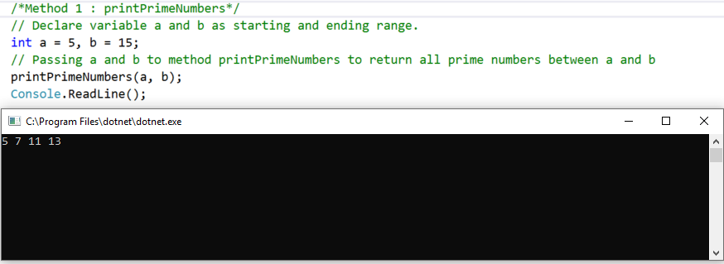

**Method 2 : getSeriesResult**

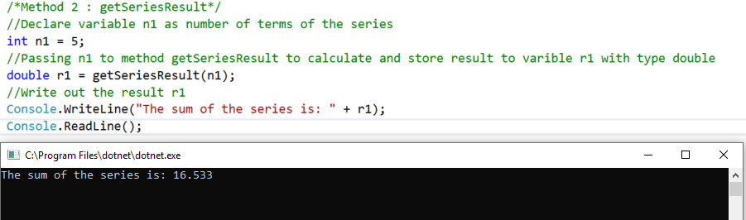

**Method 3 : decimalToBinary**

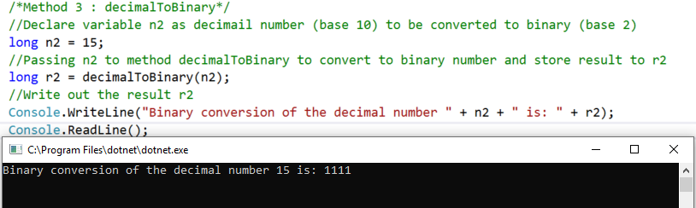

**Method 4 : binaryToDecimal**

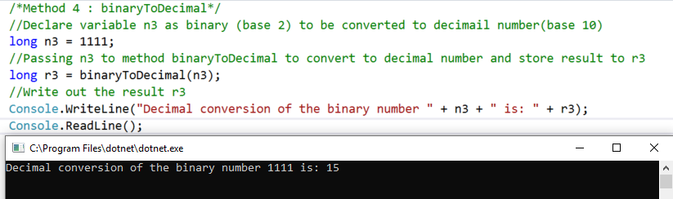

**Method 5 : printTriangle**

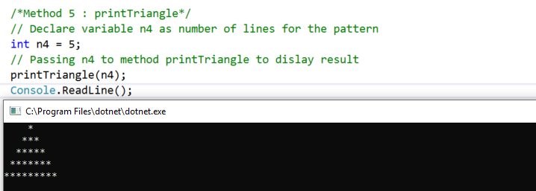

**Method 6 : computeFrequency**

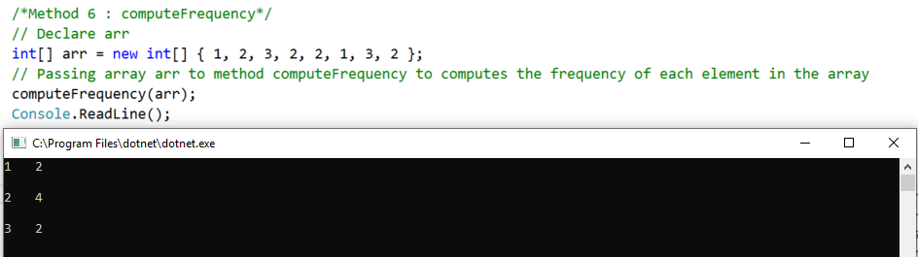

**// write your self-reflection here as a comment**

