Website Proposal



THE QUAIL GARDEN

Ethically raised free-to-fly quail eggs

Date issued: 31/10/2019

**Project Sponsor:** Hollie Astle

**Address:**

52 Thorndike Avenue

Alvaston

Derby

DE24 8NY

**Tel:**

07450309861

**Email:**

thequailgarden@gmail.com

Signature:_______________

Date:_____________________

**Project Manager:** David Mason

**Address:**

75 Burnage Hall Road

Burnage

Manchester

M19 2JZ

**Tel:**

07479206854

**Email:**

davemason0897@gmail.com

Signature:_______________

Date:_____________________

**ORGANISATION**

**Company Background and Vision**

The Quail Garden, based in Derby, is a family run, ‘free to fly’ quail egg producer with the vision of “creating a business that pays a fair wage, develops skills and employs the vulnerable.”

**Key business issues**

* The majority of sales just come from friends and family.
* There is nowhere potential customers can find out more about the company and the benefits of quail eggs.
* Currently the business doesn’t have a national delivery service.
* To gain bigger supply contracts they need to create more legitimacy.

**Web contribution**

Currently The Quail Garden is active on Facebook and Instagram. This is where they share most of their company news and information as well as being their main medium for promoting and selling.

Facebook: /TheQuailGarden

Instagram: @thequailgarden

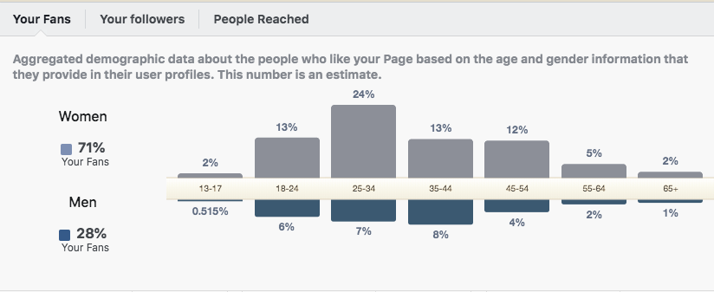

Figure Demographics from Facebook Insights – Represents 196 total followers

**CUSTOMERS**

**Main audiences**

The Quail Garden currently just targets consumers but would like to target businesses to gain larger supply contracts. The main audience for business and consumers are as follows.

*Consumers* - Ages 25-34, Women, Middle Class, Ethically Minded

*Businesses* – High-end restaurants (French, Vietnamese, English), Farm and local produce shops, Boutique Pubs and Café’s.

**Key reasons to choose**

* Free-to-fly eggs
* Ethically lead business
* Quail eggs have a higher nutrient value than chicken eggs
* Family run

**Market research**

Although quail eggs are considered a delicacy in some areas of Europe they are typically farmed in large quantities and intense conditions (CIWF, 2016). Smaller and harder to open than their rival chicken eggs, quail eggs contain more nutrients per 100g. They are a good source of Folate, Vitamin B12, Pantothenic Acid, Iron and Phosphorus, and a very good source of Protein, Riboflavin and Selenium (Nutrition Data, 2019).

Consumers are increasingly looking to source ethical produce as 45% of buyers cite animal welfare as the most important reason they buy ethical food/drink (Mintel, 2019).

They’re a valuable addition to chefs for gourmet meals, with the likes of Jamie Oliver endorsing, “they’re quick, delicious and pretty” (Theglobeandmail, 2016).

*Current Competitors*

* Norfolk Quail - [www.norfolkquail.co.uk](http://www.norfolkquail.co.uk)
* Clarence Court - [www.clarencecourt.co.uk/](http://www.clarencecourt.co.uk/)
* Sainsbury’s, Waitrose and Ocado

**Pain points**

* The majority of quail eggs are mass-produced.
* Lack of ethical ‘free-to-fly’ quail eggs
* Smaller and more ‘fiddly’ than other eggs.
* An unknown egg compared to its rival the chicken egg
* Consumers are unaware of how to use/cook with quail eggs

**VISION**

**How you want visitors to feel**

*Welcomed* into The Quail Garden family.

*Encouraged* to learn about The Quail Garden and its values.

*Informed* about the benefits of adding quail eggs to your diet.

*Reassured* that the products are produced ethically.

**Purpose of the new site**

The purpose of the website will be to draw potential customers to a centralized place to learn about the company and its values. The site will also be used to gain more sales and promote to potential customers, especially larger supply opportunities. Finally the site will promote and educate consumers on the uses and benefits of quail eggs.

**Content areas**

*Home page -* The home page will be the landing page for new visitors and such should showcase the brand of the business as well as portraying what the businesses values and vision is.

*About page* - The about page is an extension of the home page where it will give the visitor a further view of the client’s ethical values and information about the business members.

*News Page* - This page will show a blog that will contain quail egg recipes and news about the company. The blog area will be prefilled with two blogs (supplied by the client). The website will be connected to WordPress after the deadline so that the client can update the blog themselves.

*Quails egg page* - This page will inform the user of the health benefits and uses of quails egg.

*How to buy* - This page is will be targeted towards business and consumers. For the consumers the page will inform them to contact them via Facebook or the contact page to enquire about the quantity and collection of the eggs. For businesses this page will inform them of the types of businesses the client can cater for as well as information on the reasons for them to buy eggs from The Quail Garden. Throughout the page there will be sufficient call to actions leading to the contact page to enquire.

*Contact page* – This page will contain a simple form with a drop down menu to differentiate business and consumer enquiries. It will also contain all other contact information for the client.

*Images* – The images required for the site will be agreed and sourced by the client.

*Branding* – The branding, including logo, colours and typography, will be supplied by the client.

**Required functionality**

*Contact form* – For customers to enquire about placing an order

*Social media feed* – To showcase the clients Facebook and Instagram content

*Blog area* – To keep customers up to date with the client’s latest news and other quail egg related content.

*Responsive and Accessible* - To ensure usability across all platforms the website will be responsive and viewable on mobile, tablet, and desktop. The website will be created to ensure accessibility across all ages and abilities.

**Out of scope**

The website will not include any ecommerce functionality as the client does not currently have a national delivery service. This can be added later through WordPress using plugins such as Woo Commerce.

The website will not include a facility to upload new blog posts although once the website is deployed it can be added to WordPress to allow the client to update the blog themselves.

**PRODUCTION**

**Who will be contributing?**

The Developer (David Mason) will be responsible for researching, designing and building the pages and functionality of the website.

The Business Owner, Hollie Astle, will be responsible for providing all content (copy, branding and images) for the website.

**Phases**

This project will consist of six stages. After each stage there will be a meeting to ensure the project is on track before moving onto the next stage.

*Research* – This phase will involve user and market research, competitor analysis, and user personas.

*Architecture* – The aim of this phase is to create an outline of how the website will function for the user.

*Design* – Page mock-ups and mood boards will be created to showcase how the website will portray The Quail Garden’s brand.

*Build* – Once the final design has been decided and signed off the website will be built. Then the client will review the site before proceeding to the testing phase.

*Test* – This will involve user testing to assess accessibility, compatibility, performance and functionality. The findings will be reviewed and applied to further improve the website.

*Deploy* – The website will be handed over to the client.

**Deadlines**

Research – w/b 4th November 2019

Architecture – w/b 18th November 2019

Design – w/b 25th November 2019

Build – w/b 6th January 2020

Test – w/b- 3rd February 2020

Deploy - **Tuesday 3rd March 2020**

**Budget**

This is a free project in conjunction with Manchester Metropolitan University. Due to other projects, the developer can only allocate 225 hours per project.

If the client wishes to connect the website to their own domain/ database they will have to fund that themselves.