David O’Neill

C15737551

Enterprise Application Development

Lab 03 - Graphql

Table of Contents

**No table of contents entries found.**

# Question One



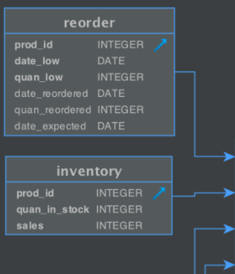For this I chose these tables and relations: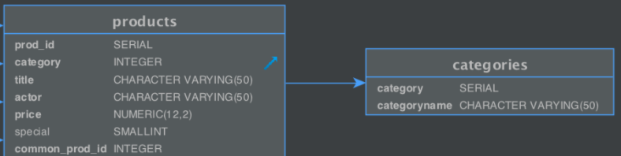   
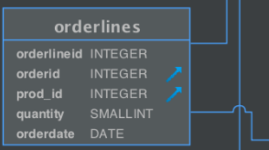

This is the GraphQL schema that I created:

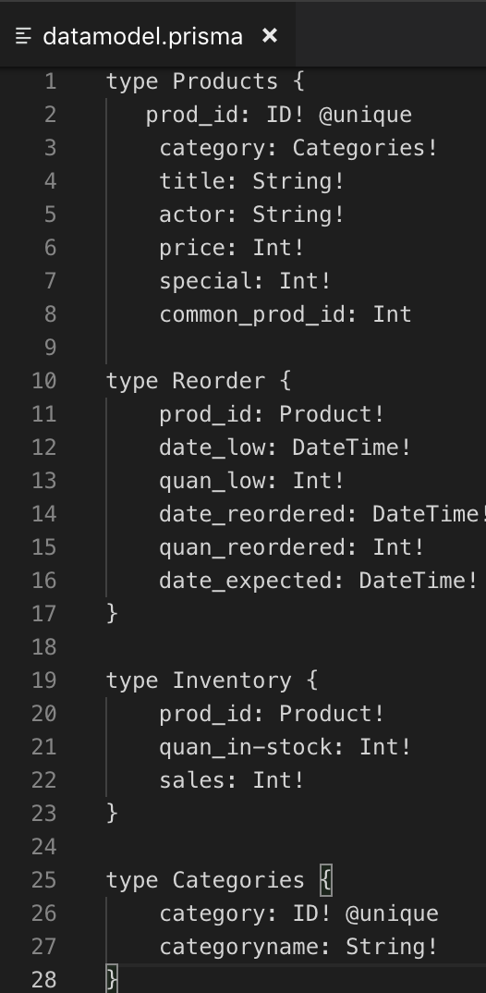 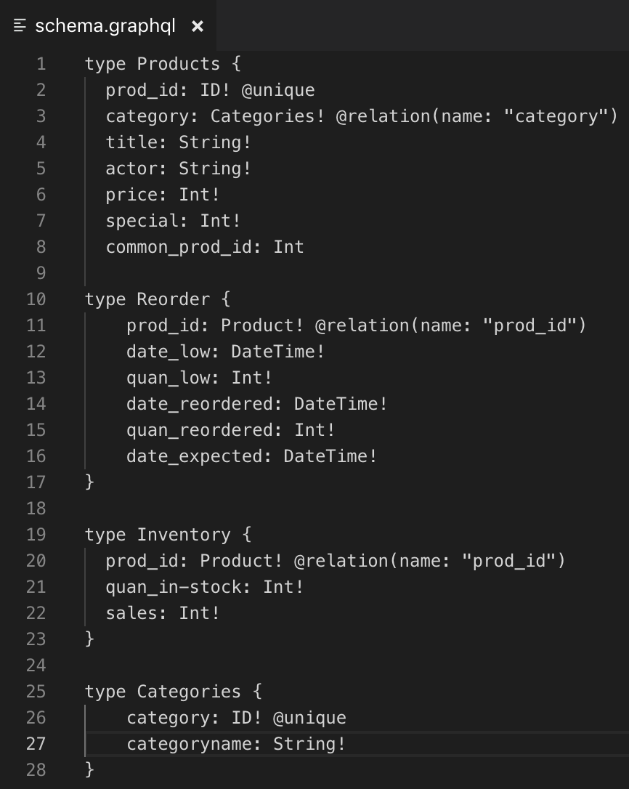

# Question Two

