Buttons
https://www.figma.com/design/oRDLRL9OUNcTQ0k6G5MBPS/Losa-Flotante?node-id=1153-2937&m=dev
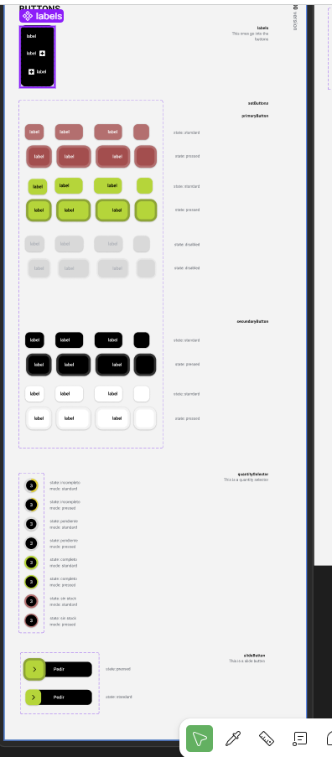
https://www.figma.com/design/oRDLRL9OUNcTQ0k6G5MBPS/Losa-Flotante?node-id=434-3501&m=dev
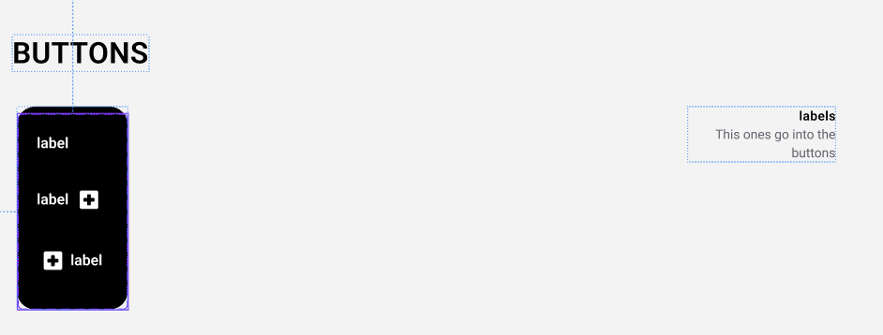
https://www.figma.com/design/oRDLRL9OUNcTQ0k6G5MBPS/Losa-Flotante?node-id=434-2434&m=dev
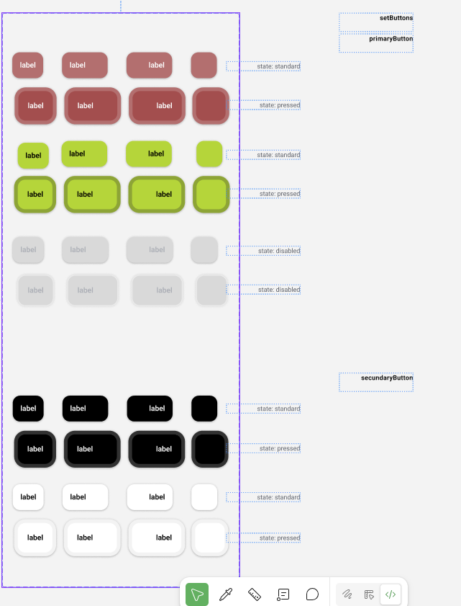
https://www.figma.com/design/oRDLRL9OUNcTQ0k6G5MBPS/Losa-Flotante?node-id=879-4242&m=dev
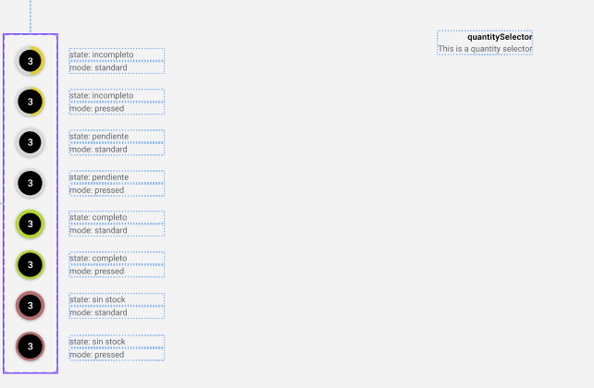
https://www.figma.com/design/oRDLRL9OUNcTQ0k6G5MBPS/Losa-Flotante?node-id=997-3096&m=dev
