Cards
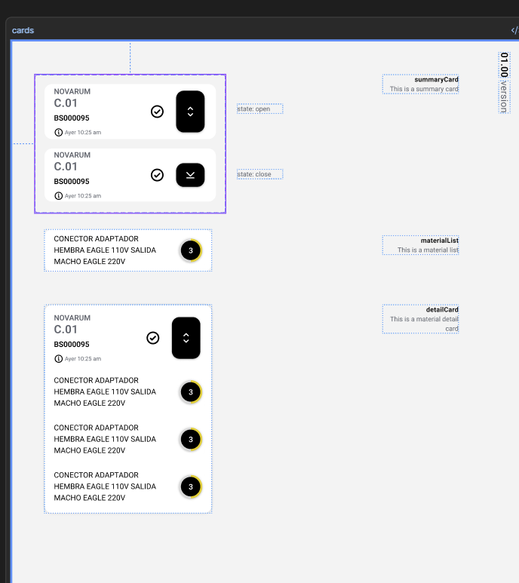
https://www.figma.com/design/oRDLRL9OUNcTQ0k6G5MBPS/Losa-Flotante?node-id=1027-3998&m=dev
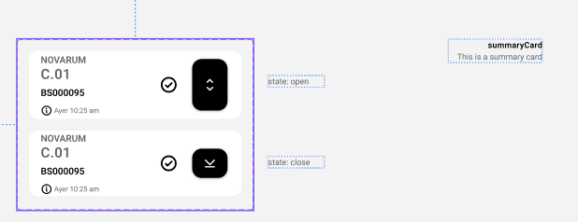
https://www.figma.com/design/oRDLRL9OUNcTQ0k6G5MBPS/Losa-Flotante?node-id=677-2515&m=dev
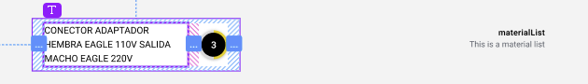
https://www.figma.com/design/oRDLRL9OUNcTQ0k6G5MBPS/Losa-Flotante?node-id=1213-4316&m=dev
