Forms
https://www.figma.com/design/oRDLRL9OUNcTQ0k6G5MBPS/Losa-Flotante?node-id=1153-2987&m=dev
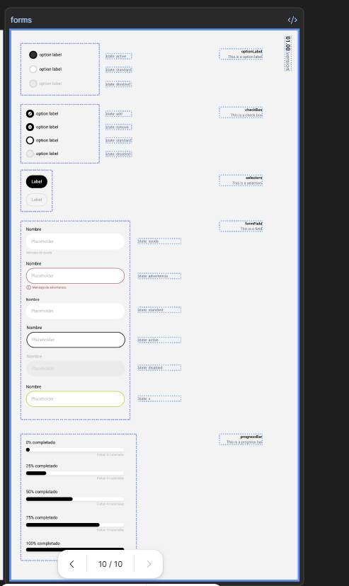
https://www.figma.com/design/oRDLRL9OUNcTQ0k6G5MBPS/Losa-Flotante?node-id=1153-2987&m=dev
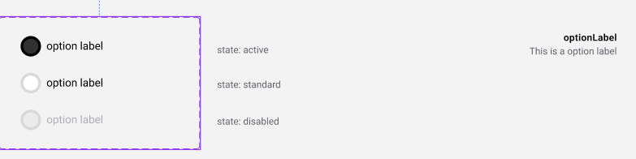
https://www.figma.com/design/oRDLRL9OUNcTQ0k6G5MBPS/Losa-Flotante?node-id=1029-4233&m=dev
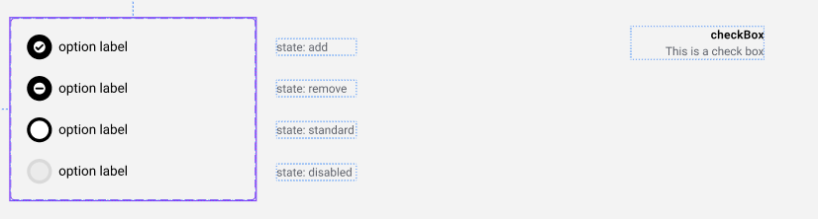
https://www.figma.com/design/oRDLRL9OUNcTQ0k6G5MBPS/Losa-Flotante?node-id=1123-24554&m=dev
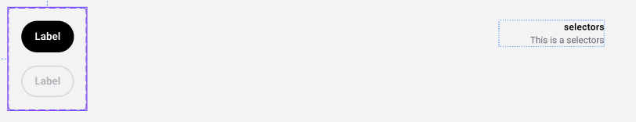
https://www.figma.com/design/oRDLRL9OUNcTQ0k6G5MBPS/Losa-Flotante?node-id=763-2791&m=dev
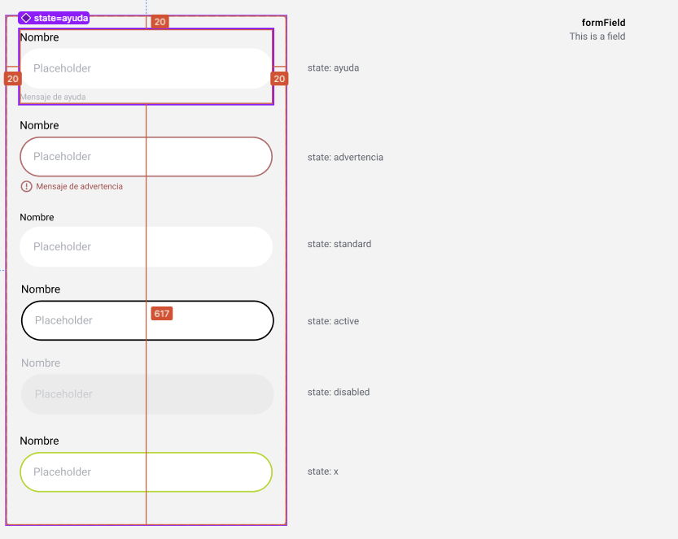
https://www.figma.com/design/oRDLRL9OUNcTQ0k6G5MBPS/Losa-Flotante?node-id=801-3386&m=dev
