Iconos
https://www.figma.com/design/oRDLRL9OUNcTQ0k6G5MBPS/Losa-Flotante?node-id=1153-3008&m=dev
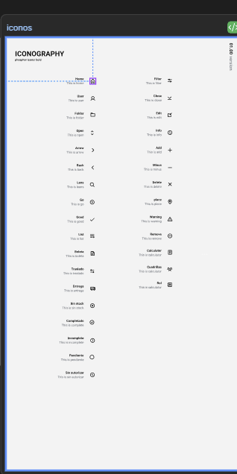
https://www.figma.com/design/oRDLRL9OUNcTQ0k6G5MBPS/Losa-Flotante?node-id=639-2191&m=dev
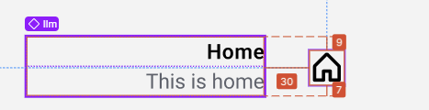
https://www.figma.com/design/oRDLRL9OUNcTQ0k6G5MBPS/Losa-Flotante?node-id=639-2171&m=dev
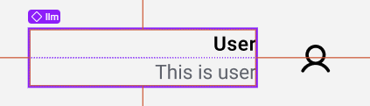
https://www.figma.com/design/oRDLRL9OUNcTQ0k6G5MBPS/Losa-Flotante?node-id=639-2168&m=dev
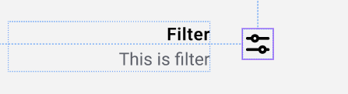
https://www.figma.com/design/oRDLRL9OUNcTQ0k6G5MBPS/Losa-Flotante?node-id=617-1948&m=dev
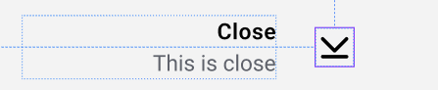
https://www.figma.com/design/oRDLRL9OUNcTQ0k6G5MBPS/Losa-Flotante?node-id=639-2188&m=dev
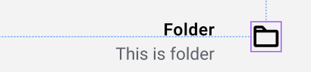
https://www.figma.com/design/oRDLRL9OUNcTQ0k6G5MBPS/Losa-Flotante?node-id=639-2162&m=dev
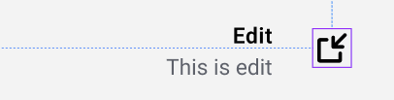
https://www.figma.com/design/oRDLRL9OUNcTQ0k6G5MBPS/Losa-Flotante?node-id=617-1923&m=dev
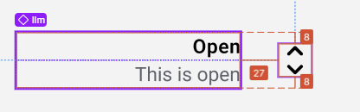
https://www.figma.com/design/oRDLRL9OUNcTQ0k6G5MBPS/Losa-Flotante?node-id=639-2165&m=dev
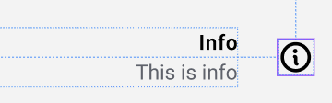
https://www.figma.com/design/oRDLRL9OUNcTQ0k6G5MBPS/Losa-Flotante?node-id=626-2802&m=dev
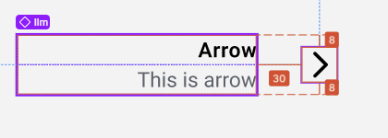
https://www.figma.com/design/oRDLRL9OUNcTQ0k6G5MBPS/Losa-Flotante?node-id=639-2121&m=dev

https://www.figma.com/design/oRDLRL9OUNcTQ0k6G5MBPS/Losa-Flotante?node-id=639-2287&m=dev
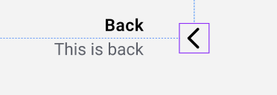
https://www.figma.com/design/oRDLRL9OUNcTQ0k6G5MBPS/Losa-Flotante?node-id=639-2124&m=dev
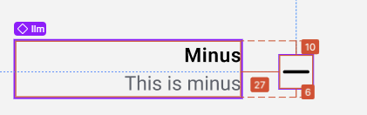
https://www.figma.com/design/oRDLRL9OUNcTQ0k6G5MBPS/Losa-Flotante?node-id=617-2166&m=dev

https://www.figma.com/design/oRDLRL9OUNcTQ0k6G5MBPS/Losa-Flotante?node-id=639-2127&m=dev
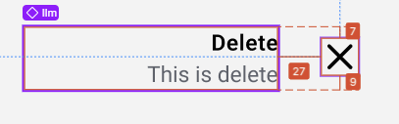
https://www.figma.com/design/oRDLRL9OUNcTQ0k6G5MBPS/Losa-Flotante?node-id=639-2137&m=dev
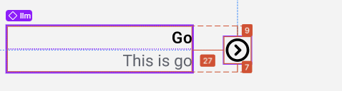
https://www.figma.com/design/oRDLRL9OUNcTQ0k6G5MBPS/Losa-Flotante?node-id=747-2591&m=dev
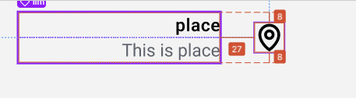
https://www.figma.com/design/oRDLRL9OUNcTQ0k6G5MBPS/Losa-Flotante?node-id=639-2176&m=dev
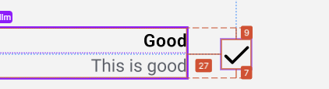
https://www.figma.com/design/oRDLRL9OUNcTQ0k6G5MBPS/Losa-Flotante?node-id=758-2678&m=dev
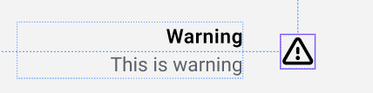
https://www.figma.com/design/oRDLRL9OUNcTQ0k6G5MBPS/Losa-Flotante?node-id=639-2181&m=dev
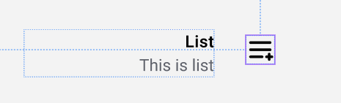
https://www.figma.com/design/oRDLRL9OUNcTQ0k6G5MBPS/Losa-Flotante?node-id=1029-4229&m=dev
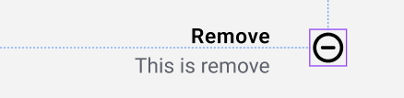
https://www.figma.com/design/oRDLRL9OUNcTQ0k6G5MBPS/Losa-Flotante?node-id=622-2458&m=dev
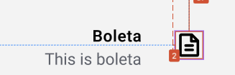
https://www.figma.com/design/oRDLRL9OUNcTQ0k6G5MBPS/Losa-Flotante?node-id=1102-2842&m=dev
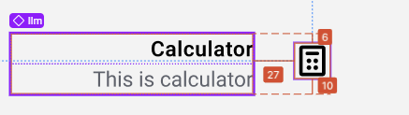
https://www.figma.com/design/oRDLRL9OUNcTQ0k6G5MBPS/Losa-Flotante?node-id=1153-3008&m=dev
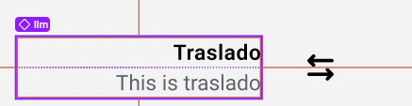
https://www.figma.com/design/oRDLRL9OUNcTQ0k6G5MBPS/Losa-Flotante?node-id=1342-354&m=dev
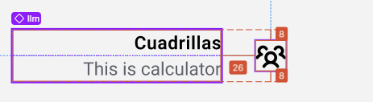
https://www.figma.com/design/oRDLRL9OUNcTQ0k6G5MBPS/Losa-Flotante?node-id=622-2459&m=dev
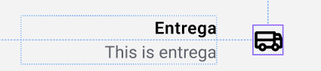
https://www.figma.com/design/oRDLRL9OUNcTQ0k6G5MBPS/Losa-Flotante?node-id=1342-361&m=dev
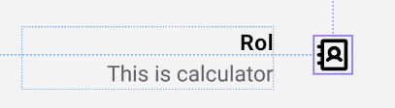
https://www.figma.com/design/oRDLRL9OUNcTQ0k6G5MBPS/Losa-Flotante?node-id=639-2156&m=dev
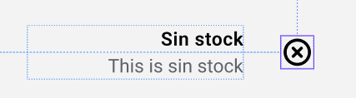
https://www.figma.com/design/oRDLRL9OUNcTQ0k6G5MBPS/Losa-Flotante?node-id=639-2157&m=dev
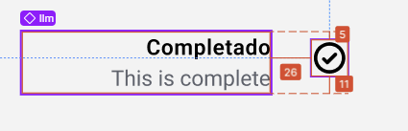
https://www.figma.com/design/oRDLRL9OUNcTQ0k6G5MBPS/Losa-Flotante?node-id=639-2158&m=dev

https://www.figma.com/design/oRDLRL9OUNcTQ0k6G5MBPS/Losa-Flotante?node-id=639-2159&m=dev
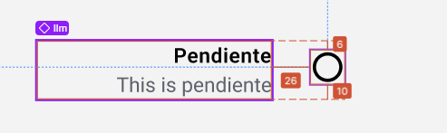
https://www.figma.com/design/oRDLRL9OUNcTQ0k6G5MBPS/Losa-Flotante?node-id=716-2400&m=dev
