Nav
https://www.figma.com/design/oRDLRL9OUNcTQ0k6G5MBPS/Losa-Flotante?node-id=1153-2834&m=dev
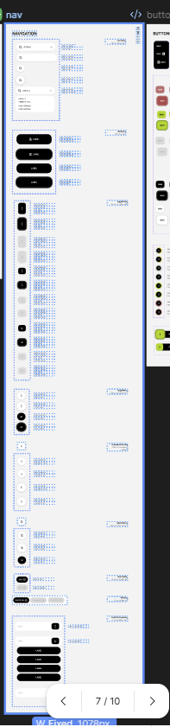
https://www.figma.com/design/oRDLRL9OUNcTQ0k6G5MBPS/Losa-Flotante?node-id=1014-3556&m=dev
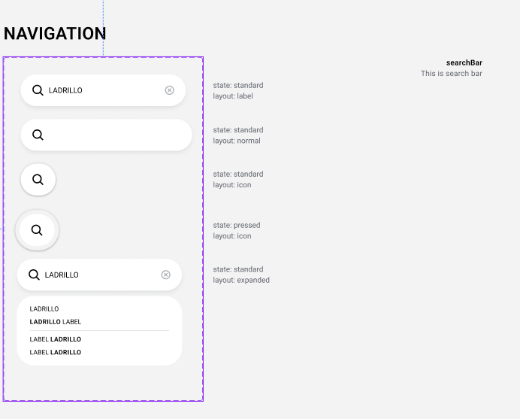
https://www.figma.com/design/oRDLRL9OUNcTQ0k6G5MBPS/Losa-Flotante?node-id=1014-3648&m=dev
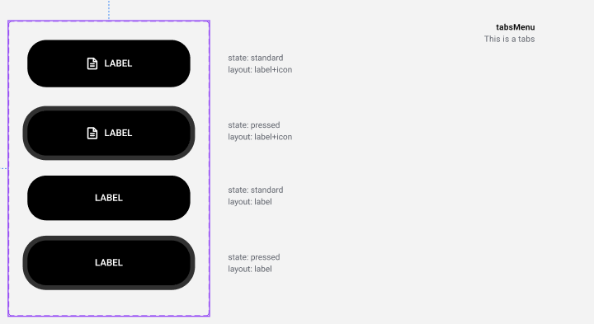
https://www.figma.com/design/oRDLRL9OUNcTQ0k6G5MBPS/Losa-Flotante?node-id=1023-3745&m=dev
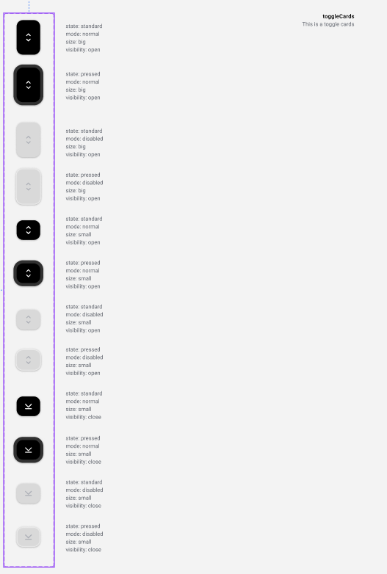
https://www.figma.com/design/oRDLRL9OUNcTQ0k6G5MBPS/Losa-Flotante?node-id=1026-3823&m=dev
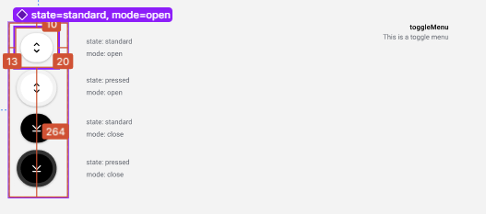
https://www.figma.com/design/oRDLRL9OUNcTQ0k6G5MBPS/Losa-Flotante?node-id=1023-3648&m=dev
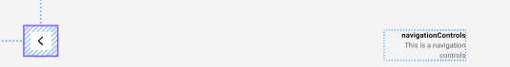
https://www.figma.com/design/oRDLRL9OUNcTQ0k6G5MBPS/Losa-Flotante?node-id=1023-3659&m=dev
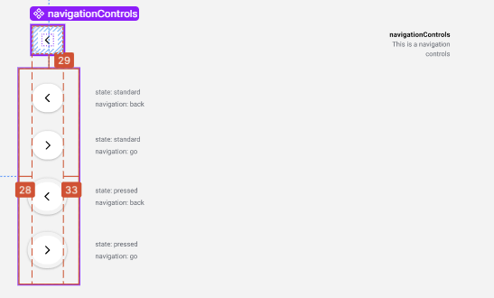
https://www.figma.com/design/oRDLRL9OUNcTQ0k6G5MBPS/Losa-Flotante?node-id=1023-3630&m=dev
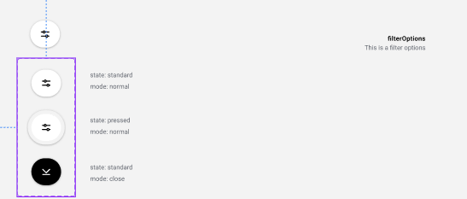
https://www.figma.com/design/oRDLRL9OUNcTQ0k6G5MBPS/Losa-Flotante?node-id=859-3039&m=dev
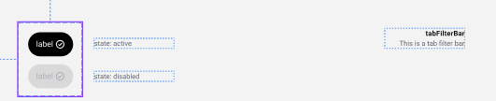
https://www.figma.com/design/oRDLRL9OUNcTQ0k6G5MBPS/Losa-Flotante?node-id=1023-3557&m=dev
https://www.figma.com/design/oRDLRL9OUNcTQ0k6G5MBPS/Losa-Flotante?node-id=1027-3905&m=dev
