COACH TESTING MANUAL
The eight rank tests — how to build them, run them, and record them

Why we test
Eight tests, run the same way every time, are what turn coaching from an opinion into a record.

A feeling is not progress
A player can train hard for three months, genuinely enjoy it, and come out the other side no better at anything you could point to. That happens constantly, and it is almost never obvious from the inside. Everyone involved — coach, player, parent — is working off an impression.
A test replaces “he looks sharper lately” with a number that either moved or it didn't. If it moved, you know what worked. If it didn't, you know months earlier than you otherwise would, and you still have time to change the plan.

The setup is the test
The single most important thing in this manual is that every layout is built the same way every time. Ten yards means ten yards, measured, not paced out by eye.
A test set up loosely produces a number that looks exactly like a real one. That is worse than not testing at all: nobody distrusts it, it goes on the player's record, and it quietly corrupts every comparison made against it afterwards. A player whose figure-8 cones drifted to eight yards apart will post a career-best score and learn nothing.
This is the whole reason the field layouts in this manual carry exact distances. Build each one once with a tape measure, and photograph it if it helps you rebuild it the same way next time.

The level is earned, not awarded
No one is moved up a level because they have been around a while, because they train hard, or because they are a good kid. Every level is gated on the same eight tests at the same numbers for every player in the programme.
That protects everyone. A player cannot be argued into a level by a persistent parent, and — just as importantly — a quiet player who is genuinely good cannot be overlooked. The numbers settle it.

It exposes the thing being avoided
A level requires all eight tests, not an average of them. One failing test blocks the level outright, no matter how strong the other seven are.
That is deliberate. Players naturally practise what they are already good at and quietly avoid what they are not — almost always the weak foot. A single-score system lets them hide behind a strength. Eight independent gates do not.
In practice, the test a player sits furthest from is usually the most valuable thing they could be training. The checklist tells you what that is without anybody having to guess.

It gives the player something to aim at
“Get better” is not a plan a fourteen-year-old can act on. “You need twelve cross-dribble loops on your weak foot and you are at nine” is.
Each player can see exactly what stands between them and their next level, and how close they are to each item. That turns a vague ambition into a short list of specific, finishable jobs.

It shows parents what they are paying for
Parents are buying something they mostly cannot evaluate. A test history gives them a straight answer: here is where your child started, here is where they are now, here is what we are working on next.
It also makes the honest conversations easier. When progress has genuinely stalled, the numbers say so before anyone has to.

It builds a record that outlasts memory
Every test is stored against the player. Two years on, you can see the whole arc — which levels took months and which took a year, where they plateaued, what broke the plateau.
No coach remembers that accurately, and the players certainly don't. The record does.

How the levels work, and how to run a testing day

The ladder
There are seven levels. Level 1 is the base that every player starts at. Levels 2 through 7 are earned in order — there is no skipping, and no partial credit for clearing a level ahead of the one below it.

Three gates per level
- All eight rank tests passed at that level. One failing test blocks the level.
- The session minimum for that level reached.
- That level's Coach Mission assigned and completed.

Writing the score: the level goes first
Most tests use a different drill at each level, and the numbers overlap badly. A 6 in the Dribbling column is either a figure-8 at Level 2 or an obstacle run at Level 7 — opposite ends of the ladder, identical number. A 100 in the Juggling column is either feet-only at Level 3 or the weak-foot ladder at Level 7.
So where the number alone is ambiguous, write the level first, then the score, separated by a dash. 7-6 is an obstacle score of 6 at Level 7. 2-6 is a figure-8 score of 6 at Level 2. Use the dash rather than a space, so 2 and 6 can never be read back as 26.
Where a prefix is not needed, just write the number on its own — do not add one out of habit, or whoever does the data entry has to work out whether the leading digit is a level or part of the score.
- Juggling — always. Every level is a different drill.
- Dribbling — Levels 6 and 7 only. Figure-8 (Levels 2–3) and cross-dribble (Levels 4–5) are told apart by size; the obstacle course collides with figure-8, so prefix those.
- Passing — Levels 5, 6 and 7 only. The gate scores at Levels 2–4 are small enough to be obvious, but the three colour drills all sit at 10.
- Shooting — always. Every level is a different distance or a different ball.
- First Touch — always. Three different boxes and two serve types share one number.
- Power, Distance and Skill Moves — never. The drill never changes at any level, so the number already says everything.

Running a testing day
- Build every layout to the measurements in this manual. Measure it the first time rather than pacing it out.
- Warm the player up properly before anything is recorded. A cold number sits on their record permanently.
- Record what actually happened, including poor scores. A generous number today makes the next honest test look like a regression, and the player pays for it twice.
- If a drill was not run, leave the field blank. Blank means “not tested”. Zero means “tested, scored nothing” — and a zero will hold the player's level down.
- You do not have to run all eight tests in one session. The app carries each field's most recent value forward, so a test recorded last month still counts until it is retested.
- Use the same coach for the serving tests where you can. Serve pace and stride length vary between people, and both feed straight into the score.

Session minimums
L2 — 6 sessions · L3 — 12 sessions · L4 — 16 sessions · L5 — 12 sessions · L6 — 12 sessions · L7 — 12 sessions
Because Level 4 requires 16 sessions, the 12-session minimum on Levels 5, 6 and 7 is already satisfied by anyone who has passed Level 4. From Level 4 onward the session count stops being a real gate.
Every threshold in this manual is generated directly from the live rank engine, so the numbers on these pages and the numbers the app checks against cannot drift apart.

Juggling
Ball mastery — control, surface variety, and repeatable touch under fatigue.

WHAT YOU NEED
One ball · Stopwatch

FIELD LAYOUT
- No setup required. Any flat open space with room for the ball to be played overhead.

HOW TO RUN IT
- Every juggling drill gets a 4-minute window. The one exception is speed touches, which is 300 touches in 3 minutes.
- Levels 2 and 3 (any surface, feet only): inside the 4 minutes the player may start as many runs as they like. Take their TWO BEST runs and add them together — that sum is the score.
- The two-best-combined rule applies ONLY to Levels 2 and 3. Every other juggling drill below is a single continuous effort.
- Body-part challenge (4 minutes): the player must touch the ball with all 14 body parts. A drop resets the count to zero.
- The 14 parts, in order: 1 left lace · 2 right lace · 3 left inside foot · 4 right inside foot · 5 left heel · 6 right heel · 7 left outside foot · 8 right outside foot · 9 left thigh · 10 right thigh · 11 chest · 12 left shoulder · 13 right shoulder · 14 head.
- Speed touches (3 minutes): 100 juggles on the left foot, 100 on the right foot, and 100 alternating both feet — 300 total, without dropping the ball.
- 14-in-14 (4 minutes): all 14 body parts hit within 14 touches. Level 6 needs one clean rep; Level 7 needs three in a row.
- Weak-foot ladder (4 minutes): 100 touches with the weak foot, playing the ball up, controlling it down, then kicking it back up. A drop resets the count.

HOW TO SCORE AND RECORD IT
- Write the level first, then the score, separated by a dash — every juggling level is a different drill. A Level 3 score of 120 is written 3-120.
- Best juggles (any surface) — the two-best sum from the 4-minute window.
- Best juggles (feet only) — the two-best sum from a separate 4-minute window.
- Body-part challenge — how many of the 14 parts were reached before a drop.
- Speed touches in 3 minutes — total touches completed.
- 14-in-14 reps in a row — how many consecutive clean reps.
- Weak-foot ladder touches — highest count reached before a drop.

LEVEL REQUIREMENTS
Level | What the player must do | Recorded in
2 | 50 juggles (any surface) | Best juggles (any surface) ≥ 50
3 | 100 juggles, feet only | Best juggles (feet only) ≥ 100
4 | 14 body-part juggling challenge | Body-part challenge (parts completed) ≥ 14
5 | 300 speed touches in 3 min | Speed touches in 3 minutes ≥ 300
6 | 14-in-14 touches | 14-in-14 reps in a row ≥ 1
7 | Weak-foot ladder 100 + 14-in-14 three in a row | 14-in-14 reps in a row ≥ 3  Weak-foot ladder touches (up & down) ≥ 100

WHAT TO WRITE ON THE SCORE CARD
One cell. Always prefix the level.
Level | Write this on the card | Reading it back
2 | 2-60 | 60 juggles any surface (two best runs added). Needs 50
3 | 3-120 | 120 juggles feet only. Needs 100
4 | 4-14 | All 14 body parts reached
5 | 5-310 | 310 speed touches in 3 min. Needs 300
6 | 6-1 | One clean 14-in-14 rep
7 | 7-100 and 7-3 | Two entries: weak-foot ladder 100, and three 14-in-14 reps in a row. Level 7 is the only level needing two numbers - write the second underneath

Dribbling
Close control at speed, weak-foot competence, and control through traffic.

WHAT YOU NEED
One ball · Cones · Poles · Hurdles · Stopwatch

FIELD LAYOUT
- Figure-8: place two cones 10 yards apart.
- Cross-dribble: place one cone in the middle, then four more cones 5 yards out from it at the 12, 3, 6 and 9 o'clock positions.
- Obstacle shuttle: build a course of six sections in order — a 5-cone weave, a 4-pole cross section, 4 skill-move gates, a 5-hurdle section, a minefield of scattered cones, and a turn cone at the end.
- Every section is 5 yards wide and 5 yards long. Build them to that and the course is the same every time.
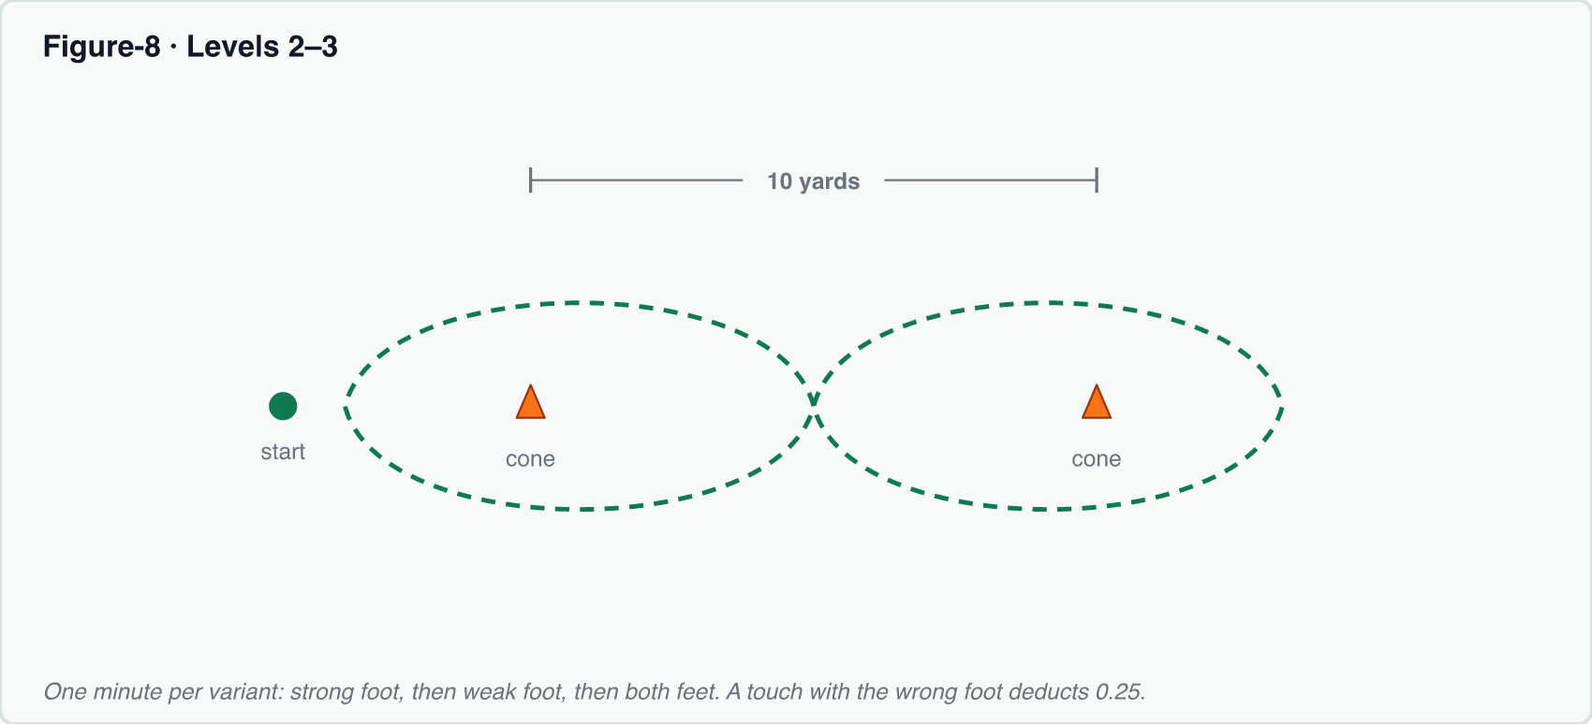
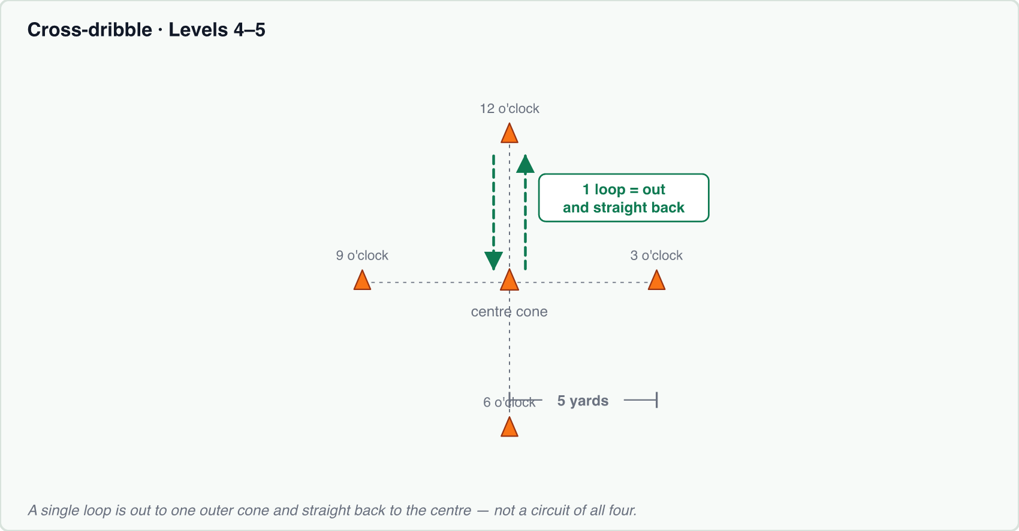
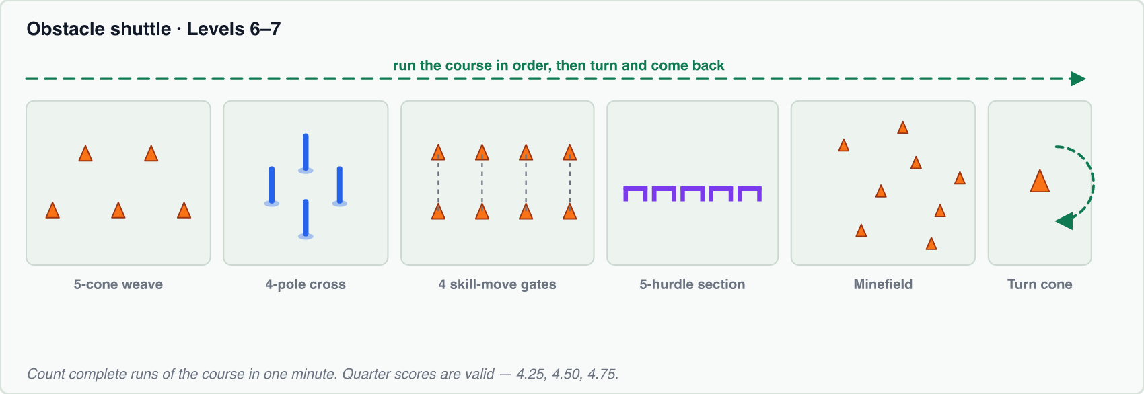

HOW TO RUN IT
- Every dribbling drill is run three times: one minute strong foot, one minute weak foot, one minute both feet. Each is scored and recorded separately.
- Figure-8: complete as many full figure-8s around the two cones as possible inside the minute.
- Cross-dribble: a single loop is out from the centre cone to one outer cone and back to the centre — not a full circuit of all four. Count the loops completed in the minute.
- Obstacle shuttle: run the full course — weave all 5 cones without skipping, cross through the poles rather than going around the outside, perform one skill move through each of the 4 gates, take controlled touches around each of the 5 hurdles, dribble the minefield without striking a cone, then turn the final cone and come back. Count complete runs of the course in the minute.

HOW TO SCORE AND RECORD IT
- Scores are recorded to the quarter — 4.25, 4.50 and 4.75 are all valid entries.
- Prefix the level at Levels 6 and 7 only: an obstacle score of 6 is written 7-6, because a bare 6 is also a Level 2 figure-8. Figure-8 and cross-dribble need no prefix — their sizes never overlap.
- Figure-8 wrong-foot penalty: if the player is dribbling with the right foot and takes a touch with the left, deduct 0.25. Worked example — 5 completed figure-8s with 2 wrong-foot touches scores 4.50.
- Enter each foot variant in its own field: strong foot, weak foot, both feet.

LEVEL REQUIREMENTS
Level | What the player must do | Recorded in
2 | 6 figure-8 loops (strong/weak/both) | Figure-8 loops (strong / weak / both) ≥ 6
3 | 7.5 figure-8 loops (strong/weak/both) | Figure-8 loops (strong / weak / both) ≥ 7.5
4 | 12 cross-dribble loops (strong/weak/both) | Cross-dribble loops (strong / weak / both) ≥ 12
5 | 15 cross-dribble loops (strong/weak/both) | Cross-dribble loops (strong / weak / both) ≥ 15
6 | 4.00+ obstacle shuttle sets (strong/weak/both) | Obstacle shuttle score (strong / weak / both) ≥ 4
7 | 6.00+ obstacle shuttle sets (strong/weak/both) | Obstacle shuttle score (strong / weak / both) ≥ 6

WHAT TO WRITE ON THE SCORE CARD
Three cells, written strong / weak / both. Prefix only at Levels 6 and 7.
Level | Write this on the card | Reading it back
2 | 6.00 / 6.00 / 6.00 | Figure-8 loops. Needs 6 on each
3 | 7.50 / 7.75 / 7.50 | Figure-8 loops. Needs 7.5 on each
4 | 12 / 12 / 13 | Cross-dribble loops. Needs 12 on each
5 | 15 / 15 / 16 | Cross-dribble loops. Needs 15 on each
6 | 6-4.00 / 6-4.25 / 6-4.00 | Obstacle runs. Needs 4 on each. Prefixed, or a bare 4 reads as nothing in particular
7 | 7-6.00 / 7-6.00 / 7-6.25 | Obstacle runs. Needs 6 on each. A bare 6 would look like a Level 2 figure-8

Passing
Accuracy off both feet, and the ability to pick a target under time pressure.

WHAT YOU NEED
Balls (a supply, not one) · Cones · Four coloured gates · Stopwatch

FIELD LAYOUT
- Gate passing (Levels 2-4) — build a T shape. From a central cone, walk 5 yards left and lay a 2-yard gate; return and do the same 5 yards right.
- From the central cone, walk 10 yards away from the gates and place a middle cone, then a further 10 yards and place two cones — the ball supply at the top of the T.
- Colour passing (Levels 5-7) — mark a 3x3 box and fill it with balls. Place four coloured gates 12 yards out from the box corner: 4 yards wide for Levels 5 and 6, narrowing to 2 yards for Level 7.
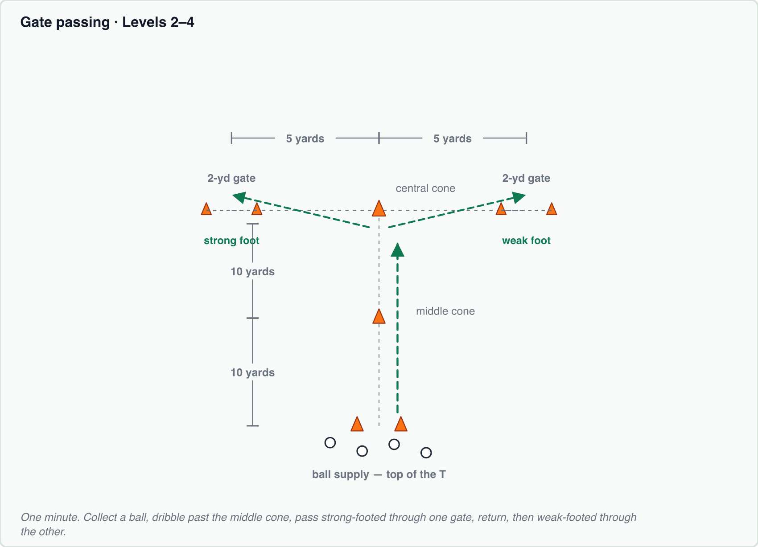
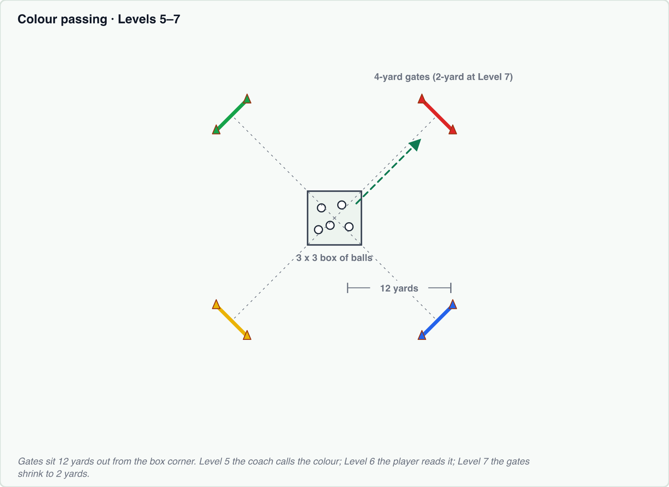

HOW TO RUN IT
- Every passing drill is a one-minute test.
- Gate passing: the player collects a ball at the top of the T, dribbles past the middle cone, and passes strong-footed through one gate. They return, collect another, and pass weak-footed through the other. Repeat for the full minute.
- Colour mini-goal passing (Level 5): the player checks in and hears a colour called by the coach, takes a touch out of the box, and passes into the gate of that colour. Either foot may be used.
- Read-colour passing (Level 6): identical, except the player must look up and read the colour themselves rather than being told it.
- 2-yard gate passing (Level 7): identical to the read-colour version, with the gates narrowed from 4 yards to 2.

HOW TO SCORE AND RECORD IT
- Gate passing (Levels 2-4): count successful passes through each gate and record them separately — strong foot and weak foot. No level prefix needed.
- Colour drills (Levels 5-7): the player uses whichever foot the pass calls for, and the coach tallies each pass under the foot actually used. Count successful passes into the correct gate within the minute.
- Prefix the level on the colour drills — all three sit at 10, so a bare 10 is unreadable. Ten passes at Level 6 is written 6-10.

LEVEL REQUIREMENTS
Level | What the player must do | Recorded in
2 | 2 strong + 2 weak gate passes | Gate passes (strong / weak) ≥ 2
3 | 3 strong + 3 weak gate passes | Gate passes (strong / weak) ≥ 3
4 | 4 strong + 4 weak gate passes | Gate passes (strong / weak) ≥ 4
5 | 10 each foot to color mini-goal | Color mini-goal passes (strong / weak) ≥ 10
6 | 10+ each foot, read raised color | Read-color passes (strong / weak) ≥ 10
7 | 10+ each foot through 2-yd gate | 2-yd gate passes (strong / weak) ≥ 10

WHAT TO WRITE ON THE SCORE CARD
Two cells, written strong / weak. Prefix only at Levels 5, 6 and 7.
Level | Write this on the card | Reading it back
2 | 2 / 2 | Gate passes in the minute
3 | 3 / 3 | Gate passes in the minute
4 | 4 / 4 | Gate passes in the minute
5 | 5-10 / 5-10 | Colour mini-goal, tallied under the foot actually used
6 | 6-10 / 6-10 | Read-colour, tallied under the foot actually used
7 | 7-10 / 7-10 | 2-yard gate, tallied under the foot actually used

Power
Striking power off both feet.

WHAT YOU NEED
A full-size goal · Balls · Cones · Radar / power gun

FIELD LAYOUT
- Set up at a big goal. Walk out 4 yards and place two sets of cones, one at each end. The 4-yard mark is where the player strikes from.
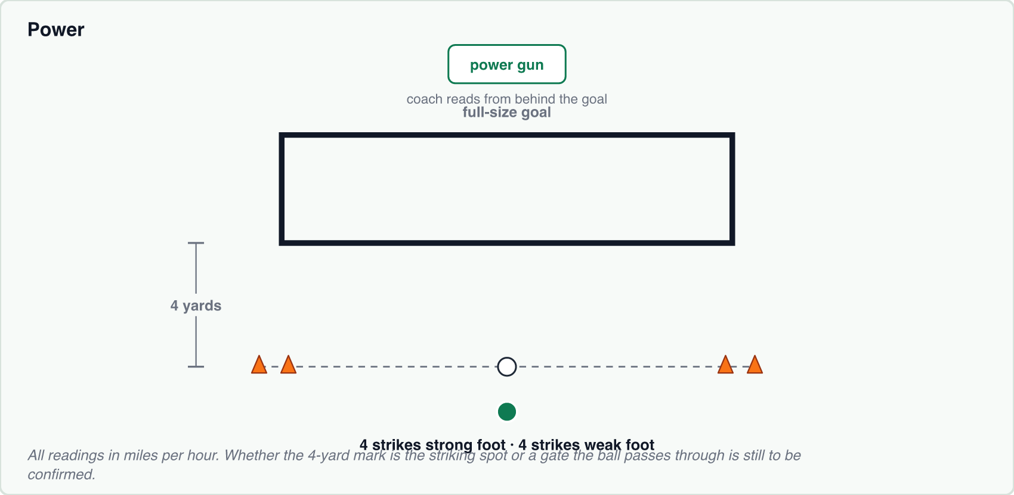

HOW TO RUN IT
- The player strikes four balls with the strong foot and four with the weak foot.
- The coach stands behind the goal and reads each strike off the power gun.

HOW TO SCORE AND RECORD IT
- All readings are in miles per hour. No level prefix — the drill is identical at every level, so the number says everything.
- Write all four strong-foot attempts in the strong box and all four weak-foot attempts in the weak box, commas between them. Do not reduce them to a best - the app keeps every attempt and uses them for the strong/weak averages and the asymmetry figure.
- The rank check uses the BEST attempt on each foot, and both feet must clear the level's number — a big strong foot will not carry a weak one.

LEVEL REQUIREMENTS
Level | What the player must do | Recorded in
2 | Power 30+ (strong and weak) | Best strong-foot attempt ≥ 30  Best weak-foot attempt ≥ 30
3 | Power 40+ (strong and weak) | Best strong-foot attempt ≥ 40  Best weak-foot attempt ≥ 40
4 | Power 45+ (strong and weak) | Best strong-foot attempt ≥ 45  Best weak-foot attempt ≥ 45
5 | Power 50+ (strong and weak) | Best strong-foot attempt ≥ 50  Best weak-foot attempt ≥ 50
6 | Power 55+ (strong and weak) | Best strong-foot attempt ≥ 55  Best weak-foot attempt ≥ 55
7 | Power 60+ (strong and weak) | Best strong-foot attempt ≥ 60  Best weak-foot attempt ≥ 60

WHAT TO WRITE ON THE SCORE CARD
Two cells, written strong / weak. All four attempts go in the box, commas between. Never prefixed - the drill is the same at every level.
Level | Write this on the card | Reading it back
2 | 30, 28, 31, 29 / 30, 27, 26, 28 | mph. Best on each foot is 31 and 30 - both clear 30
3 | 38, 41, 40, 37 / 40, 36, 38, 39 | Best 41 and 40 - both clear 40
4 | 44, 46, 45, 43 / 45, 42, 44, 41 | Best 46 and 45 - both clear 45
5 | 51, 49, 50, 48 / 50, 47, 49, 46 | Best 51 and 50 - both clear 50
6 | 56, 54, 55, 53 / 55, 52, 54, 51 | Best 56 and 55 - both clear 55
7 | 61, 58, 60, 59 / 60, 57, 59, 56 | Best 61 and 60 - both clear 60

Distance
Distance under accuracy pressure — how far the player can strike it while keeping it on line.

WHAT YOU NEED
A large number of cones · Balls · Tape measure or marked distances

FIELD LAYOUT
- The layout is a 5-yard centre alley flanked by 2-yard alleys on each side.
- Distance markers: place the first cone 9 yards out from where the player strikes the ball, then place a cone every 3 yards after that, continuing out to 48 yards or as far as space allows.
- Side markers: from the edge of the centre alley, walk 2 yards out and place a cone, then a further 2 yards and place another. Repeat on the other side.
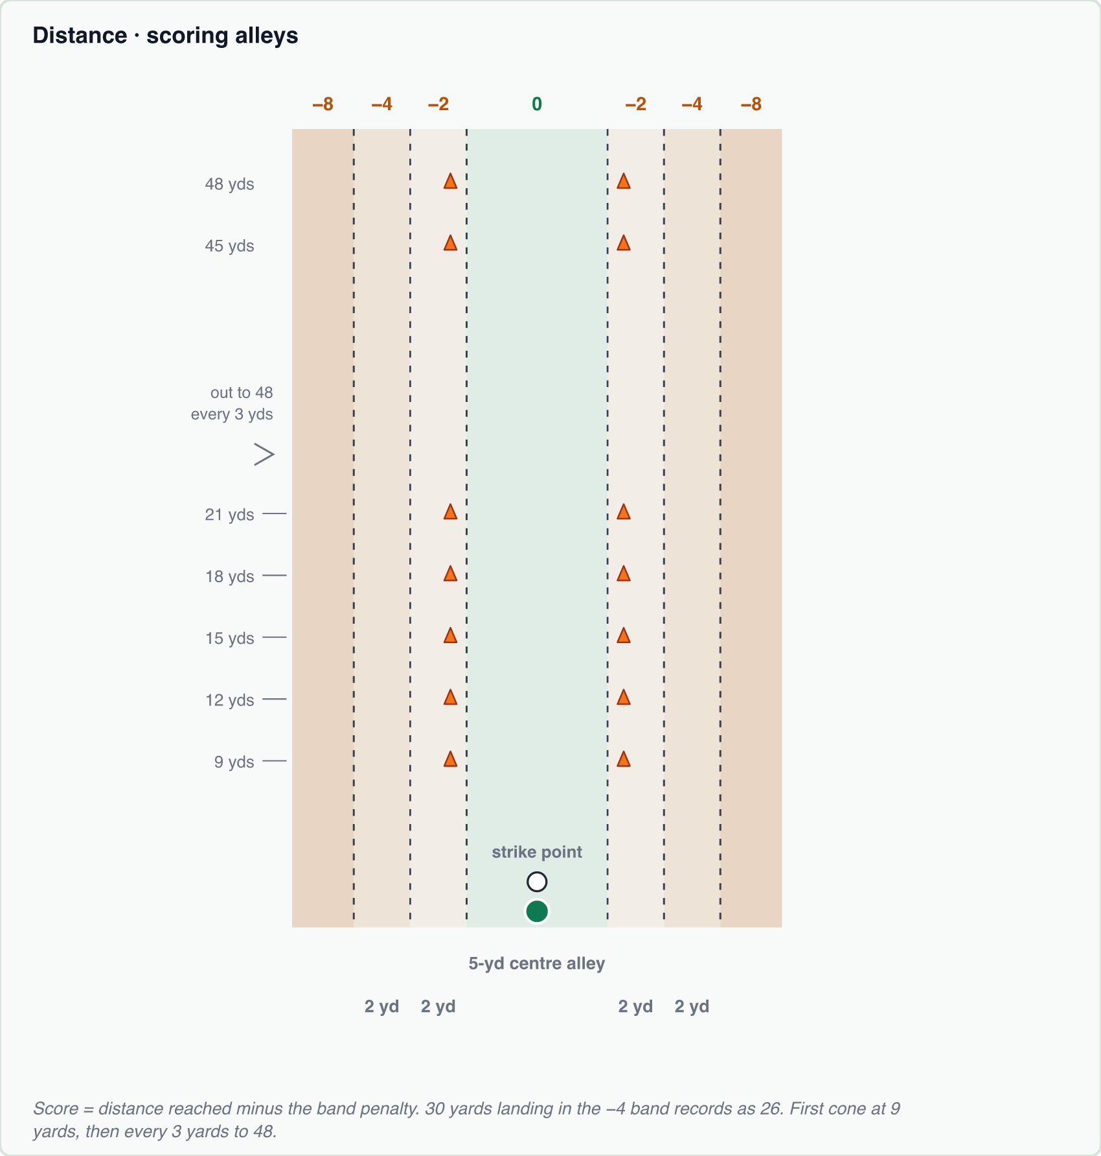

HOW TO RUN IT
- The ball is struck off the ground. It is not served from the hands.
- The player takes four strikes with the strong foot and four with the weak foot.
- Distance is read where the ball first lands — that is also the landing point the alley penalty is judged from.

HOW TO SCORE AND RECORD IT
- The recorded score is the distance reached MINUS an accuracy penalty. No level prefix — the drill never changes.
- Centre 5-yard alley — no deduction. · Between the first side cones and the centre alley, either side — minus 2. · Between the second and third set of side cones, either side — minus 4. · Completely outside the cone set — minus 8.
- Worked example: a strike that travels 30 yards but lands in the minus-four band is recorded as 26.
- Write all four attempts per foot in the one box, commas between them, each already net of its penalty.
- The rank check uses the BEST attempt on each foot, and both feet must clear the level's number.

LEVEL REQUIREMENTS
Level | What the player must do | Recorded in
2 | 15 yds strong, 12 yds weak | Best strong-foot attempt ≥ 15  Best weak-foot attempt ≥ 12
3 | 21 yds strong, 18 yds weak | Best strong-foot attempt ≥ 21  Best weak-foot attempt ≥ 18
4 | 25 yds strong, 20 yds weak | Best strong-foot attempt ≥ 25  Best weak-foot attempt ≥ 20
5 | 28 yds strong, 28 yds weak | Best strong-foot attempt ≥ 28  Best weak-foot attempt ≥ 28
6 | 31 yds strong, 31 yds weak | Best strong-foot attempt ≥ 31  Best weak-foot attempt ≥ 31
7 | 34 yds strong, 34 yds weak | Best strong-foot attempt ≥ 34  Best weak-foot attempt ≥ 34

WHAT TO WRITE ON THE SCORE CARD
Two cells, written strong / weak. All four attempts go in the box, commas between, each one already net of its alley penalty. Never prefixed.
Level | Write this on the card | Reading it back
2 | 16, 12, 14, 15 / 13, 10, 12, 11 | Yards. Best 16 and 13 - clears 15 strong, 12 weak
3 | 22, 19, 21, 18 / 18, 15, 17, 16 | Best 22 and 18 - clears 21 strong, 18 weak
4 | 25, 23, 24, 22 / 20, 18, 19, 17 | Best 25 and 20
5 | 28, 26, 27, 24 / 28, 25, 26, 23 | The 28 was a 32-yard strike that landed in the -4 band
6 | 31, 29, 30, 27 / 31, 28, 29, 26 | Best 31 on both
7 | 34, 32, 33, 30 / 34, 31, 32, 29 | Best 34 on both

Skill Moves
Breadth of the player's move repertoire and their ability to chain moves together.

WHAT YOU NEED
One ball · 6 cones · Stopwatch

FIELD LAYOUT
- Place a starting cone. Walk 7 yards out and build a diamond: set a cone in the middle, then place a cone 1 yard out from it in each of four directions.
- Walk a further 7 yards and place an end cone.
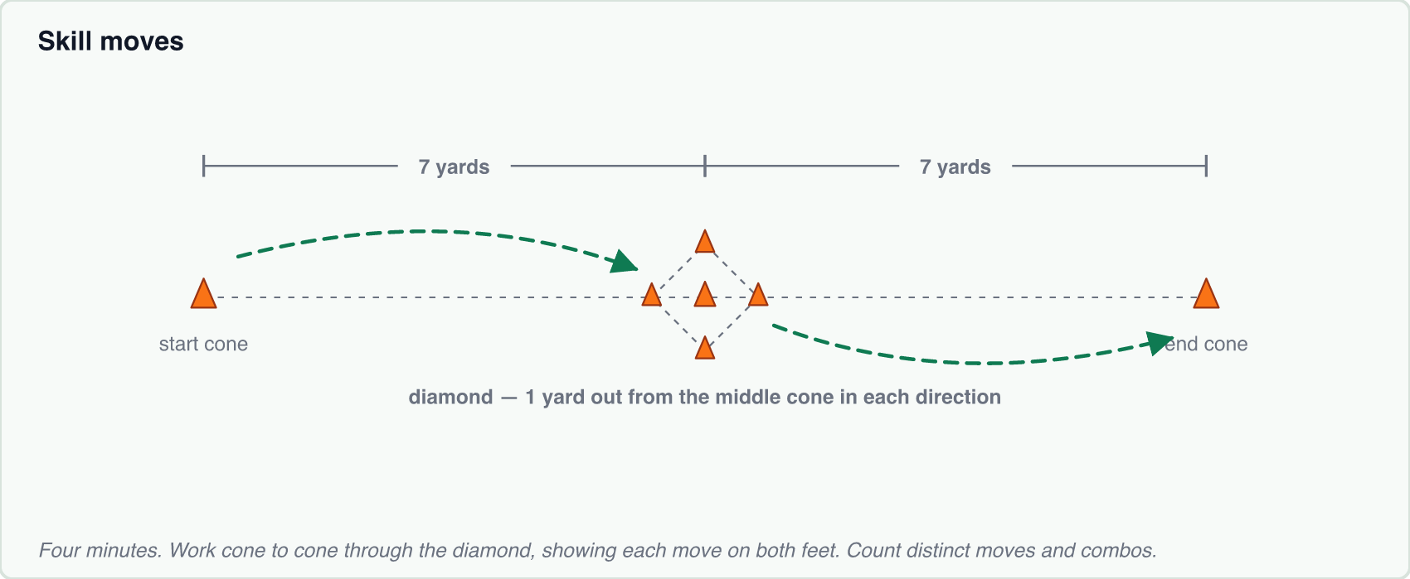

HOW TO RUN IT
- This is a 4-minute test.
- The player works from one cone to the next, performing skill moves and turn moves through the diamond and taking a getaway touch on to the next cone.
- Moves must be shown on both feet to count as proficient.
- The test measures how many DIFFERENT moves the player can produce inside the four minutes — there is no fixed approved list to work from.

HOW TO SCORE AND RECORD IT
- No level prefix on either number — the drill is the same at every level.
- Different moves executed — the count of distinct moves shown in the 4 minutes.
- Combos executed — a combo is two single moves chained together. Count these separately.
- Move names — optional free-text field for listing what the player actually showed.

LEVEL REQUIREMENTS
Level | What the player must do | Recorded in
2 | 4 different moves each foot | Different moves executed ≥ 4
3 | 8 different moves | Different moves executed ≥ 8
4 | 12 different moves | Different moves executed ≥ 12
5 | 12 moves + 4 combos | Different moves executed ≥ 12  Combos executed ≥ 4
6 | 12 moves + 8 combos | Different moves executed ≥ 12  Combos executed ≥ 8
7 | 12 moves + 12 combos | Different moves executed ≥ 12  Combos executed ≥ 12

WHAT TO WRITE ON THE SCORE CARD
Two cells, written moves / combos. Never prefixed.
Level | Write this on the card | Reading it back
2 | 4 / blank | 4 distinct moves. Combos are not tested until Level 5 - leave that cell blank, do not write 0
3 | 8 / blank | 8 distinct moves
4 | 12 / blank | 12 distinct moves
5 | 12 / 4 | 12 moves and 4 combos
6 | 12 / 8 | 12 moves and 8 combos
7 | 12 / 12 | 12 moves and 12 combos

Shooting Accuracy
Finishing into a defined target zone, static and off a moving ball.

WHAT YOU NEED
Any available goal · Balls · Cones or poles to mark the corners

FIELD LAYOUT
- Use whatever goal is available.
- Walk 1 to 2 yards in from each post to mark out the corner zones, and mark each with a cone or a pole.
- Both bottom corners and both top corners are marked — the four-corner levels use all of them.
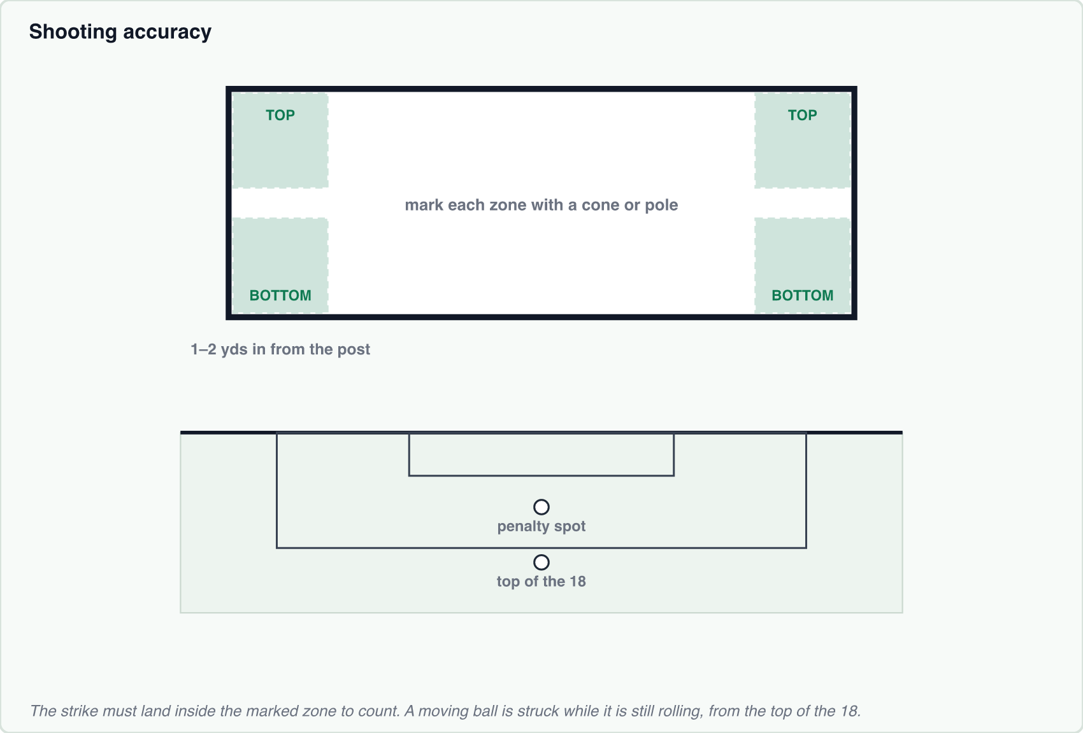

HOW TO RUN IT
- The player strikes the stated number of balls from the stated position for that level.
- The strike must land in the marked corner zone to count. Hitting the general area of the goal does not count.
- A moving ball means the ball is struck while it is still rolling, taken from the top of the 18.
- The ball is rolled in to the striker from the post they are shooting at, just enough to keep it moving as they hit it.

HOW TO SCORE AND RECORD IT
- Record the number of successful strikes into the marked zone.
- Always prefix the level — every level is a different distance or a different ball, and the four-corner levels all sit at 4. All four corners at Level 6 is written 6-4.

LEVEL REQUIREMENTS
Level | What the player must do | Recorded in
2 | Bottom corners 5× — penalty/inside box (10 balls) | Bottom corners ≥ 5
3 | Bottom corners 5× — top of 18 (10 balls) | Bottom corners ≥ 5
4 | Bottom corners 6× — moving ball, top of 18 (15 balls) | Bottom corners ≥ 6
5 | All 4 corners once — penalty spot (10 balls) | All-4 corners hit once ≥ 4
6 | All 4 corners once — top of 18 (10 balls) | All-4 corners hit once ≥ 4
7 | All 4 corners once — moving ball (15 balls) | All-4 corners hit once ≥ 4

WHAT TO WRITE ON THE SCORE CARD
One cell. Always prefix the level.
Level | Write this on the card | Reading it back
2 | 2-5 | 5 bottom corners from the penalty spot, of 10 balls
3 | 3-5 | 5 bottom corners from the top of the 18, of 10
4 | 4-6 | 6 bottom corners off a moving ball, of 15
5 | 5-4 | All four corners once from the penalty spot
6 | 6-4 | All four corners once from the top of the 18
7 | 7-4 | All four corners once off a moving ball

First Touch
One-touch control of a ball arriving at increasing distance and pace.

WHAT YOU NEED
Balls · Cones to mark the box · 3 marker cones · Stopwatch · Tape measure

FIELD LAYOUT
- Mark the receiving box — 5x5 for Levels 2 and 3, 3x3 for Levels 4 through 7. The player stands inside it.
- You need three marker cones: a START cone, an END cone, and a MIDDLE cone that the coach carries.
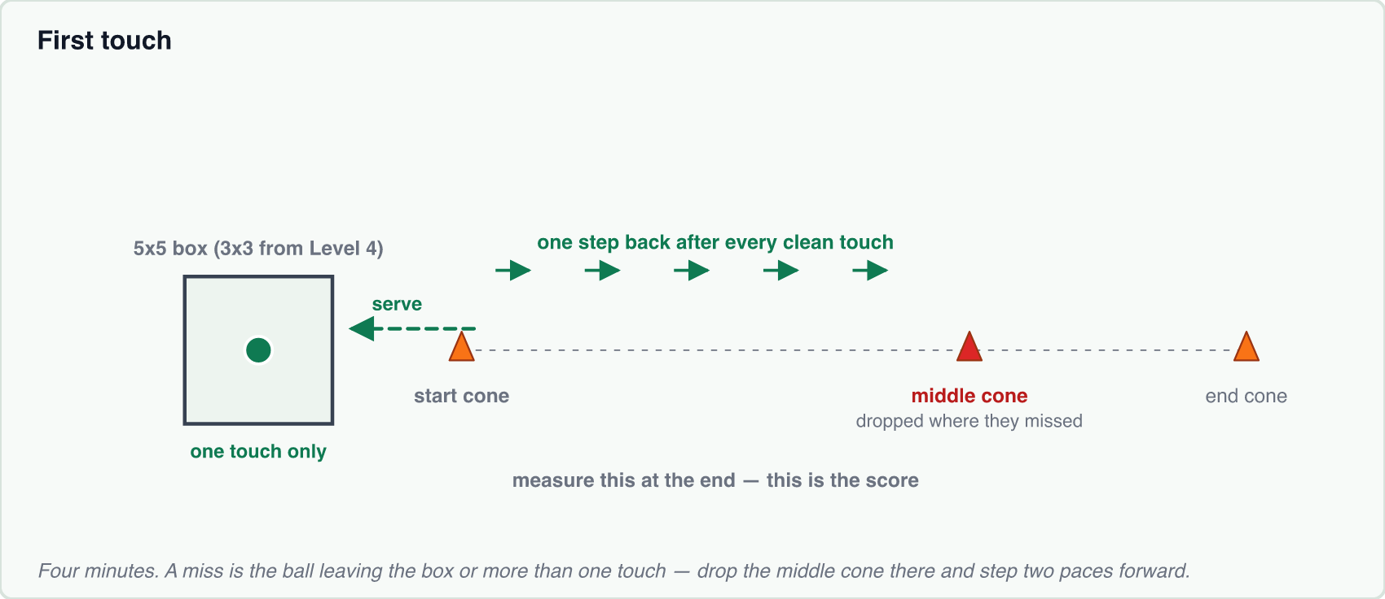

HOW TO RUN IT
- Every variant of this test is ONE TOUCH — there is no three-touch version. Each variant runs for 4 minutes.
- The coach serves from the start cone. The player must bring the ball under control inside the box in a single touch.
- The ground versions are served along the ground; the aerial versions are served in the air. At Level 4 the ball is simply served faster than at Levels 2 and 3 — there is no pace to measure, it just has to come in quicker.
- On a success, the coach steps one pace back and serves again.
- On a miss — the ball leaving the box, or more than one touch — the coach drops the MIDDLE cone at the position reached, steps two paces forward, and continues from there.
- If the player works back out as far as the middle cone again, the coach picks it up and carries on stepping back.
- After 4 minutes, measure from the start cone to wherever the middle cone finished. That measured distance is the score.
- One step is roughly a yard, but stride length varies between coaches — which is exactly why the distance is measured at the end rather than counted in steps.

HOW TO SCORE AND RECORD IT
- Ground, 5x5 box, 1 touch — covers Levels 2 and 3.
- Ground, 3x3 box, 1 touch, faster-paced ball — covers Level 4.
- Aerial, 3x3 box, 1 touch — covers Levels 5, 6 and 7.
- All three are measured distances in yards.
- Always prefix the level — 20 yards is a Level 3 ground score, a Level 4 paced score or a Level 7 aerial score. A Level 7 result of 20 is written 7-20.

LEVEL REQUIREMENTS
Level | What the player must do | Recorded in
2 | 5x5 box, ground, reach 15 yds (1 touch) | Ground, 5x5 box, 1 touch ≥ 15
3 | 5x5 box, ground, reach 20 yds (1 touch) | Ground, 5x5 box, 1 touch ≥ 20
4 | 3x3 box, ground, reach 20 yds (1 touch, faster-paced ball) | Ground, 3x3, 1 touch, faster-paced ball ≥ 20
5 | 3x3 box, aerial, reach 10 yds (1 touch) | Aerial, 3x3 box, 1 touch ≥ 10
6 | 3x3 box, aerial, reach 15 yds (1 touch) | Aerial, 3x3 box, 1 touch ≥ 15
7 | 3x3 box, aerial, reach 20 yds (1 touch) | Aerial, 3x3 box, 1 touch ≥ 20

WHAT TO WRITE ON THE SCORE CARD
One cell, in yards. Always prefix the level.
Level | Write this on the card | Reading it back
2 | 2-15 | 5x5 box, ground, measured 15 yards
3 | 3-20 | 5x5 box, ground, measured 20 yards
4 | 4-20 | 3x3 box, faster-paced ball, measured 20 yards
5 | 5-10 | 3x3 box, aerial, measured 10 yards
6 | 6-15 | 3x3 box, aerial, measured 15 yards
7 | 7-20 | 3x3 box, aerial, measured 20 yards

