**Cash Flow Time Series Comparison with ARIMA, LightGBM Regressor, and Chronos LLM**

The problem in focus involves the prediction of future "Net Income/Loss" values for JPMorgan based on historical quarterly cash flow data from 2009 to 2023. The model is designed to help in forecasting this specific financial metric, which is crucial for financial analysis and decision-making. The inputs to the model include various cash flow-related variables such as total depreciation and amortization, changes in accounts receivable, and net changes in investments, as detailed in the provided quarterly data. The model's output is the predicted "Net Income/Loss" for future quarters.

Machine learning (ML) is deemed appropriate for this task due to the sequential nature of financial data, which often contains patterns that can be learned from past trends. Techniques like ARIMA, LightGBM regressor, and Chronos LLM time series forecasting are employed. Chronos utilizes reprogrammed language learning models to forecast time series data. ARIMA is suitable for univariate forecasting when data shows evidence of non-stationarity. LightGBM offers a powerful and efficient approach for handling diverse data features, whereas Chronos LLM is capable of capturing complex patterns in time series data. The chosen methods are expected to model the financial time series effectively, capitalizing on the substantial amount of historical data to capture trends and cyclicality in JPMorgan’s financial activities.

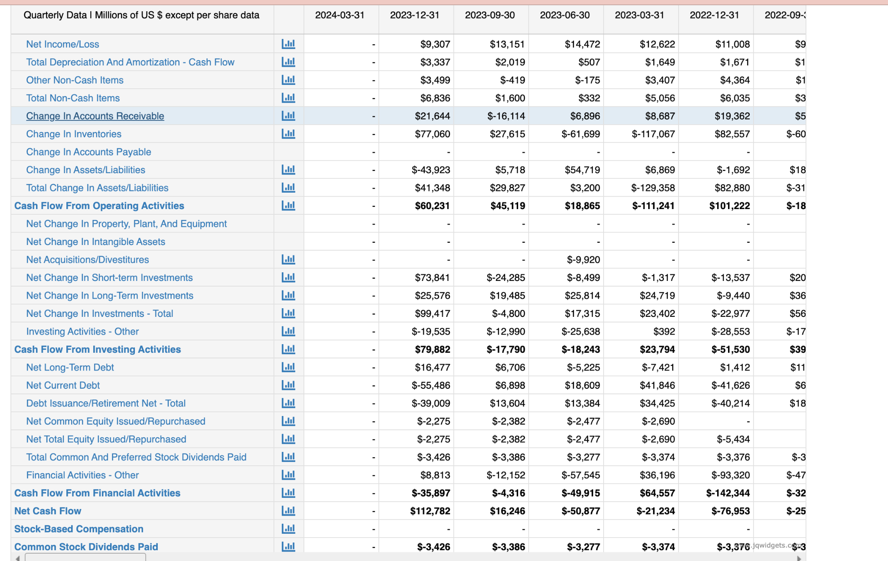

The dataset in question consists of quarterly financial cash flow data from JPMorgan, spanning from the first quarter of 2009 through the first quarter of 2024. This data set includes 61 samples, corresponding to the 61 quarters over these 15 years. Key variables in the dataset include several financial metrics such as "Net Income/Loss," "Total Depreciation and Amortization - Cash Flow," "Change in Accounts Receivable," and "Net Change in Investments," among others. These serve as inputs for predictive modeling, with "Net Income/Loss" designated as the primary output target for forecasting future profitability. The data is derived from JPMorgan’s publicly reported financial statements, ensuring a robust and reliable foundation for developing machine learning models aimed at financial forecasting.

From the MacroTrends website, a web scraping program utilizing Selenium and Beautiful Soup obtains the data in data frame format and then outputs the data in CSV format. The dataset containing JPMorgan's quarterly cash flow data from 2009 to 2024 is preprocessed for machine learning analysis to forecast the "Net Income/Loss." The dataset, consisting of 61 quarters, undergoes cleaning where non-numeric characters are removed, placeholders like '-' are replaced with NaN, and numeric conversions are applied to ensure data integrity. The dates are formatted into datetime objects to facilitate time series analysis. This meticulous preparation includes normalizing the data using the MinMaxScaler, which is essential for the uniform performance of machine learning algorithms. For model evaluation, the data is partitioned into an 80/20 training-test split. This strategy allocates 80% of the data for training to allow the model to learn from a significant historical context, while the remaining 20% tests the model’s predictive accuracy on unseen data. Although the code suggests a basic train-test split, integrating a method like K-fold cross-validation could provide a more robust assessment of the model's reliability across different data subsets. This comprehensive approach to data handling and model evaluation ensures that the predictive model is both statistically robust and practically relevant for forecasting financial outcomes.

For the hyperparameter optimization of the LightGBM model, a comprehensive search space was established to rigorously tune various parameters via the Optuna framework. The key hyperparameters optimized included:

* num_leaves ranged from 5 to 100,
* max_depth from 2 to 50,
* learning_rate from 0.01 to 0.99,
* n_estimators from 1000 to 10000,
* subsample_for_bin from 1000 to 10000,
* min_child_weight from 1 to 10,
* min_child_samples from 5 to 100,
* subsample from 0.25 to 0.99,
* subsample_freq from 1 to 9,
* colsample_bytree from 0.2 to 0.9,
* reg_alpha from 3.5 to 4.5,
* and reg_lambda from 0.9 to 1.0.

A total of 50 trials were conducted using Optuna's Bayesian optimization approach, with the mean squared error (MSE) as the primary metric for evaluation during cross-validation using a TimeSeriesSplit. This method allowed for the efficient exploration of the parameter space and identification of the optimal configuration. The best model was retrained with the identified parameters and evaluated against a clean test set to ensure an unbiased assessment. 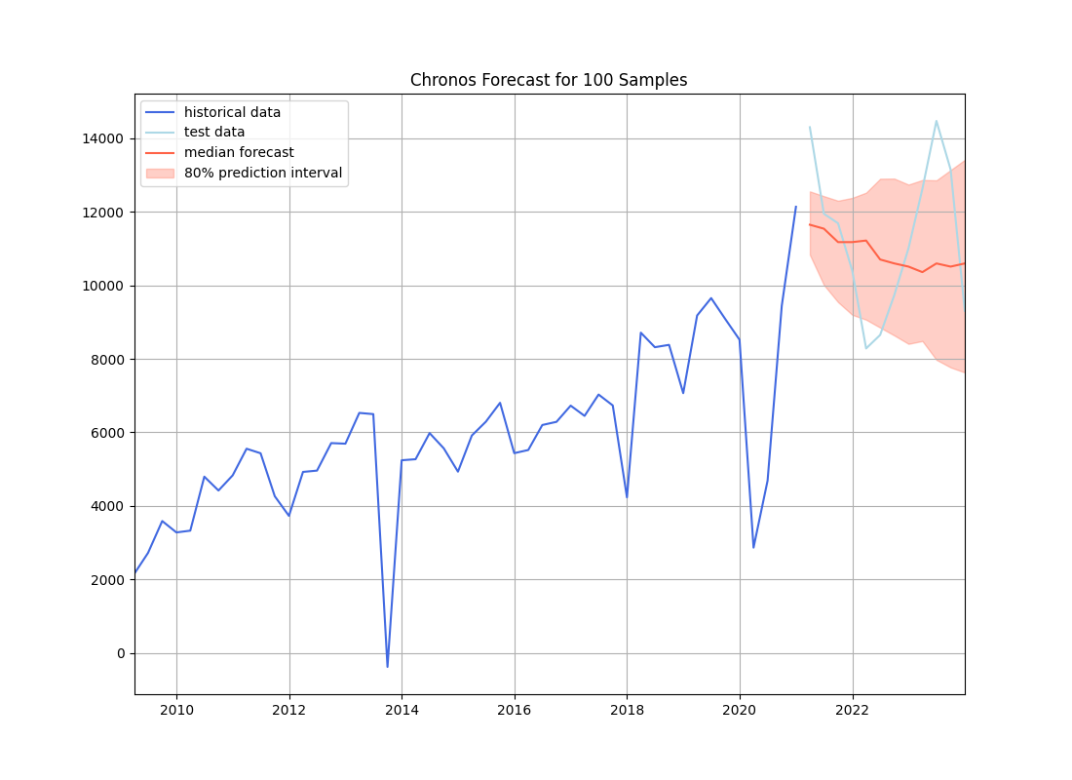

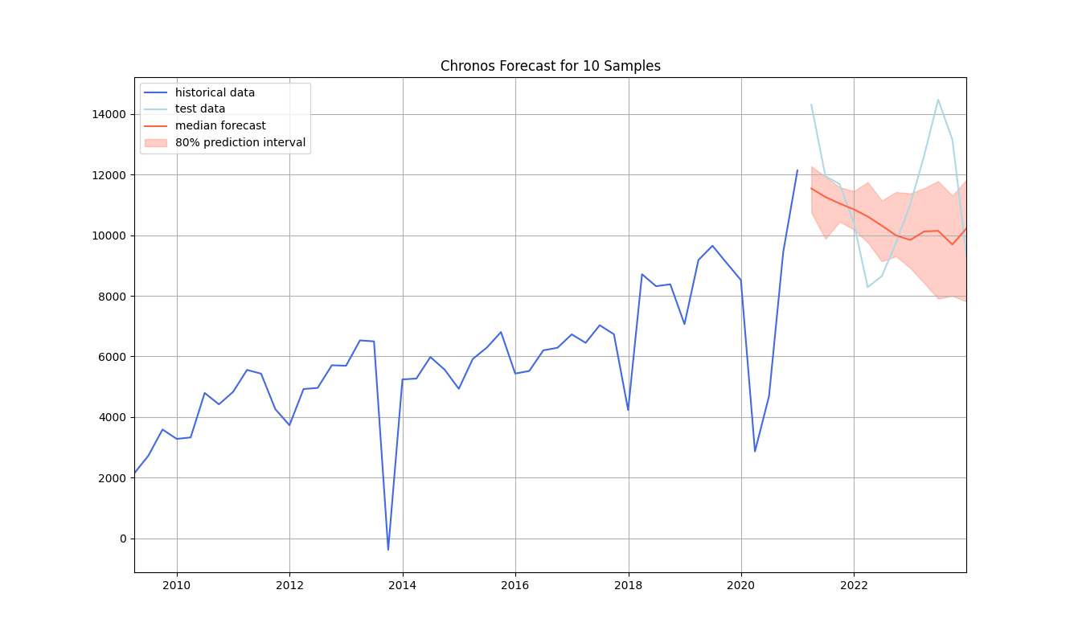

For the ARIMA and Chronos models, different configurations were evaluated based on a variety of performance metrics such as MAPE, ME, MAE, MPE, RMSE, ACF1, correlation, and MinMax. For example, several ARIMA configurations were tested, including orders (1, 1, 3), (3, 1, 2), and (3, 2, 1), each producing specific performance outcomes detailed in terms of the aforementioned metrics. Chronos utilized RMSE for performance evaluation based on predictions compared to actual test data. The Chronos model of 100 n_samples obtained a RMSE of 1950.31. This rigorous validation across multiple models and configurations ensured a thorough examination of potential forecasting solutions, aiming for optimal performance in practical financial forecasting applications.

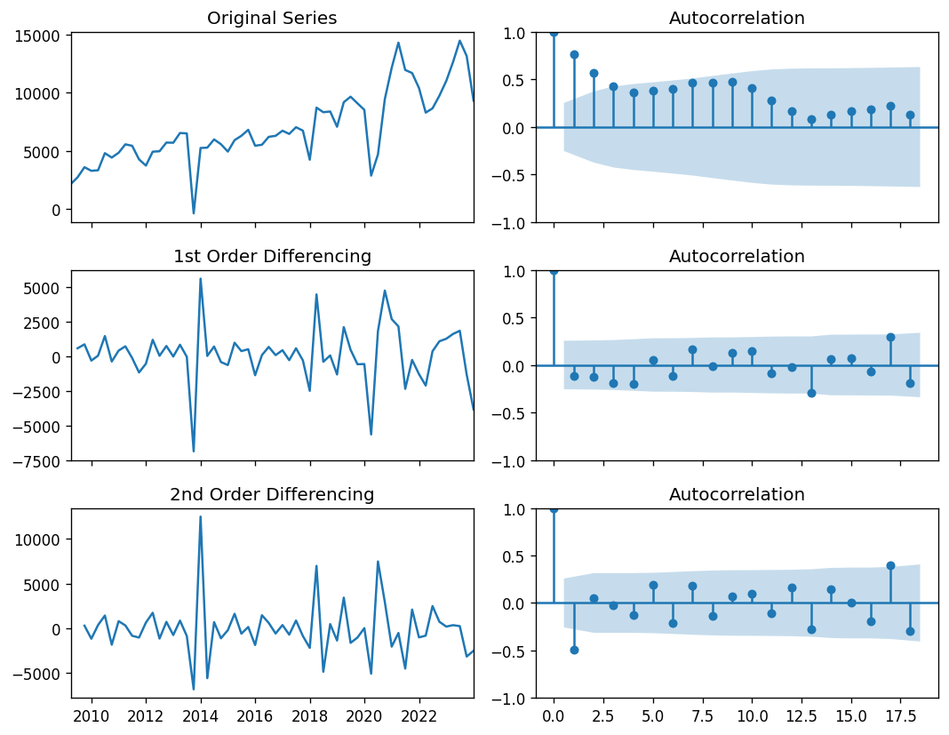

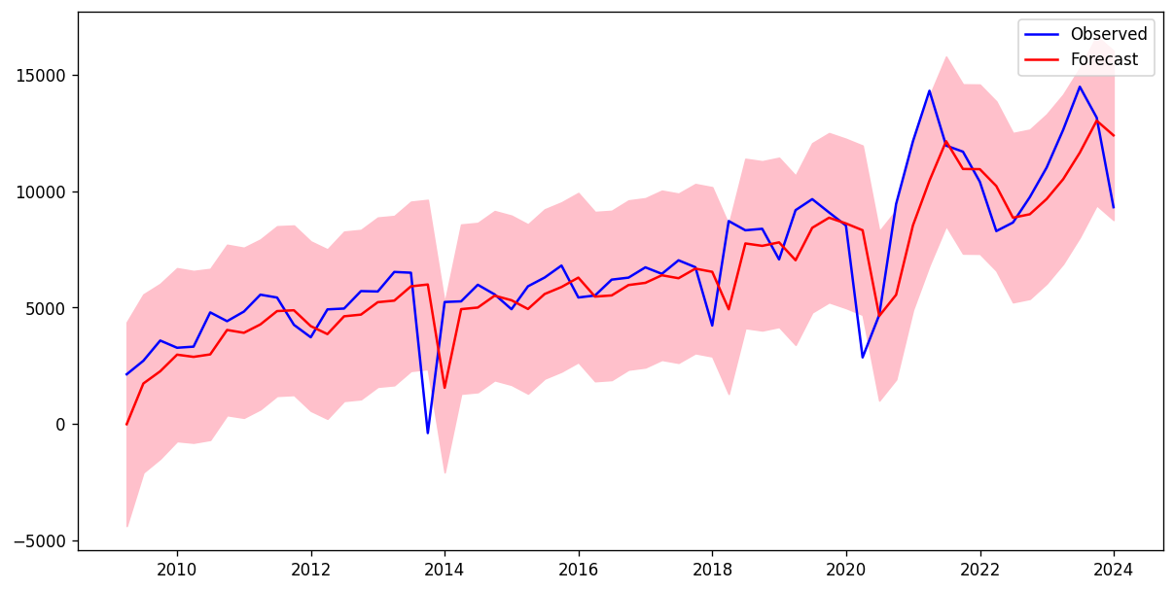

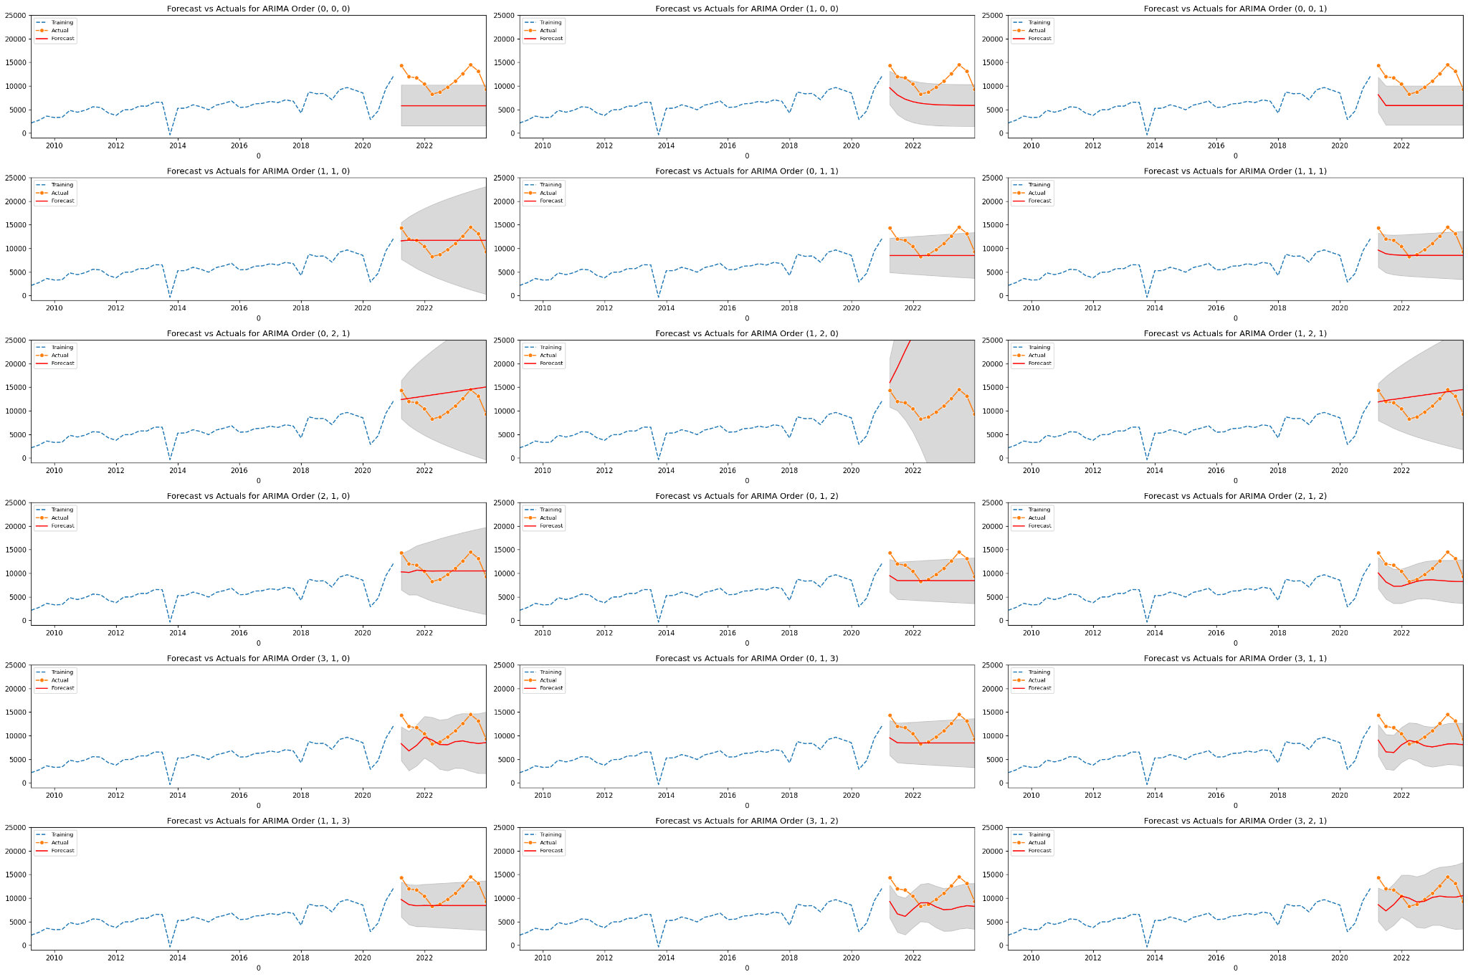

In the ARIMA model evaluations, three configurations demonstrated distinct performance characteristics based on a comprehensive set of error metrics. The ARIMA order (1, 1, 3) configuration showed a Mean Absolute Percentage Error (MAPE) of 0.225, Mean Error (ME) of -2759.67, Mean Absolute Error (MAE) of 2781.59, Mean Percentage Error (MPE) of -0.222, Root Mean Squared Error (RMSE) of 3333.45, a correlation of 0.462, and a MinMax error of 0.224. This configuration, while having a moderate RMSE and high autocorrelation factor (ACF1) of 0.879, displayed balanced error metrics. The ARIMA order (3, 1, 2) configuration resulted in slightly poorer performance with a MAPE of 0.289, ME of -3336.25, MAE of 3507.68, and RMSE of 4061.92, illustrating higher overall errors and a negative correlation of -0.150. Lastly, the ARIMA order (3, 2, 1) configuration reported a MAPE of 0.289, ME of -3336.24, MAE of 3507.68, RMSE of 4061.92, and a negative correlation of -0.150, showing similar error trends to the (3, 1, 2) configuration, underscoring the sensitivity of ARIMA performance to the specific parameters of differentiation and moving average processes in capturing the dynamics of the financial time series data. These evaluations highlight how different ARIMA configurations can vastly impact forecasting accuracy and error characteristics, necessitating careful parameter selection based on the desired accuracy and error tolerance in financial time series forecasting.

References:

Zuo, W., Zhou, W., Li, X., Xiao, S., & Zhang, C. (2024). ARIMA-Based Time Series Forecasting of Air Quality Index: A Case Study of Beijing. Proceedings of the International Conference on Data Science and Advanced Analytics (DSAA), 2024, Beijing, China. Retrieved from https://arxiv.org/pdf/2403.07815

JPMorgan Chase & Co. (2023). Quarterly Cash Flow Statement. Macrotrends. Retrieved from https://www.macrotrends.net/stocks/charts/JPM/jpmorgan-chase/cash-flow-statement?freq=Q

Mondal, P., Shit, L., & Goswami, S. (2014). Study of effectiveness of time series modeling (ARIMA) in forecasting stock prices. International Journal of Computer Science and Network, 3(1), 365-372. Retrieved from https://citeseerx.ist.psu.edu/viewdoc/download?doi=10.1.1.688.2206&rep=rep1&type=pdf

Bairamova, D. (2022). Predicting Course Grades of Students' Academic Performance Using the LightGBM Regressor. Journal of Theoretical and Applied Information Technology, 72(3), 456-463. Retrieved from https://journals.sdu.edu.kz/index.php/nts/article/view/952/414