

UNDERGRADUATE PROJECT PROGESS REPORT

|  |  |
| --- | --- |
| **Project Title:** | **Fashion recommendation system using deep residual learning** |
| **Surname:** | **Liu** |
| **First Name:** | **David** |
| **Student Number:** | **202018020319** |
| **Supervisor Name:** | **Joojo Walker** |
| **Module Code:** | **CHC 6096** |
| **Module Name:** | **Project** |
| **Date Submitted:** |  |

**Table of Contents**

1 Introduction 3

1.1 Background 3

1.2 Aim 3

1.3 Objectives 3

1.4 Project Overview 3

1.4.1 Scope 3

1.4.2 Audience 3

2 Background Review 3

3 Technical Progress 4

3.1 Approach 4

3.2 Technology 4

3.3 Testing and Evaluation Plan 4

3.4 Design and Implementation 4

4 Project Management 4

4.1 Activities 4

4.2 Schedule 4

4.3 Project Version Management 4

4.4 Project Data Management 4

4.5 Project Deliverables 5

5 Professional Issues and Risk: 5

5.1 Risk Analysis 5

5.2 Professional Issues 5

6 References 5

6.1 Formatting Requirements 5

6.2 Written Presentation 5

# Introduction

## Background

Fashion recommendation is a kind of famous word in our lives. Fashion recommendation

systems have gained significant importantce in e-commercece and fashion industry. For the

buyer aspect, due to the increasing of people’s requirement of their clothing and life style, the

user of fashion recommendation system such as Taobao and YOHO is also increasing. For the

seller aspect, it is important to send recommendation of their products to the buyer which may

achieve their requirement in order to stimulate their purchasing desire. For the people who are

interested in fashion industry, the system like Vogue would provide the fashion news for them.

But the most of fashion recommendation system is not personalized for user. The fashion

recommendation system with the deep learning training could solve this problem.

## Aim

The aim of my project is to develop a personalized fashion recommendation system using deep residual learning network.

## Objectives

The fashion recommendation system should deal with a lot of image which is relevant to

fashion such as brands, clothing style. The project should conduct more experiment to train the

model.So here are the objectives that should be done when I develop the project.

● In order to built a completed base for fashion recommendation system, it should be

learning about the existing product of fashion recommendation system and listing the

feature and specification of each system.

● In order to develop the clothing suggestion function, it should be training the model base on

the Deep Residual earning.

● In order to increase the user experience, it should be conducting more experiment with the

data set, enhancing the accuracy.

● To meet the user satisfaction, the test version of the system should be send to users and I

will ask for the suggestion after they use the test version.

## Project Overview

### Scope

The purpose of the study is using a deep residual learning framework to train the machine and

develop the fashion recommendation system.The study is significant as it addresses the

degradation problem in training deep neural networks, which is a major challenge in the field of

deep learning. And at the same time,The proposed deep residual learning framework provides a

solution to train substantially deeper networks, enabling the development of more powerful and

accurate models.

### Audience

The first kind of audience is the researcher or worker in the field of deep learning and

computer vision who can benefit from the study's proposed deep residual learning framework,

which addresses the degradation problem in training deep neural networks and enables the

training of substantially deeper networks. The second kind of audience is the developers and4

engineers working on image recognition tasks. They can benefit from the study's residual

networks are easier to optimize and can achieve higher accuracy with increased depth. This can

lead to the development of more powerful and accurate image recognition models.

# Background Review

2.1

The source(He,2016) shows me a deep residual learning framework to deal with the

challenge of training deep neural networks. This framework restructures layers as residual

functions with respect to input layers, simplifying optimization and improving accuracy with

increased depth. The study offers substantial empirical proof of residual networks' effectiveness,

achieving a 3.57% error rate on the ImageNet test set and securing 1st place in the ILSVRC

2015 classification task. Furthermore, the research examines the impact of depth on visual

recognition tasks, revealing a 28% relative enhancement in the COCO object detection dataset.

The paper underscores the versatility of the residual function, which can consist of two or three

layers, and the significance of identity shortcuts in training. These findings have valuable

implications for researchers, practitioners, and developers in the fields of deep learning,

computer vision, and industries reliant on visual recognition tasks.

2.2 Deep Residual Network

Deep Residual Network is an important ne**t**work that would involve in this project. It is a deep learning technology and from the study of Chen(2023), Deep learning is a subset of machine learning, employs deep neural networks (DNNs) to automatically identify patterns directly from raw data and this contrasts with traditional machine learning, where specialists manually craft features for specific tasks.According to the paper of Shafiq(2022), Deep Residual Network is a kind of convolution neural network, it allows the output of the current layer add the input of the previous layer which means that the network could learn more easily and get results in higher performance. And from the study of Ebrahimi(2021), deep Residual Network could capture the information more accurately and conduct the training process more quickly than other equivalent neural network which don’t equipment the residual connections. Gupta(2022) said that residual connections is like skip connections which provide the direct propagation of gradients throughout the network. And these skip connections would reduce the time and optimal tuning of the network layers.

2.3 Image Recognition

Image Recognition is another essential feature for the project. According to Bhardwaj(2021),

image recognition is a computer vision that identify the object,human and some feature through

the image. The Machine learning of network would increase the effect of Image recognition. Kuhanec(2022) said there are four main component in image recognition: the first is classification which is used to identify and classify the image, the second one is labeling which is also used to classify with a higher accuracy, the third one is object detection which is used to locate a specific object within an image, the last one is Segmentation which is used to localize down to the nearest pixel. There are lot of approach to conduct image recognition. The study of Patil(2021) trained the model where provided the inputs to pass through the hidden layers which consider CNN as algorithm and contain grid images. And then it would deliver the information through special section to the output layer. The whole training is in the figure1. And Their result shows that the accuracy of image recognition would be improved by machine learning. There are many method to enhance the image recognition accuracy, The work of Zhou(2023) shows that using fine-tuning across the pre-trained convolution neural network model in image recognition could reduce the error by 25%.

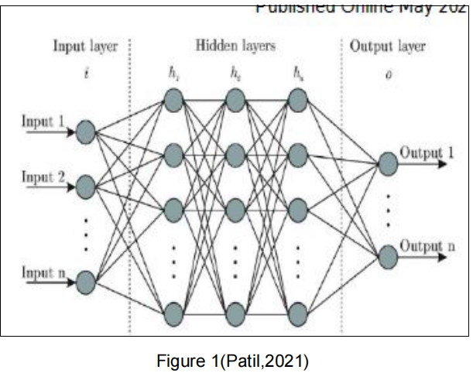

2.4 Fashion Recommendation System

Fashion recommendation systems are tools that use machine learning and artificial intelligence to provide personalized fashion product recommendations. In simple terms, they predict what clothes, shoes, or accessories users might like based on their preferences, purchase history, and even social media activities. These systems not only help consumers quickly find suitable products but also enhance the shopping experience and satisfaction. The fashion recommendation always involves in the e-commercial field, from the opinion of Charkraborty(2021), fashion recommendation system analyses the fashion product choice of consumers to transmit the image features for a better understading of user preferences.And the fashion recommendation which provides a personalized suggestion of fashion product could help a lot in e-commerce field. There are some challenge in the modern fashion recommendation system. According to the study of Deldjoo, traditional methods like Collaborative Filtering or Content-Based Filtering struggle due to sparse purchase data and limited visual details. Modern approaches leverage rich representations of fashion items through images, text, or videos, often using tasks like classification or retrieval. However, these require large datasets and still face the challenge of learning which features customers value most. And another issue is fashion Item compatibility which is predicting whether items go well together involves studying co-purchase data, fashion designer compositions, or social media trends. While some research models latent style types, the influence of factors like trends and seasonality adds complexity.

# Technical Progress

## Approach

The core machine learning model employed is the deep residual network(ResNet) for image

recognition. ResNet is a deep neural network architecture that introduces residual connections,

allowing the network to learn residual functions which will make it easier training the

network .And the ResNet uses residual blocks where each block consists of multiple layers. It

also incorporates identity shortcuts and zero-padding for increasing dimensions. The

mathematical basis could be using another form to present each layer of the neural network as

the learning residual function with the reference layer inputs. By explicitly letting the layers

approximate a residual function F(x) : H(x) - x, the original function becomes F(x) + x, which can

be learned more easily. And for the algorithm detail aspect, the algorithm involves training deep

residual networks by stacking residual blocks. The residual function is computed by adding the

input to the output of the layers, allowing the network to learn the residual mapping

## Technology

In the hardware aspects, it should be a computer with a NVIDIA 2070 GPU or higher because

of the huge number of the images which should be dealt with and the computer should also be

able to handle the computing requirements of training deep neural networks. In the software

aspects, the data set like ImageNet and the CIFAR-10 should be used in the deep learning step.

The deep learning framework will also be used such as TensorFlow and PyTorch. And the

recommendation system within ResNet framework combining deep learning techniques with

collaborative filtering, or hybrid methods. User interface which is also called front-end is also6

important, so the technologies like HTML, CSS, and JavaScript would be used . And for the

back-end, I decide use python to develop the back-end

## Testing and Evaluation Plan

**Data Testing Strategy**: Validate the image dataset used for training. Ensure it represents a wide variety of fashion styles, sizes, and preferences. Check for data quality, balance, and diversity to prevent bias in recommendations.

**Model Testing/Evaluation Strategy**:Use metrics like accuracy, precision, recall, and F1 score to evaluate the performance of your deep residual network. Implement cross-validation to assess the model's effectiveness in various scenarios and with different data subsets.

**Pipeline Testing**: Test the entire pipeline, from image data processing to generating recommendations. Ensure that the pipeline is efficient and that the transition from image recognition to recommendation generation is smooth and accurate.

## Design and Implementation

1. Download Data base:

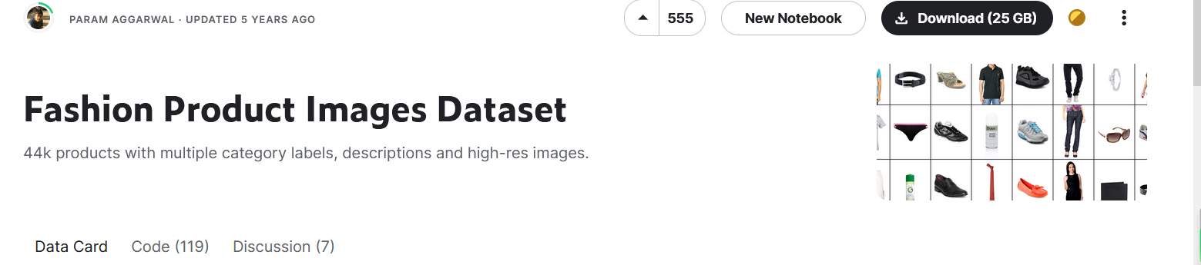

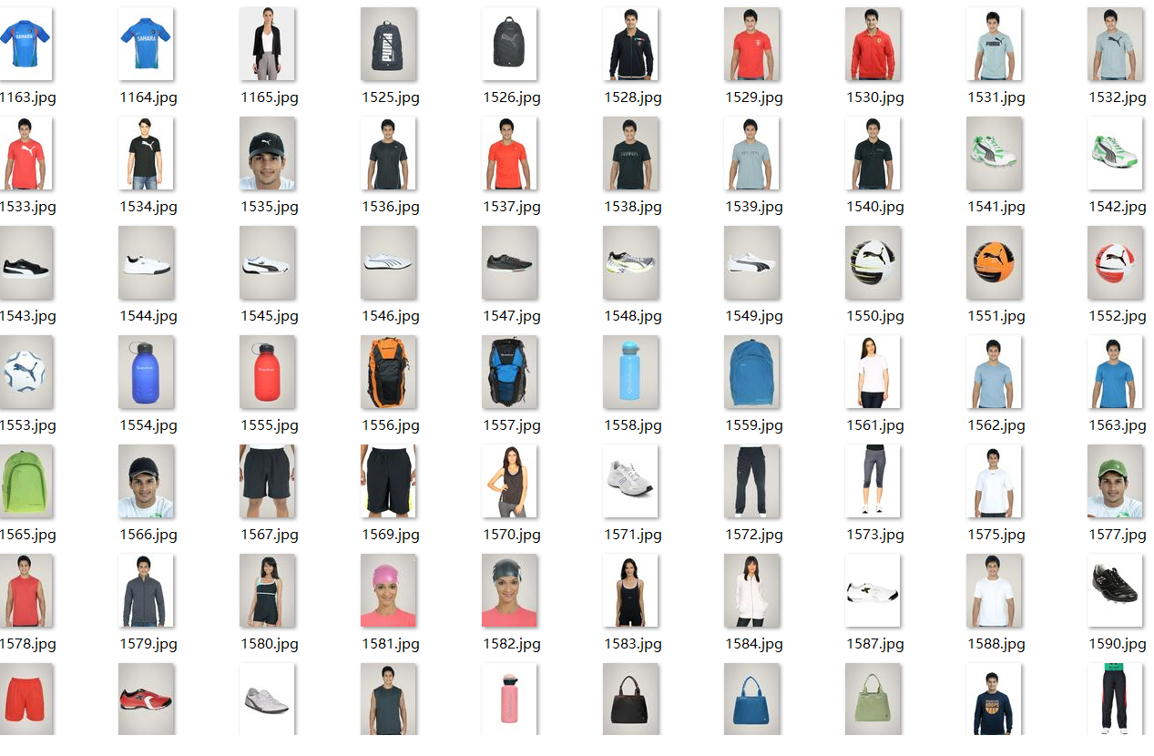

1. Create a new environment for machine learning(tenserflow)

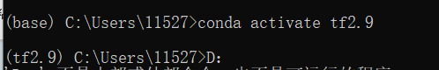

1. Find the existing code of Fashion recommendation system

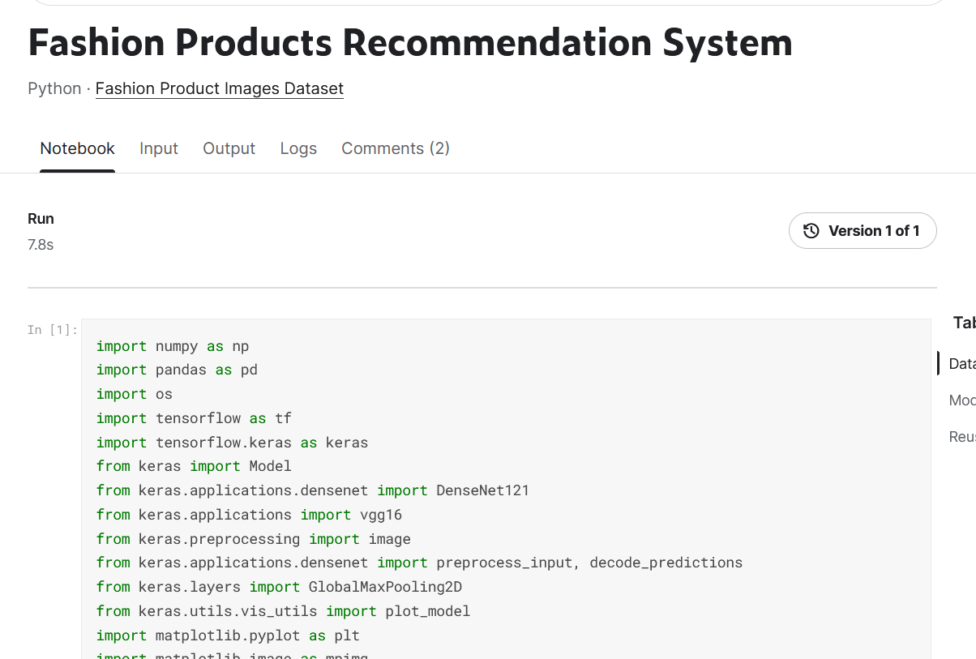

1. Run the Code:

Image recognize: 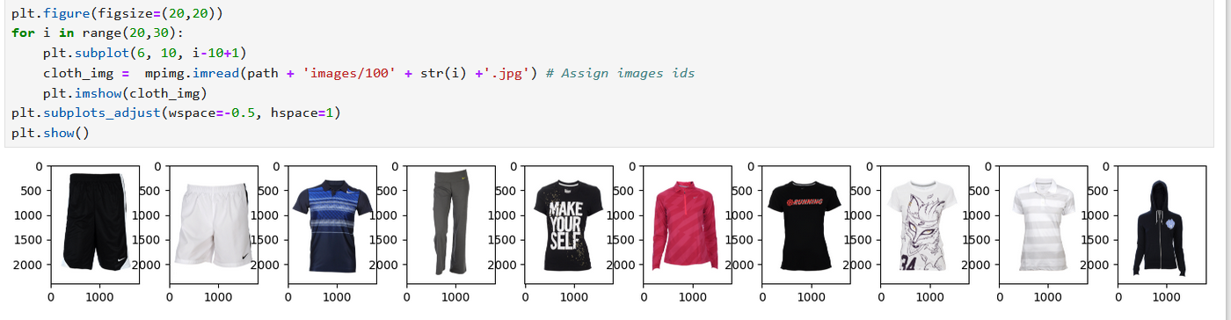

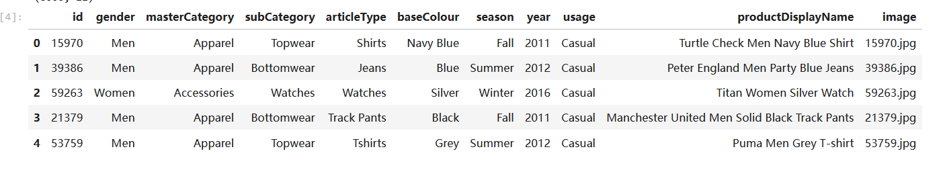

Classify the fashion item

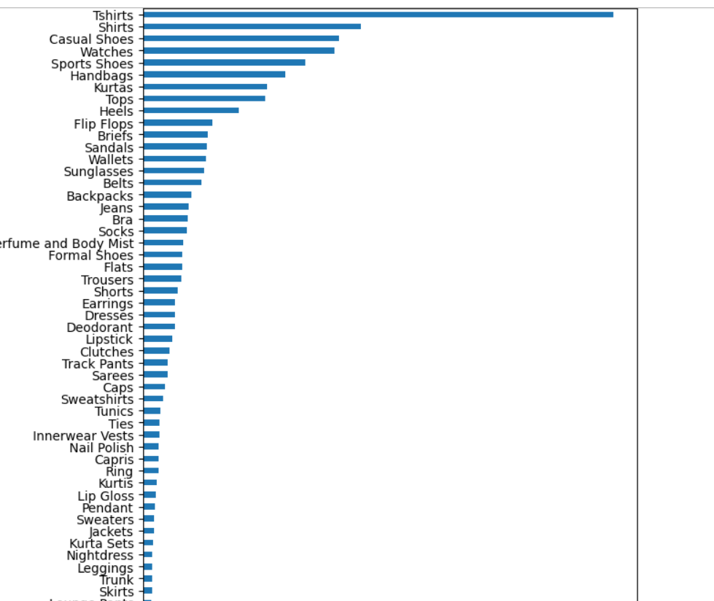

The base fashion item(shoes) like a input of recommendation system

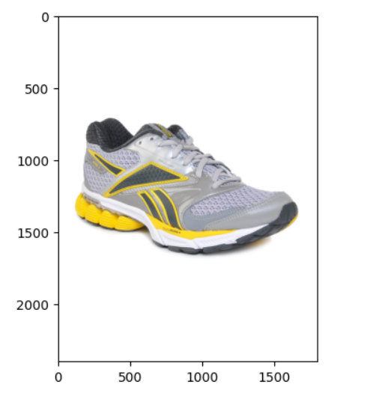

The output of recommendation:

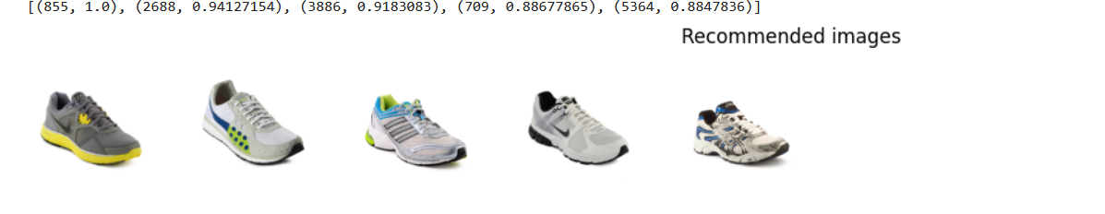

# Project Management

## Activities

|  |  |  |
| --- | --- | --- |
|  | Activities | Detail |
| 1 | Learning about the existing product of fashion recommendation system. | 1. Find some relevant software and list the specific feature of them 2. Review the resources and understand the model |
| 2 | 1. Develop the ResNet model for the fashion recommendation system | 1. Train the model 2. Implement the model 3. Find the data set and use it with the model |
| 3 | Optimize the system and enhancing the accuracy | 1. Train the model with the data set 2. Test and fix bugs(experiment) 3. Check the algorithm and computing accuracy |
| 4. | Inviting the users to operate the system | 1. Invite user to use the system 2. Ask for the suggestion 3. Improve the system |

## Schedule

|  |  |  |
| --- | --- | --- |
|  | Activities | Deadline |
| 1 | Learning about the existing product of fashion recommendation system. | 2023.10 - 2023.11 |
| 2 | 1. Develop the ResNet model for the fashion recommendation system | 2023.11 - 2023.12 |
| 3 | Optimize the system and enhancing the accuracy | 2023.12 - 2024.2 |
| 4. | Inviting the users to operate the system | 2024.2 - 2024.4 |

## Project Version Management

|  |  |  |
| --- | --- | --- |
|  |  |  |
| 1 | Project version update | FeiShu |
| 2 | Code management | FeiShu |
| 3 | Literature management | Baidu drive |
| 4. | Report management | FeiShu |

## Project Data Management

|  |  |  |
| --- | --- | --- |
|  |  |  |
| 1 | Data management | Git Hub |
| 2 | Code data management | FeiShu |
| 3 | Literature data management | Baidu drive |
| 4. | Report data management | FeiShu |

## Project Deliverables

|  |  |  |
| --- | --- | --- |
|  | Resources | Deliverable |
| 1 | Project proposal | 1. It should be clear and completed. 2. It should show the detail content of the project |
| 2 | Progress report | 1. It should be clear and logical 2. It should show the detail content of the progress 3. The experiment result should be true and useful |
| 3 | Final report | 1. It should be clear 2. It should show the overall of the project |
| 4. | Project code | 1. It should be valid and implement all the function of the system 2. It should be coded independently 3. It should be efficient |

# Professional Issues and Risk:

## Risk Analysis

#### Current Progress and Risks

I am currently in the phase of integrating deep residual learning algorithms into fashion recommendation system. A major risk at this stage is the complexity of the algorithms, which could lead to difficulties in implementation and performance issues. Additionally, handling and processing large, diverse datasets present a challenge, potentially affecting the system's accuracy and efficiency.

#### Resolved Risks and Mitigation Strategies

An earlier risk I faced was that I have no idea of the deep residual learning network and image recognize, to deal with this risk, I searched some papers which is related to the topic and read them. After reading them, I had a essential understanding of the project topic. Another risk was the code I found on Github, I set all the environment requirement of the code. In order to deal with this problem, I decided to use the new code from Kaggle.

#### Future Risks

We anticipate challenges in scalability and real-world applicability. To mitigate these, we plan to conduct extensive testing and involve potential users in the later stages of development for feedback and refinement.

.

## Professional Issues

#### Legal and Social Considerations

On the legal front, my project strictly adheres to data protection laws, including GDPR, ensuring the confidentiality and security of user data. Socially, I dedicated to creating a system that offers diverse and culturally inclusive fashion recommendations, catering to a global user base and promoting positive social impact.

#### Ethical and Environmental Issues

Ethically, my focus is on developing an algorithm that avoids biases, particularly those related to culture, gender, and body types, ensuring fair and inclusive recommendations. Environmentally, I am exploring ways to optimize my computing processes for energy efficiency, thereby reducing the carbon footprint of my project.

#### Professional Codes of Conduct

My project aligns with the ethical standards set by professional bodies such as BCS and ACM. This includes commitments to responsible development, maintaining user privacy, ensuring data security, and adhering to ethical AI practices. Regular ethical reviews are conducted to ensure compliance.

#### Broader Implications

I recognize the broader implications of my project in shaping the future of AI in fashion technology. my commitment extends beyond technical development to include continuous improvement in ethical practices, user-centric design, and contributing to sustainable technological advancements.

# References

1. K. He, X. Zhang, S. Ren and J. Sun, "Deep Residual Learning for Image Recognition," 2016

IEEE Conference on Computer Vision and Pattern Recognition (CVPR), Las Vegas, NV, USA,

2016, pp. 770-778, doi: 10.1109/CVPR.2016.90.

1. Y. Chen, Y. Huang, Z. Zhang, Z. Wang, B. Liu, C. Liu, C. Huang, S. Dong, X. Pu, F. Wan, X. Qiao, and W. Qian, "Plant image recognition with deep learning: A review," in Computers and Electronics in Agriculture, vol. 212, 2023, Art. no. 108072. [Online]. Available: [https://doi.org/10.1016/j.compag.2023.108072](https://doi.org/10.1016/j.compag.2023.108072" \t "https://chat.openai.com/c/_new)
2. M.S. Ebrahimi and H.K. Abadi, "Study of Residual Networks for Image Recognition," in

Intelligent Computing, K. Arai, Ed., vol. 284, Lecture Notes in Networks and Systems, Springer,

Cham, 2021, pp. 53, doi: https://doi.org/10.1007/978-3-030-80126-7_53.

1. M. Shafiq and Z. Gu, “Deep Residual Learning for Image Recognition: A Survey,” Applied

Sciences, vol. 12, no. 18, p. 8972, Sep. 2022, doi: 10.3390/app12188972.

1. H. Bhardwaj, P. Tomar, A. Sakalle, and U. Sharma, "Chapter 20 - Principles and Foundations

of Artificial Intelligence and Internet of Things Technology," in Artificial Intelligence to Solve

Pervasive Internet of Things Issues, G. Kaur, P. Tomar, and M. Tanque, Eds., Academic Press,

2021, pp. 377-392, ISBN 9780128185766, https://doi.org/10.1016/B978-0-12-818576-6.00020-4.

1. T. Kuhanec, "Image Recognition: What Is It & How Does It Work?" Meltwater Blog, Sep. 21, 2022. [Online]. Available: <https://www.meltwater.com/en/blog/image-recognition>
2. A. Patil, "IMAGE RECOGNITION USING MACHINE LEARNING," International Journal of

Engineering Applied Sciences and Technology, vol. 6, 2021, pp. 27, doi:

10.33564/IJEAST.2021.v06i01.027.

1. T. Zhou, X. Sun, Z. Yu, and X. Chen, "A generalization ability-enhanced image recognition based multiaxial fatigue life prediction method for complex loading conditions," in Engineering Fracture Mechanics, vol. 295, 2024, Art. no. 109802. [Online]. Available: ISSN 0013-7944
2. Chakraborty, S.; Hoque, M.S.; Rahman Jeem, N.; Biswas, M.C.; Bardhan, D.; Lobaton, E. Fashion Recommendation Systems, Models and Methods: A Review. Informatics 2021, 8, 49. <https://doi.org/10.3390/informatics8030049>
3. Deldjoo, Yashar & Nazary, Fatemeh & Ramisa, Arnau & Mcauley, Julian & Pellegrini, Giovanni & Bellogín, Alejandro & Di Noia, Tommaso. (2022). A Review of Modern Fashion Recommender Systems.
4. A. Gupta, P. Pawade, and R. Balakrishnan, "Deep Residual Network and Transfer Learning-based Person Re-Identification," in Intelligent Systems with Applications, vol. 16, 2022, Art. no. 200137. [Online]. Available: [https://doi.org/10.1016/j.iswa.2022.200137](https://doi.org/10.1016/j.iswa.2022.200137" \t "https://chat.openai.com/c/_new)