summary

## Cluster Parameters

|  |  |  |  |  |
| --- | --- | --- | --- | --- |
| Year | Group | Min_Pts_Mean | Eps_Space_Mean | Eps_Time_Mean |
| 2012 | All | 9 | 49 | 2696 |
| 2012 | Group 2012 | 9 | 49 | 2696 |
| 2012 | Group 2013 |  |  |  |
| 2012 | Group 2014 |  |  |  |
| 2013 | All | 8 | 101 | 35150 |
| 2013 | Group 2012 | 7 | 128 | 51800 |
| 2013 | Group 2013 | 9 | 49 | 3518 |
| 2013 | Group 2014 |  |  |  |
| 2014 | All | 6 | 206 | 68210 |
| 2014 | Group 2012 | 5 | 235 | 81020 |
| 2014 | Group 2013 |  |  |  |
| 2014 | Group 2014 | 8 | 65 | 4204 |

## Cluster Frequency over time

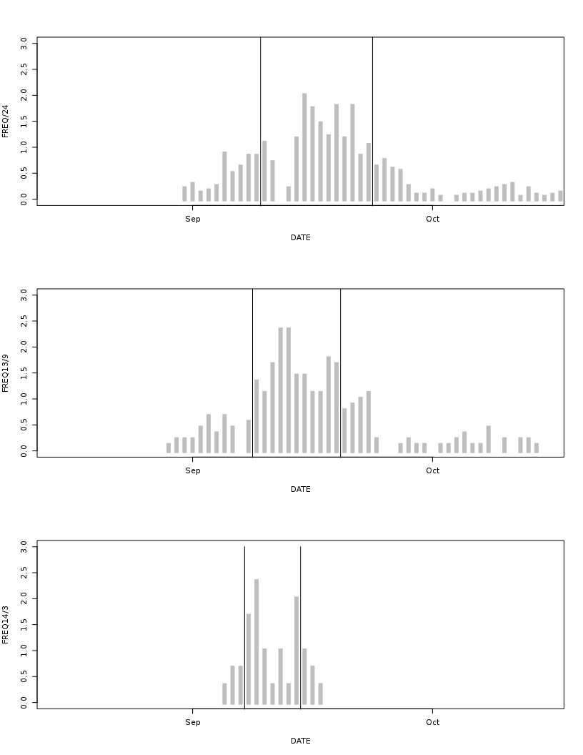

## Spawning Shoal Use

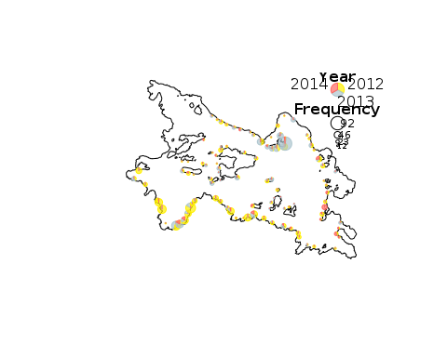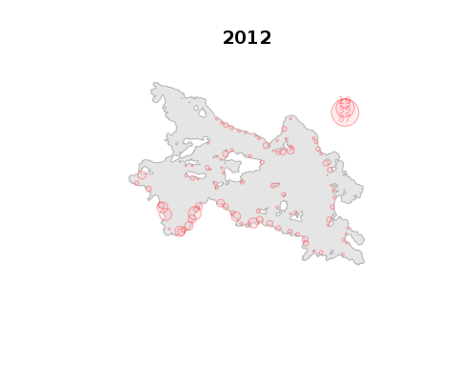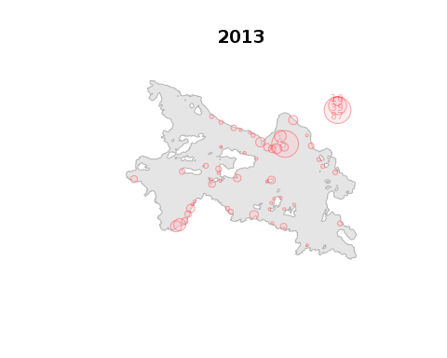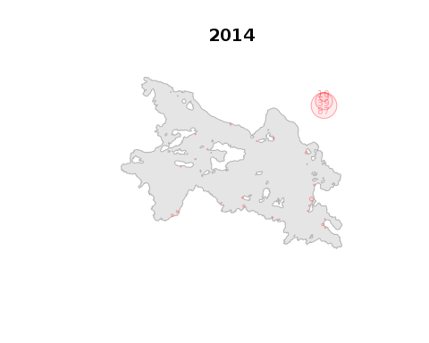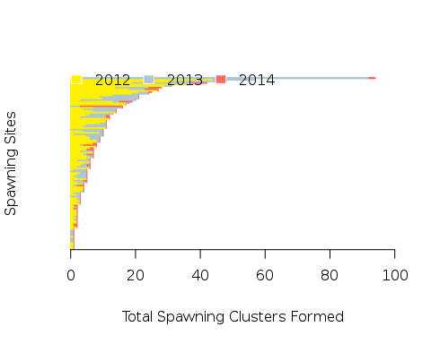

|  |  |  |  |  |  |  |  |  |  |
| --- | --- | --- | --- | --- | --- | --- | --- | --- | --- |
| YEAR | MONTH | SEX | n | STEPLENGTH.MEAN | STEPLENGTH.SD | PERSINDEX.MEAN | PERSINDEX.SD | ACCEL.MEAN | ACCEL.SD |
| 2012 | 9 | F | 1 | 10025.489 | 4622.311 | 0.2050472 | 0.1370929 | - | - |
| 2012 | 9 | M | 4 | 8731.341 | 4387.931 | 0.0871905 | 0.2131392 | - | - |
| 2012 | 9 | U | 23 | 8833.055 | 4600.003 | 0.1693087 | 0.1828684 | - | - |
| 2013 | 9 | F | 6 | 8498.933 | 3922.805 | 0.1823621 | 0.1681308 | 0.384827515046443 | 0.178450705931469 |
| 2013 | 9 | M | 9 | 5955.442 | 3772.561 | 0.0478137 | 0.2089443 | 0.502223137820033 | 0.283301864748982 |
| 2013 | 9 | U | 14 | 5325.443 | 4423.990 | 0.0576985 | 0.3227749 | - | - |
| 2014 | 9 | F | 3 | 6773.380 | 4905.827 | 0.1093797 | 0.2047660 | 0.332737357317068 | 0.101552193928837 |
| 2014 | 9 | M | 5 | 4348.522 | 5143.833 | -0.1235328 | 0.3597988 | 0.571243894078242 | 0.242832422480265 |
| 2014 | 9 | U | 10 | 2877.500 | 2954.169 | -0.0657076 | 0.3315191 | - | - |

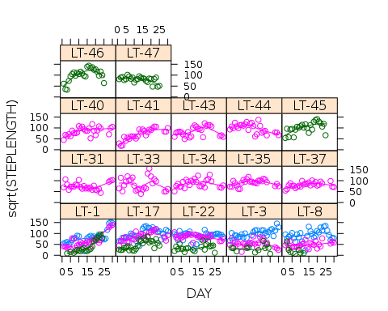

|  |  |  |  |
| --- | --- | --- | --- |
|  | Chisq | Df | Pr(>Chisq) |
| SEX | 2.651570 | 1 | 0.1034477 |
| cDAY | 21.963218 | 1 | 0.0000028 |
| I(cDAY^2) | 8.987048 | 1 | 0.0027190 |
| YEAR | 84.035349 | 2 | 0.0000000 |

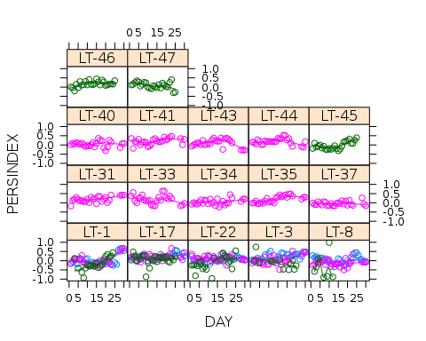

|  |  |  |  |
| --- | --- | --- | --- |
|  | Chisq | Df | Pr(>Chisq) |
| SEX | 15.57477 | 1 | 0.0000793 |
| cDAY | 16.03111 | 1 | 0.0000623 |
| I(cDAY^2) | 2.36845 | 1 | 0.1238099 |
| YEAR | 23.99317 | 2 | 0.0000062 |

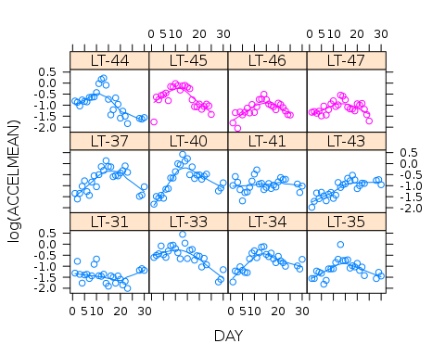

|  |  |  |  |
| --- | --- | --- | --- |
|  | Chisq | Df | Pr(>Chisq) |
| SEX | 3.9062208 | 1 | 0.0481077 |
| cDAY | 2.4116034 | 1 | 0.1204390 |
| I(cDAY^2) | 24.7085688 | 1 | 0.0000007 |
| YEAR | 0.7516694 | 1 | 0.3859482 |