## Results

Both male and female lake trout begin to migrate from the summer refuge into shallower water approximately the same time the 15°C thermocline breaks to the surface (August 30, 2013; Figure 4). A clear bimodal depth distribution is apparent for both males and females during the spawning season (~September) with 41% and 16% of detections <= 4 m depth of respectively.

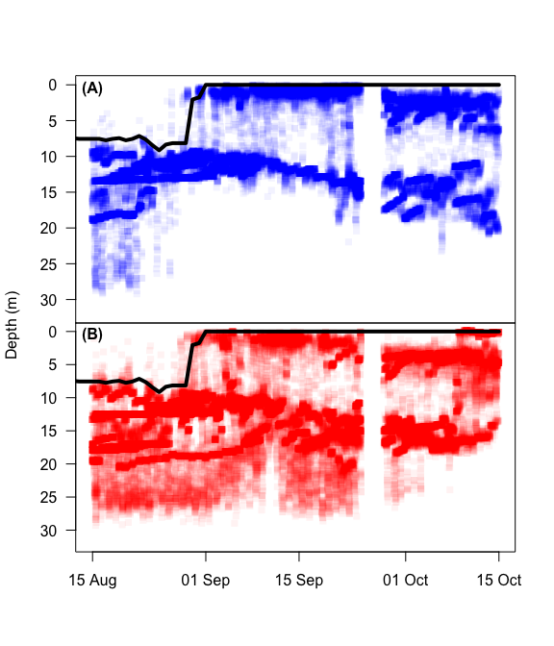

**Figure 4:** Depth distribution of males (A) and females (B) during the spawning season in Alexie Lake, NWT. The black line represents the 15° C thermocline. Points were given transparency value of 5%, therefore the darker the colour the higher the density of points

Lake trout spatial distributions differed among sexes during the spawning season in Alexie Lake. Males were found to have higher densities nearshore than females (Figure 2 & 5)

**Table 1:** Summary statistics for spawning male, spawning female and non-spawning female lake trout movement metrics during the 2013 spawning season in Alexie Lake, NWT. I report the number of fish (n), means and standard deviations of daily distance travelled (km), persistence index (PI), and acceleration (m s-2).

|  |  |  |  |  |
| --- | --- | --- | --- | --- |
| Sex | n | Daily Distance (km) | PI | Acceleration (m s-2) |
| Spawning Male | 5 | 7.02 (3.56) | 0.07 (0.18) | 0.49 (0.28) |
| Spawning Female | 5 | 7.5 (3.48) | 0.17 (0.17) | 0.37 (0.18) |
| Non-spawning Female | 1 | 11.91 (2.97) | 0.23 (0.09) | 0.36 (0.08) |