Homework 2 Report: CV Verification using LLM Agent and MCP Tools
StudentID:1155246323 Name:PENGZIYU
1. Introduction
This report presents an intelligent CV verification system built using a Large Language Model (LLM) agent integrated with MCP tools. The system evaluates the reliability of candidate CVs by retrieving and comparing social information from LinkedIn and Facebook. Instead of binary rejection, the system produces a continuous confidence score between 0 and 1.
2. System Workflow
The system follows a multi-stage pipeline combining document processing, LLM reasoning, MCP tool usage, and scoring:
1) CV ingestion: CV PDFs are loaded and converted into text.
2) Information extraction: Candidate name and location are inferred from CV text.
3) Tool-based search: The LLM decides which MCP tools to call.
4) Profile retrieval: LinkedIn and Facebook profiles are retrieved.
5) Cross-source verification: Information across platforms is compared.
6) Discrepancy detection: Conflicts in location, job role, or industry are flagged.
7) Confidence scoring: A continuous reliability score is generated.
3. Scoring Methodology
The system assigns a confidence score in the range [0,1] based on evidence coverage and cross-platform consistency.
Base score: 0.50.
LinkedIn evidence bonus: +0.40 if retrieved; −0.15 if missing.
Facebook evidence bonus: +0.10 if retrieved; −0.05 if missing.
Location inconsistency penalty: −0.12.
Job/industry inconsistency penalty: −0.15.
Company weak-support penalty: −0.02.
Compound conflict penalty: −0.12 when multiple inconsistencies occur.
CV support penalty: applied when LinkedIn information is not supported by CV text.
4. Results and Interpretation
CV_1: Score = 0.88. Minor location inconsistency but strong evidence overall.
CV_2: Score = 1.00. High consistency across all sources.
CV_3: Score = 0.45. LinkedIn missing; evidence limited.
CV_4: Score = 0.58. Location and job conflicts detected.
CV_5: Score = 0.59. Multiple discrepancies across platforms.
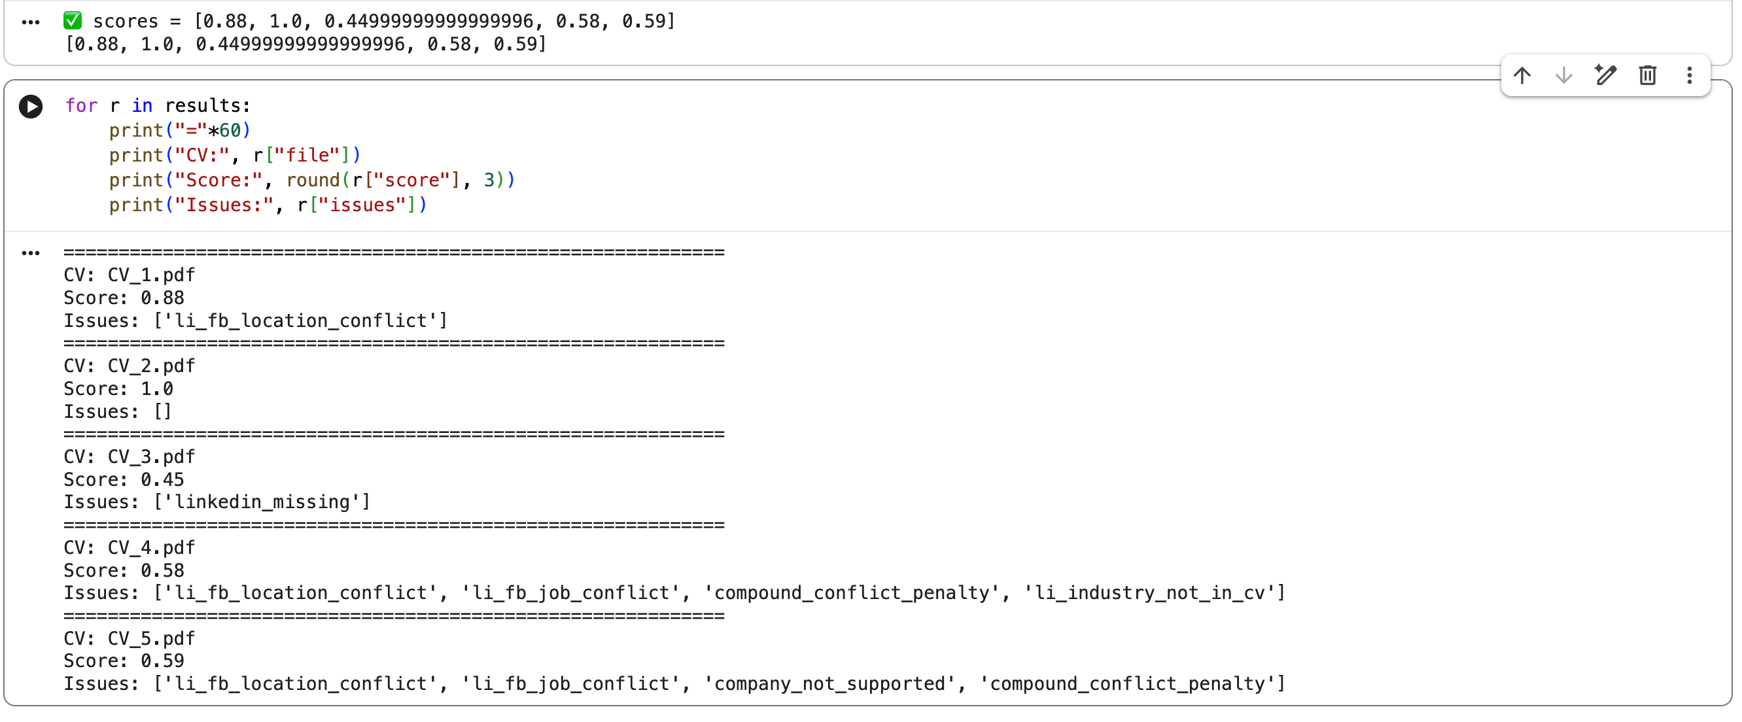
5. Discussion
The system demonstrates how LLM agents combined with MCP tools can verify CV credibility. Discrepancies reduce the confidence score rather than triggering rejection, aligning with risk-based verification.
6. Limitations
Limitations include incomplete social data, name ambiguity, and heuristic scoring parameters that may require tuning.
7. Conclusion
This project builds an end-to-end CV verification pipeline using LLM reasoning and MCP tools, producing interpretable confidence scores and identifying discrepancies.

