**Networking Notes**

**Index**

1. Components
2. OSI or ISO Model
3. Classification
4. Devices
5. Home Network
6. Ip Addresses
7. Protocols
8. DNS & DHCP
9. Network Commands

**Computer Netwoking**

It is an communication between two or more network interfaces

**Components of Computer Networking**

1. Two or More Computers/Devices
2. Cables as links between the computers
3. A Network Interface Card (NIC) on each
4. Computer
5. Switches
6. Routers
7. Software called Operating System (OS)

**OSI Model**

The Open Systems Interconnection (OSI) model describes seven layers that computer systems use to communicate over a network. It was the first standard model for network communications, adopted by all major computer and telecommunication companies in the early 1980s

The modern Internet is not based on OSI, but on the simpler TCP/IP model. However, the OSI 7-layer model is still widely used, as it helps visualize and communicate how networks operate, and helps isolate and troubleshoot networking problems.

OSI was introduced in 1983 by representatives of the major computer and telecom companies, and was adopted by ISO as an international standard in 1984.

**Layers**

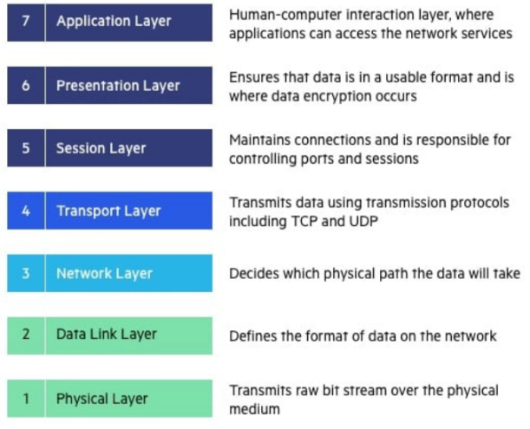

The Basic elements of a layered model are

1. services
2. protocols
3. and interfaces

A service is a set of actions that a layer offers to another (higher) layer.

A protocol is a set of rules that a layer uses to exchange information.

A interface is communication between the layers.

Sender And Receiver Example

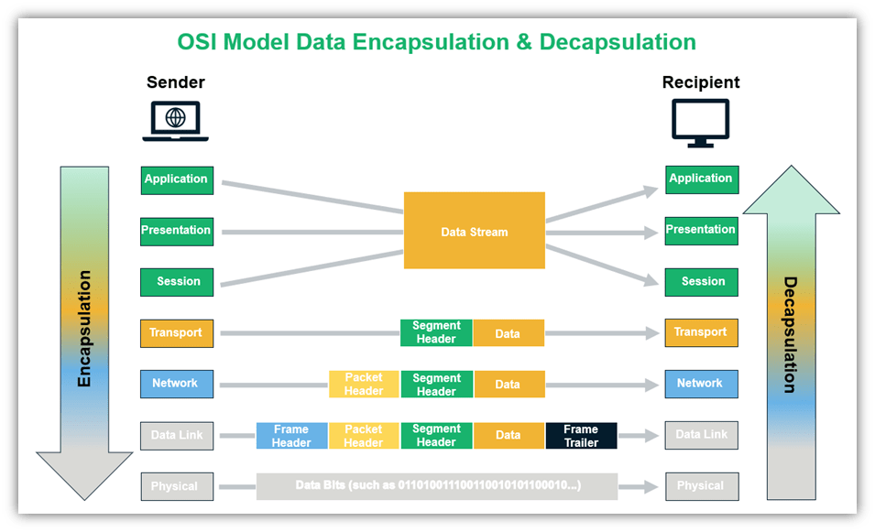

Data Unit For Each Layer

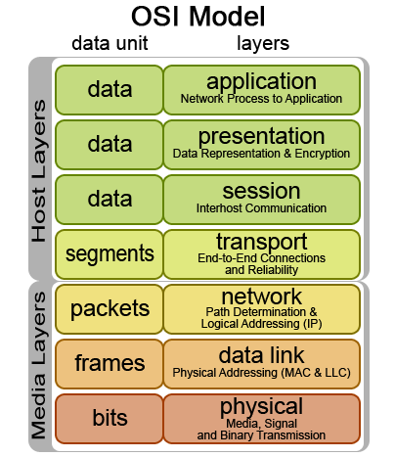

**APPLICATION LAYER** is an end-user interaction via browser, terminals, access directories, etc

**PRESENTATION LAYER** deals with encoding(eg-> ASCII encoding),encryption (like when applying SSL/TLS), Compression (such as by using gzip)

**SESSION LAYER** deals with creating sessions for different parties like opening, closing and managing dialogues, For eg -> the web browser could have one tab opened for video, one for email, another for online shopping, and so on. The session layer is tasked with keeping all those connections alive, managing them, and terminating them

**TRANSPORT LAYER** helps to transport the data in segments to right application and service .

example,Consider an Apache server running in the background listening at port **80** or port **443** for incoming connections. If an incoming message has a destination port as 80, the transport layer will deliver the message to the corresponding service.

The protocol data unit (PDU) at this layer is a segment. The original data is broken up into chunks called segments and sent over multiple pathways to gain some efficiency (by avoiding congestion). It also incorporates security since the segments are scattered and makes it harder for an attacker to read the entire message. also it is responsible for error correction.

**NETWORK LAYER** of the OSI model routes the data along multiple pathways. The PDU for this OSI layer is referred to as a packet. It contains information such as source and destination IP addresses to identify end devices. The most commonly used protocol at this layer is IPv4. The network layer is responsible for:

* Routing packets from source to destination (host-to-host delivery) across different networks,
* Translating logical addresses into physical addresses, and
* Fragmenting packets into smaller pieces to allow it to travel across links with lower maximum transmission units (MTU).

**DATA LINK LAYER**

The data link layer is layer two of the OSI model and the last layer where encapsulation (frame assembly and disassembly) occurs. It takes the data from the layers above it and links it to the last layer while sending out information. The PDU for the data link layer is called a frame, which is a packet with a header and a trailer. The header signals the beginning of the frame, and the trailer indicates the end of data transmission for a particular frame.

The data link layer has two sublayers:

* **Logical Link Control (LLC) layer (the upper sublayer)** — The LLC sublayer assists with multiplexing and de-multiplexing over the MAC layer. It takes the packet from the network layer and adds control information to deliver it to right destination (hop-to-hop flow and error control).
* **Media Access Control (MAC) layer (the lower sublayer)** — The MAC sublayer interacts directly with the physical layer and deals with framing/de-framing, typically done by NIC cards on PCs. It is also responsible for collision resolution on shared or broadcast links where multiple end nodes connect to the same link

**PHYSICAL LAYER**

The first and lowest layer of the OSI model is called the physical layer. It deals with how the devices are physically connected to one another using cables, switches, NICs, etc. and the raw transfer of data via them. Examples include the following to send and receive information:

* Ethernet cables,
* Fiber optic cables,
* Radio signals used in wireless communication, etc. to send or receive information.

Physical layer responsibilities include bit-by-bit-delivery, converting signals from one form to another, line coding, carrier sensing and collision detection, bit synchronization, defining the transmission mode, etc

OSI, TCP, TCP/IP Protocol Suite



Reference

sectigostore -> [link](https://sectigostore.com/blog/how-osi-model-network-communication-layers-work/" \l ":~:text=OSI%20Layer%207:%20Application%20Layer)